



CONFIGURATION SOFTWARE:

TELEPHONE
INTERFACE
MODULE

Creating or changing the Phone Input numbers will require downloading the database to the lighting controllers and should be preceded by retrieving the existing database from the controllers or simply opening the existing master database file. The download or retrival can be achieved by a serial connection or by a network connection. See the Synergy Configuration Software Manual for details

Phone Inputs
Phone inputs can be triggered with the addition of a Modem to the synergy controller. A controller with a voice modem will answer the phone, prompt the caller to enter a phone input number, prompt the caller to enter a level, say Thank You, and hangup. If the phone input number is valid, then the level gets applied to the group (and its members) that the phone input controls.
You may need to check the option that allows the Phone Input tab to be viewed:
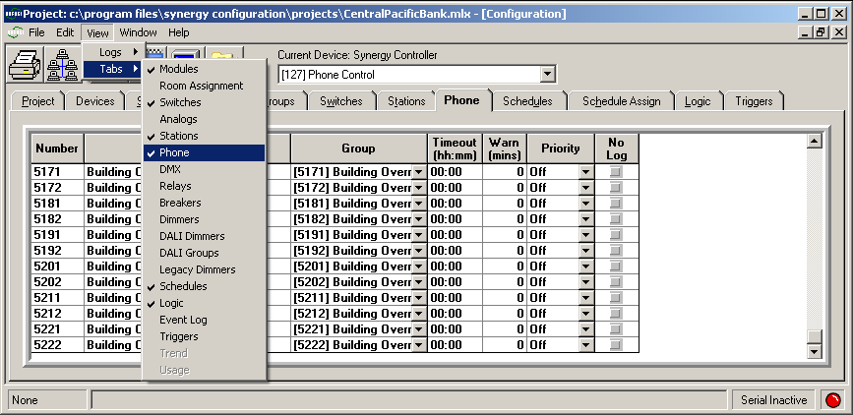
Change your Current Device to the one desired (1), and select the phone input tab (2).
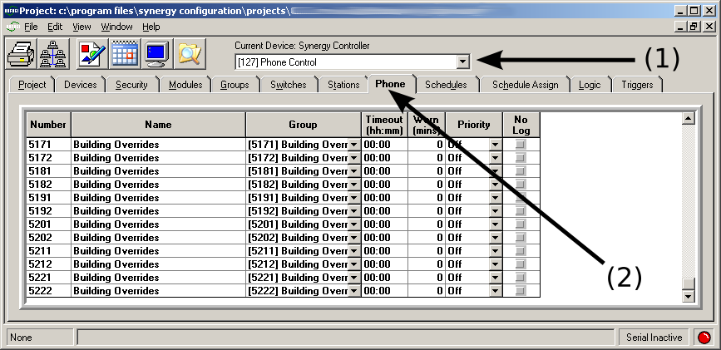

Adding a Phone Input number
Phone input codes can range from 0000 to 9999. They can be assigned to control any group internal to the controller. The group, however, can control any output object inside of or external to the controller.
Adding phone input numbers is accomplished by using the mouse (Right Click) and choosing the Add Phone option, or by using Shift+Ins keys on the keyboard.
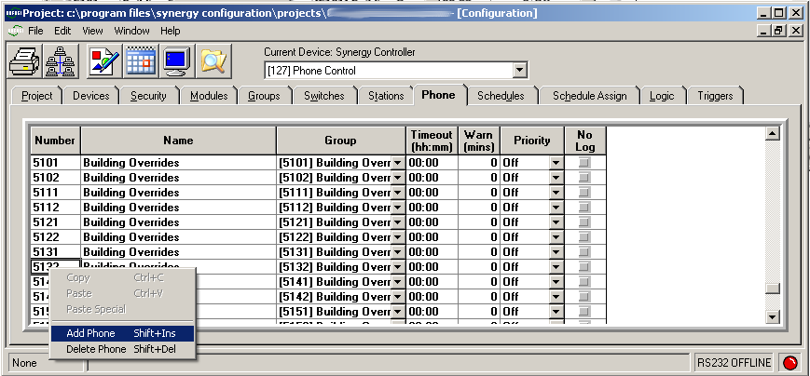
This brings up a phone input number entry dialog, which accepts a single entry or a range of entries
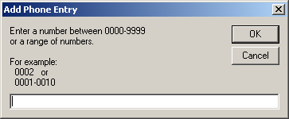
The Phone Input can be assigned a group that it controls. A Timeout and Warn time can also be associated with each Phone Input number, allowing the lights to be overridden only for a certain period of time. The Phone Input can control the group at a specific Priority. There is also an option to disable the logging that occurs when a Phone Input is triggered.

Changing a Phone Input number
Sometimes it is necessary to change the phone input number. Currently, this is only possible by adding a new number, selecting the same local group as the old number, and deleting the old phone input number.
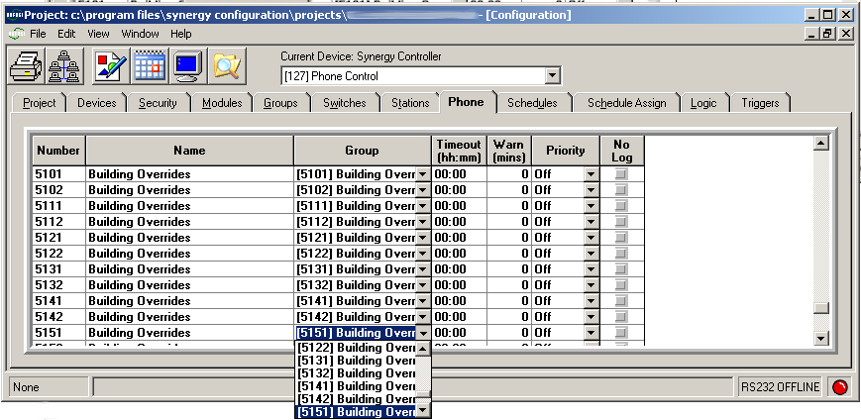
Deleting phone input numbers is accomplished by using the mouse (Right Click) and selecting the Delete Phone option, or by using Shift+Ins keys on the keyboard.
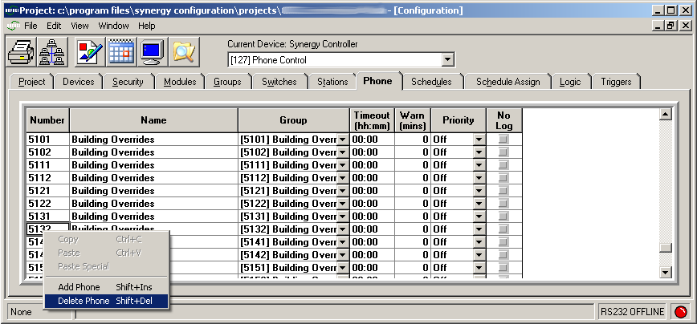

Voice Selection
There are a number of recorded voice options for the Synergy lighting control system. In addition to the existing options, Synergy can also utilize your own recordings, but the WAV files must be in a certain format and will need to be downloaded to the controller using a serial console (e.g. Hyperterminal) or BACnet file services.
The recorded voice options are available under the Network Services button:
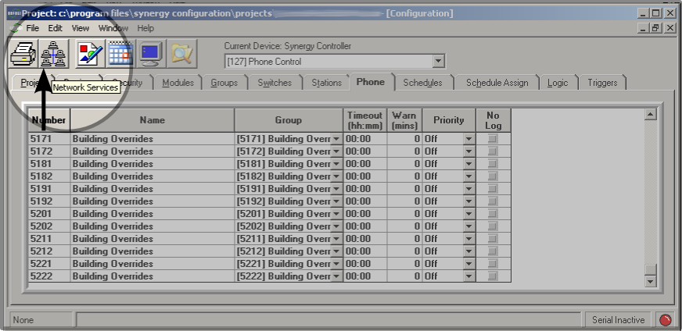
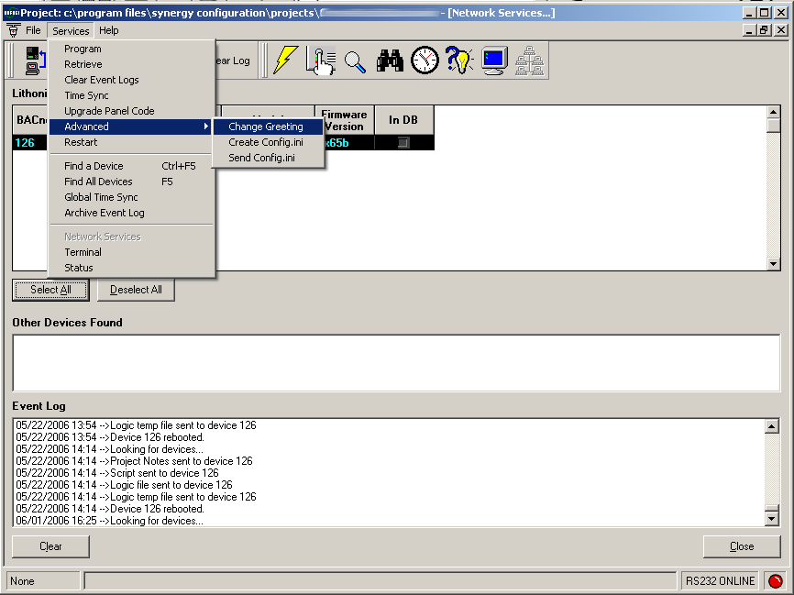
Selecting the Change Greeting option brings up the Telephone Interface Module (TIM) voice selection dialog. There options include a choice of male or female voice, and a short, normal, or long greeting. There is a the ability to test the voice prior to downloading it.
