

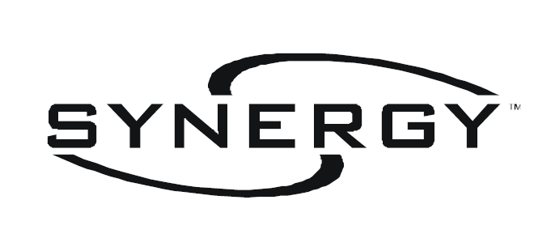

CONFIGURATION SOFTWARE:

PANEL
FIRMWARE
UPGRADE

Downloading the database to the lighting controllers is similar to retrieving the existing database from the controllers. This can be achieved by a serial connection or by a network connection.

This section will cover:

- Upgrading panel firmware using a laptop computer with a serial connection

- Upgrading panel firmware using a pc which is installed on the “S2” network

Upgrading panel firmware using a serial connection
Occasionally new firmware will become available to provide new features or to correct problems. To upgrade the panels, perform the following procedure.

Your screen will appear as below. You must first (1) change the connection type to “Serial” by using the drop down arrow. Second (2) click the “Network Services Button” – The button in the upper left area of the screen that looks like a cluster of 5 computers. Synergy will search for all controllers attached to the “S2” network.

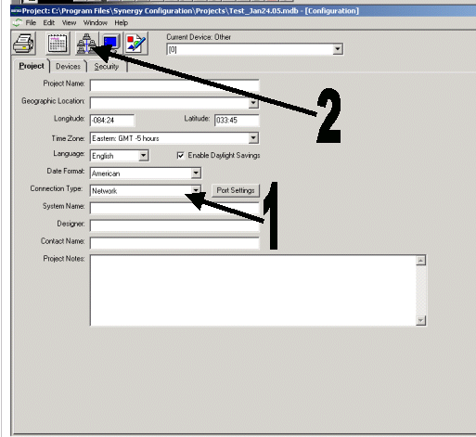

The following screen should appear, showing the current firmware version (2) of each controller:

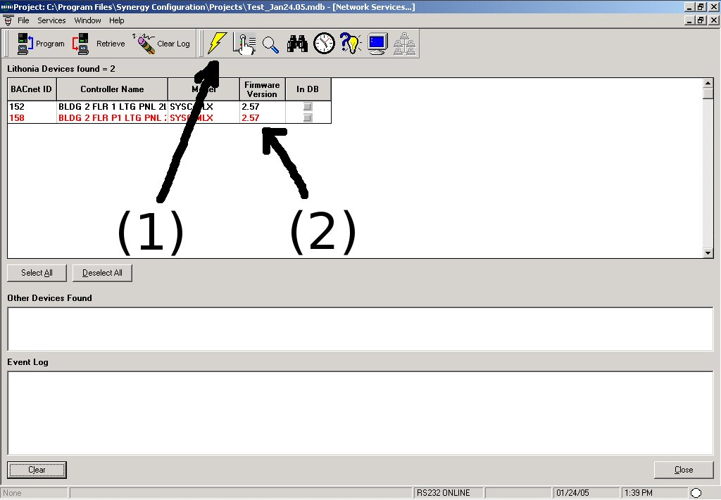
Click on the “Select All” button. All controllers will now be highlighted. Click the "Upgrade Device Firmware" button (1). The following window will appear:

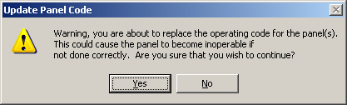
Choose "Yes," and a dialog box for selecting the firmware (RTB file) to use in the upgrade will open.

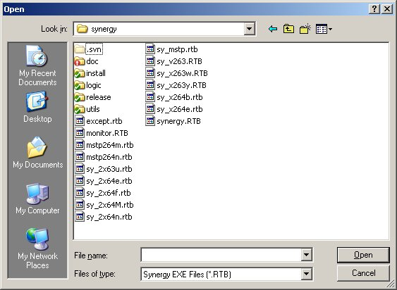
Select the firmware file (RTB file) that you want to use in the upgrade, and click "Open" which will start the download. Monitor the "Event Log" portion of the screen for status of the upgrade.

When the firmware download is complete, and the panels have restarted, refresh the list of devices by clicking on the "Find All Devices" icon. Verify that the version number is correct from each controller.

Upgrading panel firmware using a network connection
The process for upgrading a panel using a network connection is identical to programming using a serial connection with the exception of the type of “connection” that is chosen.

For “Connection Type” choose “Network” and then follow the steps as above.

After the control panels have been upgraded, you can close the “Network Services Window” by clicking on the lower “X” in the upper right corner of the screen. The “Project Window” will appear. The lighting control panels have been upgraded and you can now close “Synergy Config”.

