Thank you for downloading Synfig Studio — the free and open-source animation software!

First of all, please make sure to copy “SynfigStudio.app” from this DMG archive into your “Applications” folder and then try to start from there.

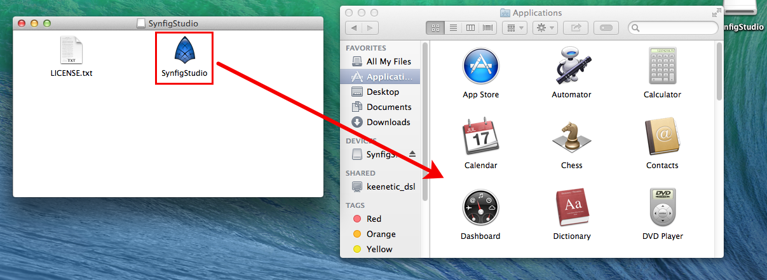

If you get an error message like "Can't be opened because it comes from a non identified developer", then you can solve this in the following way:
- In the Finder, locate the app you want to open. (Don’t use Launchpad to do this. Launchpad doesn’t allow you to access the shortcut menu.)
- Control-click the app icon, then choose Open from the shortcut menu.
- Click Open.
The app is saved as an exception to your security settings, and you can open it in the future by double-clicking it just as you can any registered app.

Note: You can also grant an exception for a blocked app by clicking the “Open Anyway” button in the General pane of Security & Privacy preferences. This button is available for about an hour after you try to open the app. To open this pane, choose Apple menu > System Preferences, click Security & Privacy, then click General.

See more details here - https://support.apple.com/kb/PH25088?locale=en_US

