**Second Run Logistics LLC**

***Syniah Peterson***

***Date: 02/08/2024***

## Project Name: Second Run Logistics LLC

## Project Overview:

This website is for a small business owners’ trucking company. It’s purpose is to get the company name out there and allow the business owner to share a website that can answer all questions that potential customers may have about what services he offers and what his business represents. The intended users for this website are potential customers for the small trucking company.

The website will consist four webpages. The first being a home page which will contain images of the trucks, information about the business and why it’s a good business for their needs. The second webpage is about the services the trucking company offers with buttons that will allow users to read and go more in depth with the service they intend to use. The third webpage is about price estimates for certain jobs, this webpage will consist of a form and the user can input their information and submit the form to receive an estimate on work they are interested in. The fourth page is about the companies contact information and will have a form for user to input their information if they wish to talk to the business owner about a specific inquiry. The final webpage is about locations the trucking company delivers to as well a map (API) that will tell the user where the business is located. All these webpages will share a common header that will consist of the logo and navigation links to all the webpages and a footer that contains contact information for the business such as social media accounts, phone numbers, and emails.

## Site Map:

## Page Design [one section needed for each page/sub-page]:

For **each** page listed in your site map, provide *at least* the following requirements:

* Home page
  + Purpose: To allow users to get to know the company and understand company values. This is like an about us page and an advertisement as to why the customers should choose this particular company
  + Audience: Customers

* + Dynamic functionality: Interactive images
* Service page
  + Purpose: Lists all the services the trucking company provides in detail.
  + Audience: Customers

Wireframe: 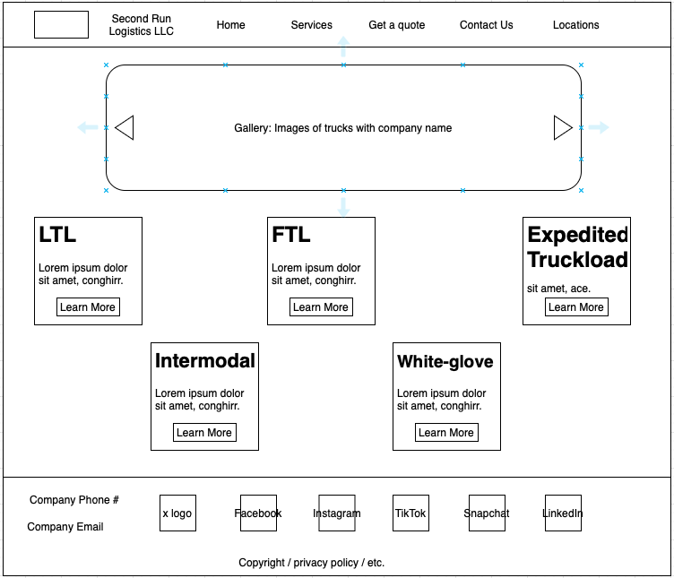

* + Dynamic functionality: User clicks a button
* LTL page
  + Purpose: Explain in detail what less than truckload service would consist of.
  + Audience: Customers

* + Dynamic functionality: User clicks a button
* FTL page
  + Purpose: Explain in detail what full truckload service would consist of.
  + Audience: Customers

* + Dynamic functionality: User clicks a button
* Expedited page
  + Purpose: Explain in detail what expedited truckload service would consist of.
  + Audience: Customers

* + Dynamic functionality: User clicks a button
* Intermodal page
  + Purpose: Explain in detail what intermodal freight shipping service would consist of.
  + Audience: Customers

* + Dynamic functionality: User clicks a button
* White-glove page
  + Purpose: Explain in detail what white-glove service would consist of.
  + Audience: Customers

* + Dynamic functionality: User clicks a button
* Get-a-quote page
  + Purpose: To allow customers to quote a price for services they are interested in.
  + Audience: Customers

* + Dynamic functionality: Form submission
* Received-quotes page
  + Purpose: To store input from the form on the get-a-quote page.
  + Audience: Admin

* + Dynamic functionality: Form submission
* Contact-us page
  + Purpose: To store all contact information for the company and allow customers to send inquiries to the company.
  + Audience: Customers

* + Dynamic functionality: Form submission
* Contacts page
  + Purpose: To store input from the form on the contact us page by customers who sent in inquiries to the company.
  + Audience: Admin

* + Dynamic functionality: Form submission
* Locations page
  + Purpose: To share the location of the company on a map and to show customer what locations services are offered in.
  + Audience: Customers

* + Dynamic functionality: Map