# Issue : Not able to find a price rule for a customer in Management Center

# Steps

1. Login to Management Center.

URL : <https://caldwell1:23001/lobtools>

1. Enter your username and password

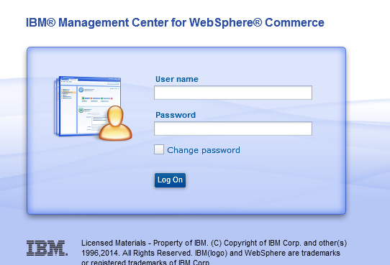

1. Click on Work on Approved Content.

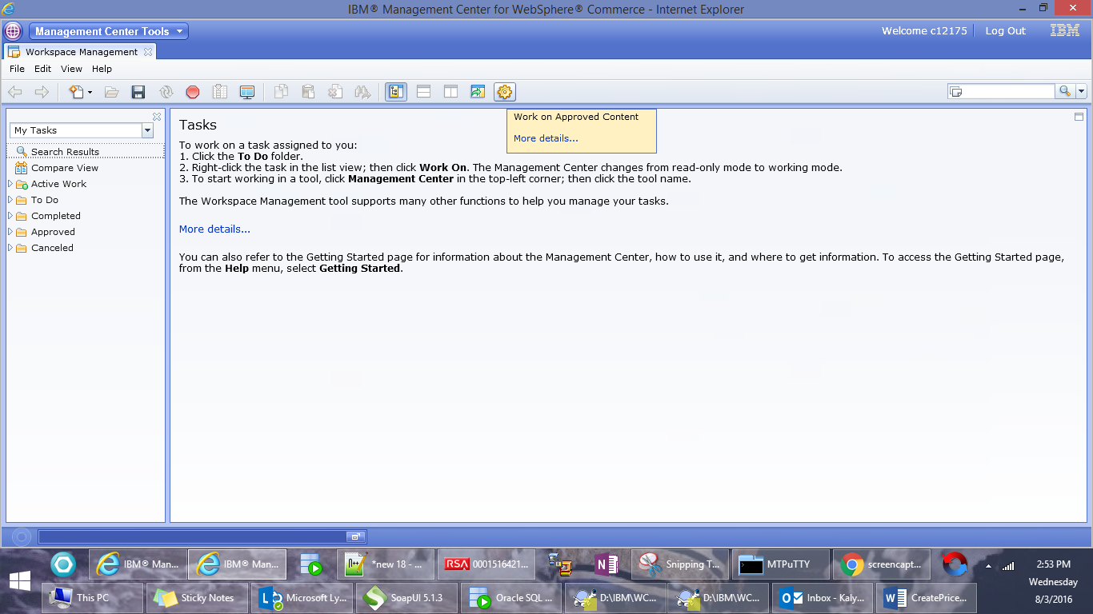

1. Select Catalog Filter and Pricing

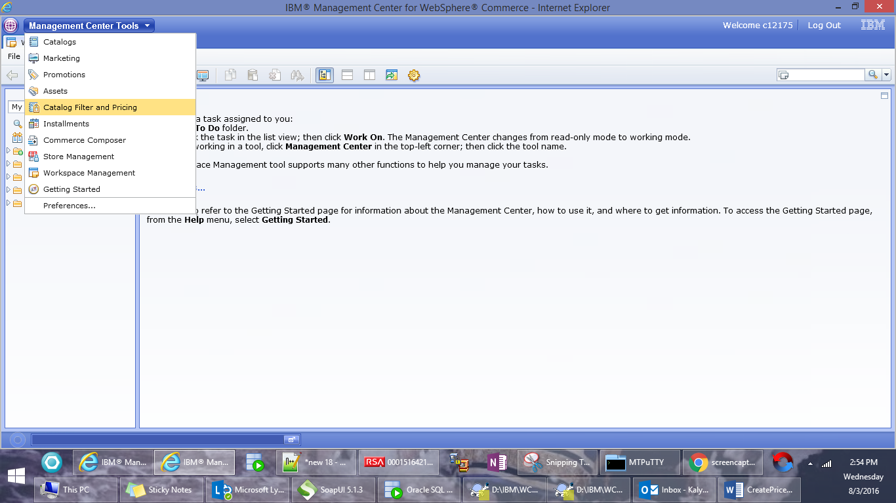

1. Select “Avnet” as store from the dropdown

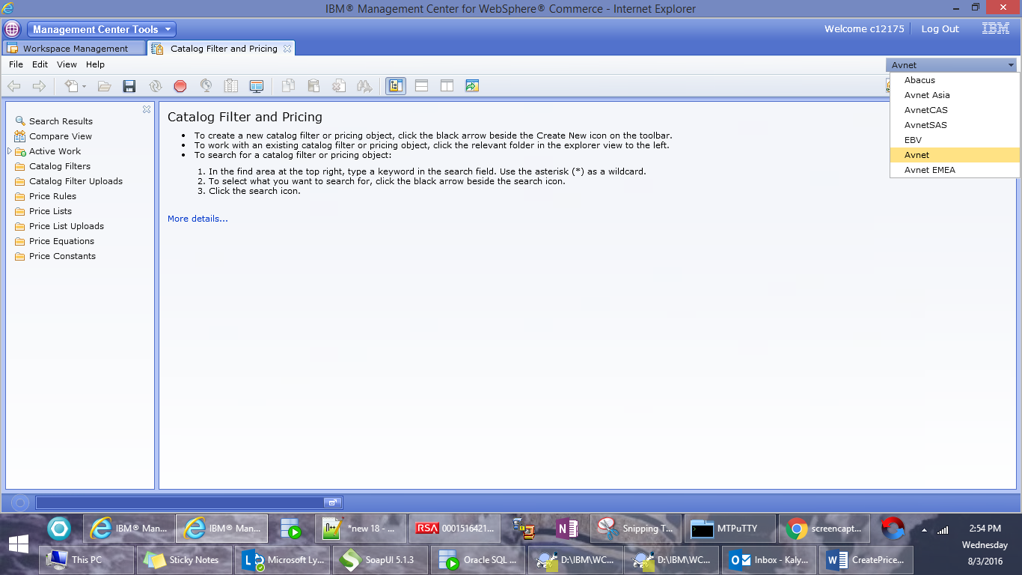

1. Create new Price List

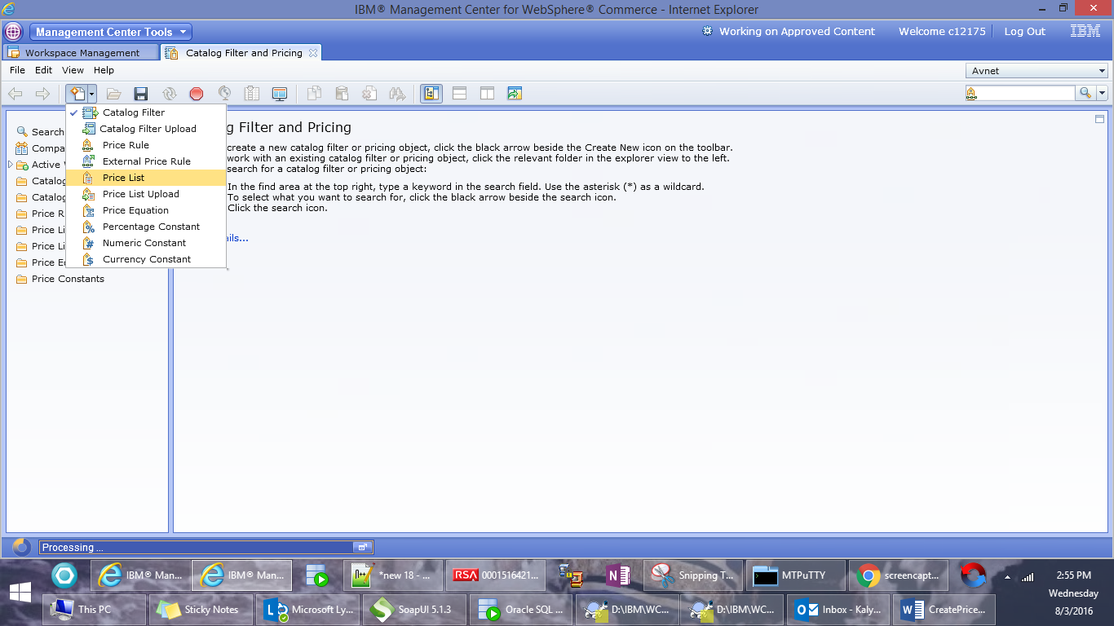

1. Enter the name and description as AV_<<AcountNumber>>_G_PL

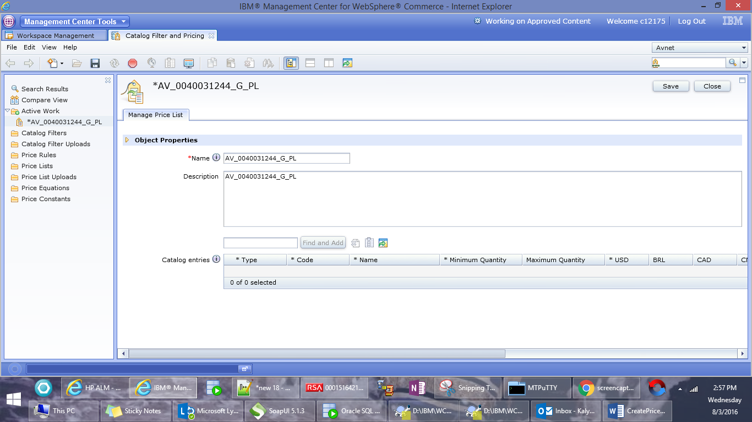

1. Click on Save to save your changes.



1. Create new Price Rule

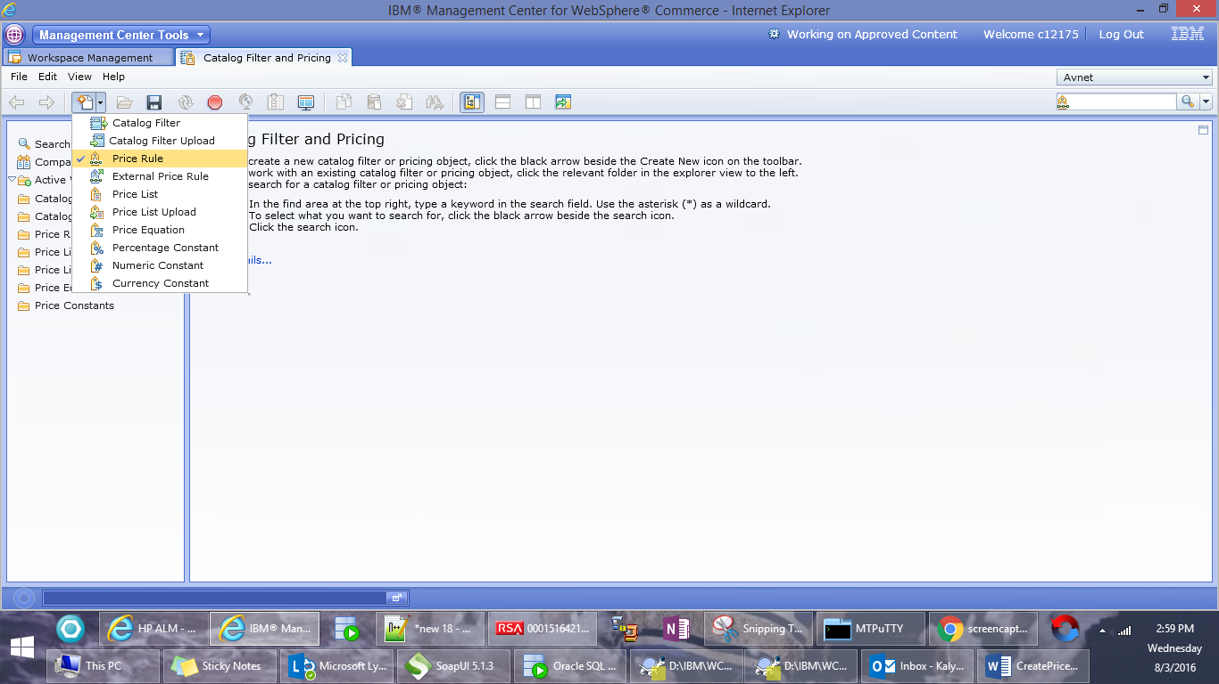

1. Enter Name and description as AV_<<AcountNumber>>_G_PR and click on Save.

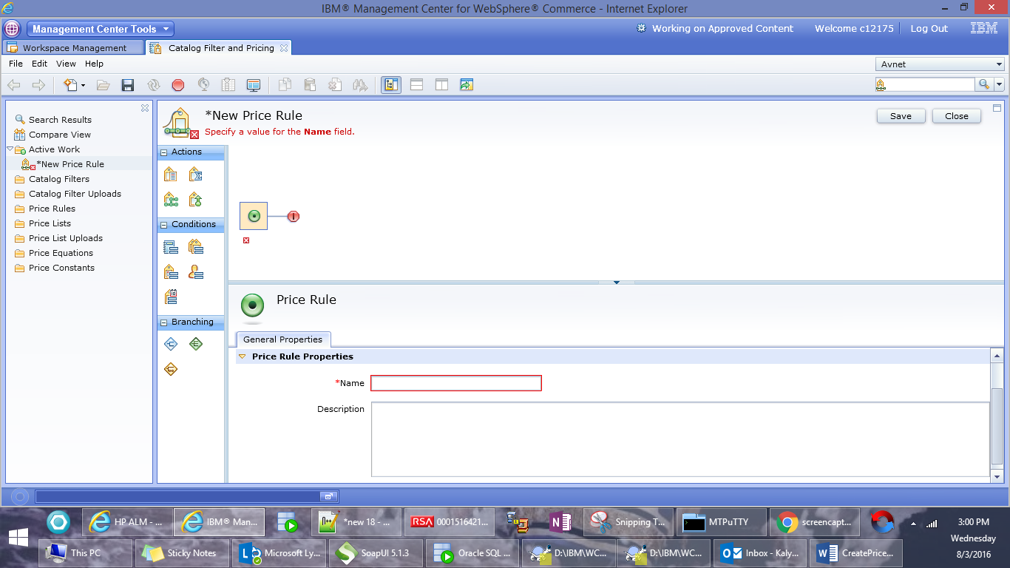

1. Drag and drop the conditional branch

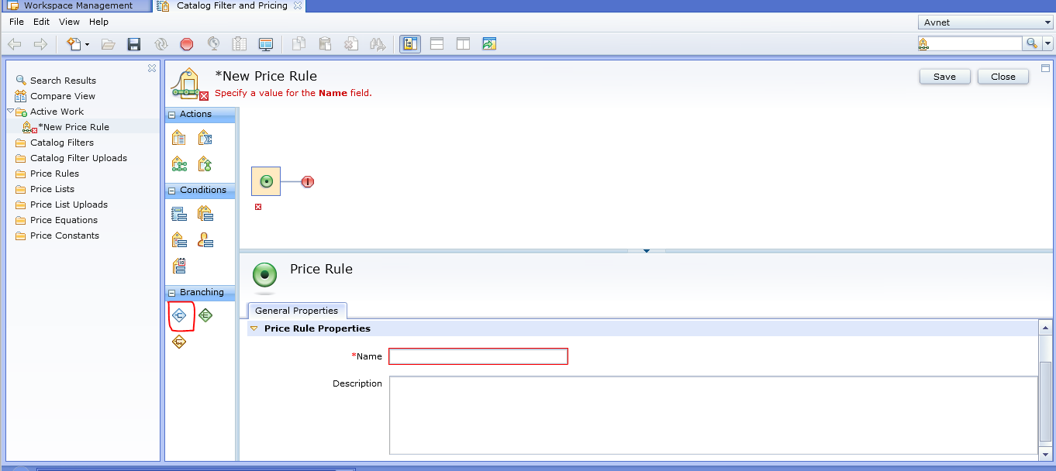

1. Enter the Path names as below

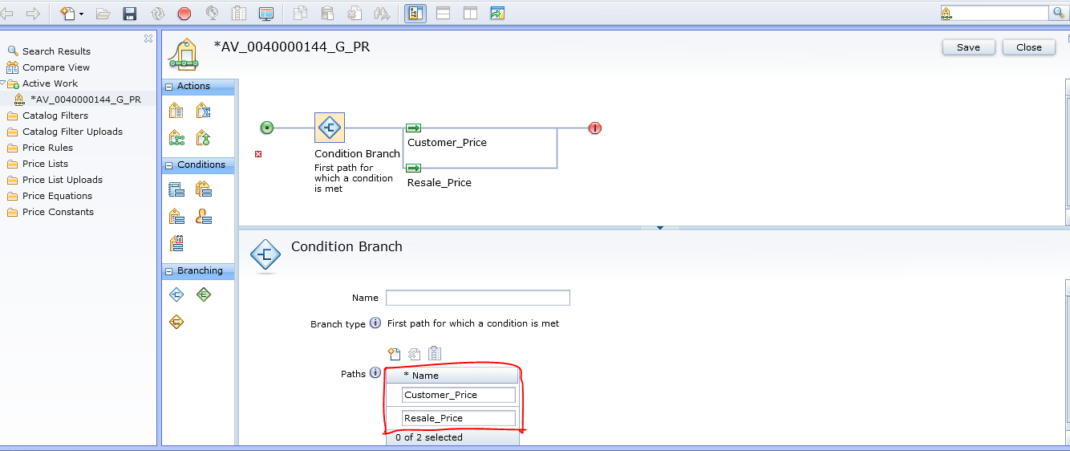

1. Drag and drop the price list condition on the Customer_Price line

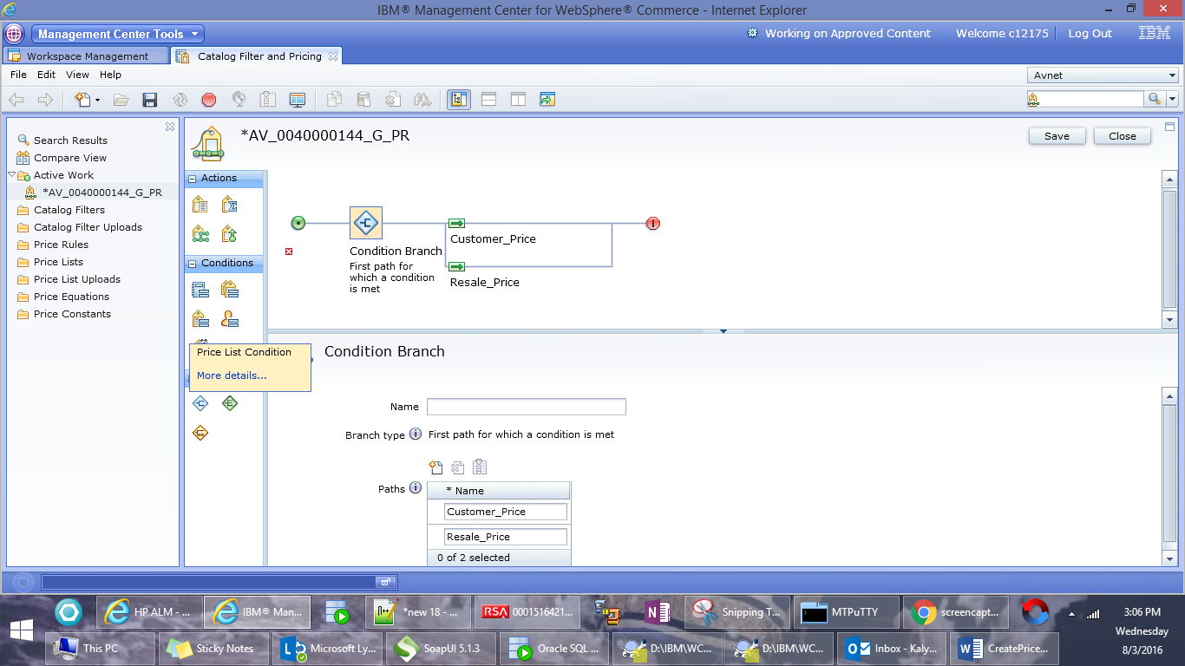

1. Enter the pricelist as AV_<<AccountNumber>>_G_PL and click on Find and Add.

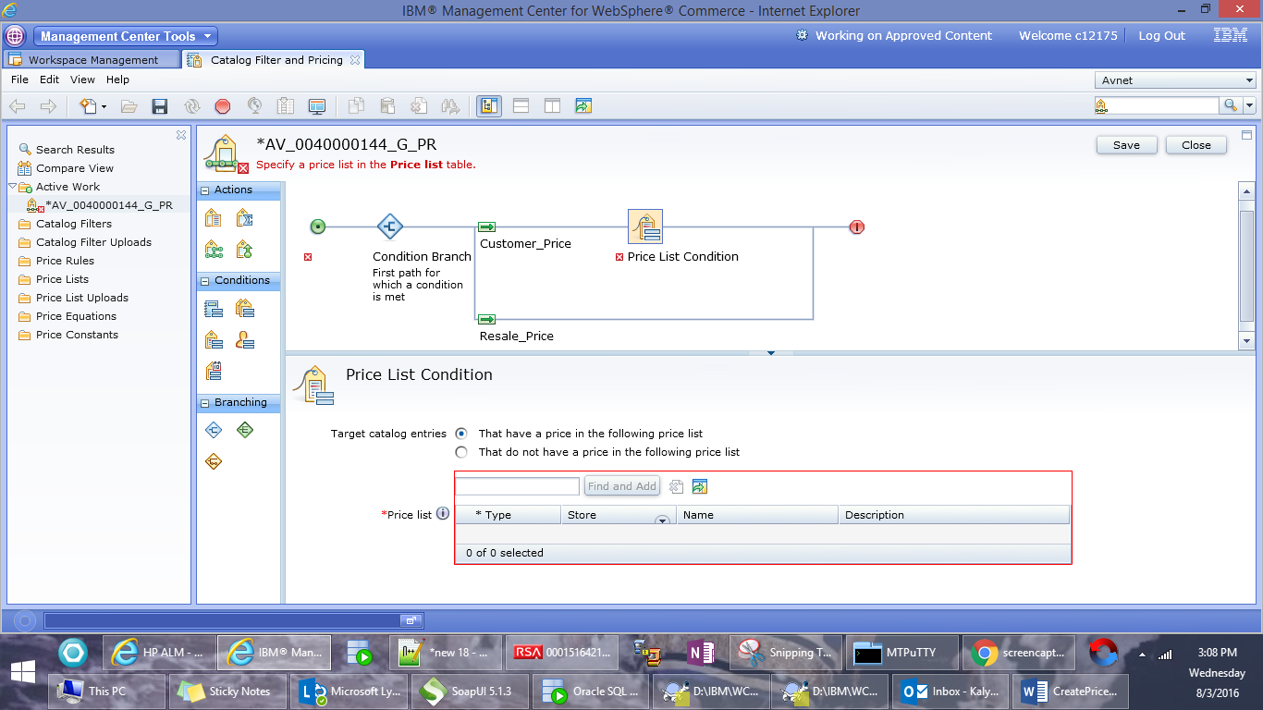

1. Drag and drop the Get Price from price list in the Customer_Price line.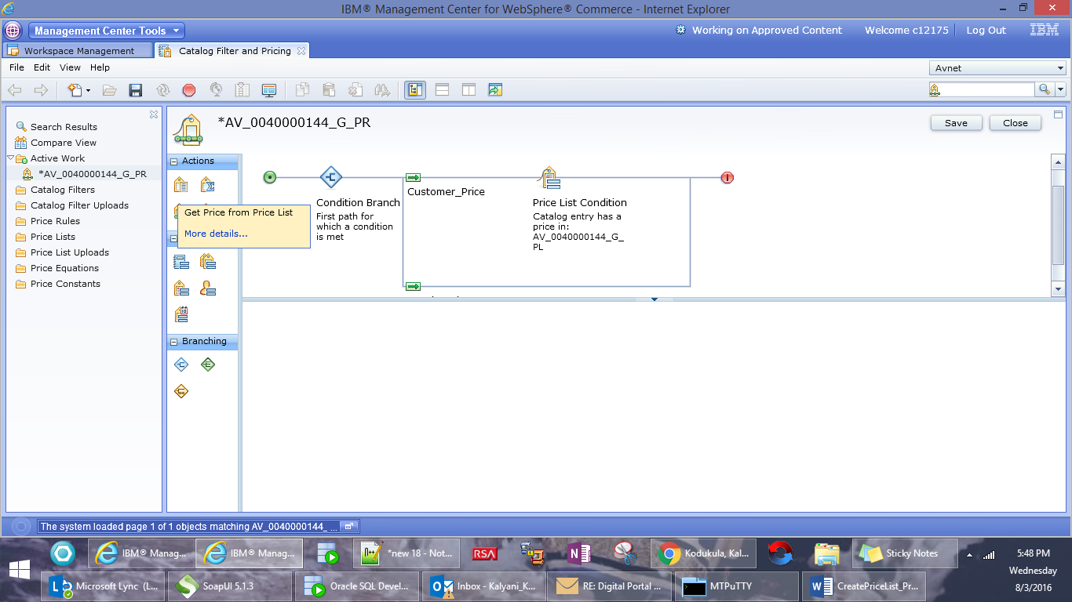
2. Enter the pricelist as AV_<<AccountNumber>>_G_PL and click on Find and Add.

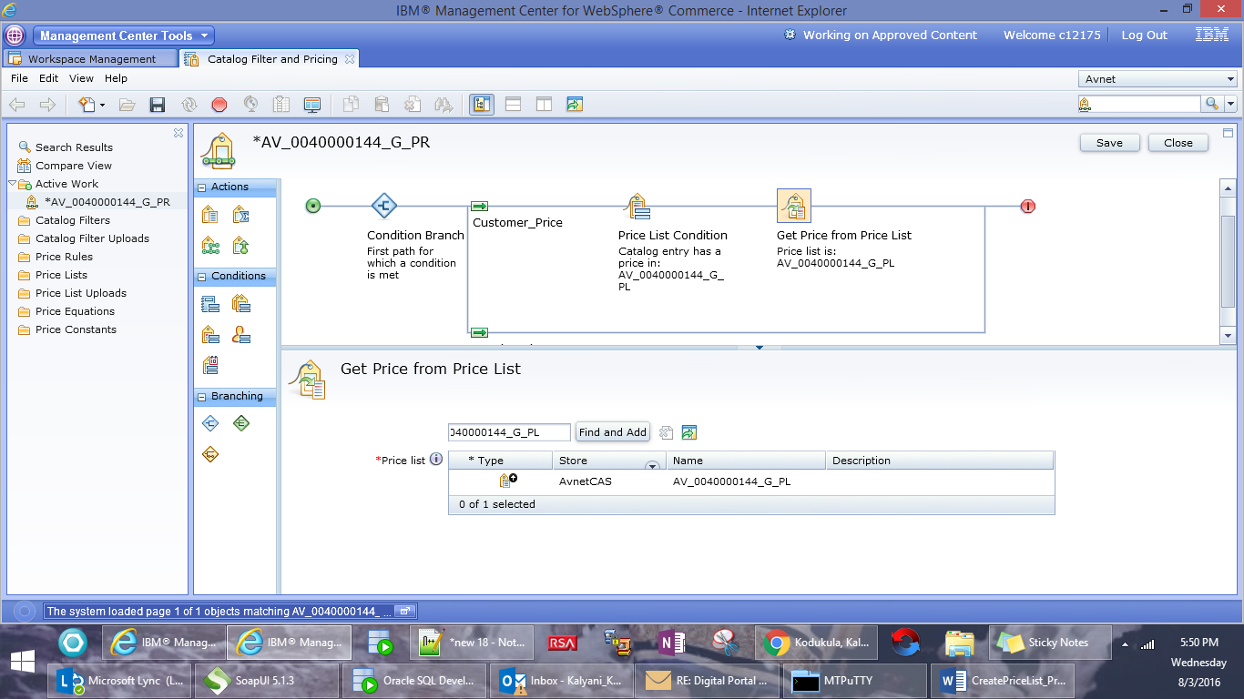

1. Drag and drop the Nested Price Rule condition

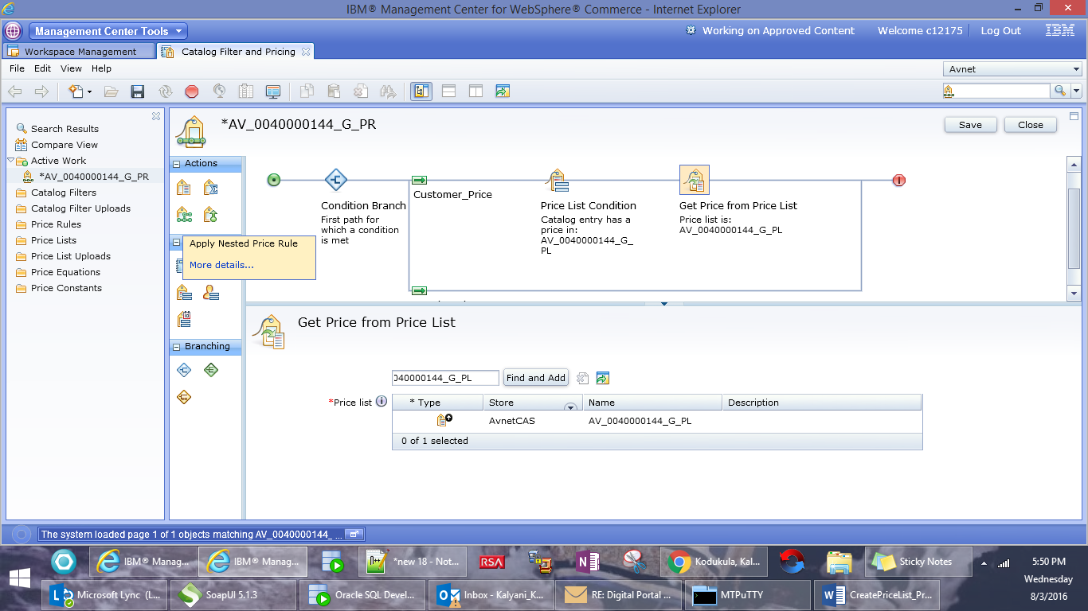

1. Enter the pricelist as EMA_WEBRESALE_PRICE_RULE and click on find and add.

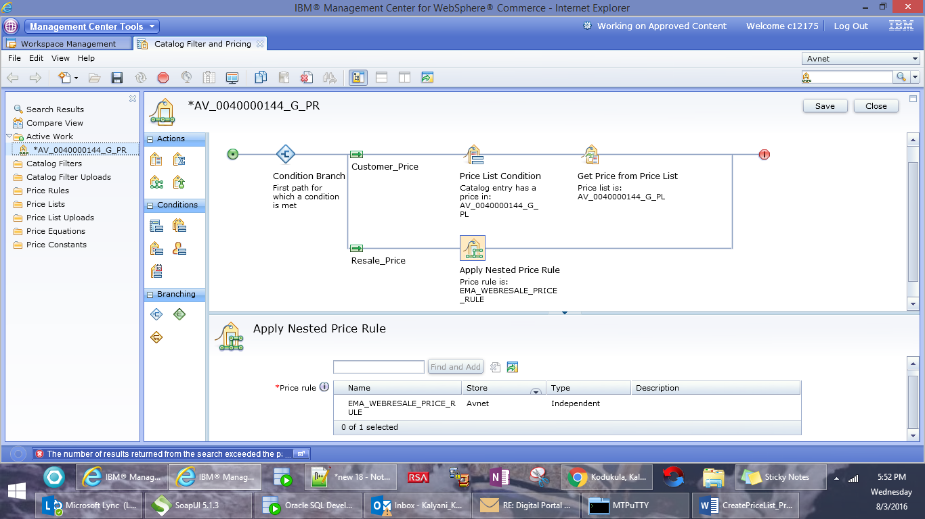

1. Click on Save .