**TROUBLESHOOTING INVENTORY MISMATCH IN DIGITAL PORTAL**

At many times we encounter situations where the inventory of an item displayed in the digital portal does not match the inventory of the same item at the SAP side. In most cases the initial input for us will be a screenshot of the PDP page containing the item for which there is an inventory mismatch as shown below: 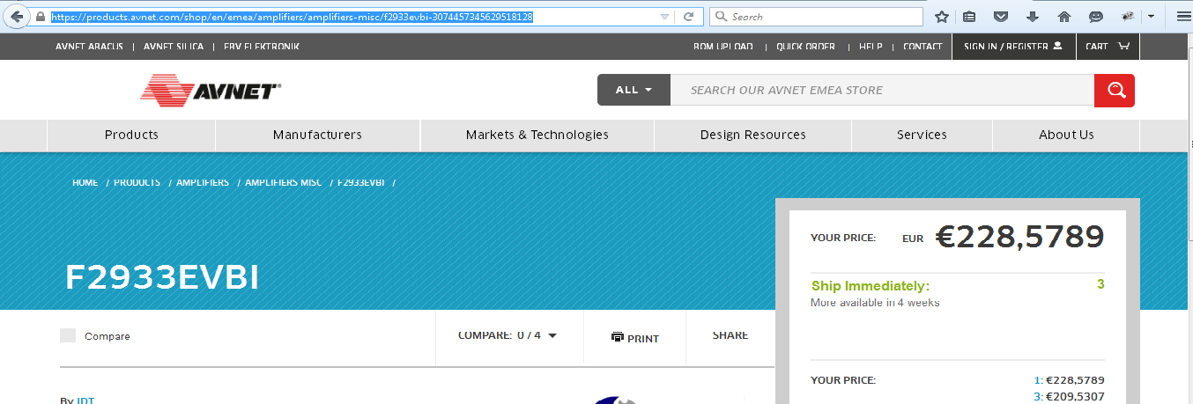

In those situation the following steps can be followed to sync the data:

1. **Get the catentry_id of the item.**

The catentry_id of the item will be present in the url of the pdp page. For example the url of the PDP page of a part in amp0lifier category is :

[**https://products.avnet.com/shop/en/emea/amplifiers/amplifiers-misc/f2933evbi-3074457345629518128**](https://products.avnet.com/shop/en/emea/amplifiers/amplifiers-misc/f2933evbi-3074457345629518128)

Here the last set of digits- **3074457345629518128** makes up the catentry_id.

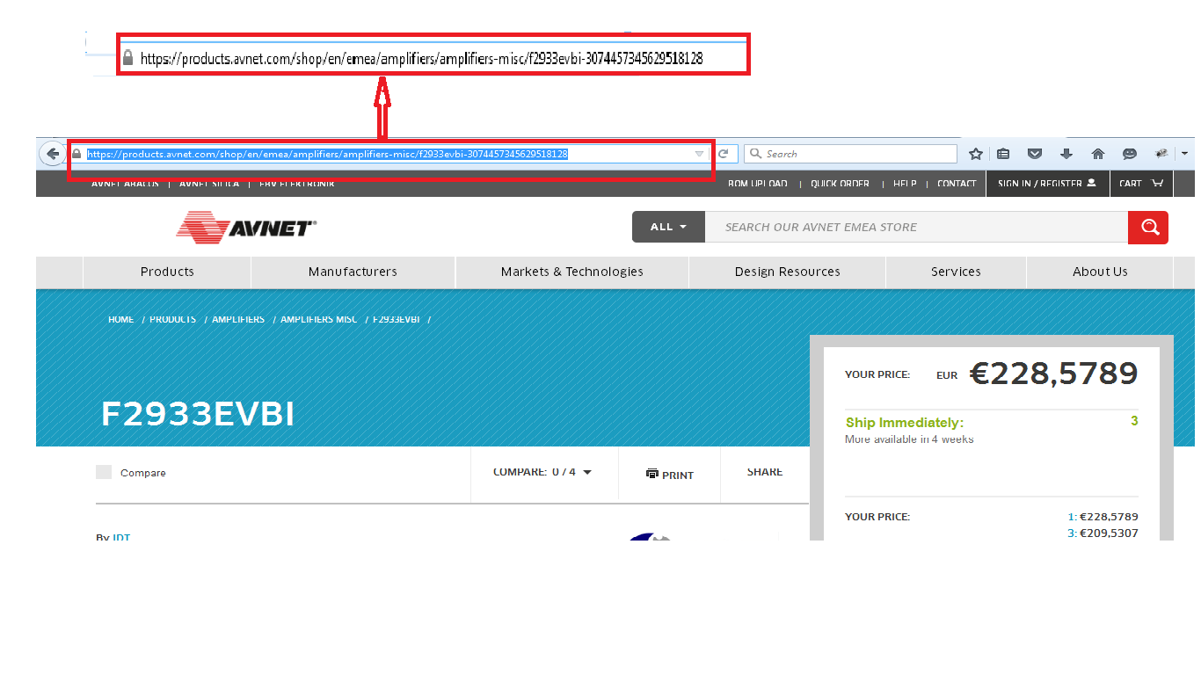

Once we get the catentry_id of the item, we can proceed with the following troubleshooting steps based on the region.

1. **EMEA:**

Follow the below steps for EMEA:

**Step1:**

For EMEA region there are 3 different speed boats and the item may belong to any of the speed boat or it may be a combination part (belong to more than one speed boat). Due to this special scenario while displaying in digital portal we will be summing the inventories of the item in all the speedboats.

Before proceeding with the troubleshooting we need to find out to which speed boat the item belongs. For this execute the below query in the preprod DB (AVS93DB):

**Select * from XERPPARTNUMBER where catentry_id=<catentry_id>**

A sample result is provided for the above query:

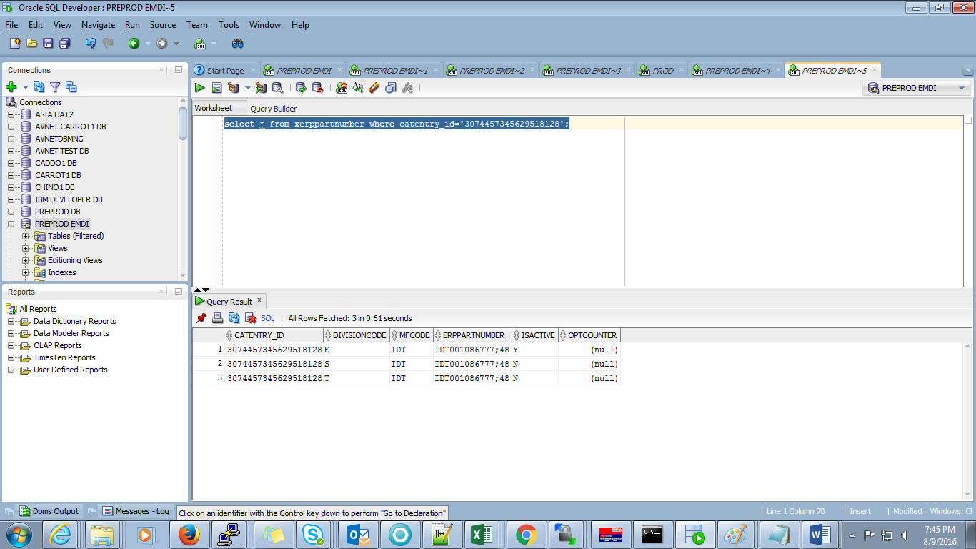

Check the ISACTIVE column and DIVISIONCODE column to see to which speed boat does the item belong. The item belong to that speedboat whose ISACTIVE flag has value ‘Y’. Here the ISACTIVE column of the E division is ‘Y’ and hence this is an EBV only part. If ISACTIVE column value is ‘Y’ for more than one DIVISIONCODE column then it is a combination part.

The DIVISIONCODE values for each speedboat is listed in the below table:

|  |  |
| --- | --- |
| DIVISIONCODE | Speedboat |
| E | EBV |
| S | SILICA |
| T | APOLLO |

Thus the following combination is possible for an item

1. EBV only part
2. Silica only part
3. Abacus only part
4. Combination part (combination of E-S or S-T or E-T or E-S-T)

We need to follow slightly different procedure for each type and they are detailed below:

1. **EBV only part**
2. Go to the folder /diexpcontent/wcs2archive/preprod/epos2ecom
3. Run the below command

**grep “<erppartnumber>” *DIGEXP_EMEA_INV001.csv**

Here <erppartnumber> is the value of the column against ‘E’ divisioncode returned in the result of the first query. DIGEXP_EMEA_INV001.csv is the generic pattern name of the inventory csv file we receive.

This command will return a list of files that has record for this erppartumber. A sample result is shown below.

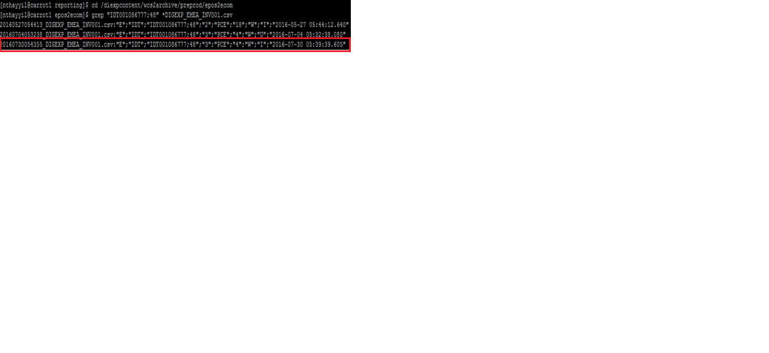

Here all the files having inventory record for the erppartnumber is listed. From this choose the latest file. The latest file can be identified from the timestamp appended to the beginning of the file.

Check the quantity value received for the item in that particular file. The quantity value is the 4th column of the csv file. We can cross check this by running the less command as follows:

less <filename>

A sample is shown:

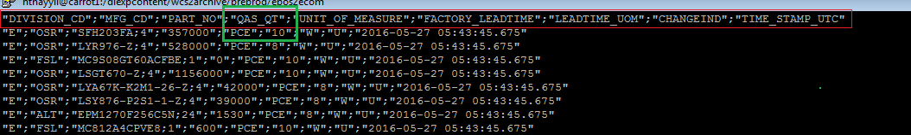

If the quantity shown in the feed file is same as that shown in digital portal, then it is an issue at EPOS side. EPOS has not sent the latest inventory feed for the item. We need to raise QC ticket with EPOS to send the latest feed file for the item.

If the quantity in the feed file is different from that in the digital portal, it is an issue with the inventory dataload or solr indexing. To resolve this follow step2.

1. Silica/Abacus only part
2. Go to the folder /diexpcontent/wcs2archive/preprod/sap2ecom
3. Run the below command

**grep “<erppartnumber>” *DIGEXP_EMEA_INV001.csv**

Here <erppartnumber> is the value of the column against ‘S’ divisioncode (for Silica part) or ‘T’ divisioncode (for Abacus part) returned in the result of the first query. DIGEXP_EMEA_INV001.csv is the generic pattern of the inventory csv file we receive.

As explained above we need to choose the latest feedfile and then check the quantity value. A sample result is shown below.

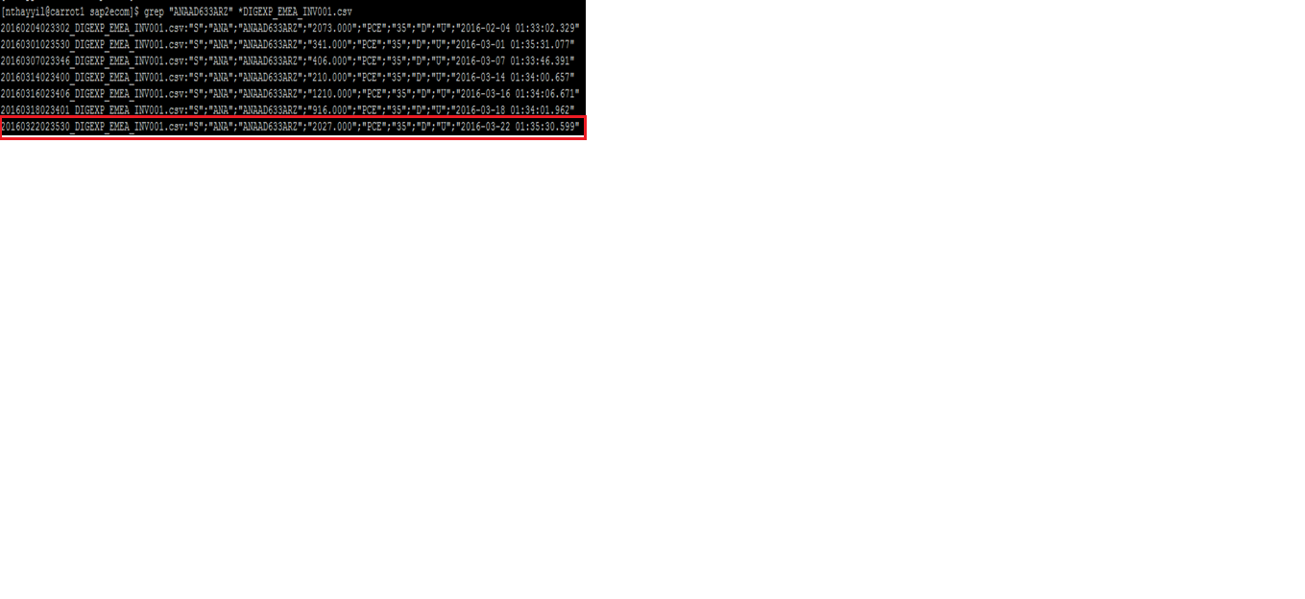

less <filename>

A sample is shown:

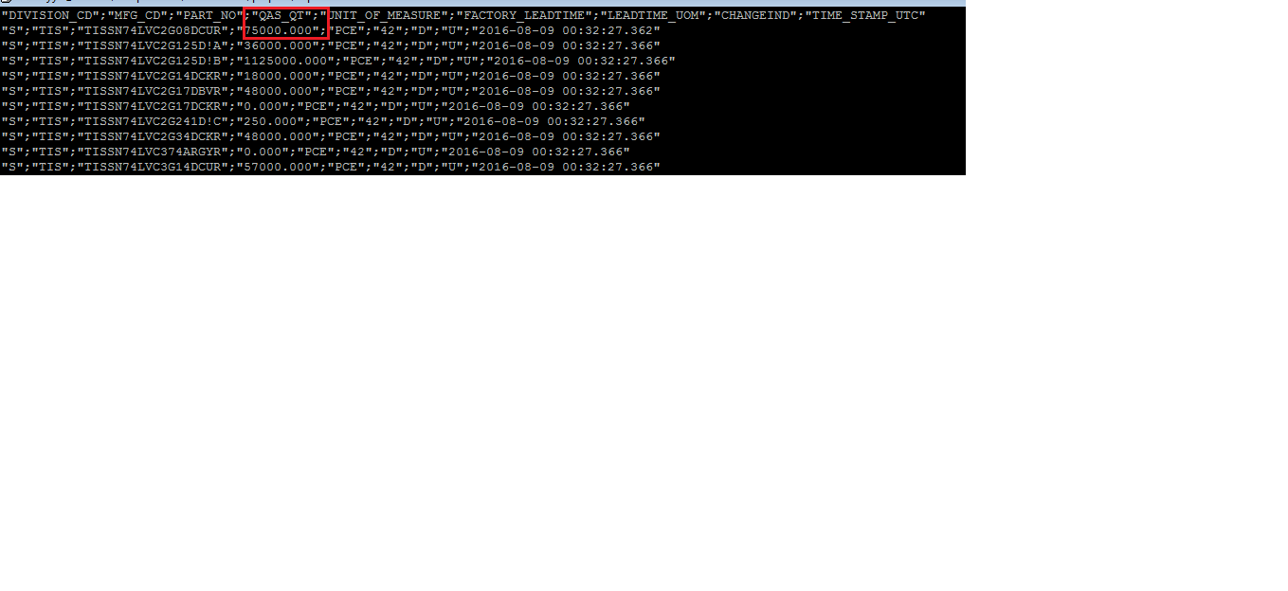

If the quantity shown in the feed file is same as that shown in digital portal, then it is an issue at SAP side. SAP has not sent the latest inventory feed for the item. We need to raise QC ticket with SAP to send the latest feed file for the item.

If the quantity in the feed file is different from that in the digital portal, it is an issue with the inventory dataload or solr indexing. To resolve this follow step2.

1. Combination part

If it is a combination part, we have to go to the respective archive folder for each region and grep the erppartnumber as detailed in the above steps. Then sum the quantity values obtained for each region and compare it with digital portal.

**NOTE:** The actual unique key for the item is combination of divisioncode,mfcode and erppartnumber. Thus we need to cross check if the divisioncode and mfcode for the record returned is same as that returned in the preprod DB (AVS93DB). If there is same erppartnumber for different divisioncode or mfcode we need to ignore that record from our analysis. For example, consider an item having DIVISIONCODE- ‘E’, MFCODE –‘INF’ and ERPPARTNUMBER=’ YOB3A21B1H9AE2’. Now, there can be another item with same erppartnumber but with different mfcode or divisioncode (occurs rarely). So if we are searching the feed file for finding quantity for first part using the erppartnumber (grep “<erppartnumber>”), the other part having same erppartnumber will also come up in the search result. Thus we have to make sure that the mfcode and divisioncode of the returned parts are also same as the part we are searching.

**Step 2:**

If the inventory value in the last feed file and digital portal are different then there is either an issue with inventory dataload or solr indexing.

**Issue with dataload:**

To confirm if there is issue with dataload we need to obtain the present inventory value for the catentry_id in the preprod DB (AVS93DB). Run the below query for obtaining the inventory:

***Select catentry_id, sum(quantity) from inventory where catentry_id=<catentry_id> group by catentry_id***

This query will return the sum of the inventories in case it is a combination part.

If the value in the preprod DB (AVS93DB) and feed file are different go to step3 and if they are same go to step 4

**Step 3:**

If the value in preprod DB (AVS93DB) is different from that of feed file, then it is possibly an issue with dataload. The dataload for inventory may have failed for this item. To find the error reason for dataload follow the below steps according to the speedboat

**EBV:**

1. Go to folder /diexpcontent/wcsdataload/preprod/ebvinv/error/logs
2. Run the below command:

grep “<filename>” *.log

Here the <filename> is the feed file name we got in step 1.This command will list the log file name of the job that ran for this file. We can go through the logfile and see the reason for the error and take the remedial measures.

**Apollo:**

1. Go to folder /diexpcontent/wcsdataload/preprod/silinv/error/logs
2. Run the below command:
3. grep “<filename>” *.log

As explained in EBV section we need to go through the log file and find the issue.

NOTE: If it is a combination part we have both the above steps and see any error occurred during the dataload for any of the speedboat.

**Step4:**

If the value in the feed file is same as preprod DB (AVS93DB) but different from digital portal, the latest value may not have been indexed to solr. To confirm this hit the solr query for prod server:

[***http://corvette1:24000/solr/MC_10001_CatalogEntry_Inventory_generic/select?q=catentry_id:<catentry_id***](http://corvette1:24000/solr/MC_10001_CatalogEntry_Inventory_generic/select?q=catentry_id:%3ccatentry_id)***>***

If the inventory value returned by this url is different from that in preprod DB (AVS93DB), the latest data is not indexed. Request for a fresh indexing of inventory data.

1. **EMA**

For EMA we do not have different speedboats as in EMEA. We can follow the below steps for resolution.

**Step1:**

For EMA before proceeding with troubleshooting we need to find out the erppartnumber as SAP sends the erppartnumber in the feed file.

Run the below query for obtaining the erppartnumber:

***Select ERPPARTNUMBER from XCATENTRY where DIVISIONCODE=’G’ and catentry_id=<catentry_id>***

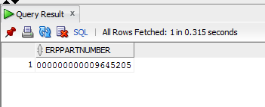

After getting the catentry_id we can follow below steps:

1. Go to folder /diexpcontent/wcs2arcvhive/preprod/esap2ecom
2. Run the below command:

grep “<erppartnumber>” *DIGEXP_EMA_GENAVAINVENTORY.csv

As explained in EMEA section, this command will list all the files having record for the item and we need to find the latest file and quantity associated with it.

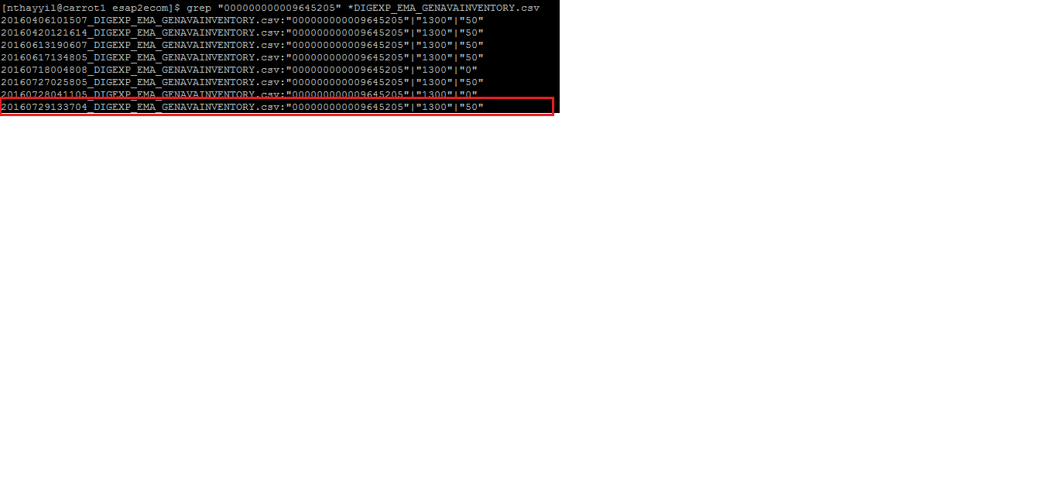

For EMA, quantity is in the 3rd column of the csv feed file as shown below. Here MATERIAL_NO is the erppartnumber of the item.

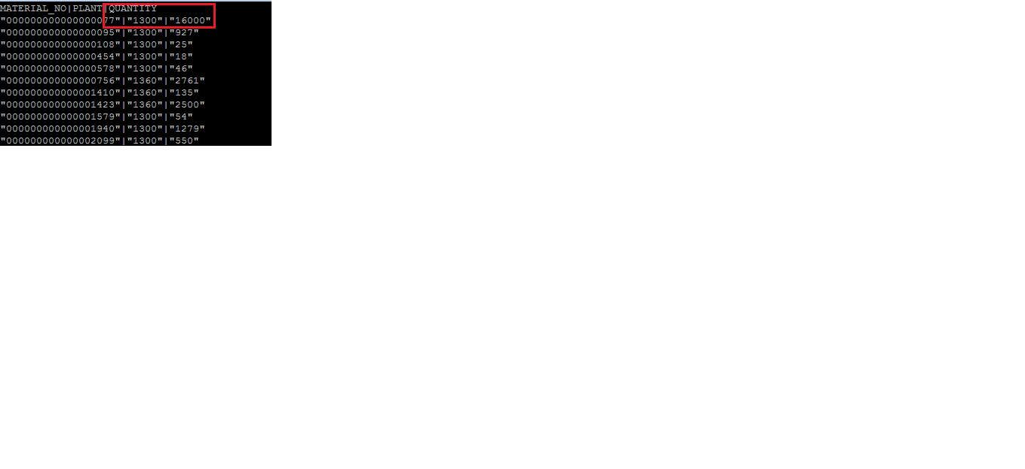

**Step 2:**

If the inventory value in the last feed file and digital portal are different then there is either an issue with inventory dataload or solr indexing.

**Issue with dataload:**

To confirm if there is issue with dataload we need to obtain the present inventory value for the catentry_id in the preprod DB (AVS93DB). Run the below query for obtaining the inventory:

***Select catentry_id ,quantity from inventory where catentry_id=<catentry_id>***

This query will return the inventory for the part.

If the value in the preprod DB (AVS93DB) and feed file are different go to step3 and if they are same go to step 4

**Step 3:**

If the value in preprod DB (AVS93DB) is different from that of feed file, then it is possibly an issue with dataload. The dataload for inventory may have failed for this item. To find the error reason for dataload follow the below steps

1. Go to folder /diexpcontent/wcsdataload/preprod/emainv/error/logs
2. Run the below command:

grep “<filename>” *.log

Here the <filename> is the feed file name we got in step 1.This command will list the log file name of the job that ran for this file. We can go through the logfile and see the reason for the error and take the remedial measures.

**Step4:**

If the value in the feed file is same as preprod DB (AVS93DB) but different from digital portal, the latest value may not have been indexed to solr. To confirm this hit the solr query for prod server:

[***http://corvette1:24000/solr/MC_10001_CatalogEntry_Inventory_generic/select?q=catentry_id:<catentry_id***](http://corvette1:24000/solr/MC_10001_CatalogEntry_Inventory_generic/select?q=catentry_id:%3ccatentry_id)***>***

If the inventory value returned by this url is different from that in preprod DB (AVS93DB), the latest data is not indexed. Request for a fresh indexing of inventory data.

1. **ASIA**

For ASIA we donot have different speedboats as in EMEA. We can follow the below steps for resolution.

**Step1:**

For ASIA before proceeding with troubleshooting we need to find out the erppartnumber as SAP sends the erppartnumber in the feed file.

Run the below query for obtaining the erppartnumber:

***Select ERPPARTNUMBER from XCATENTRY where DIVISIONCODE=’A’ and catentry_id=<catentry_id>***

After getting the catentry_id we can follow below steps:

1. Go to folder /diexpcontent/wcs2arcvhive/preprod/asap2ecom
2. Run the below command:

grep “<erppartnumber>” * DIGEXP_ASIA_INVENTORY.CSV

As explained in EMEA section, this command will list all the files having record for the item and we need to find the latest file and quantity associated with it.

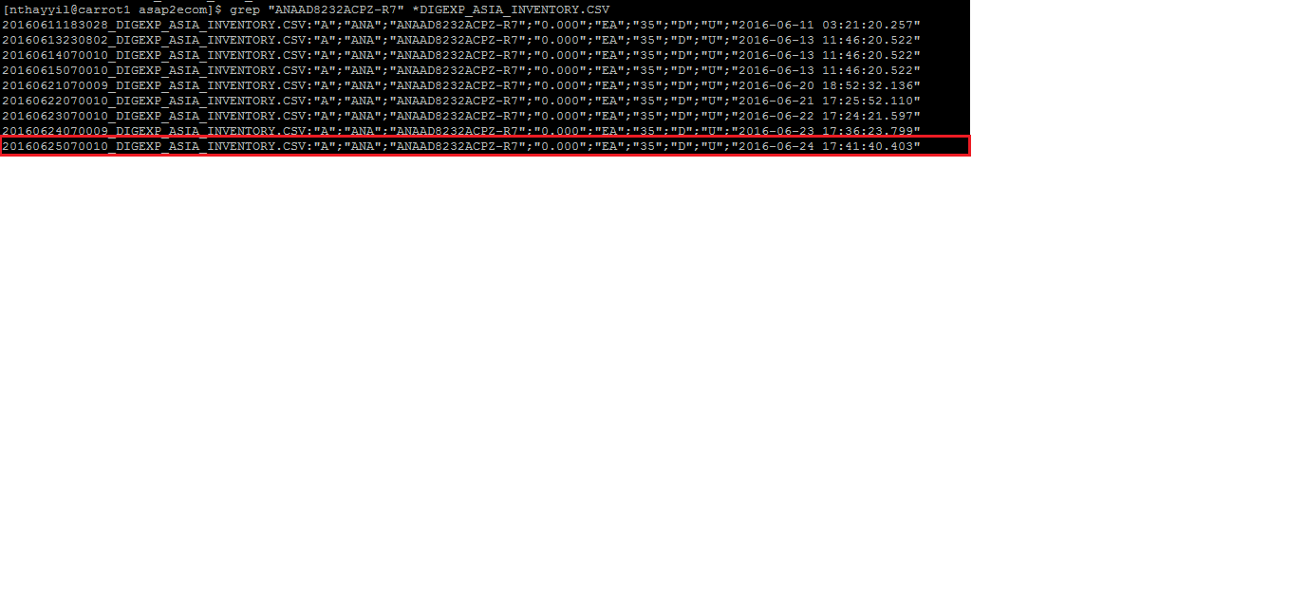

For ASIA quantity is in the 4th column of the csv feed file as shown below: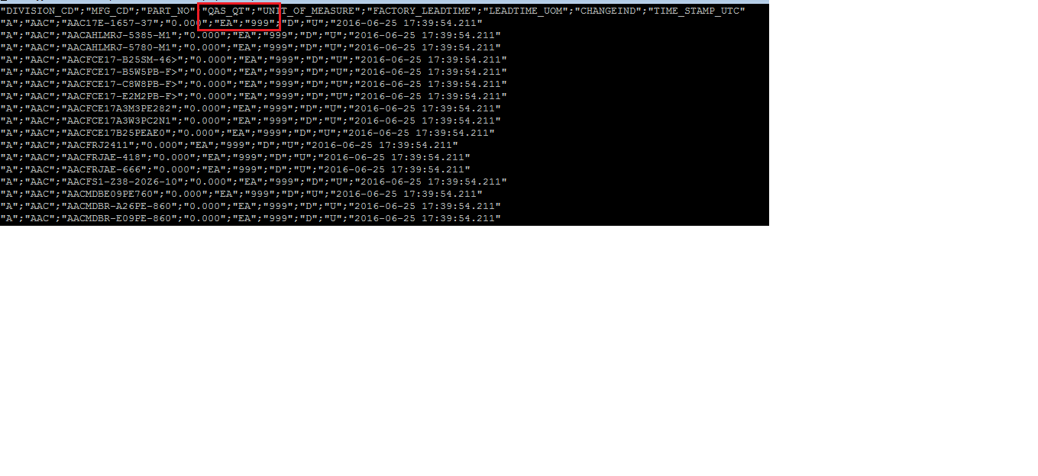

**Step 2:**

If the inventory value in the last feed file and digital portal are different then there is either an issue with inventory dataload or solr indexing.

**Issue with dataload:**

To confirm if there is issue with dataload we need to obtain the present inventory value for the catentry_id in the preprod DB (AVS93DB). Run the below query for obtaining the inventory:

***Select catentry_id ,quantity from inventory where catentry_id=<catentry_id>***

This query will return the inventory for the part.

If the value in the preprod DB (AVS93DB) and feed file are different go to step3 and if they are same go to step 4

**Step 3:**

If the value in preprod DB (AVS93DB) is different from that of feed file, then it is possibly an issue with dataload. The dataload for inventory may have failed for this item. To find the error reason for dataload follow the below steps

1. Go to folder /diexpcontent/wcsdataload/preprod/asiainv/error/logs
2. Run the below command:

**grep “<filename>” *.log**

Here the <filename> is the feed file name we got in step 1.This command will list the log file name of the job that ran for this file. We can go through the logfile and see the reason for the error and take the remedial measures.

**Step4:**

If the value in the feed file is same as preprod DB (AVS93DB) but different from digital portal, the latest value may not have been indexed to solr. To confirm this hit the solr query for prod server:

[***http://corvette1:24000/solr/MC_10001_CatalogEntry_Inventory_generic/select?q=catentry_id:<catentry_id***](http://corvette1:24000/solr/MC_10001_CatalogEntry_Inventory_generic/select?q=catentry_id:%3ccatentry_id)***>***

If the inventory value returned by this url is different from that in preprod DB (AVS93DB), the latest data is not indexed. Request for a fresh indexing of inventory data.