# Connecting to the server

1. Connect through Winscp to any server

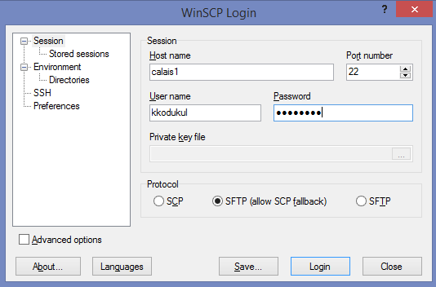

1. Navigate to the below path : /diexpcontent/prod/upstream

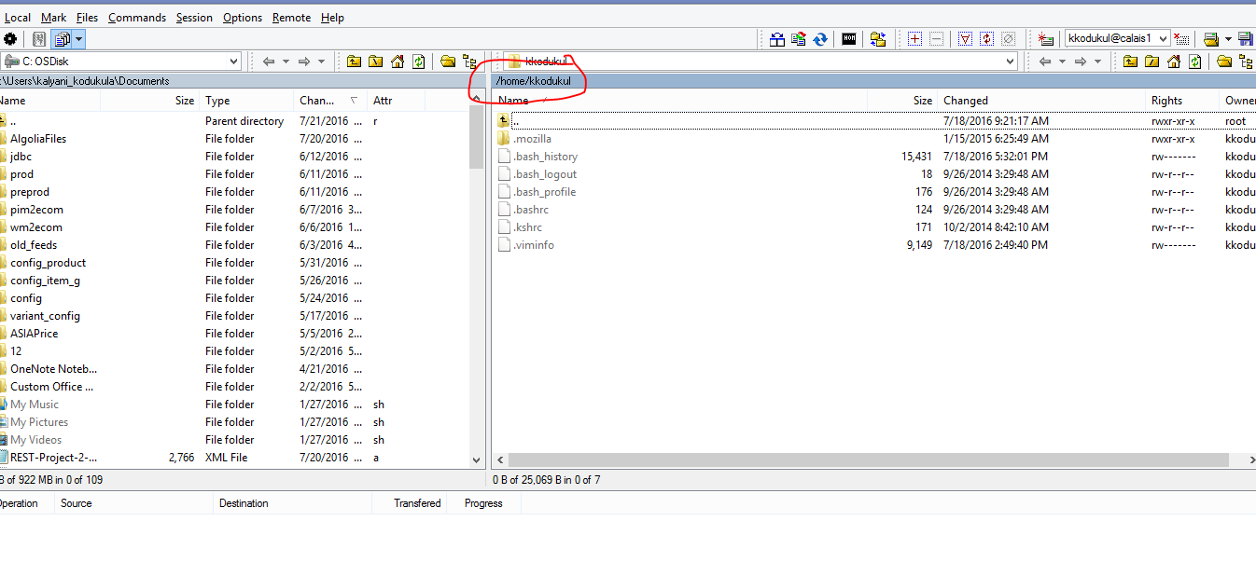

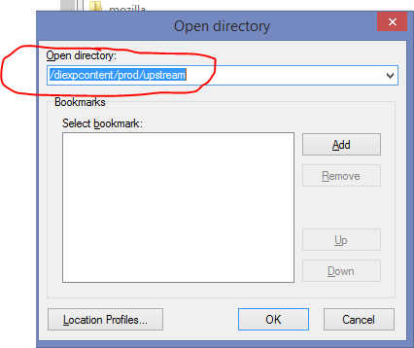

1. Drag and drop the file from left side to right side

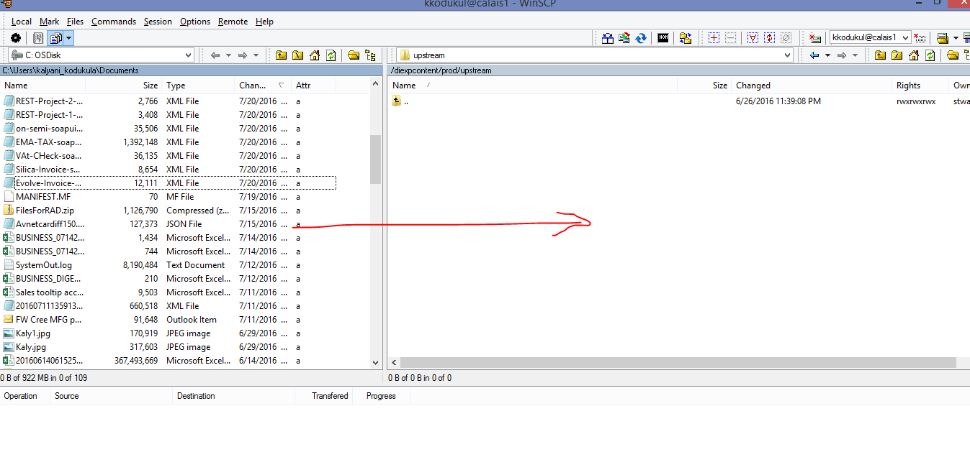

# Price Add - File Creation

1. Create an excel file with the below name

For EMA – PRICECORRECTION<<TIMESTAMP>>_DIGEXP_EMA_UPSTREAM_PRICEFEED.csv

For EMEA – PRICECORRECTION<<TIMESTAMP>>_DIGEXP_EMEA_UPSTREAM_PRICEFEED.csv

For ASIA – PRICECORRECTION<<TIMESTAMP>>_DIGEXP_ASIA_UPSTREAM_PRICEFEED.csv

1. Copy the below header as first line in the file.

**For EMA**

MDM_MATERIAL_ID|CURRENCY|CONDITION_SQ_NO|MIN_ORDER_QT|MULT_ORDER_QT|PRICE|PRICEPERQUANTITY|START_DATE|END_DATE|DELETE

MDM_MATERIAL_ID 🡪 Use below query to search for the MDM material id of the part.

select mdmmaterialnumber from xcatentry where catentry_id=<<CATENTRY_ID>>;

where CATENTRY_ID = the number at the end on the PDP url of the product

CURRENCY 🡪USD

CONDITION_SQ_NO 🡪Tier of the price (sequence). Start it from 1,2,3…

MIN_ORDER_QT 🡪 min quantity

MULT_ORDER_QT 🡪 empty

PRICE 🡪Price

PRICEPERQUANTITY 🡪 price per unit always default to 1.

START_DATE 🡪Start Date when the price should be visible

END_DATE 🡪 Date till when the price is valid.

DELETE 🡪 Always default to “0”

**FOR EMEA**

PARTNUMBER|CURRENCY|CONDITION_SQ_NO|MIN_ORDER_QT|MULT_ORDER_QT|PRICE|PRICEPERQUANTITY|START_DATE|END_DATE|DELETE

PARTNUMBER 🡪 PartNumber

select partnumber from emdi.catentry where catentry_id=<<CATENTRY_ID>>;

CURRENCY 🡪EUR

CONDITION_SQ_NO 🡪 Tier of the price (sequence). Start it from 1,2,3…

MIN_ORDER_QT 🡪 min quantity

MULT_ORDER_QT 🡪 mult qty

PRICE 🡪Price

PRICEPERQUANTITY 🡪 price per unit always default to 1.

START_DATE 🡪Start Date when the price should be visible

END_DATE 🡪 Date till when the price is valid.

DELETE 🡪 Always default to “0”

**FOR ASIA**

PARTNUMBER|CURRENCY|CONDITION_SQ_NO|MIN_ORDER_QT|MULT_ORDER_QT|PRICE|PRICEPERQUANTITY|START_DATE|END_DATE|DELETE

PARTNUMBER 🡪 PartNumber

select partnumber from emdi.catentry where catentry_id=<<CATENTRY_ID>>;

CURRENCY 🡪USD

CONDITION_SQ_NO 🡪 Tier of the price (sequence). Start it from 1,2,3…

MIN_ORDER_QT 🡪 min quantity

MULT_ORDER_QT 🡪 empty

PRICE 🡪Price

PRICEPERQUANTITY 🡪 price per unit always default to 1.

START_DATE 🡪Start Date when the price should be visible

END_DATE 🡪 Date till when the price is valid.

DELETE 🡪 Always default to “0”

# Sample File

