
El Salvador’s Prison Population: Two Decades of Change
Over the past twenty years, El Salvador has experienced a dramatic transformation in its penal system. Most striking has been the recent surge in the absolute number of prisoners and the percentage of the population incarcerated—propelled by abrupt political and legal shifts since 2022. This report synthesizes available data from 2004 to 2025, visualizing both the total prison population in absolute terms and as a share of El Salvador’s population.
Key Findings
El Salvador’s approach to criminal justice, especially after the declaration of a state of emergency in 2022, has resulted in an extraordinary escalation in incarceration. For most of the past two decades, prison numbers and incarceration rates rose gradually. In just the last several years, however, the country’s prison population has more than tripled, placing El Salvador at the top of the global incarceration rankings.[1][2][3][4][5][6][7][8][9][10]
Trends in the Absolute Prison Population
Growth from 2004 to 2021
From 2004 to 2021, the number of prisoners in El Salvador increased from around 12,300 to about 35,000. This steady growth reflected a long-standing trend of increasing law enforcement and tough-on-crime policies. During this period, the increase was relatively linear, with annual increments generally in the range of 1,000 to 2,500 prisoners, paralleling gradual expansions in the country’s population and occasional crackdowns on organized crime.^{[1][3][10]}
Explosion Since 2022
The most consequential shift started in 2022. With the onset of the “State of Exception,” a dramatic campaign targeting gang activity and suspending due process led to mass detentions. By 2023, the number of people behind bars leaped to over 100,000—a roughly threefold increase in just two years. Recent figures suggest this trend continued into 2024 and 2025, with the prison population stabilizing just above 105,000.^{[2][3][4][11][7][8][9][10]}
Absolute Prison Population in El Salvador, 2004–2025:
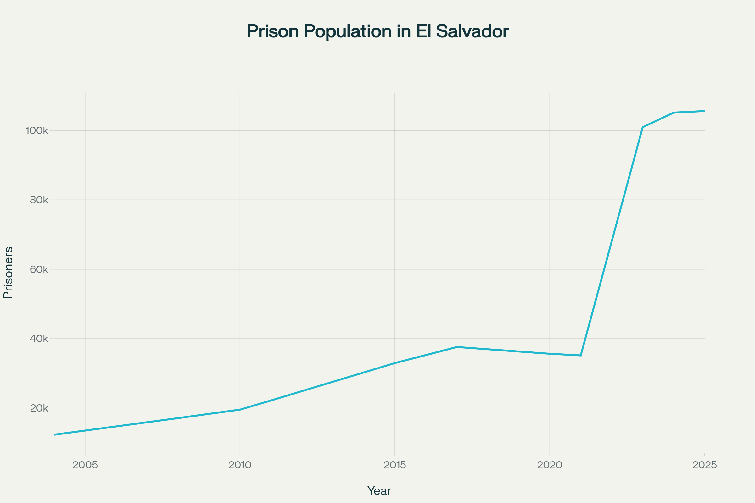
Absolute Prison Population in El Salvador, 2004–2025
Proportion of Total Population Incarcerated
Historical Context
For most of the last twenty years, the percentage of El Salvador’s population in prison hovered below 0.6%. This figure was already above the global average but did not approach the extremes now being witnessed. Traditionally, fluctuations reflected variations in crime rates, shifts in judicial policy, and demographic changes.^{[1][3][7][10]}
The Modern Era: Unprecedented Rates
Since 2022, the incarceration rate skyrocketed. By 2023, fully 1.6% of the country’s population was incarcerated—an unprecedented figure for a nation not actively engaged in wartime internment policies. As of 2025, the imprisonment rate reached an estimated 1.66%—meaning that one out of every sixty Salvadorans is in prison, the highest rate in the world by a significant margin. Among adult males, the figure is even starker: recent human rights reports indicate that 3 out of every 100 Salvadoran men are incarcerated.^{[2][4][12][7][13][9]}
Percent of El Salvador's Population Incarcerated (2004–2025):
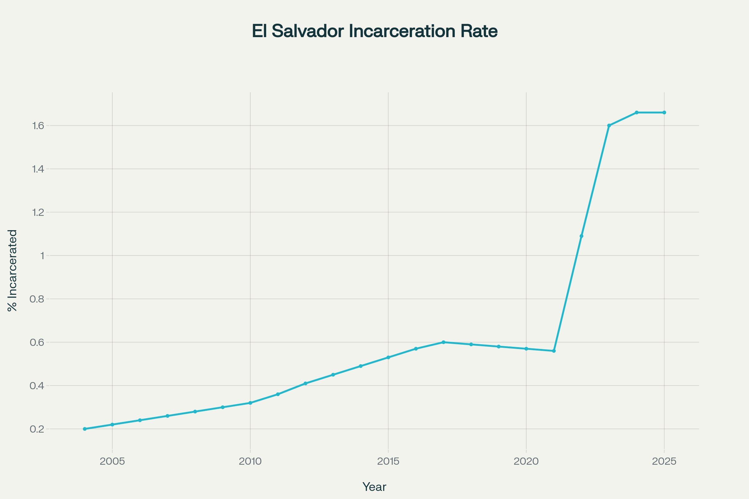
Percent of El Salvador's Population Incarcerated (2004–2025)
Causes and Implications
Policy Shifts and the “State of Exception”
El Salvador’s recent surge in imprisonments stems nearly entirely from the 2022 government crackdown on gang-related violence. Under President Nayib Bukele, the country suspended constitutional guarantees, implementing a state of emergency that has been repeatedly extended. Military and police were given broad powers to detain without warrants or formal charges, leading to the detention of over 100,000 individuals—many with little or no access to due process or legal representation.[2][14][11][12][7][13][8][9][10][15][16][17]
Overcrowding and Conditions
Such rapid expansion has produced severe overcrowding—with occupancy rates exceeding 160% of official capacity, and some facilities reportedly running at 300% of designed limits. Human rights organizations have documented deaths in custody, allegations of torture, and widespread procedural violations. International observers have noted that the reported data may even understate real conditions, given restricted access for observers.^{[2][3][4][9][16]}
Broader Social Context
The proportion of the population incarcerated in El Salvador now outstrips not only regional neighbors but also countries with even the most notoriously punitive justice systems, including the United States and Cuba. For context: the global average hovers around 182 per 100,000 (0.18%), but El Salvador now sits at over 1,650 per 100,000 (1.66%).^{[1][7][10]}
Public opinion within El Salvador remains sharply divided. While many support these unprecedented policies due to perceived improvements in security and reductions in homicide rates, critics warn of long-term consequences for civil liberties, judicial independence, and social cohesion.[2][14][11][7][13][8][9][16][17]
Conclusion
The past two decades in El Salvador showcase how sharp changes in political and legal context can radically reshape the prison population. After years of incremental increases, the onset of the “State of Exception” has brought El Salvador to international prominence as the country with the world’s highest incarceration rate. Experts urge caution, noting that while the crackdown has decreased reported homicides, the long-term impact on justice, human rights, and societal health remains deeply uncertain.
The current statistics—105,000+ individuals imprisoned, representing 1.66% of the population—highlight a degree of carceral expansion unprecedented outside of war or extreme authoritarian regimes. How El Salvador navigates the consequences of this policy will be watched closely by legal scholars, humanitarian organizations, and policymakers worldwide.[2][3][14][11][6][12][7][13][8][9][10][15][16][17]

Sources: Uses data from World Prison Brief, OMCT, Statista, TheGlobalEconomy.com, Worldometer, Prison Policy Initiative, Bloomberg, and Amnesty International, gathered and interpolated from 2004 through 2025. All rates and absolute figures are based on cited estimates and official reports from national and international organizations.

Absolute Prison Population in El Salvador, 2004–2025

Percent of El Salvador's Population Incarcerated (2004–2025)
⁂

- https://www.theglobaleconomy.com/El-Salvador/prisoners/
- https://www.irishruleoflaw.ie/el_salvador_s_policy_of_mass_incarceration
- https://www.prisonstudies.org/country/el-salvador
- https://www.omct.org/site-resources/files/factsheets/Factsheet-El-Salvador-EN_2025-06-20-151105_tgpx.pdf
- https://www.prisonpolicy.org/global/2024.html
- https://www.statista.com/chart/25644/prison-population-by-100000-residents/
- https://www.statista.com/statistics/262962/countries-with-the-most-prisoners-per-100-000-inhabitants/
- https://www.bloomberg.com/news/articles/2023-09-12/el-salvador-jails-1-6-of-population-in-crime-crackdown
- https://www.hrw.org/news/2025/03/20/human-rights-watch-declaration-prison-conditions-el-salvador-jgg-v-trump-case
- https://www.prisonstudies.org/sites/default/files/resources/downloads/world_prison_population_list_14th_edition.pdf
- https://www.wola.org/analysis/mass-incarceration-and-democratic-deterioration-three-years-of-the-state-of-exception-in-el-salvador/
- https://www.lemonde.fr/en/international/article/2025/09/18/el-salvador-from-surf-city-beaches-to-overflowing-prisons-the-two-sides-of-the-bukele-model_6745501_4.html
- https://www.amnesty.org/en/latest/news/2024/12/el-salvador-mil-dias-regimen-excepcion-modelo-seguridad-a-costa-derechos-humanos/
- https://www.bbc.com/news/world-latin-america-68244963
- https://en.wikipedia.org/wiki/Salvadoran_gang_crackdown
- https://www.theatlantic.com/international/archive/2025/04/el-salvador-bukele/682367/
- https://www.congress.gov/crs_external_products/IN/PDF/IN12510/IN12510.2.pdf
- https://globaledge.msu.edu/countries/el-salvador/statistics
- https://www.worldometers.info/world-population/el-salvador-population/
- https://passportranker.org/population/el-salvador
- https://worldpopulationreview.com/countries/el-salvador
- https://www.prison-insider.com/en/countryprofile/el-salvador-2024
- https://www.cia.gov/the-world-factbook/countries/el-salvador/
- https://www.unodc.org/documents/data-and-analysis/prison/Prison_brief_2025.pdf
- https://data.worldbank.org/indicator/SP.POP.TOTL?locations=SV
- https://statbase.org/data/slv-persons-held-in-prisons-count/
- https://en.wikipedia.org/wiki/El_Salvador
- https://www.reddit.com/r/charts/comments/1l3yp1f/murder_rate_in_el_salvador_vs_incarceration_rate/
- https://digitalcommons.bucknell.edu/cgi/viewcontent.cgi?article=1735&context=honors_theses
- https://en.wikipedia.org/wiki/Crime_in_El_Salvador

