Here’s a detailed content calendar and a framework for creating visuals and layouts tailored for Synergyze Weaves LLP to implement an effective content commerce strategy.

1. Content Calendar
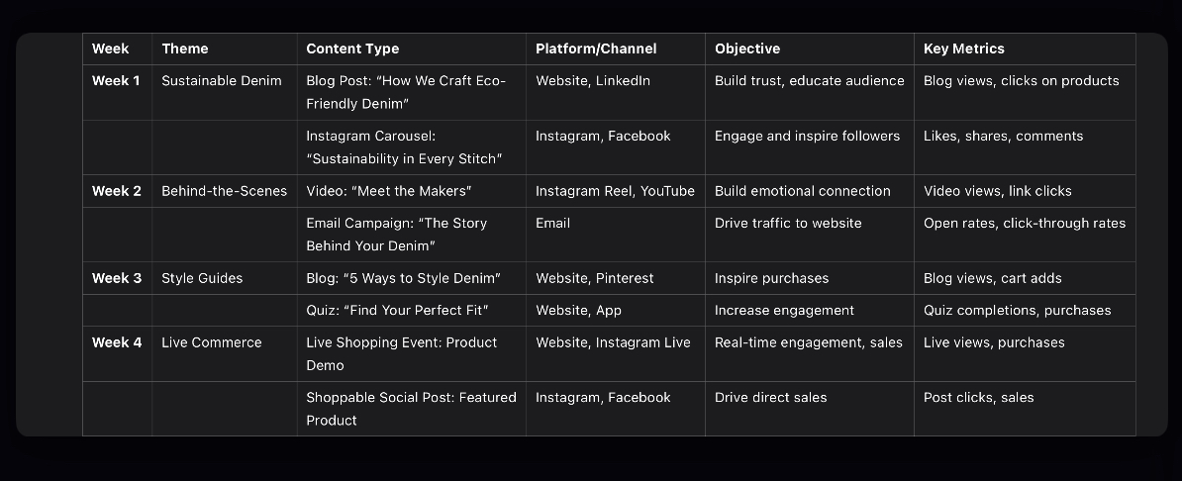
The calendar is divided into weekly themes with specific content types and distribution channels.

2. Visual and Layout Framework

A. Website Layout

• Homepage:
• Hero Banner:
• Feature your latest collection or sustainability initiative.
• Include a CTA like: “Shop the Story Behind Your Denim”.
• Dynamic Content Feed:
• Showcase trending blog posts, videos, and UGC.
• Include embedded shoppable links for seamless purchases.
• Product Pages:
• Add “Inspiration Stories”:
• Highlight artisan features or eco-friendly practices.
• Example: “This jacket saved 50 gallons of water during production.”
• Enable 360° Product Views:
• Let customers zoom and rotate products.
• Include UGC:
• Add Instagram photos of customers wearing the product.
• Blog Section:
• Use a masonry-style layout for visual appeal.
• Include CTA banners between articles like: “Loved this story? Shop the collection now!”

B. Mobile App Layout

• Homepage:
• Include a personalized content feed powered by customer behavior.
• Add “Tap to Shop” functionality directly on featured stories or videos.
• Menu Options:
• Quick access to “Style Guides,” “Sustainability Stories,” and “Shop.”
• Interactive Features:
• Quizzes: Add a “Find Your Fit” quiz on the homepage for quick access.
• Live Commerce Integration: Show upcoming events prominently.

C. Social Media Visual Templates

• Instagram Post/Carousel:
• Design Tool: Use Canva.
• Template Structure:
1. Slide 1: Eye-catching visual of the product with a tagline (e.g., “Sustainability in Every Stitch”).
2. Slide 2: A quick fact about the product’s eco-friendly impact.
3. Slide 3: CTA with link info (e.g., “Shop Now—Link in Bio”).
• YouTube Thumbnail:
• Elements:
• High-quality image of the artisan or product.
• Bold text: “Behind the Scenes: How We Make Eco-Friendly Denim”.

D. Email Layout

• Header:
• Large banner image featuring the product.
• Tagline: “Your Sustainable Style, Made with Care.”
• Body:
• Include 2-3 sections:
1. Featured content (e.g., “The Story Behind Your Jacket”).
2. Shoppable product highlights with CTA buttons: “Shop the Collection.”
3. Customer testimonials or UGC.
• Footer:
• Sustainability badge or certification logo (e.g., CommuneConnect Certified).

3. Actionable Tools for Graphics and Content

• Canva:
• For creating carousels, Instagram posts, and blog banners.
• Use the “E-commerce” templates for shoppable designs.
• Adobe Photoshop/Illustrator:
• For advanced product visuals and marketing materials.
• Figma:
• For app and website mockups.
• Lumen5:
• For converting blogs into short video content for social platforms.

4. Key Metrics to Monitor

• Engagement:
• Blog views, video plays, social media impressions.
• Conversion:
• Click-to-purchase rates on shoppable content.
• Average cart size influenced by style guides or interactive features.
• Retention:
• Repeat visits to website/app driven by compelling content.

Here’s a tailored content strategy plan and sample templates for Synergyze Weaves LLP to implement and leverage content commerce effectively.

Tailored Content Strategy Plan

1. Content Themes and Objectives

• Sustainability Stories:
• Highlight eco-friendly practices in your supply chain and production processes.
• Objective: Build trust and attract conscious consumers.
• Artisan Highlights:
• Showcase the people behind your products with videos and articles.
• Objective: Humanize the brand and foster emotional connections.
• Style and Utility Guides:
• Provide educational content like “How to Style Sustainable Denim” or “Caring for Eco-Friendly Fabrics.”
• Objective: Educate and engage customers while promoting your products.
• Live Commerce Events:
• Host events featuring product demos, behind-the-scenes tours, or Q&A sessions.
• Objective: Drive real-time engagement and sales.

2. Implementation Roadmap

Phase 1: Content Creation (0-3 Months)
1. Identify key content topics aligned with your brand values (e.g., sustainability, craftsmanship).
2. Develop a mix of written (blogs, guides), visual (images, videos), and interactive (live streams, quizzes) content.

Phase 2: Content Distribution (3-6 Months)
1. Launch content across your website, social media, and email campaigns.
2. Integrate shoppable links in blogs, videos, and social posts.

Phase 3: Content Commerce Optimization (6+ Months)
1. Use analytics to refine content based on engagement and conversion rates.
2. Experiment with personalized content recommendations and dynamic feeds.

3. Technology Integration

• Content Creation:
• Canva: For designing visual content.
• Adobe Premiere Pro: For editing product and artisan videos.
• Content Distribution:
• Hootsuite: For scheduling and managing social media content.
• Mailchimp: For email marketing campaigns.
• Shoppable Content:
• Shopify Plus: For embedding shoppable links on your website.
• Bambuser: For live shopping events with integrated purchase options.
• Analytics:
• Google Analytics: To track engagement and sales from content.
• Hotjar: For heatmaps and user behavior analysis.

Sample Content Templates

A. Blog Post Template

Title: “5 Ways to Style Sustainable Denim for Every Occasion”

Introduction:
Discover how our eco-friendly denim can be your go-to choice for every occasion. From casual outings to formal events, we’ve got you covered!

Content Sections:
1. Casual Chic:
• Pair our relaxed-fit jeans with a white tee and sneakers.
• Shop the look: [Add Shoppable Link].
2. Workwear Ready:
• Elevate your style with our tailored denim trousers and a classic blazer.
• Add to Cart: [Shoppable Link].
3. Weekend Vibes:
• Embrace comfort with our stretch denim shorts and oversized sweater.
• Get Yours Now: [Shoppable Link].

Conclusion:
With sustainable denim, you don’t have to compromise on style or values. Shop the collection today!

B. Social Media Post Template

Platform: Instagram

Post Content:
🌿 Meet the Makers 🌿
Behind every Synergyze Weaves product is a story of craftsmanship and care. This week, meet Aditi, who hand-stitches every sustainable denim jacket with precision and love. 💚
🔗 Tap to shop her featured designs and support ethical fashion!

Visual:
• A carousel with:
• Image 1: Aditi working in the studio.
• Image 2: The finished denim jacket with a shoppable tag.

Hashtags: #SustainableFashion #EthicalStyle #SynergyzeWeaves

C. Video Content Template

Format: Instagram Reel / TikTok / YouTube Short

Title: “How We Make Your Sustainable Denim”

Content Flow:
1. Intro (5 Seconds):
• Highlight your commitment to sustainability: “From farm to fashion, here’s how we create eco-friendly denim.”
2. Middle (30 Seconds):
• Show the production process:
• Raw material sourcing.
• Artisan handwork.
• Eco-friendly washing techniques.
3. Ending (5 Seconds):
• Add a call-to-action: “Shop sustainable denim today. Link in bio!”
4. Overlay Text:
• Include shoppable links (if platform allows) or a strong CTA.

D. Email Campaign Template

Subject Line: “The Story Behind Your Favorite Denim”

Body:
Hello [Name],
At Synergyze Weaves, every product has a story. This week, we’re spotlighting our eco-friendly denim collection.
• 🌱 Sustainably Made: Crafted using 100% organic cotton.
• 🤝 Ethically Produced: Supporting local artisans.
• ♻️ Planet-Friendly: Low-water washing techniques.

✨ Shop Now and Get 10% Off: [Link]

Thank you for supporting sustainable fashion,
The Synergyze Weaves Team

E. Interactive Content Template

Title: “Find Your Perfect Fit” (Quiz)

Description:
Take our quick quiz to discover the ideal sustainable denim for your style and needs!

Questions:
1. What’s your go-to style?
• ☐ Skinny
• ☐ Relaxed
• ☐ High-Waist
2. What’s your favorite activity?
• ☐ Casual Outings
• ☐ Work Meetings
• ☐ Weekend Adventures

Result Page:
“Based on your answers, we recommend our High-Waist Relaxed Fit Jeans. Perfect for work and play! Shop Now: [Shoppable Link]”

Key Metrics for Success

• Engagement:
• Time spent on content pages.
• Social shares and likes.
• Conversions:
• Sales attributed to shoppable content.
• Click-through rates on product links.
• Customer Retention:
• Repeat purchases from customers engaging with educational or storytelling content.

Would you like me to assist with a detailed content calendar, or help create graphics and layouts for your website or app?

