Here’s a **detailed content calendar** and a **framework for creating visuals and layouts** tailored for Synergyze Weaves LLP to implement an effective content commerce strategy.

**1. Content Calendar**

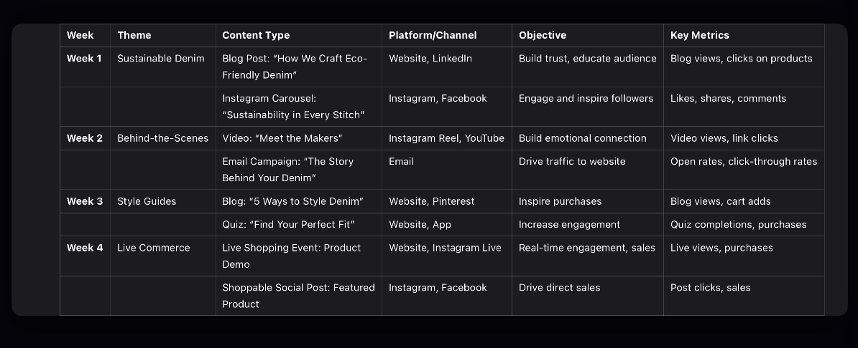

The calendar is divided into weekly themes with specific content types and distribution channels.

**2. Visual and Layout Framework**

**A. Website Layout**

• **Homepage**:

• **Hero Banner**:

• Feature your latest collection or sustainability initiative.

• Include a CTA like: *“Shop the Story Behind Your Denim”*.

• **Dynamic Content Feed**:

• Showcase trending blog posts, videos, and UGC.

• Include embedded shoppable links for seamless purchases.

• **Product Pages**:

• Add **“Inspiration Stories”**:

• Highlight artisan features or eco-friendly practices.

• Example: *“This jacket saved 50 gallons of water during production.”*

• Enable **360° Product Views**:

• Let customers zoom and rotate products.

• Include UGC:

• Add Instagram photos of customers wearing the product.

• **Blog Section**:

• Use a **masonry-style layout** for visual appeal.

• Include CTA banners between articles like: *“Loved this story? Shop the collection now!”*

**B. Mobile App Layout**

• **Homepage**:

• Include a **personalized content feed** powered by customer behavior.

• Add “Tap to Shop” functionality directly on featured stories or videos.

• **Menu Options**:

• Quick access to “Style Guides,” “Sustainability Stories,” and “Shop.”

• **Interactive Features**:

• **Quizzes**: Add a “Find Your Fit” quiz on the homepage for quick access.

• **Live Commerce Integration**: Show upcoming events prominently.

**C. Social Media Visual Templates**

• **Instagram Post/Carousel**:

• **Design Tool**: Use Canva.

• **Template Structure**:

1. Slide 1: Eye-catching visual of the product with a tagline (e.g., “Sustainability in Every Stitch”).

2. Slide 2: A quick fact about the product’s eco-friendly impact.

3. Slide 3: CTA with link info (e.g., “Shop Now—Link in Bio”).

• **YouTube Thumbnail**:

• **Elements**:

• High-quality image of the artisan or product.

• Bold text: *“Behind the Scenes: How We Make Eco-Friendly Denim”*.

**D. Email Layout**

• **Header**:

• Large banner image featuring the product.

• Tagline: *“Your Sustainable Style, Made with Care.”*

• **Body**:

• Include 2-3 sections:

1. Featured content (e.g., “The Story Behind Your Jacket”).

2. Shoppable product highlights with CTA buttons: *“Shop the Collection.”*

3. Customer testimonials or UGC.

• **Footer**:

• Sustainability badge or certification logo (e.g., CommuneConnect Certified).

**3. Actionable Tools for Graphics and Content**

• **Canva**:

• For creating carousels, Instagram posts, and blog banners.

• Use the **“E-commerce” templates** for shoppable designs.

• **Adobe Photoshop/Illustrator**:

• For advanced product visuals and marketing materials.

• **Figma**:

• For app and website mockups.

• **Lumen5**:

• For converting blogs into short video content for social platforms.

**4. Key Metrics to Monitor**

• **Engagement**:

• Blog views, video plays, social media impressions.

• **Conversion**:

• Click-to-purchase rates on shoppable content.

• Average cart size influenced by style guides or interactive features.

• **Retention**:

• Repeat visits to website/app driven by compelling content.

Here’s a **tailored content strategy plan** and **sample templates** for Synergyze Weaves LLP to implement and leverage content commerce effectively.

**Tailored Content Strategy Plan**

**1. Content Themes and Objectives**

• **Sustainability Stories**:

• Highlight eco-friendly practices in your supply chain and production processes.

• Objective: Build trust and attract conscious consumers.

• **Artisan Highlights**:

• Showcase the people behind your products with videos and articles.

• Objective: Humanize the brand and foster emotional connections.

• **Style and Utility Guides**:

• Provide educational content like “How to Style Sustainable Denim” or “Caring for Eco-Friendly Fabrics.”

• Objective: Educate and engage customers while promoting your products.

• **Live Commerce Events**:

• Host events featuring product demos, behind-the-scenes tours, or Q&A sessions.

• Objective: Drive real-time engagement and sales.

**2. Implementation Roadmap**

**Phase 1: Content Creation (0-3 Months)**

1. Identify key content topics aligned with your brand values (e.g., sustainability, craftsmanship).

2. Develop a mix of written (blogs, guides), visual (images, videos), and interactive (live streams, quizzes) content.

**Phase 2: Content Distribution (3-6 Months)**

1. Launch content across your **website**, **social media**, and **email campaigns**.

2. Integrate shoppable links in blogs, videos, and social posts.

**Phase 3: Content Commerce Optimization (6+ Months)**

1. Use analytics to refine content based on engagement and conversion rates.

2. Experiment with personalized content recommendations and dynamic feeds.

**3. Technology Integration**

• **Content Creation**:

• **Canva**: For designing visual content.

• **Adobe Premiere Pro**: For editing product and artisan videos.

• **Content Distribution**:

• **Hootsuite**: For scheduling and managing social media content.

• **Mailchimp**: For email marketing campaigns.

• **Shoppable Content**:

• **Shopify Plus**: For embedding shoppable links on your website.

• **Bambuser**: For live shopping events with integrated purchase options.

• **Analytics**:

• **Google Analytics**: To track engagement and sales from content.

• **Hotjar**: For heatmaps and user behavior analysis.

**Sample Content Templates**

**A. Blog Post Template**

**Title**: **“5 Ways to Style Sustainable Denim for Every Occasion”**

**Introduction**:

Discover how our eco-friendly denim can be your go-to choice for every occasion. From casual outings to formal events, we’ve got you covered!

**Content Sections**:

1. **Casual Chic**:

• Pair our relaxed-fit jeans with a white tee and sneakers.

• Shop the look: [Add Shoppable Link].

2. **Workwear Ready**:

• Elevate your style with our tailored denim trousers and a classic blazer.

• Add to Cart: [Shoppable Link].

3. **Weekend Vibes**:

• Embrace comfort with our stretch denim shorts and oversized sweater.

• Get Yours Now: [Shoppable Link].

**Conclusion**:

With sustainable denim, you don’t have to compromise on style or values. Shop the collection today!

**B. Social Media Post Template**

**Platform**: Instagram

**Post Content**:

🌿 **Meet the Makers** 🌿

Behind every Synergyze Weaves product is a story of craftsmanship and care. This week, meet Aditi, who hand-stitches every sustainable denim jacket with precision and love. 💚

🔗 Tap to shop her featured designs and support ethical fashion!

**Visual**:

• A carousel with:

• Image 1: Aditi working in the studio.

• Image 2: The finished denim jacket with a shoppable tag.

**Hashtags**: #SustainableFashion #EthicalStyle #SynergyzeWeaves

**C. Video Content Template**

**Format**: Instagram Reel / TikTok / YouTube Short

**Title**: **“How We Make Your Sustainable Denim”**

**Content Flow**:

1. **Intro (5 Seconds)**:

• Highlight your commitment to sustainability: “From farm to fashion, here’s how we create eco-friendly denim.”

2. **Middle (30 Seconds)**:

• Show the production process:

• Raw material sourcing.

• Artisan handwork.

• Eco-friendly washing techniques.

3. **Ending (5 Seconds)**:

• Add a call-to-action: “Shop sustainable denim today. Link in bio!”

4. **Overlay Text**:

• Include shoppable links (if platform allows) or a strong CTA.

**D. Email Campaign Template**

**Subject Line**: **“The Story Behind Your Favorite Denim”**

**Body**:

Hello [Name],

At Synergyze Weaves, every product has a story. This week, we’re spotlighting our eco-friendly denim collection.

• 🌱 **Sustainably Made**: Crafted using 100% organic cotton.

• 🤝 **Ethically Produced**: Supporting local artisans.

• ♻️ **Planet-Friendly**: Low-water washing techniques.

✨ Shop Now and Get 10% Off: [Link]

Thank you for supporting sustainable fashion,

The Synergyze Weaves Team

**E. Interactive Content Template**

**Title**: **“Find Your Perfect Fit” (Quiz)**

**Description**:

Take our quick quiz to discover the ideal sustainable denim for your style and needs!

**Questions**:

1. What’s your go-to style?

• ☐ Skinny

• ☐ Relaxed

• ☐ High-Waist

2. What’s your favorite activity?

• ☐ Casual Outings

• ☐ Work Meetings

• ☐ Weekend Adventures

**Result Page**:

“Based on your answers, we recommend our High-Waist Relaxed Fit Jeans. Perfect for work and play! Shop Now: [Shoppable Link]”

**Key Metrics for Success**

• **Engagement**:

• Time spent on content pages.

• Social shares and likes.

• **Conversions**:

• Sales attributed to shoppable content.

• Click-through rates on product links.

• **Customer Retention**:

• Repeat purchases from customers engaging with educational or storytelling content.

Would you like me to assist with a **detailed content calendar**, or help create **graphics and layouts** for your website or app?