CampusCart
A Full-Stack E-Commerce Platform for Computer Science Students
Full Stack Development Project Report
Submitted by
[Your full name]
[Roll or register number]
Under the guidance of
[Guide or teacher name]
[Department name]
[College name]
[Month and year]

Contents
Abstract 2
1. Introduction 2
1.1 Problem statement 2
1.2 Objectives 2
1.3 Scope 2
1.4 End users 3
2. Modules 3
3. Technology stack 4
4. System design 4
4.1 Architecture 4
4.2 Data model 4
4.3 REST API 6
5. Implementation highlights 6
5.1 Preventing overselling 6
5.2 Consistency without transactions 6
5.3 One place for totals 7
5.4 Order status rules 7
5.5 Authentication and authorization 7
5.6 Running without a database install 7
6. User interface 7
7. Testing 12
7.1 Results 12
7.2 Selected test cases 13
7.3 Problems found by testing 13
8. Limitations 13
9. Future scope 14
10. Conclusion 14
Appendix: running the project 14

Abstract
CampusCart is a full-stack e-commerce web application for Computer Science students. Students need a specific mix of products, such as development boards, core textbooks, laptops, and everyday college gear, and general online stores are not organized around those needs.
The system lets a student search and filter a catalog, read verified reviews, compare products, build a cart, check out with a simulated payment, and track an order. It adds features aimed at CS students: one-click Project Kits, a budget-aware Build Your Setup planner, and browsing by semester. Administrators manage products, inventory, orders, users, coupons and reviews, and they get an analytics dashboard.
The application uses React on the frontend, Node.js and Express for a REST API of 74 routes, and MongoDB through Mongoose for storage. It was verified with 167 automated API tests, 38 browser tests that include WCAG AA accessibility audits in both themes, and a Postman collection of 100 requests.

1. Introduction

1.1 Problem statement
College students, and Computer Science students in particular, buy a recurring set of products: microcontroller boards for labs, standard textbooks each semester, laptops and accessories, and stationery. On a general store these are scattered across unrelated departments, mixed with products no student needs, and there is no way to ask what a given lab or semester requires.

1.2 Objectives
- Build a working end-to-end store: browse, cart, checkout, order tracking and reviews.
- Provide an administrator interface for products, inventory, orders and users.
- Add features that reflect how CS students actually shop, rather than only a student label.
- Keep stock and order data correct, even when several people order at once.
- Make the application simple to run and reliable to demonstrate.

1.3 Scope
The project covers the complete shopping and store-management workflow. Payments are simulated and never ask for real card or UPI details. Product data and prices are illustrative. Production hardening such as rate limiting and email verification is outside the scope of this academic project.

1.4 End users
User | What they can do
Guest | Browse, search, filter, compare products and read reviews
Student | Everything a guest can, plus use a cart and wishlist, check out, track and cancel orders, review delivered products, and save setup builds
Administrator | Manage products, categories, inventory, kits, coupons, orders, users and reviews, and view analytics

2. Modules
Module | Features
User authentication | Registration, login, logout, profile, password change, saved addresses
Product management | Add, view, update and hide products, categories, image upload, specifications
Product discovery | Partial-word search, Ctrl+K quick search, filters for category, brand, price, rating, stock and semester, sorting, pagination
Shopping cart | Add, remove, change quantity, live prices and stock checks, totals, free-shipping progress
Coupons | Percent and flat discounts, with minimum order, caps, dates, and total and per-student limits
Order management | Three-step checkout, order history, status timeline, cancellation that restores stock
Reviews and ratings | Verified-purchase reviews only, one per product, rating breakdown
Wishlist | Save products for later
Project Kits | Bundles for a lab, semester or hackathon, added to the cart in one click
Build Your Setup | Choose one product per slot against a budget, with a running total, and save the build
Compare | Up to 4 products side by side, with differences highlighted
Admin dashboard | Revenue, category sales, order status, top products, low-stock alerts

3. Technology stack
Layer | Technology | Why it was chosen
Frontend | React 19, Vite, React Router | Component-based UI with fast development builds
Server data | TanStack Query, Axios | Caching, and consistent loading and error states
Charts | Recharts | Composable charts for the dashboard
Backend | Node.js, Express 5 | One language across the stack, and simple REST routing
Validation | Zod | Clear per-field error messages
Database | MongoDB, Mongoose | Flexible documents suit products with very different specifications
Embedded database | mongodb-memory-server | Runs a real mongod with nothing to install
Authentication | JWT, bcrypt | Stateless login, with hashed passwords
Testing | Vitest, Supertest, Playwright, axe-core, Newman | API, browser, accessibility and collection tests

4. System design

4.1 Architecture
The application has three tiers. The React client talks to the Express API over JSON, and the API reads and writes MongoDB through Mongoose. Inside the API, each request passes through distinct layers, so business rules stay in one place and can be tested directly.
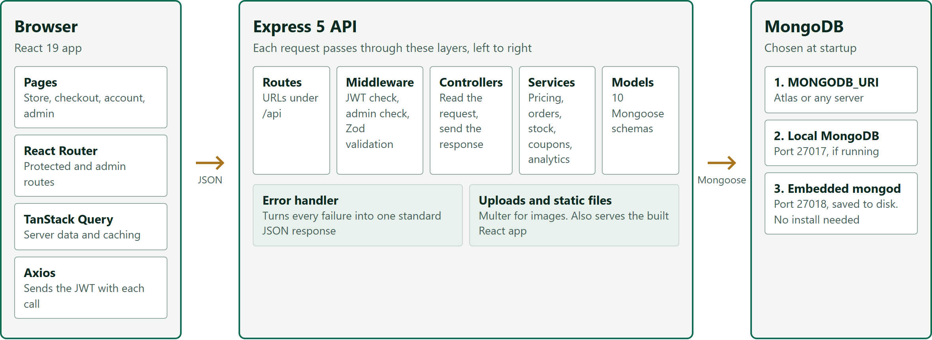
Figure 1: System architecture

4.2 Data model
The data is stored in 10 MongoDB collections. Relationships are held as references, and Figure 2 shows how they connect.
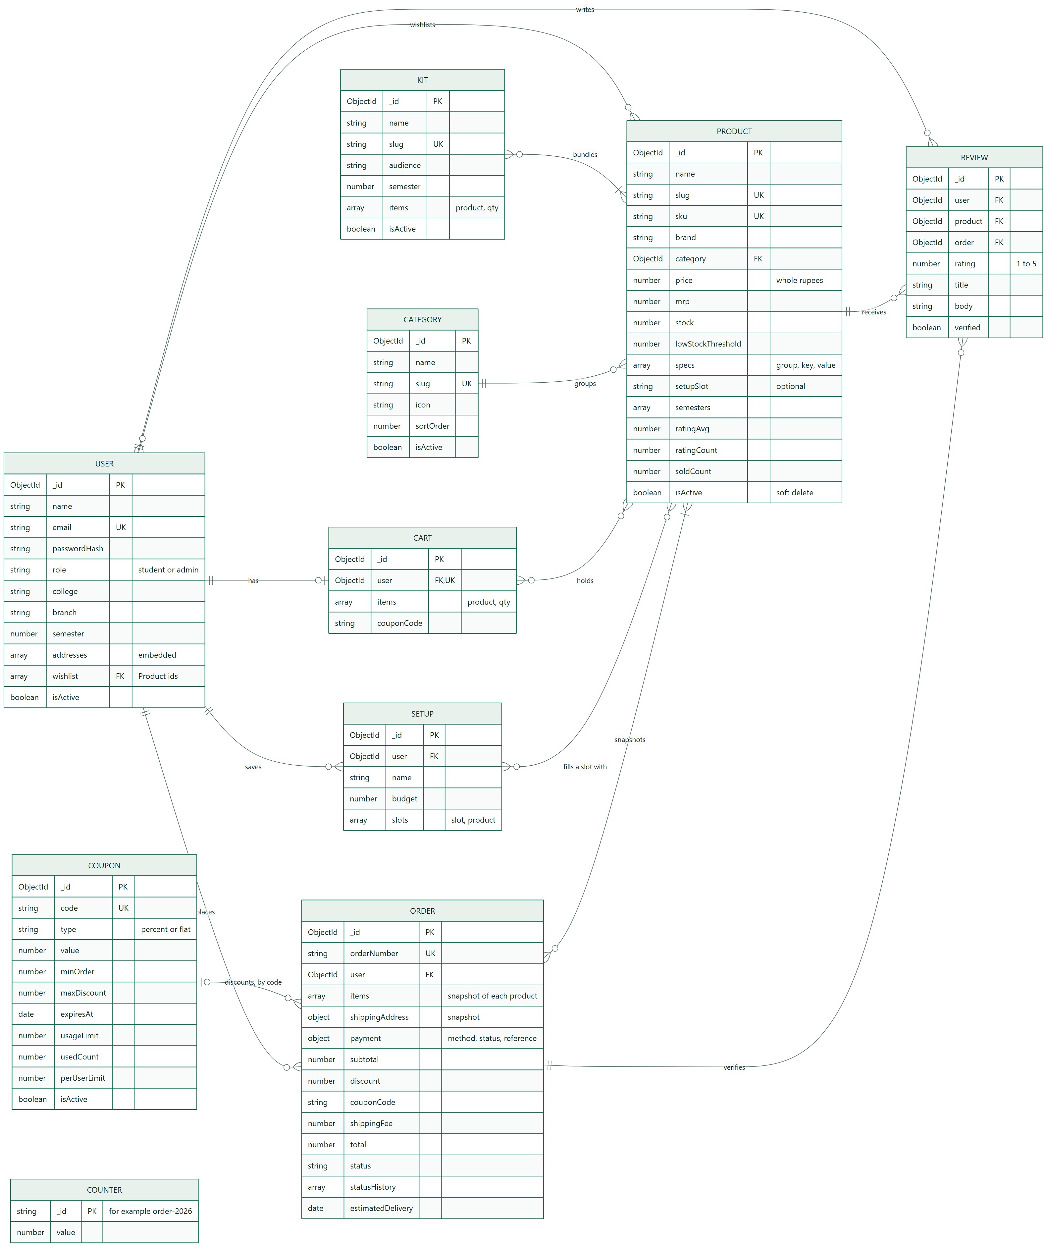
Figure 2: Entity relationship diagram
Several modelling decisions keep the data correct over time:
- Orders copy their data. Each order stores a snapshot of its items and delivery address, so later edits to a product cannot change what an old order shows.
- Carts store no prices. A cart holds products and quantities, and totals are always calculated from current prices.
- Products are hidden, not deleted. Past orders and reviews keep working.
- Money is in whole rupees. This avoids decimal rounding errors.
- Unique indexes back the rules. One review per user and product is enforced by the database itself, even if two requests arrive together.

4.3 REST API
The API exposes 74 routes under /api. Responses follow one format: { success, data, meta } on success and { success: false, message, errors } on failure. The full reference is in docs/API.md.
Area | Examples | Access
Auth and profile | POST /auth/login, PATCH /users/me | Public or user
Products | GET /products, GET /products/compare, POST /products | Public or admin
Cart and wishlist | POST /cart/items, POST /cart/coupon, POST /wishlist/:id | User
Orders | POST /orders, POST /orders/:id/cancel, PATCH /orders/:id/status | User or admin
Reviews | GET /products/:id/reviews, POST /products/:id/reviews | Public or user
Kits and setups | POST /kits/:id/add-to-cart, GET /setups/slots | Public or user
Administration | GET /users, GET /coupons, GET /admin/analytics/summary | Admin

5. Implementation highlights

5.1 Preventing overselling
If two students order the last unit together, only one may succeed. A check followed by a separate update would allow both through, so stock is reduced in a single conditional update, which MongoDB applies atomically:
Product.findOneAndUpdate(
{ _id: line.product, isActive: true, stock: { $gte: line.qty } },
{ $inc: { stock: -line.qty, soldCount: line.qty } },
);
If no document matches, there was not enough stock, and the student sees how many are left. An automated test runs two competing orders and asserts that exactly one succeeds.

5.2 Consistency without transactions
MongoDB transactions need a replica set, and this application runs on a single server. Order placement therefore tracks each step it completes and reverses them on failure:
- Take the items out of the cart atomically, which also stops a double-clicked button creating two orders.
- Validate prices, stock and the coupon.
- Reserve stock for each item, then reserve one use of the coupon.
- Create the order.
- On any failure, return reserved stock and coupon use, and restore the cart.

5.3 One place for totals
A single pricing function calculates the subtotal, discount, shipping and total. The cart page and order placement both use it, so the two can never disagree.

5.4 Order status rules
An order moves one step at a time through Pending, Confirmed, Shipped and Delivered, and the server rejects any attempt to skip a step. Cancellation is allowed only before shipping. It uses a conditional update, so two simultaneous requests cannot restore stock twice.

5.5 Authentication and authorization
Passwords are hashed with bcrypt. Login returns a JSON Web Token, which the client sends with each request. Middleware verifies the token and loads the user, and a second middleware protects admin routes. A request for another student's order returns "not found", so order ids cannot be probed.

5.6 Running without a database install
At startup, the server uses MONGODB_URI if set, then a local MongoDB if one is running, and otherwise starts an embedded mongod that saves to disk. An empty database fills itself with demo data: 59 products in 11 categories, 6 kits, 5 coupons, and orders spread across 90 days, so the dashboard has real figures to show.

6. User interface
The visual design is based on a printed circuit board, which suits the subject. The dark theme uses a green solder-mask background with gold accents, and the light theme resembles a printed datasheet. The home page hero is a board whose traces connect each store section to a central chip.
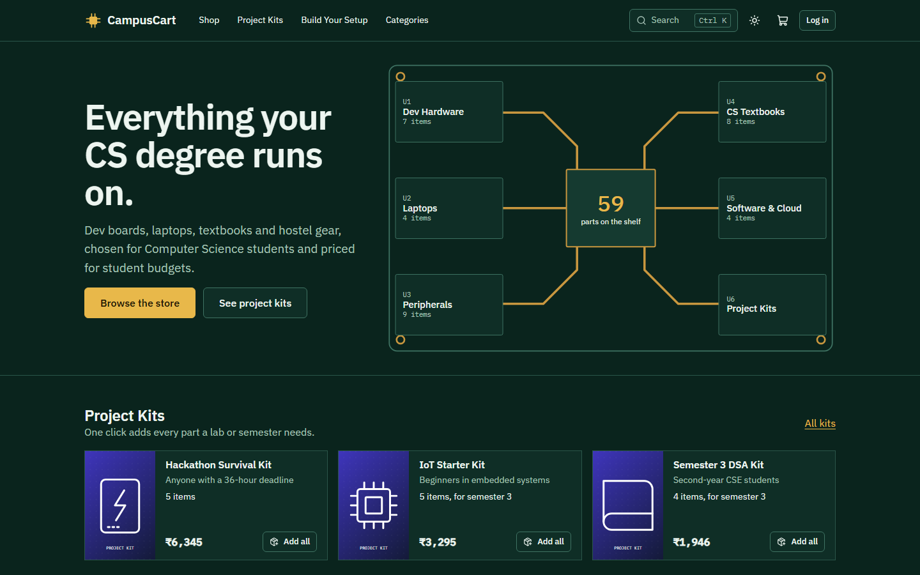
Figure 3: Home page, dark theme
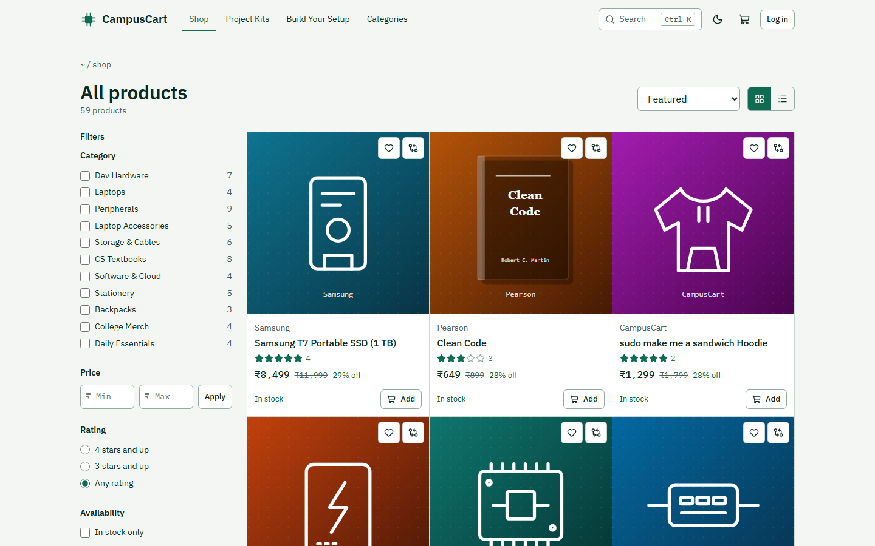
Figure 4: Catalog with filters, light theme
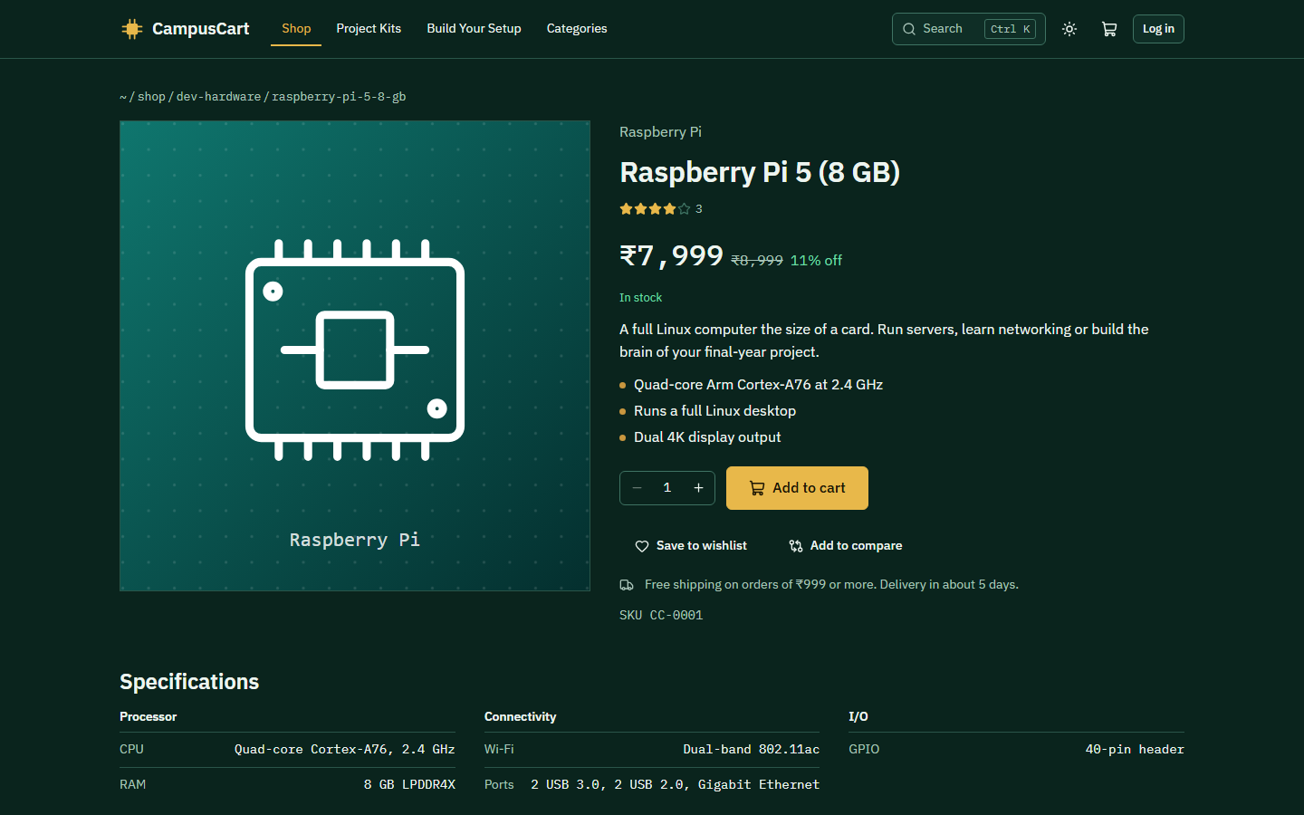
Figure 5: Product page with specifications
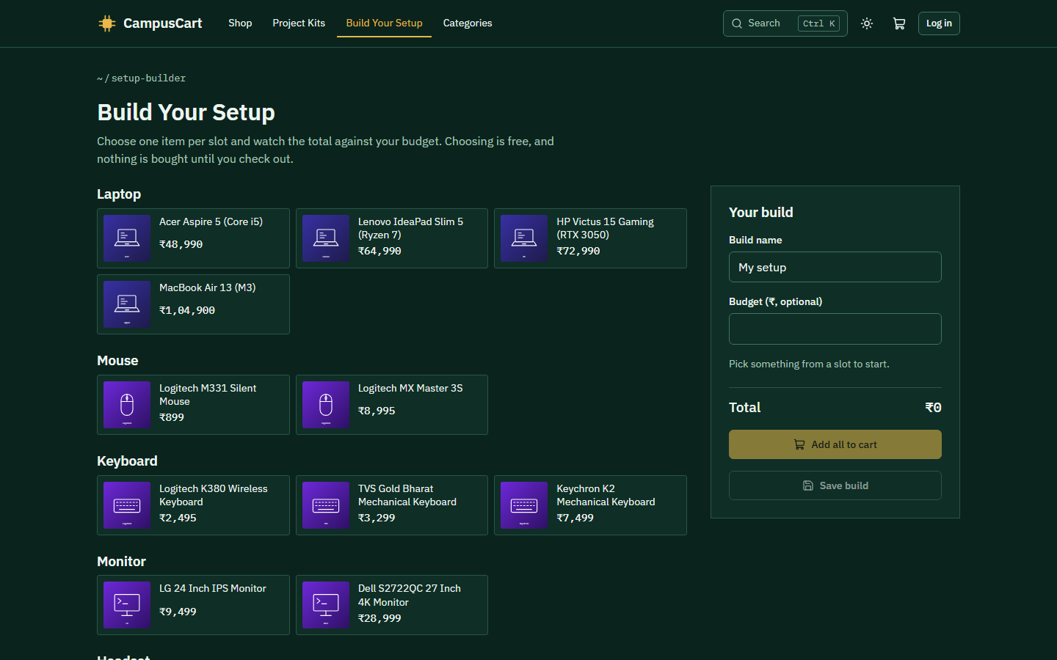
Figure 6: Build Your Setup planner
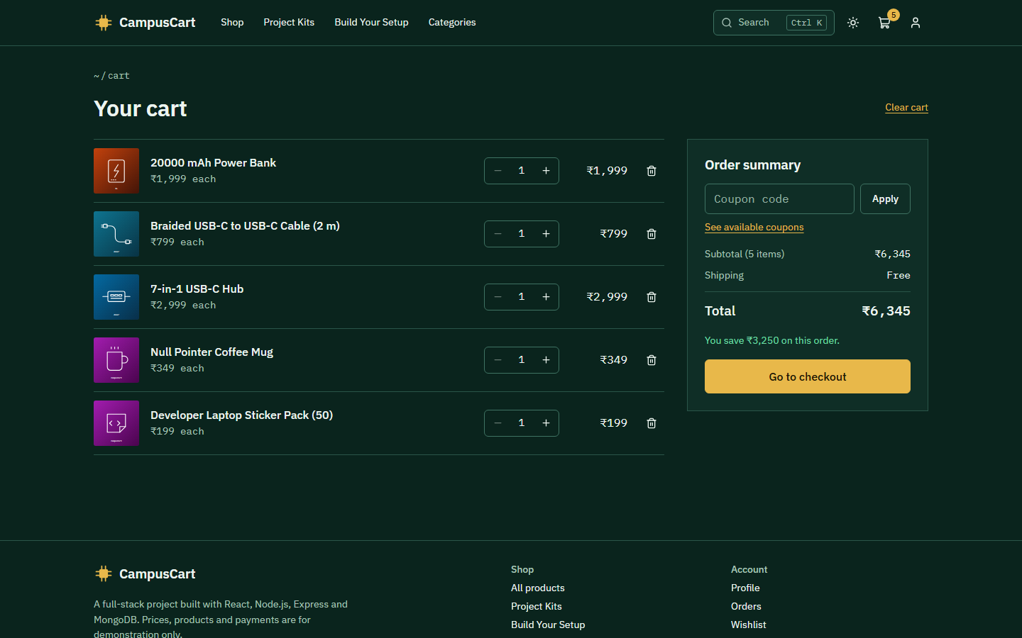
Figure 7: Cart with coupon entry and order summary
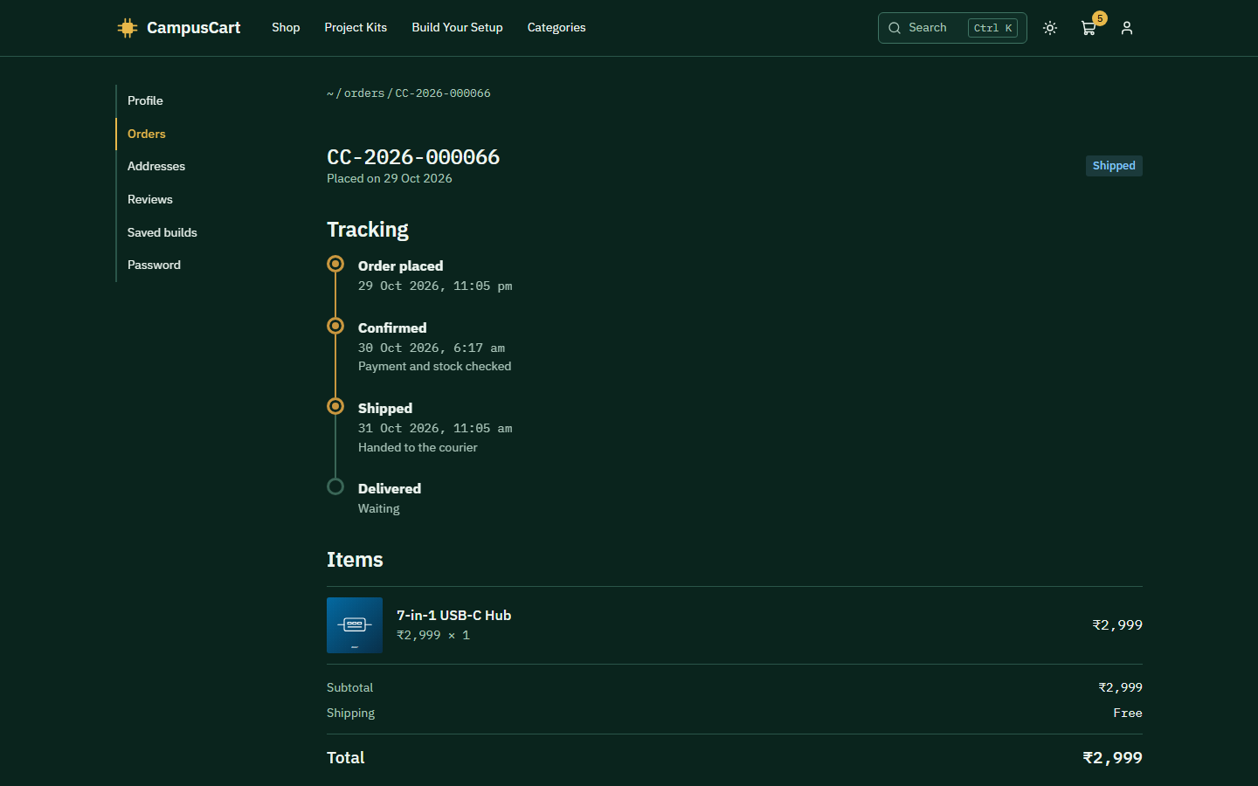
Figure 8: Order tracking timeline
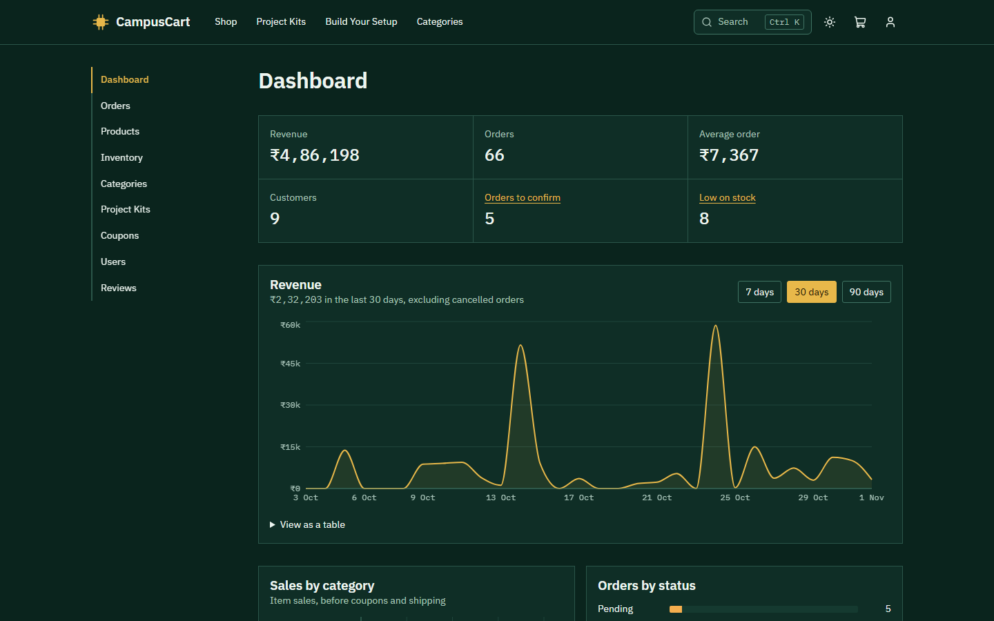
Figure 9: Admin dashboard
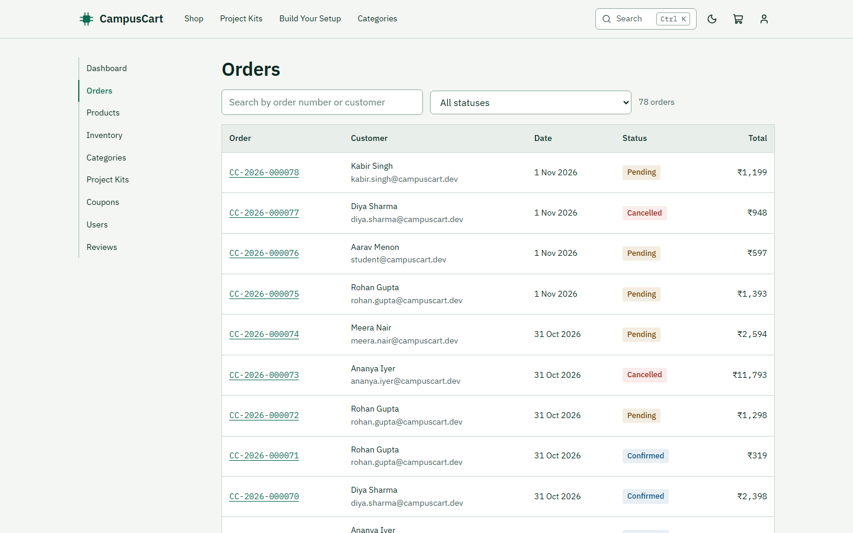
Figure 10: Admin order management, light theme
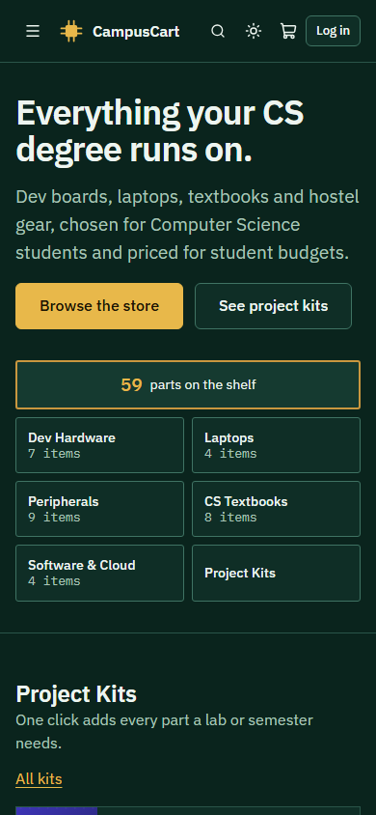
Figure 11: Responsive layout at phone width

7. Testing

7.1 Results
All of these were run on the final version of the application, and all passed.
Suite | Tool | Size | What it covers
API tests | Vitest, Supertest | 167 tests | Auth, permissions, filters, cart and coupon rules, orders, reviews, analytics, seed data
Browser tests | Playwright | 38 tests | Complete student and admin journeys, in a real browser
Accessibility | axe-core | Included in the browser tests | WCAG 2.1 AA audit of every main page, in both themes
API collection | Postman, Newman | 100 requests | Every endpoint except image upload (which the other suites cover), including rejected requests

7.2 Selected test cases
Scenario | Expected result
Two students order the last unit | Exactly one order succeeds, and stock ends at zero
A later item in the cart runs out during ordering | Earlier stock is returned and the cart is restored
A coupon has reached its limit, and two orders arrive | One succeeds, and the limit is not exceeded
An admin tries to skip from Pending to Shipped | Rejected with an explanation
An order is cancelled twice | The second attempt fails, and stock is restored only once
A student reviews a product before delivery | Rejected until the order is delivered
A student opens an admin page or API route | Blocked, with a 403 from the API
A student opens another student's order | Reported as not found
The server is killed and restarted | All data is still there

7.3 Problems found by testing
Testing found real defects that were then fixed, each with a test that failed first:
- Lost data on restart. A repeated persistence test failed about one run in three. On Windows, stopping the embedded database is an instant kill, which lost writes not yet in the journal. Requiring journaled writes resolved it.
- Crash on navigation. Browser tests found that an effect returned the result of window.scrollTo, which React treated as a cleanup function. Every page change crashed the app in Chromium.
- Low contrast. The accessibility audit found status badges that were too faint in the light theme, and invalid list markup.
- Free products. A code review found that a blank price field was converted to ₹0. Blank values are now rejected.
- Logout redirect. Logging out on an admin page could send the next student login back to that page.

8. Limitations
- Payments are simulated, and no real money moves.
- Security hardening such as rate limiting and email verification is not included, by design.
- Product images in the demo data are generated illustrations, although admins can upload photos.
- A price change between viewing the cart and placing the order uses the new price without a separate warning.
- Past category sales follow a product if it later moves to a different category.

9. Future scope
- A seller role, so students can resell used textbooks and hardware.
- Real payment integration, such as Razorpay.
- Email notifications for orders, and password reset.
- Personalized recommendations based on branch and semester.
- Deployment to a public host with a managed database.

10. Conclusion
CampusCart delivers a complete e-commerce workflow in the MERN stack and adds features designed around Computer Science students. Beyond the standard create, read, update and delete operations, it handles concurrent orders correctly and enforces its rules on the server. It was verified through automated API, browser and accessibility tests, which caught several real defects along the way. The result meets the project objectives and provides a solid base for the extensions listed above.

Appendix: running the project
npm install
npm start

Then open http://localhost:5000
Role | Email | Password
Student | student@campuscart.dev | Student@123
Admin | admin@campuscart.dev | Admin@123

