If the frontend was changed do the following:

1. execute "npm run build" in cmd in the synquesticon folder to create a production ready build

2. copy the build folder over to the C: drive of the remote computer syn.ife.no

3. copy the contents of the build folder to the "inetpub/wwwroot" folder

4. restart the IIS synquesticon webpage to load the new changes

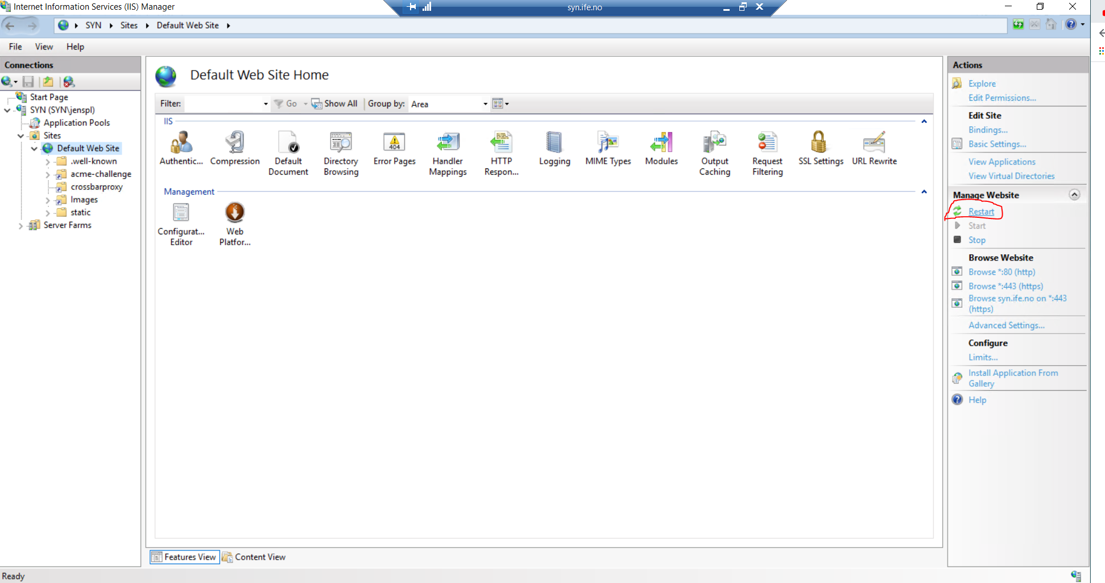

If the backend was changed do the following:

1. copy the backend folder in synquesticon to the C: drive of the remote machine "syn.ife.no"

2. copy the backend folder to the "syncronicon_backend" folder and overwrite all existing files

3. Open windows services

4. stop the service called “SynBackend” on the Syn.ife.no remote machine

5. restart the service called “SynBackend” on the syn.ife.no remote machine

