# Hosting Synquesticon on a webserver with reverse proxy

Synquesticon uses the following ports by default:

The web application uses port 3000.  
The crossbar uses port 8080.  
The MongoDB server uses port 3001.

The main issue with using so many different ports is that they are generally blocked on all secured networks. It is a hazzle to have to open them on the side hosting it, but then also other organizations that might want to use the software would have to do the same. Therefore, it is useful to setup what’s called a reverse proxy, where all traffic is received through a port that is open, e.g. 80 (http) or 443 (https), and then passed on to the correct recipients that are listening on the other ports internally.

To be hosted on a web server Synquesticon must first be built into a production ready module using the command “npm run build” in the “WebEntry” folder. This will generate a “build” folder after the commands completion. The content in this folder should be moved into the static root directory of the webserver, “wwwroot” in our case. This will let the webserver serve the build version of Synquesticon.

The next steps are specific to IIS, but there should be equivalent options for other webservers.

## Configuring IIS

In the IIS Manager you must first install “URL Rewrite”. Once installed locate and select the “Default web site” under the “sites” folder. Unless it has been modified or is part of a bigger web server where multiple sites are served, in which case you select the site that is serving Synquesticon. Next open the “URL Rewrite” feature for this site.

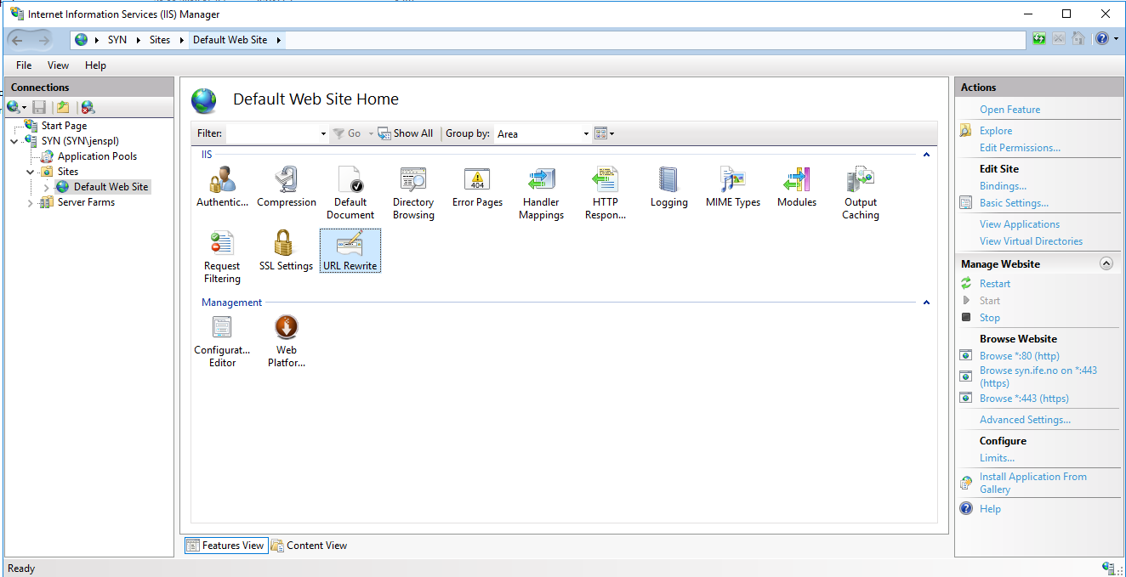

### MongoDB reverse proxy rule

Press “Add Rule(s)” under “Actions” in the column to the right. Select “Reverse Proxy” and name it “BackendRProxy”, in the Inbound rules server name write “ <http://localhost:3001>” and create the rule by pressing “ok”. Now open the newly created rule and write the following regular expression in the “Pattern” field:

(^.*)(api/.*)

In the “Action properties – Rewrite URL” modify the last {R:1} to {R:2} instead.

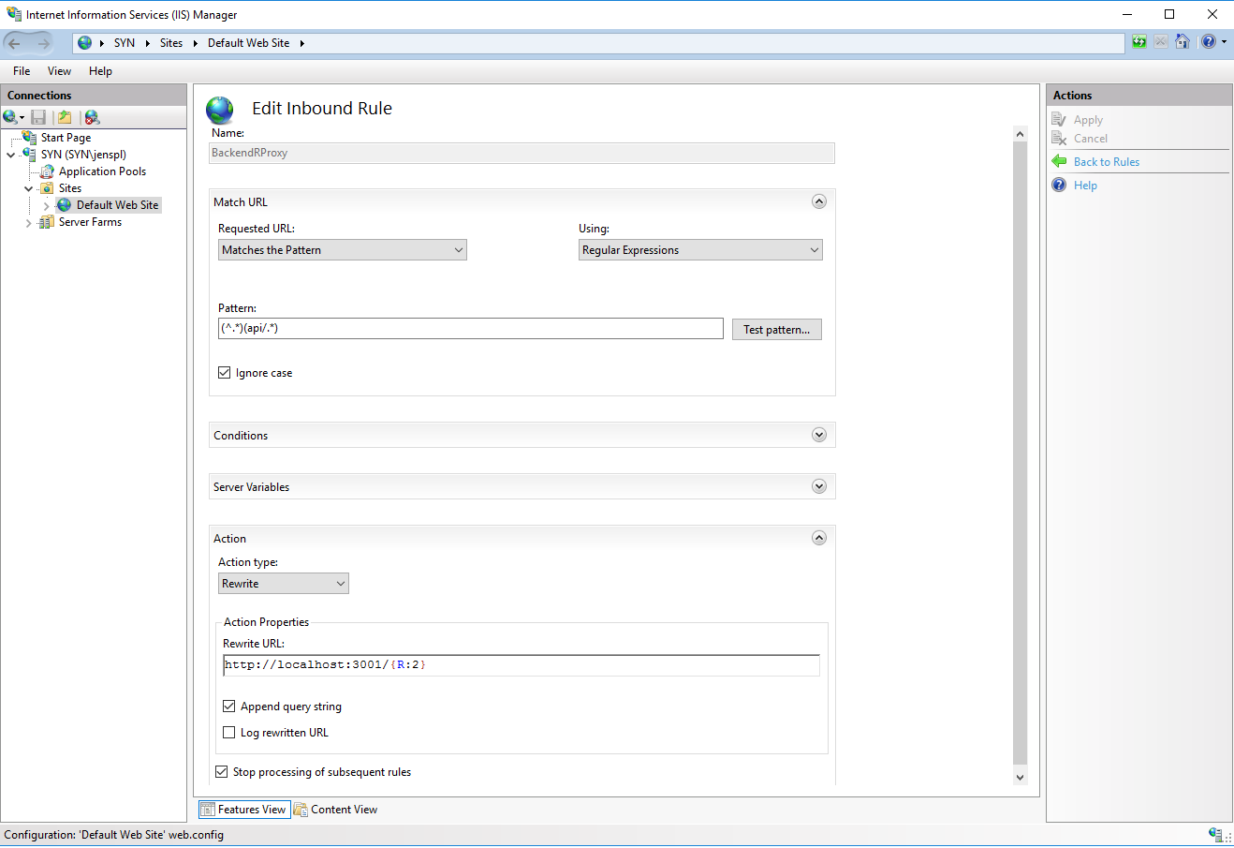

### Mqtt reverse proxy rule

Press “Add Rule(s)” under “Actions” in the column to the right. Select “Reverse Proxy” and name it “MqttRProxy”, in the Inbound rules server name write “ <http://localhost:9001>” and create the rule by pressing “ok”. Now open the newly created rule and write the following regular expression in the “Pattern” field:

(^.*)(mqttproxy.*)

In the “Action properties – Rewrite URL” modify the last {R:1} to {R:2} instead.

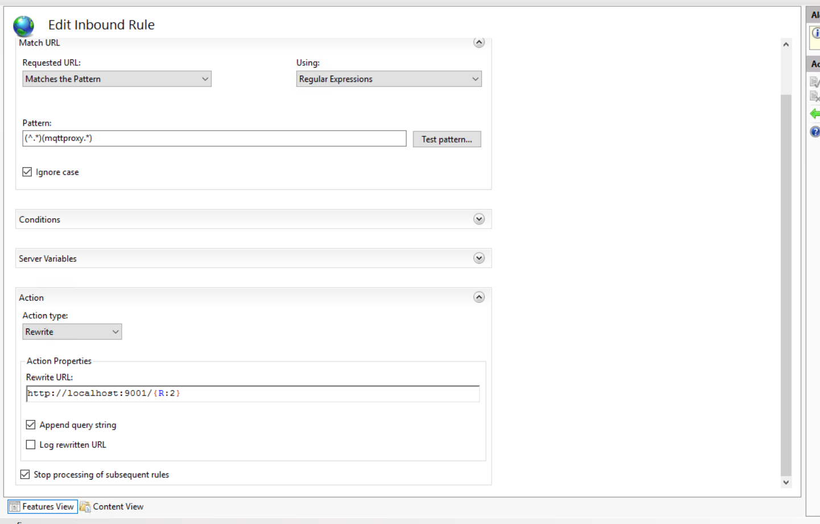

### Http to Https rule

The next rule is not required but might save some headache later in case someone tries to access the site using a non-secure layer (http). This rule will convert all http traffic to https instead. Add a new “Reverse Proxy” Rule and name it “http-to-https” then press “ok”. Open the created rule to configure it. In the “Pattern” field type the following regular expression:

(.*)

Next under conditions select “Match all” and then press the “Add…” button and configure as in the following image.

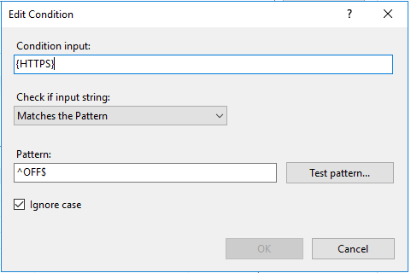

### Backend to webserver rule

Add a new “Blank Rule” and name it “BackendReverseRule”. Under the “Precondition” drop down menu select “Add Precondition”. Under “Using” select “Regular Expressions”. Under “Logical grouping” select “Match All”. Press the “Add…” button and name it “ResponseIsHtml”, add the following in the image below and press “ok”.

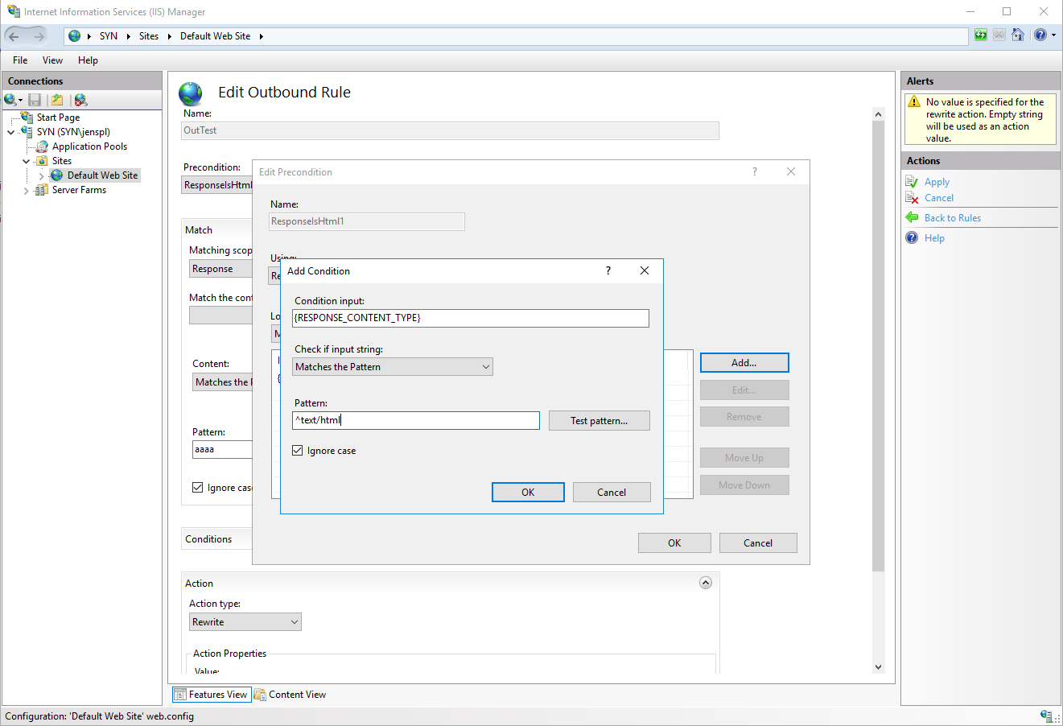

Configure the rest of the rule as in the image below, replacing “syn.ife.no” with your server’s name or IP address and press “Apply”:

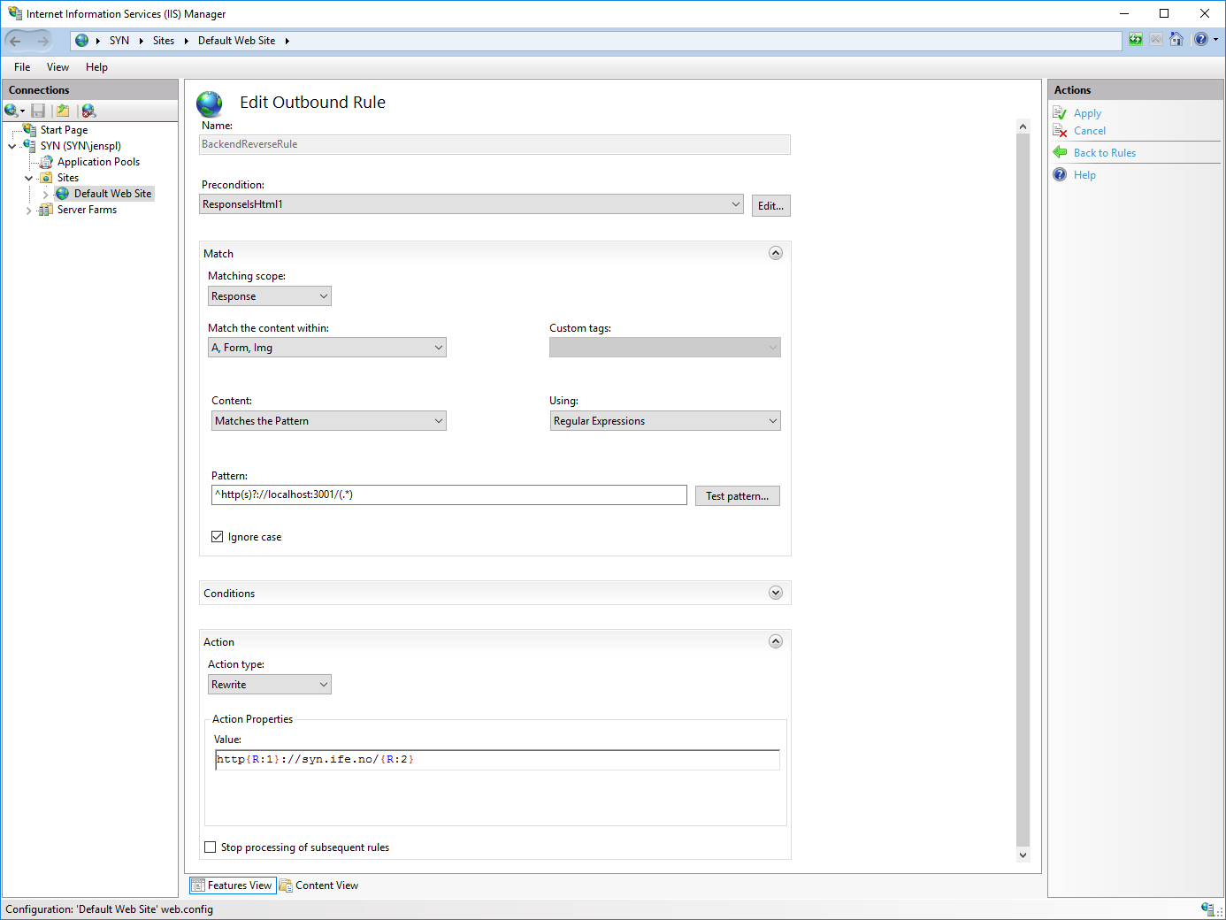

Next under “Server Variables” press the “Add…” button and configure as in the following image:

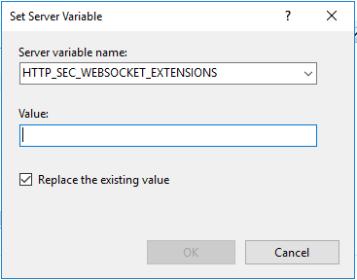

Under “Action” change the “Action type” to “Redirect”. In the “Redirect URL” filed type the following:

https://{HTTP_HOST}/{R:1}

Check the image below for what the finished rule should look like:

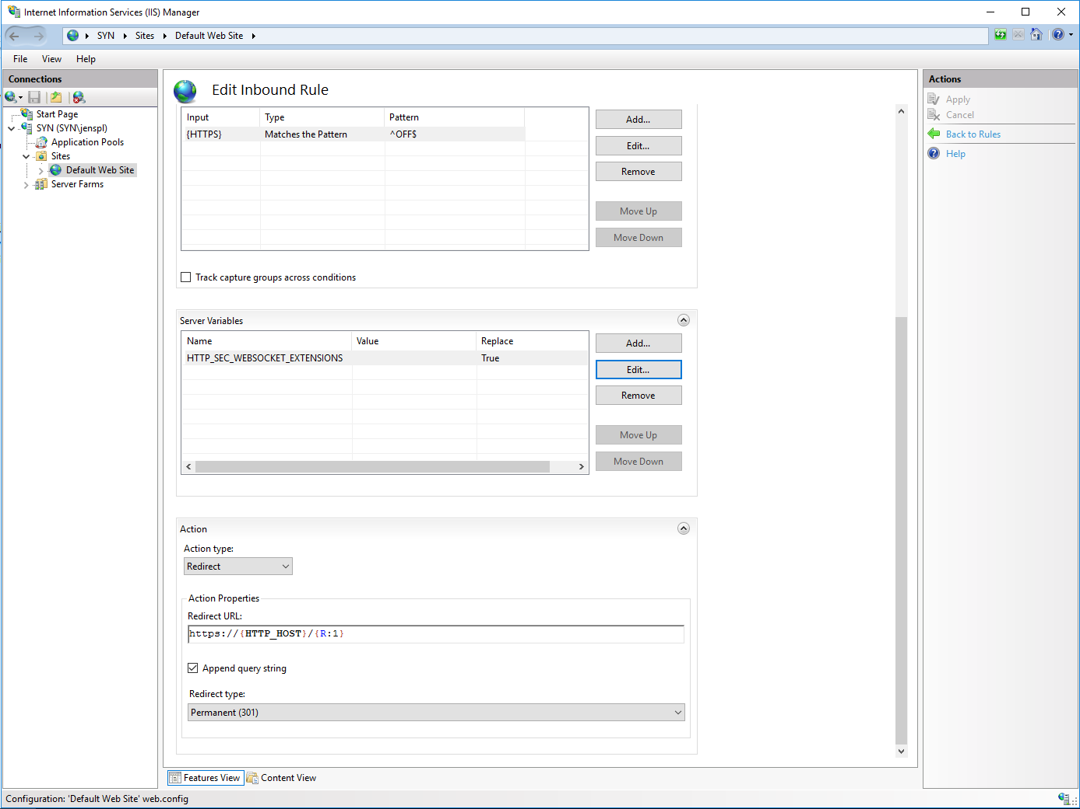

### Mqtt to webserver rule

Add a new “Blank Rule” and name it “MqttReverseRule”. Under the “Precondition” drop down menu reuse the condition we made for the backend reverse rule “ResponseIsHtml1”.

Configure the rest of the rule as in the image below, replacing “syn.ife.no” with your server’s name or IP address and press “Apply”:

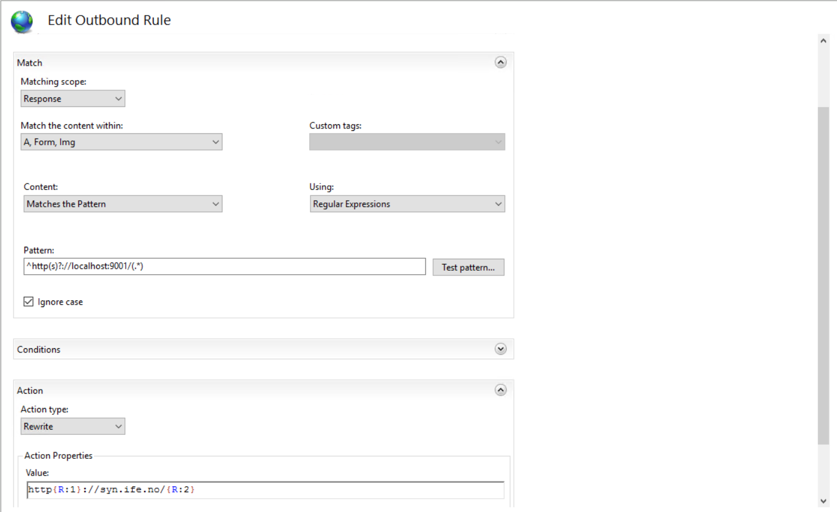

### Virtual directory for images

The file structure under the web server is different from the one used in development mode, as such it is necessary to add a virtual folder to the web site that can serve as the image upload folder. Right click the “Default Web Site” in the left panel and select “Add Virtual Directory”, in the “Alias” field type “Images”, and in the physical path browse to a folder that you create named “images”.

That finishes the configuration of the IIS manager and the website part of Synquesticon. However, there are still steps that are necessary to perform in order to setup automatic start of the rest of the Synquesticon system.

## Setting up the rest of Synquesticon

The following files from the “WebEntry” folder should be copied into a folder on the server machine: “config.json”, and the “backend” folder. We put the file and folder into a folder called “Synquesticon_backend”. In addition to these files it is necessary to create two windows batch files.

“start_backend.bat” with the following content: (Update file paths to match your system)

cd C:\synquesticon_backend\backend   
 npm start

“start_mqtt.bat” with the following content: (Update file paths to match your system)

cd C:\ synquesticon_backend\mqttAEDES  
node aedes.js

### Setup automatic start of mqtt and the MongoDB when server starts

With the bat files in place we can now configure Windows to automatically run these files on server start up and to restart the services if needed. To add the bat files as services a third-party utility is required which can be acquired from the following web page: <http://nssm.cc/>. Download NSSM and either place it in the windows path or add the location to the path variable in Environment Variables.

Next run the command line with admin rights and type the following command: “nssm install SynBackend”, in the window that pops up, under “path” browse to the “start_backend.bat” file that was created earlier. Leave the “Arguments” empty and press “Install Service”.

Repeat the process with a new service and call it “SynMqtt”, browse to the “start_mqtt.bat” file under “Path”. Again, no arguments are needed. Press “Install service”.

Now that the services have been installed, they can be viewed in the “Services” applications that can be found by searching for it in the taskbar. Navigate to the newly created services and make sure they are running, if not right click and start the services.