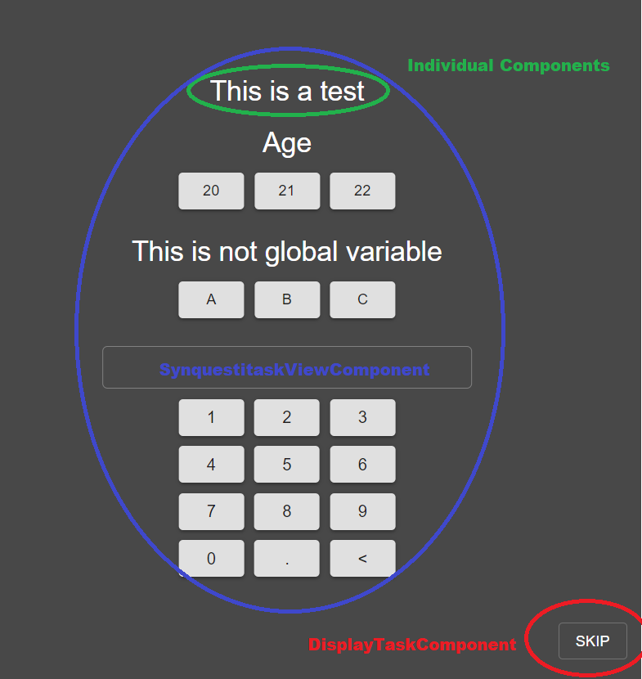

1. DisplayTaskComponent is the Player itself. It is responsible for global functionalities:
   * Player layout
   * Broadcasting global events: “Start experiment”, “End experiment”
   * Setup a profile for the experiment
   * Preload all images
   * Gazecursor: pull data from eventStore, constantly check which AOIs are hit, save gaze data
   * Travel set recursively: this is the role of DisplayTaskHelper. Using DisplayTaskHelper, we can travel deeper into next nested set without resetting other global functionalities
   1. DisplayTaskHelper:

* Checkshouldrecord data: this is specifically for a request that we can skip saving data if the set has a task containing “record data?” and the answer is “No”. This functionality is a coping mechanism to the functionality that we can send test the Player without flooding database with testing data.
* Next button: this is an old design when we didn’t have the SynquestitaskView level and Player had components. Can be refactored to move to SynquestitaskView. Basically, the next button **records the completion time and pushes logging to database; broadcast events to Observer; check the correct answer threshold; go to next Synquestitask or a nested set.**
* OnAnswer: count the number of correct answers.
* resetAOIs: since AOIs’ display is dynamic which can change when be changed when the view changes (resizing windows, scrolling), we save reference to AOIs’ viewport which should be reset when a new Synquestitask is loaded.

1. SynquestitaskViewComponent is responsible for a Synquestitask which can have multiple components. The Synquestitask is responsible for functionalities on Task’s level which are:
   * Create logger for each component (logTheStartOfTask)
   * Record the answering time, responses.
2. Individual components include:
   * InstructionViewComponent
   * ImageViewComponent
   * ButtonViewComponent: since the ButtonView has the reset functionality, this component is authorized to record its own answers, reset and record another.
   * NumpadComponent
   * TextEntryComponent

FYI: why were they named the way they are now? Synquestitask has been evolving through many different versions and designs. The names were originated from the first version, which may not reflect what they are actually doing in the current version.

