

**Index**

**1. Instructions**

**2. Controls**

**3. Console Commands**



1. **Instructions**

* To play you’ll need to start the build, adjust your settings and hit “Play!”.

Note: Ultra, 1920 x 1080 is highly recommended.

* A main menu will appear.
* When you’re ready press the backslash key ( \ ). This will bring up the developer console in which you’ll have to type “newTestingScene”.
* You’re set!

1. **Controls**

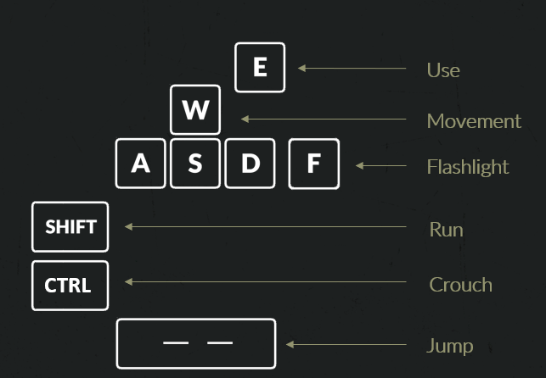



1. **Console Commands**

help: Shows all available commands.

quit: Quits the application.

clear: Clears the console.

showFps: Shows frames per second.

hideFps: Hides frames per second.

noClip: Ignore gravity, collisions and move speed increases.

clip: Restores gravity, collisions and returns to normal speed.

newGame: Starts a new game.

newTestingScene: Starts a new testing scene.

mainMenu: Returns to the main menu.

showRads: Shows accumulated radiation.

