K1 Firmware

Scheduling and Musical-Generation Hardening

STATUS  PLAN APPROVED; IMPLEMENTATION BLOCKED BEFORE AP-P4 |  | OWNER  SpectraSynq / Captain |  | LAST UPDATED  15 August 2026

Authors | Codex CTO architecture audit; Captain post-review amendments
Reviewers | FRTOS-07 publication/event review; FRTOS-08 gate/oracle review
Related docs | README.md and EXECUTION_PLAN.md in the scheduling audit pack
Scope | Contained K1 ownership, freshness, control and conditional service-path hardening

1. Abstract
K1 benefits from better FreeRTOS discipline, but not from more actors. The plan preserves AP on Core 0 and VP on Core 1, repairs the GDFT service contract before scheduler work, gives every VP frame one coherent musical generation, makes commands complete transactions, and measures freshness from sample boundary through RMT completion.
Production firmware remains byte-inert until the external AP-input-integrity P4 authority permits mutation. The explicit audio task, persistence worker, radio promotion and 24 kHz / 180-bin spectral upgrade are not assumed outcomes.

2. Goals and Non-Goals
Goals | Non-goals
Preserve the proven AP0/VP1 core bulkhead | No broad RTOS or actor-model rewrite
One immutable AP generation per VP frame | No DSP migration or parallel render work on Core 1
Loss-aware musical events and transactional controls | No speculative priority or periodic pacing change
Fault-evident gates, truthful timestamps and reversible units | No radio, flash or 24 kHz/180-bin promotion by association

3. Background and Problem Statement
The deployed system is Arduino loopTask on Core 0 plus led_task on Core 1, not an actor graph. Current source can mix independently published semantic generations, direct AP globals, readiness-before-payload mode changes and volatile multi-field commits. Current GDFT service capacity and whole-frame VP margin are not proven on the exact head.
The design boundary is ownership rather than task count: Core 0 owns acquisition and the complete AP transaction; Core 1 owns transition runtime and rendering; bounded channels carry complete state, ordered edges, persistence requests and forensic records according to their distinct semantics.

4. Proposed Architecture

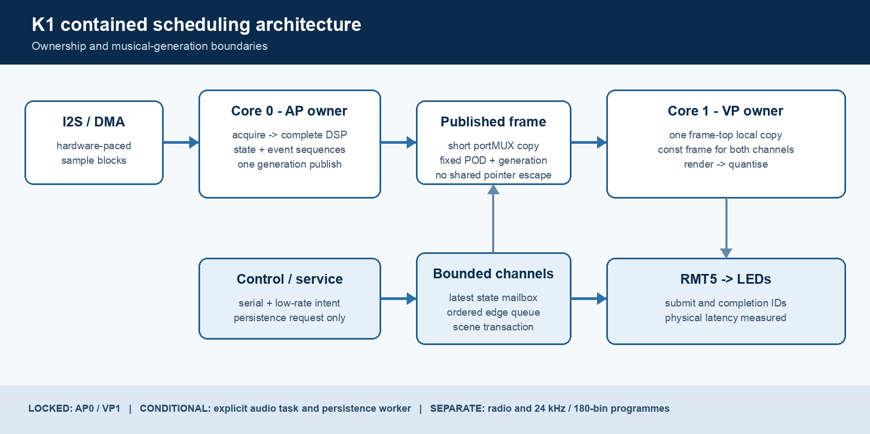
Figure 1. Contained K1 ownership and musical-generation architecture.

Core components

Component | Responsibility | Primary storage | Failure behaviour
AP owner / Core 0 | I2S acquisition, complete DSP transaction, state and event identity | Internal RAM producer frame | Never blocks on VP; exposes backlog, age and service failure
Published frame | One complete generation under a short portMUX | Fixed POD shared value | Old complete frame remains visible; no partial generation
VP owner / Core 1 | One frame-top local copy, both channels, quantise and output | Task-local immutable frame | Skips stale generations visibly; never retains shared pointer
Command channels | Classify desired state, scene, edge and persistence intent | Static mailbox or bounded queue | Visible overwrite/reject/drop policy; no silent loss
Trace/oracle | Carry identity from sample estimate to RMT completion | Producer-owned bounded rings | Fail closed on gaps, unacknowledged stop or perturbation

5. Gate 0-8 Execution Lifecycle
- Gate 0 - freeze exact authority, SHA, toolchain, timing contracts, margins and a fault-evident oracle. AP-P4 remains the external production-mutation predecessor.
- Gate 1 - capture the exact 12.8 kHz / 96 / d3 current-head baseline with quiet, Captain-confirmed real music, worst dual-channel/crossfade load and paired minimal instrumentation.
- Gate 2 - select the GDFT service contract before scheduler mechanics. Current x2_cross=0 and shorter-window candidates are a separate behaviour-changing A/B.
- Gate 3 - publish one coherent frame. First candidate is a shared whole-frame copy plus VP-local copy; explicit owned triple slots are the only fallback if measured copy cost fails.
- Gate 4 - transact complete state and scenes; preserve non-idempotent edge ordering; keep Core 1 as the sole transition-runtime owner.
- Gate 5 - prove one causal identity through RMT completion and prove the trace does not manufacture the result. Required task-creation failure becomes visible and latched.
- Gates 6-8 - run the explicit audio-task A/B only when attribution triggers it; separate request isolation from real flash/cache safety; promote only the selected compact architecture on one integrated HEAD.

6. Data and Command Contracts

Primary data contract

Field | Type | Required | Description
boot_epoch / ap_generation | uint32 | Yes | Reset-aware frame identity; payload and generation share one commit
capture_sequence | uint32 | Yes | Monotonic acquisition identity within the boot epoch
sample time estimates | uint64 + assumption | Yes | Oldest/newest estimates with explicit derivation; not loop-entry time
ap_publish_us / vp_acquire_us | uint64 | Yes | Publication freshness and VP generation age boundaries
continuous musical state | fixed POD | Yes | Spectrum, chroma, VU, peak, silence, tempo, phase and confidence
onset/beat sequences | uint32 + time/strength | Yes | Survive AP generations skipped by VP; epoch and wrap defined
scene/command generation | uint32 | By class | Complete desired state is latest-wins; edges use bounded ordered sequence

Contract guarantees

- VP observes only a complete old or complete new musical generation; no pointer to shared publication storage escapes.
- Every accepted edge advances one sequence exactly once. State-only updates cannot retrigger an event.
- Both channels of a complete scene apply on one VP frame generation. Queue/ring saturation is visible and counted.
- RMT submission and completion remain distinct, and every estimate names its assumptions and evidence boundary.
The detailed executable contract is published in EXECUTION_PLAN.md and versioned with this audit pack.
Implementation units must cite the frozen implementation SHA and the exact gate receipt they consume.

7. Consistency, Idempotency, and Replay

Continuous state is newest-complete-frame data. Desired-state commands may coalesce. Non-idempotent edges preserve accepted order and at-most-once consumption. Forensic history uses bounded producer-owned rings with sequence and drop counters. Host forced interleavings pause producer and consumer at each commit boundary, including a simulated 40 ms VP stall, wrap and epoch reset.
Scenario | Expected behaviour | Reasoning
VP stalls while AP publishes five frames | Current VP-local frame remains immutable; next acquire may skip visibly | Freshness must not violate reader lifetime
Two onsets occur between VP frames | Sequence delta is two and declared coalescer runs once | Boolean-only events can disappear
State A/B/C overwrites before consume | Complete C applies; overwrite counter records A/B | Latest-wins is valid only for complete desired state
Ordered edge queue is full | Reject/drop policy is visible and counter reconciles | Silent loss is not an accepted failure stance

8. Safety and Authority Boundaries

- Production remains byte-inert before AP-P4. Device identity, build provenance, calibration epoch and Captain-confirmed audible real music are mandatory for admitted physical evidence.
- Implementation agents cannot edit or accept the oracle, fixtures, CI or thresholds that judge their production unit.
- No heap, blocking queue/mutex or filesystem work enters the AP hot path; AP0/VP1 and the real IDLE0 slot remain locked.
- Persistence request isolation and actual flash/cache coexistence are separate gates with explicit retry, degrade and rollback policy.
- Radio promotion and the 24 kHz / 180-bin spectral proposal remain separate programmes with no borrowed acceptance.

9. Operational Readiness
Signal | SLO or alert | Owner | Launch gate
AP service and sample age | Pre-registered p99/max margin; bounded over-period sequences | Independent gate runner | Required
Publication coherence | mixed_generation_count = 0; skips visible | Harness owner | Required
Lock/copy cost | Producer and consumer wait/hold p50/p95/p99/max within margin | Device gate runner | Required
VP/RMT timing | 120 FPS contract and submit/completion boundaries satisfied | Gate runner + Captain | Required
Queue/ring integrity | High-water, rejects, drops and sequence gaps reconcile | Subsystem owner | Required
Rollout constraint: one integrated HEAD, full tests/build, authorised delta, physical sign-off, independent gate runner and usable rollback.

10. Alternatives Considered

Alternative | Why it was considered | Why it was not selected
Broad actor rewrite | Clear conceptual stage boundaries | Creates queues, age policy and complexity without CPU capacity
Priority or periodic pacing | Small apparent scheduler change | Cannot reduce DSP service demand and creates a second cadence source
Core-1 DSP / parallel render | Potential use of inferred spare capacity | Core-1 margin and shared render ownership are unproved
Two-slot pointer swap | Avoids a VP-local whole-frame copy | Does not prove lifetime during a 38-40 ms VP stall

11. Open Questions
- Ratify the whole-frame deadline/miss semantics that operationalise the load-bearing 120 FPS target.
- Replace universal sub-8 ms latency with numerical targets for each named feature and physical boundary.
- Pre-register AP/VP/lock and instrumentation margins from the exact-head baseline before viewing candidate results.
- After Gate 5, decide whether scheduler interference triggers Gate 6 or closes it as NOT_REQUIRED.

12. Decision and Next Steps
Approve the contained architecture destination and Gate 0-8 proof DAG. Do not begin production implementation or autonomous execution yet. First close Gate 0 contracts and fault evidence; then wait for AP-P4, freeze one exact implementation SHA, and capture the current-head baseline before selecting the GDFT contract.
Milestone | Deliverable | Exit criteria
M1 | Gate 0 authority, contracts and oracle | Fault battery is RED-capable; AP-P4 receipt exists
M2 | Gates 1-2 baseline and service contract | Current timing is admitted; GDFT choice meets compute and product contracts
M3 | Gates 3-5 coherent frame, commands and causal proof | No hybrid generation, lost accepted edge or trace ambiguity
M4 | Closed G6/G7 decisions and Gate 8 integration | Selected compact architecture passes one-HEAD proof and Captain sign-off

Use footnotes for definitions, assumptions, or terms that need precision without interrupting the main narrative.

