**“Cleaning” Raw Data in AcqKnowledge**

1. Open the raw data file that you want to clean in AcqKnowledge. The raw data should be a copy of the original, in another folder so that an original version of the raw data is always preserved (lest you inadvertently save over the raw data file in the course of your work).
2. First, you will want to rescale the individual waveforms to be able to see them more clearly. 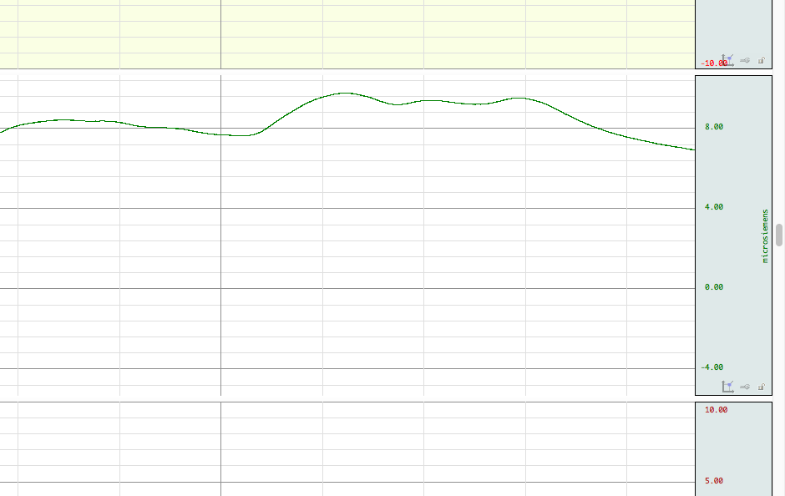To do this, click on one of number marking the right-hand, vertical axis, or one of the first two icons in the bottom of that axis bar.

3. In the dialogue box that appears, rescale the graph to 2-4 microsiemens per division by putting the desired value in the ‘Scale’ section and choose a midpoint of 1 microsiemens in the ‘Midpoint’ section.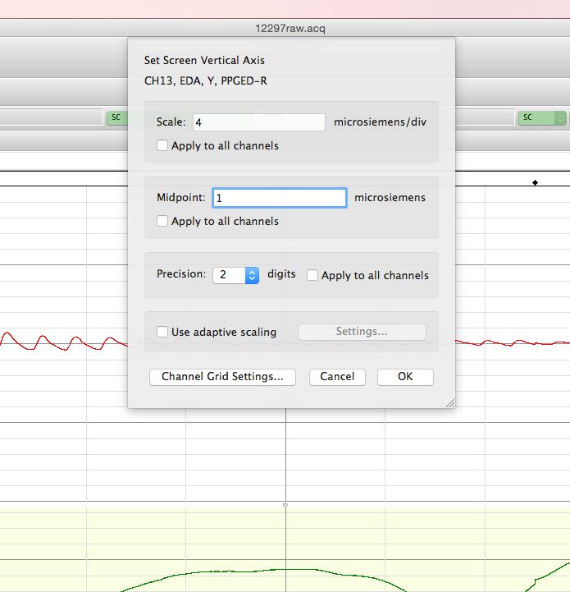

4. Next, rescale the heart waveform on the bottom of the window. This is done the same way, but rescaling to 40-50 BPM/division and a similar value (40-50) BPM for the midpoint.

The horizontal time axis will also need to be rescaled. This is done in a similar fashion as above. First click on one of the time values marking the horizontal axis at the bottom of the window, and then input a time scale of 10 seconds/division in the dialogue box that appears.

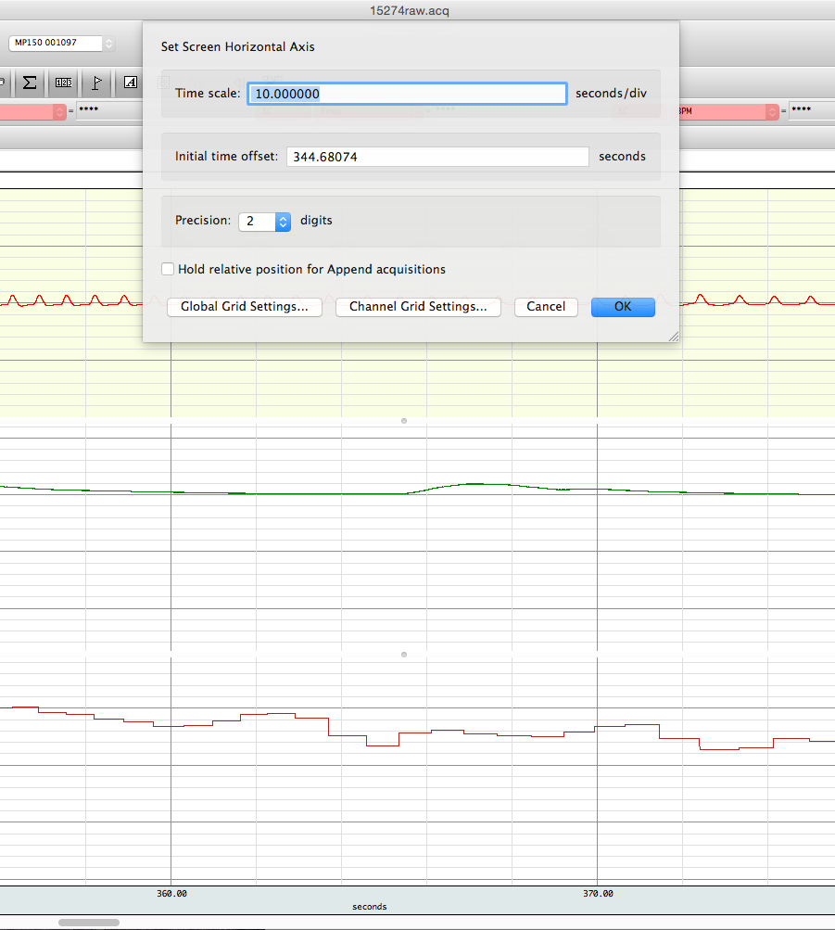5. The next step is to standardize the recording lengths for each portion of the lab session that occurred, deleting excess graph when the recording wasn’t immediately stopped with the end of that section of the stimulus presentation.

For the current experiment, the apolitical and political treatment groups had different recording lengths based on which set of videos they were shown first. Check in the spreadsheet to see which group the study participant was in. Then consult the spreadsheet listing the cutoff times for each group. The first part of the recording should have been stopped at either 330 or 350 seconds for this experiment, depending on the stimuli group. (The cumulative end point after the second set of videos is 710 seconds. The final end time for the graphs should be 1010 seconds.)

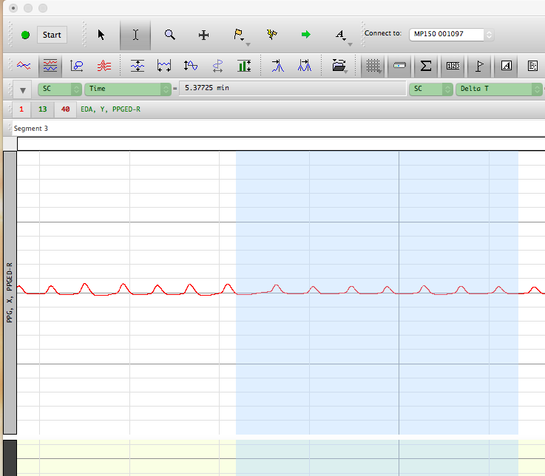

6. To delete the excess portions of the graph, choose the I-beam cursor in the top, left-hand corner of the window (next to the regular mouse pointer).

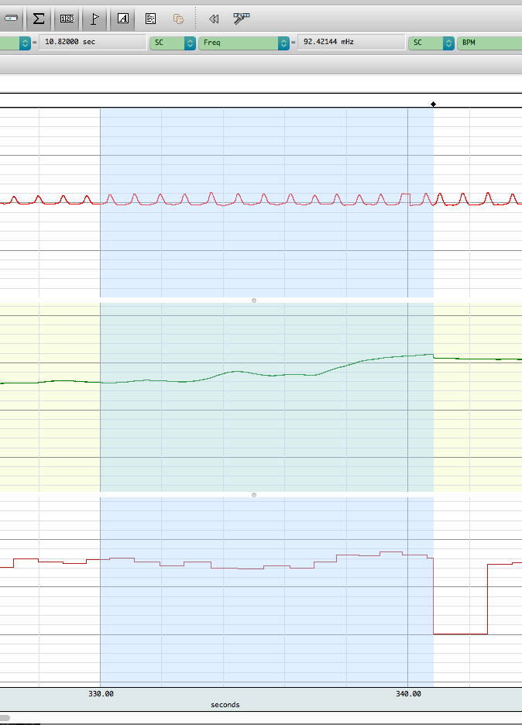

7. Then, highlight the area of the graph from the diamond marker on the top horizontal axis (which denotes that the recording was paused) back to the desired time as indicated on the bottom horizontal axis. (For the graph in question, the section of the graph from 330 to 341 seconds is being deleted.) A note of caution: the I-beam function does not allow for the edges of the selected area to be repositioned (a typically normal feature for software with I-beam functionality, but not here) so make sure that the highlighted area is selecting the exact area desired.

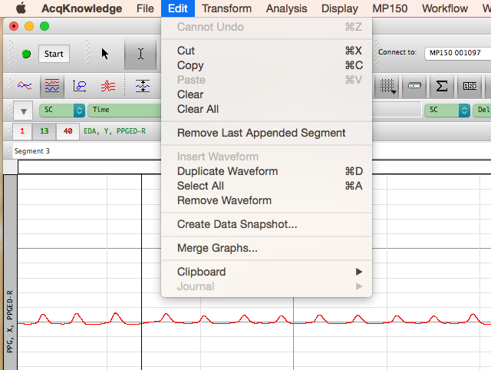8. To delete the highlighted portion, click the ‘Edit’, then hit ‘Clear All’. This will delete the highlighted area for all three waveforms.

9. Repeat this deletion procedure after the second pause in recording, deleting the excess graph from the diamond back to 710 seconds, and then again at 1010 seconds.

10. The final step to the cleaning is to remove heart rate artifacts from when the PPG instrument malfunctioned. These show up as vertical drops down to zero BPM, sometimes followed by a spike twice as high as the preceding heart rate level. Usually, these are labeled by AcqKnowledge with little blue circles. Two examples, with and without the post-drop spike, are 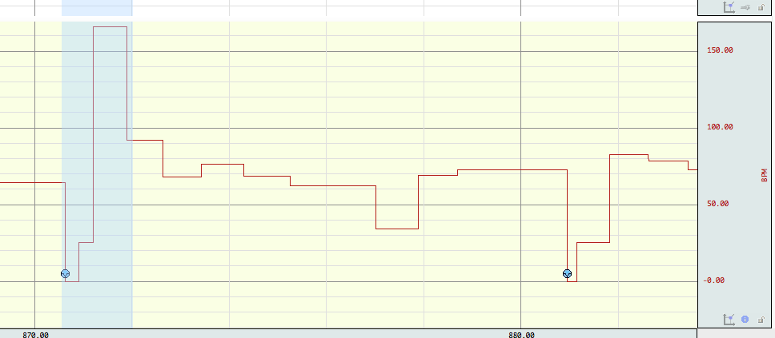circled in the picture below.

11. These are removed by using the ‘connect endpoints’ function, which smooths over the artifact with a line from the heart rate level before the artifact to the one after. First select the I-beam cursor, and highlight directly before and directly after the artifact, taking care to select as close to the edges of the artifact as possible.

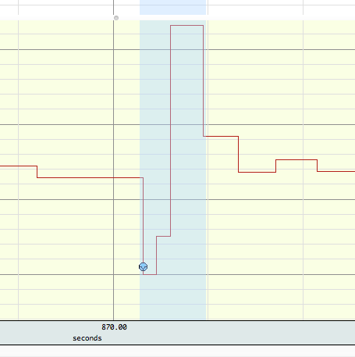

12. Then, make sure that the HR waveform is selected. Do this by clicking on any portion of the bottom graph containing this waveform. The bottom graph should now be highlighted in yellow, with the other graphs white. (If the bottom graph is not selected, the connect endpoints function will alter whichever of the upper two graphs is selected, which we don’t want.)

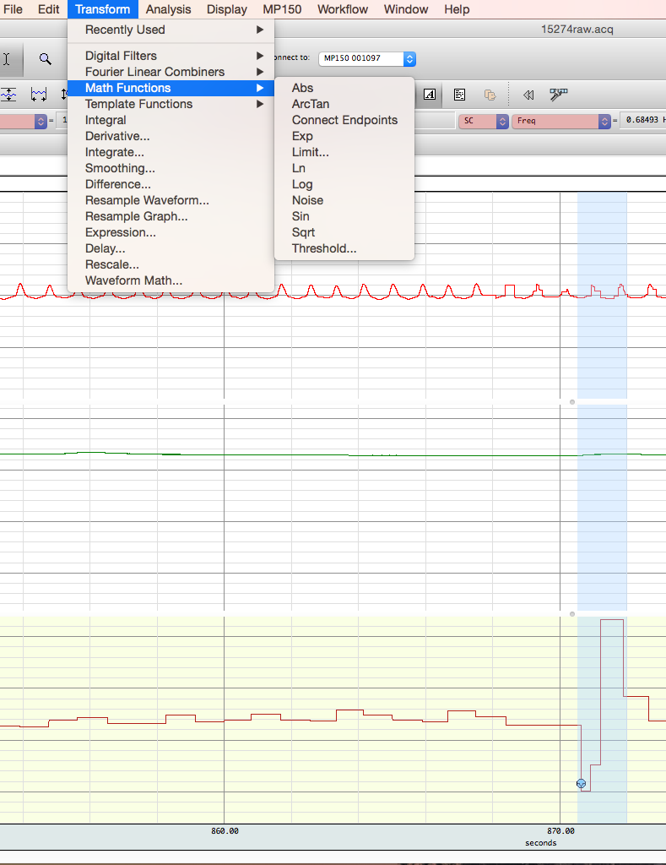

13. Now, execute the 'connect endpoints’ function. This is done by clicking on the ‘Transform’ tab, then clicking/sliding your mouse over the ‘Math Functions’ sub-tab, and finally selecting ‘Connect Endpoints’.

14. The wave form will now be smoothed, with a (likely sloped) straight line in the highlighted area where the artifact was before.

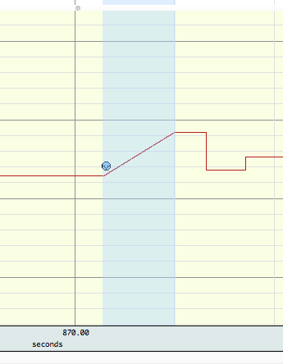

15. Repeat this process as needed throughout the graph. However, **do not** attempt to remove artifacts at the very beginning of the recording and immediately after the recording was paused, as there is no endpoint from before the artifact to connect it to. (The HR from before the pause is not a reliable reference estimation point, as a fair amount of time passed while the recording was paused, and thus the participant heart rate may have changed substantially. Plus, these portions of the graph with those artifacts won’t be used in the analyses anyway.)

16. Once the excess portions of the graph have been deleted and the heart rate artifacts have been removed, remember to save the cleaned graph so that you don’t lose your work. The original raw data should have been saved as XXXXXraw.acq (with the X’s being the 5-digit participant ID number). Save the recording without changing the name. (Since you should be working in a folder containing copies of the raw data, such that the pure raw data is never lost.) After saving the file, go back into the folder containing it, and delete the ‘raw’ from the end, to signify that it has been cleaned/modified.