**ROBOTS**

Robots are machines capable of performing a complex series of tasks automatically. Throughout history, robots have provided efficient and practical utility for society. They can be autonomous or semi-autonomous, and have various applications to the real world, including: space exploration, firefighting, etc. Contrary to popular belief, robots do not always take humanoid forms but are generally designed to carry out a task regardless of appearance.

**What is the state of the art of this new technology?**

At the turn of the 20th century, robotics have been increasingly developed and continue to reach new heights every year.

One of the earliest humanoid robots can be traced back to 1928 with “Eric” delivering a speech at the annual exhibition of the Model Engineers Society in London. Eric was covered in aluminium and powered by a 12V battery, and a person could control him remotely or through voice commands.

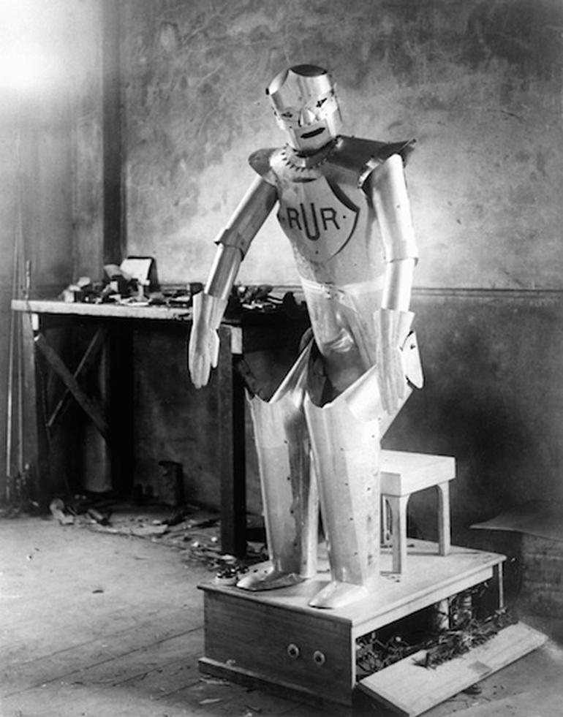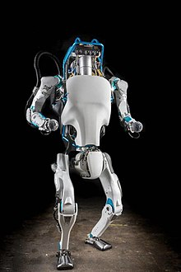

*Eric invented in 1928 (left), and Atlas invented in 2013 (right).*

Representative of recent robotic advancements, Boston Dynamics created a bipedal humanoid robot, *Atlas*, in 2013 and is still being developed to this day. Atlas is able to perform a variety of movements: jumping on boxes, turning 180 degrees, doing a backflip, and running through obstacles.

Furthermore, combining robotic technology and silicone prosthetics, we are now seeing the rise of realistic humanoid sexbots which have the potential to change the sex industry and the future of sex.

Comparing today’s robots to those made in the 1900s, we can see how far robotic development have come and in the words of AI specialist, Gary Bradski, “a new species, *Robo sapiens*, are emerging”.

**What can be done now?**

With the technology available today, robots are able to perform a variety of functions, and potentially touch on all aspects of life and society.

For example, French company, Shark Robotics, developed a firefighting robot called Colossus that was used to aid in the fires at Notre Dame de Paris in April, 2019. Colossus was mounted with a water cannon that would normally require 2-3 people, and when at full capacity, needing a further 7 people.

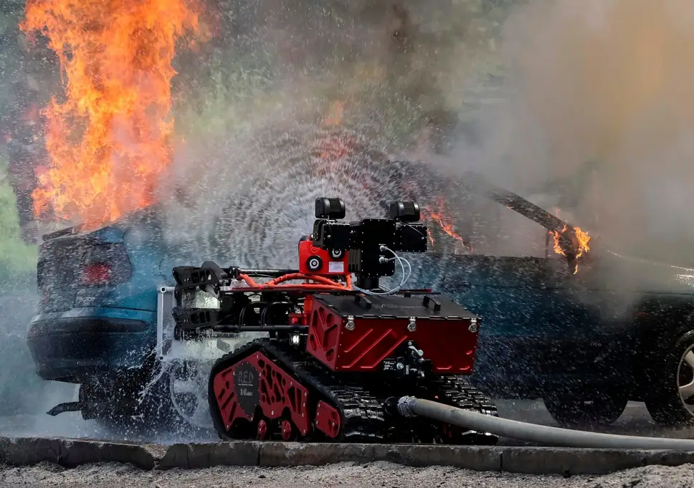

*Colossus in action at Notre Dame de Paris in April, 2019.*

It took an important role in creating a “standoff”, a buffer zone between the firefighters and fiery environment, allowing firefighters to tend to other pressing matters. This demonstrates how robots can be used to reinforce firefighting efforts.

Additionally, sex toys have come a long way. Currently, those interested can order their very own life-like robotic doll from one of the top manufacturers in the world built to ideal body specifications. These robots have limited speech, can blink, regurgitate some information and have sex with their owners. In a way you can somewhat understand the appeal as users have access to quick sex without the risks of STIs. It is not surprising that sexbots are becoming more widespread, and a few countries such as Japan have adopted such technology for prostitution services.

These are only a few examples of how robots can be useful to society, and its uses extend beyond just firefighting but also in the fields of business, medicine, and the military.

**What is likely to be able to do be done soon (say in the next 3 years)?**

It’s hard to definitively say what can be done in the next 3 years as the technical field is open to quite probably breakthroughs by engineers and scientists. Therefore, it can be more accurate to measure future prospects by looking at projects on the horizon.

Expected to be operational later this year, collectively known as the Astrobees, Honey, Queen, and Bumble are three flying robots developed by NASA to work alongside astronauts on future missions. Maria Bualat, the Astrobee project manager at NASA’s Ames Research Center in California’s Silicon Valley, stated “Astrobee will prove out robotic capabilities that will enhance human exploration. Performing such experiments in zero gravity will ultimately help develop new hardware and software for future space missions.”

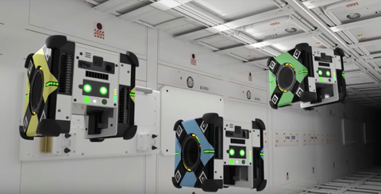

*The Astrobees are expected to be online in Fall, 2019.*

Currently, the Astrobees are able to perform routine maintenance: monitoring equipment and performing inventory, allowing scientists to focus on meaningful tasks. Robots like the Astrobees could play an increasingly prominent role in space as potential “caretakers”.

Additionally, it is safe to assume that sex robots will continue to undergo innovation to become even more hyper-realistic. It is also very likely the evolved robots will have the ability to read human behaviour and respond appropriately. They would be able to show facial expressions, hold conversations, show empathy, be able to move and feel human touch, making the interactions between the robot and the owner seem more natural.

**What technological or other developments make this possible?**

Broadly speaking, science and technology are at the foundation of robotic development as the field have encouraged scientists and engineers to invent and innovate machines. More specifically, computers have been essential in developing modern robotics because they can perform calculations and design algorithms to run diagnostics.

Additionally, we are seeing more companies allocating resources to the development of artificial intelligence, animatronics and smart sensory technology, and an increasing trend of implementation of such technologies in robots in all sectors.

The creation of the World Wide Web have made resources that were not previously accessible available, and have effectively driven individuals from all around the world to contribute to its development. For instance, NASA released the Astrobee software as open source which can be found on GitHub, allowing anyone to freely contribute to the project.



**What is the likely impact?**

Robots have the potential to have a tremendous impact depending on the scale of its implementation and the effectiveness of its application whether it is the workplace, our homes or relationships.

**What is the potential impact of this development?**

The potential impact of robotics development cannot be accurately said in a holistic sense, because specific robots can have varying impacts based on its design, application, and the area it’s targeting.

For example, sex robots can potentially cause a negative impact on human relationships whereby it exacerbate those that struggle with human connection, increasing their preference in robot companionship.

On the other hand, the use of industrial robots are having a positive economic impact with Graetz & Michaels (2018) suggesting their increased use is associated with increases in labor productivity in large parts of the developed world. The robots have directly been attributed to substantial productivity growth, accounting for 15% of the aggregate economy-wide productivity growth.

Robot densification has been tied to rising levels of total factor productivity and wages, and reductions in output prices. The *Financial Times* (2014) show an increasing trend in the use of robots by developing countries, with China taking the lead globally in purchasing robots.

**What is likely to change?**

Recently, the development of robots has been increasingly directed towards services. Areas that are particularly experiencing rapid expansions include medical robots, factory logistic systems and unmanned vehicles (popularly known as drones).

If the quality-adjusted prices of robots keep falling at a rate similar to past decades, and as new applications are developed, the Gratez & Michaels strongly suggest labor productivity will continue to increase.

**Which people will be most affected and how?**

Although robots can be used for highly complex tasks like diagnosing medical conditions and predicting financial outcomes, they are also being used to perform laborious simple tasks like cleaning, lifting and transporting. These jobs are normally done by unskilled laborers since they don’t require extensive qualifications or training, and now they are on the trend of being replaced by robots. There is no significant relationship between the increased use of industrial robots and overall employment, although robots may be reducing the employment of low-skilled workers.

**Will this create, replace or make redundant any current jobs or technologies?**

Robotics development will inevitably replace and make certain jobs redundant, but will also create new jobs in the process.

As previously stated, mainly unskilled labor jobs are at risk of being increasingly replaced by robots since the task is relatively simple and laborious; such as cleaning floors and assembling parts.

The jobs created will primarily stem from the technological field, because the advancement of robots will require further research and maintenance, and will need specialists for its development.

**How will this affect you? (300 words)**

Robots are on due course to affect our personal lives, but the extent and timing of it remains unknown.

**In your daily life, how will this affect you?**

Some supermarket companies have been trialling cleaning robots to operate in aisles and if they are successfully implemented, you will be able to enjoy a cleaner aisle experience.

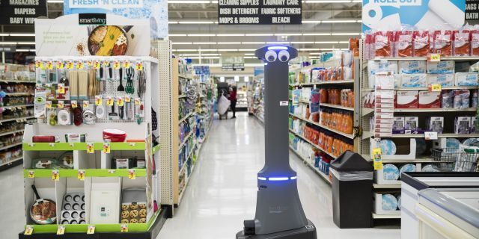

**What will be different for you?**

Some aspects of our life will have more automation and robotics involved. It might be a distant memory for some, but self-checkout machines can be considered a robot and has effectively eliminated the human element in a sales process.

**How might this affect members of your family or your friends?**

If you have family members or friends in unskilled labor jobs, their employment might be under threat from robots in the future. For instance, cleaning robots in supermarket aisles might lessen the role of floor staff and eventually replace them when technology is advanced enough.

**References**:

Kolawole, E. (2019). *What if this ATLAS shrugged? — DARPA unveils new humanoid robot*. [online] The Washington Post. Available at: https://www.washingtonpost.com/news/innovations/wp/2013/07/12/what-if-this-atlas-shrugged-darpa-unveils-new-humanoid-robot/?noredirect=on&utm_term=.81ea1fd6cb2a [Accessed 24 Jun. 2019].

Grossman, D. (2019). *Meet the New Flying Robots That NASA Is Sending Into Space*. [online] Popular Mechanics. Available at: https://www.popularmechanics.com/technology/robots/a27542297/meet-the-new-flying-robots-that-nasa-is-sending-into-space/ [Accessed 22 Jun. 2019].

Graetz, G. and Michaels, G. (2018). Robots at work. *Review of Economics and Statistics*, [online] 100(5), pp.753-768. Available at: https://www.mitpressjournals.org/doi/abs/10.1162/rest_a_00754 [Accessed 22 Jun. 2019].

Powley, T. (2014). *China becomes largest buyer of industrial robots | Financial Times*. [online] Financial Times. Available at: https://www.ft.com/content/a5cca8c0-e70c-11e3-aa93-00144feabdc0 [Accessed 22 Jun. 2019].

Han, A. (2019). *Meet the Robot Firefighter That Battled the Notre Dame Blaze*. [online] Popular Mechanics. Available at: https://www.popularmechanics.com/technology/robots/a27183452/robot-firefighter-notre-dame-colossus/ [Accessed 23 Jun. 2019].