

Consensus Algorithms in Practice
A Technical Primer on Distributed Agreement, Quorums, and Operational Trade-offs

This primer walks through the failure models that make agreement hard, the two protocol families that dominate practice, and the quorum arithmetic that connects them to latency and availability trade-offs. It is written for engineers who already know what a replicated log is and need to reason about what happens when the network, the disk, or the operator does something unexpected.
Document ID | INF-2026-014 · Consensus Primer
Version | 2.1 (internal review)
Status | Draft — circulated for technical review
Audience | Platform engineers and SREs operating replicated state
Tooling | Open XML SDK 3.3.0 · validated and rendered with LibreOffice
Classification | Internal — safe to circulate inside the infrastructure org
Priya Nair · Systems Infrastructure · November 6, 2026
File: docx-feature-sample-en.docx · Title: Consensus Algorithms in Practice · Author: Priya Nair

Contents
1 The Problem of Agreement 1
1.1 Safety, liveness, and the fault model 1
1.2 Why consensus resists simple explanations 1
2 Two Dominant Families 1
2.1 Paxos: multi-Paxos and the leader's role 1
2.2 Raft: strong leadership and log replication 2
2.3 Side-by-side comparison 2
3 Quorum Mathematics 2
3.1 The intersection property 2
3.2 Read amplification and tail latency 3
3.3 A worked example 3
4 Replication Topology 3
4.1 Placing quorums across failure domains 3
4.2 Correlated failure and correlated latency 3
4.3 Measuring commit latency 4
5 Operational Behaviour 4
5.1 Leader elections in practice 4
5.2 Snapshotting and log compaction 4
5.3 Linearizability checks 5
6 Editorial Revisions 5
6.1 Insertions and deletions 5
6.2 Formatting changes 5
6.3 An inserted table row 5
7 Review Notes 5
8 Document Automation 6
9 Shapes and Text Boxes 6
9.1 A DrawingML callout 6
9.2 A legacy VML shape 6
Appendix A System Comparison Matrix 7
Appendix B Fields Used in This Document 7
Appendix C References 8

Press F9 in Word to rebuild the table of contents.
List of Figures
Figure 1 Quorum placement across failure domains 3
Figure 2 Commit latency against cluster size 4
Figure 3 Write amplification in a three-node group 4

Press F9 in Word to rebuild the figure index.
How to read this document: the contents, the figure index, every page number and every cross-reference are Word fields. Select all and press F9 to refresh them; the file also carries an update-on-open flag so Word recalculates automatically the first time it opens the document.

1 The Problem of Agreement
A replicated log is only useful if every replica that answers a client query answers it the same way. Agreement is the property that makes that guarantee hold: once a value is decided, no two correct replicas may ever decide differently. Proving that such a protocol cannot exist under the weakest assumptions took a full journal paper; building one that works under realistic assumptions took considerably longer.

1.1 Safety, liveness, and the fault model
Safety is the property that matters most, because it is the one whose violation is observable to clients as data loss or as two conflicting histories. Liveness — the guarantee that some decision eventually happens — matters second, and only under the failure assumptions a deployment actually accepts.
The fault model is the part teams most often leave implicit. A protocol that tolerates crash faults gives no protection against a corrupted disk, a paused virtual machine, or a network partition that heals after an hour. Every operational guarantee in this primer is stated together with the fault model it assumes.

1.2 Why consensus resists simple explanations
The difficulty is not the idea but the state space. A protocol has to tolerate every interleaving of messages, every order in which leaders are elected, and every combination of stale and fresh state that a crash can leave behind. Most implementations therefore restrict the freedom of the implementer: one leader at a time, one log entry in flight, and a small number of clearly defined message types.

2 Two Dominant Families
Two protocol families dominate practice: the Paxos family, which descends from Lamport's original work, and Raft, which was designed a generation later with a different primary goal — understandability. Both solve the same problem and produce very different code.

2.1 Paxos: multi-Paxos and the leader's role
Multi-Paxos splits the protocol into a fast path and a slow path. The fast path assumes a stable leader and is effectively a two-phase append; the slow path runs the original Paxos to elect a new one. Implementations are therefore mostly a leader-change state machine wrapped around a very small per-server agreement procedure.

2.2 Raft: strong leadership and log replication
Raft keeps the leader strong: it accepts writes, and followers never serve reads without handing the request to the leader. The benefit is that the state machine has a single authoritative ordering, which makes reasoning about snapshots and membership changes considerably easier.

2.3 Side-by-side comparison
The comparison below summarises the differences that matter in production. It is referenced later by a cross-reference field, so the numbering stays correct if entries are inserted or removed.
Table 1 Protocol families at a glance
Dimension | Paxos family | Raft
Leader | Single, may change at any point in a term | Strong, elected for a term
Log | Entries may arrive out of order and are applied at commit | Entries are contiguous and committed in order
Reads | May be served by any replica with the required state | Routed through the leader by default
Membership | Reconfiguration via a separate balloting protocol | Joint consensus during the change
Snapshots | Implemented by the application | Built into the protocol
Complexity | Small core, difficult to reason about end to end | Larger core, easier to reason about
The full comparison is given inTable 1 Protocol families at a glance, on page2.

3 Quorum Mathematics
Quorums turn agreement into arithmetic. Instead of requiring every replica to acknowledge, a quorum only requires a subset large enough that any two such subsets must overlap in at least one replica.

3.1 The intersection property
Let a group of N replicas answer a read with W replicas and accept a write with R replicas. Safety requires that the two sets always share at least one replica, which is exactly the condition $R + W > N$. The smallest choice that satisfies it is a majority, and majority quorums are the default in every system worth copying.
$$\begin{matrix}3 & 3 & 2 \\ 3 & 2 & 3 \\ 2 & 3 & 3\end{matrix}$$
Pairwise quorum intersections for a five-node group with R = W = 3. Every pair overlaps in at least two replicas, so the group always has a witness to the last committed write.

3.2 Read amplification and tail latency
Widening a read quorum trades latency for consistency: the amplification factor A = W/R says how many replicas a client waits for per replica it would otherwise have needed $\frac{W}{R}$.
$$\sum_{i=1}^{N}{T(i)}$$
Aggregating per-replica latency exposes the tail: the slowest replica in the quorum dominates, which is why placement across failure domains matters more than raw replica count.

3.3 A worked example
Consider a five-node group spanning three racks. With R = 3 and W = 3, a write is committed once the leader plus two followers acknowledge, and a read is served from any three replicas that share a committed entry. The interesting case is a rack failure: two of three nodes disappear together, and the remaining three still form a legal quorum — provided the leader was not one of the survivors' only links to the rest of the group, which is why leader placement is treated as a scheduling problem rather than a random event.

4 Replication Topology
Quorum arithmetic is necessary but not sufficient. The same formula behaves very differently when the replicas share a power supply, a hypervisor host, or a top-of-rack switch.

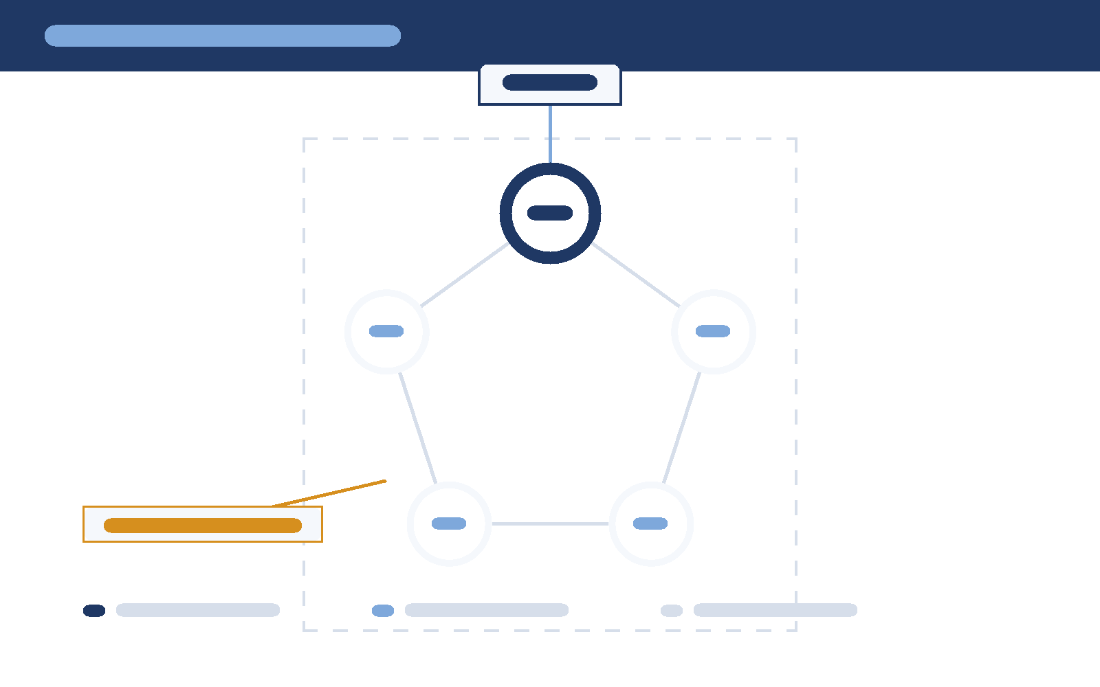
4.1 Placing quorums across failure domains

The figure shows the intended placement: the leader sits in one domain, and every quorum of three contains at least one replica outside any single domain. Text flows around the drawing because the picture is anchored to its paragraph rather than inlined.
Figure 1 Quorum placement across failure domains

4.2 Correlated failure and correlated latency
Independent failures are rare; correlated ones are ordinary. A rack reboot, a bad firmware rollout, or a congested switch take out a whole domain at once, and the latency distribution moves with them.
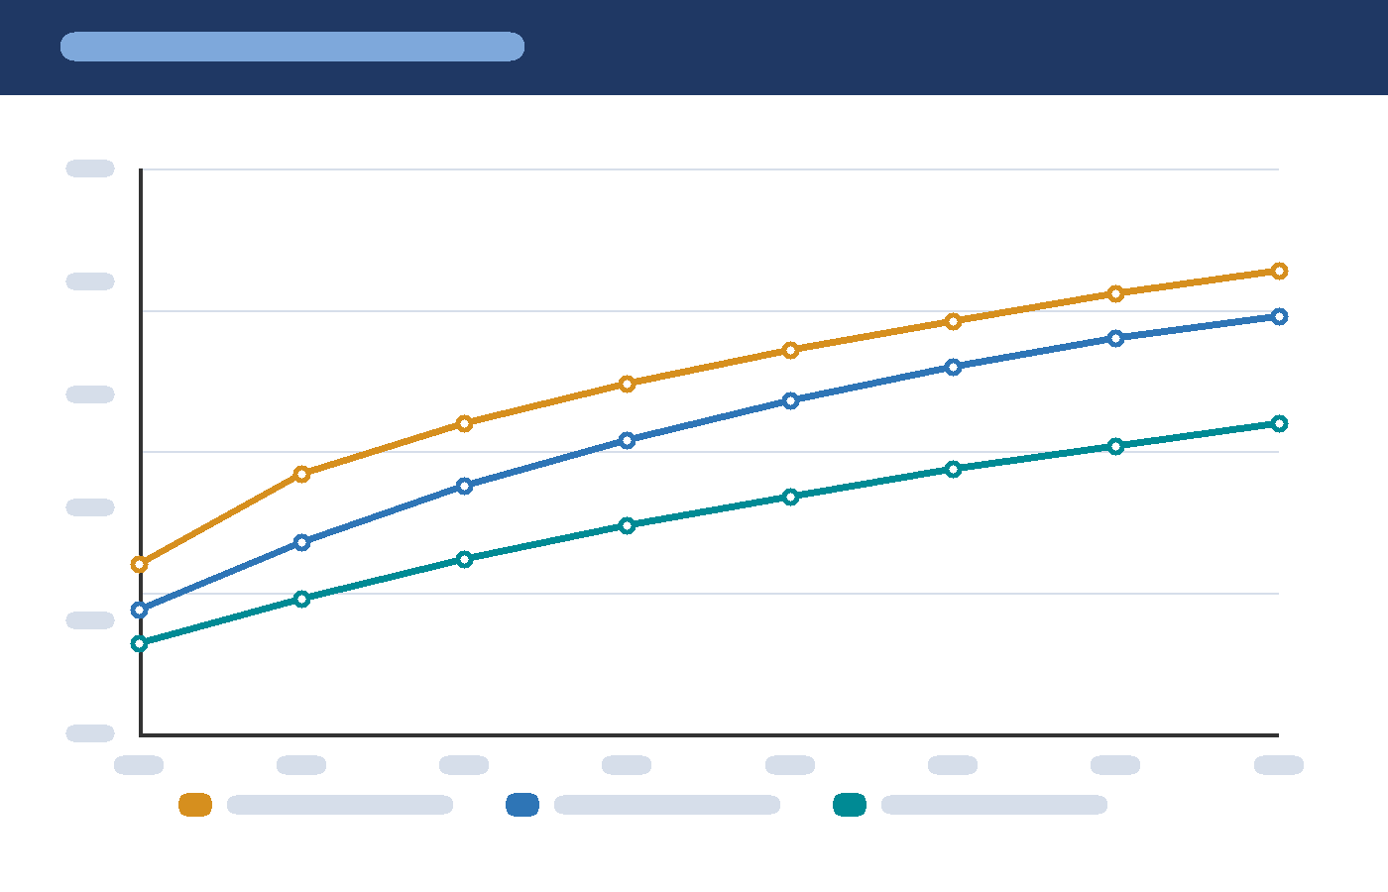
Each series is a different placement strategy. The upper curve is a single-domain group; the lower curve spreads replicas across domains. The gap widens with cluster size, which is the practical argument for placement-aware replication.
Figure 2 Commit latency against cluster size

4.3 Measuring commit latency
Instrumentation should distinguish the time a request spends waiting for a quorum from the time it spends in the client. The figure below is inlined rather than floated so that it stays with the paragraph that interprets it.
Figure 3 Write amplification in a three-node group

5 Operational Behaviour
Protocol correctness is a precondition for operations, not a substitute for them. The behaviours below are the ones that consume on-call hours.

5.1 Leader elections in practice
- The leader fails a health check and stops renewing its lease.
- Followers observe the lease expiry and start an election with a randomised timeout.
- The first candidate to collect a majority of votes becomes the new leader.
- The new leader appends a no-op entry to commit any previous term's uncommitted writes.
- Clients resume after the leader publishes its first successful append.

5.2 Snapshotting and log compaction
- Snapshots bound recovery time by replacing the log prefix with a state summary.
- Compaction garbage-collects log entries that no snapshot still references.
- Install snapshots atomically, or a crash mid-write leaves the node unable to start.
- Keep at least one snapshot per configuration term, or rollback becomes unsafe.

5.3 Linearizability checks
A linearizability checker replays the client history against a sequential specification. It finds ordering bugs that no amount of log inspection would surface, and it is the cheapest test you can add to a replication layer.

6 Editorial Revisions
The paragraphs below carry tracked revisions exactly as a review cycle would leave them: an insertion from the technical reviewer, a deletion from the editor, a character formatting change, a paragraph alignment change, and a table row added during the last pass.

6.1 Insertions and deletions
The measurement section was rewritten after the March load test,and the p99 numbers now exclude the read-repair path entirely.Accepting all revisions keeps the new wording and removes the obsolete sentence.

6.2 Formatting changes
The termcommit indexis used consistently throughout this revision.
This paragraph was left-aligned in the draft and is centred in the reviewed copy; the change itself is recorded.

6.3 An inserted table row
Revision | Summary
2.0 | Rewrote the measurement section; added the topology figure
2.1 | Added quorum arithmetic and the latency comparison

7 Review Notes
Three review comments are attached to this draft: two from the reviewer and one from the editor, and two of them carry a reply. Comments live in their own part set — comments.xml, commentsExtended.xml, commentsIds.xml, commentsExtensible.xml and people.xml — and the anchors in the body are comment range markers.
Comment anchors are invisible in the printed output but visible in the margin of Word's review pane,which is why it is safe to keep them in a distributed file.

8 Document Automation
The same field machinery drives mail merge and conditional text. The line below is a merge field with a conditional wrapper, which is the usual way to tailor a generated document to a reader segment.
Account:«Account_Name» Support tier:MERGEFIELD

9 Shapes and Text Boxes
Not every graphic in a protocol document is a chart. Warning boxes, callouts and side notes are drawn as shapes, and Word stores them in two different markup languages: DrawingML (wps:wsp) for anything written by a modern client, and VML (v:roundrect) for documents that predate it. Both appear below; the DrawingML version is the one to reach for in new files.

9.1 A DrawingML callout
DrawingML rounded rectangle (wps:wsp): quorum overlap

9.2 A legacy VML shape
VML rounded rectangle (v:roundrect): legacy markup
The two shapes above are structurally different but visually interchangeable: the DrawingML version is a DrawingML canvas inside a picture placeholder, while the VML version is a legacy drawing part with an explicit fill and stroke.

Appendix A System Comparison Matrix
The matrix below places the protocol families discussed in chapter 2 next to the quorum behaviour from chapter 3. It is laid out on a landscape page because the column set is wide.
System | Family | Leader | Log model | Quorum | Membership | Snapshots | Typical deployment
Paxos | Classic | Single | Contiguous prefix | Majority | Reconfiguration via balloting | Application-level | Storage back ends with bespoke replication
Multi-Paxos | Classic | Single, stable per term | Contiguous prefix | Majority | Reconfiguration via balloting | Application-level | General-purpose replicated logs
Raft | Modern | Strong, elected per term | Committed index with match index | Majority | Joint consensus for membership change | Built in | Databases, coordination services
EPaxos | Modern | Leaderless fast path | Arbitrary command order | Quorum by slot | Reconfiguration via fast path | Application-level | Low-latency wide replication
Viewstamped Replication | Classic | Replicated role | Replicated state machine | Quorum by view | View change | Built in | File systems and groupware

Appendix B Fields Used in This Document
Every dynamic value in this file is produced by a field. The table lists the field codes and what they drive, which makes the file a convenient reference as well as a sample.
Field | Field code | Purpose
TOC | TOC \o "1-3" \h \z \u | Table of contents from outline levels 1–3
TOC (figures) | TOC \h \z \c "Figure" | Figure index built from caption sequences
REF | REF tbl_systems \h | Cross-reference to a bookmarked caption
PAGEREF | PAGEREF tbl_systems \h | Page number of a bookmarked target
SEQ | SEQ Figure \* ARABIC | Automatic numbering of figures and tables
PAGE / NUMPAGES | PAGE · NUMPAGES | Current page and document length
STYLEREF | STYLEREF "Heading 1" | Running chapter title in the header
DATE | DATE \@ "MMMM d, yyyy" | Publication or generation date
TITLE / AUTHOR | TITLE · AUTHOR | Core document properties
FILENAME | FILENAME | Name of the file on disk
MERGEFIELD | MERGEFIELD Account_Name | Mail-merge placeholder
IF | IF { MERGEFIELD Fleet_Size } > 500 … | Conditional text driven by a merge field

Appendix C References
- Lamport, L. The Part-Time Parliament. TOCS 16, 1998.
- Fischer, M., Lynch, N. and Paterson, M. Impossibility of Distributed Consensus with One Faulty Process. JACM 32(2), 1985.
- Ongaro, D. and Ousterhout, J. In Search of an Understandable Consensus Algorithm (Raft). USENIX ATC, 2014.
- Herlihy, M. and Wing, J. Extending the Safety of Transactions. TOCS 11(2), 1993.
- Chandra, T. et al. Paxos Made Live. Google Tech Talk, 2007.

Fischer, Lynch and Paterson showed that in a fully asynchronous system, agreement cannot be achieved if even one process may crash — the impossibility result is now known simply as FLP.
Lamport's Part 1 paper is still the clearest introduction to the partial-order machinery that makes these proofs tractable.
The FLP result is about guaranteeing termination in every schedule. Practical protocols sidestep it by adding failure detectors or randomness so that progress happens under the schedules that actually occur.

