Nama : Ariyansa Yusuf Saputra

NPM : 43A87006200224

Kelas : TI / 05 / A / M

Matakuliah : Sistem Cerdas

1. Jelaskan apa yang di maksud dengan
   1. Logika samar (fuzzy logic)
   2. Logika tegas (crisp)
   3. Logika proporsi (probability)
   4. Fuzzyfication
   5. Interface system
   6. Defuzzification
2. Jelaskan apa yang dimaksud dengan
   1. Fungsi Kurva linier
   2. Fungsi Kurva Segitiga
   3. Gambarkan model kurva yang dimaksud
3. Buatkan proses fuzzy interface system (FIS) menggunakan metode Tsukamoto dengan studi kasus sebagai berikut
4. **Diketahui & Ditanyakan (ABSEN 20)**

|  |  |  |
| --- | --- | --- |
| I | Diketahui : |  |
|  | PERMINTAAN TERBESAR (pb1) | 103.100 |
|  | PERMINTAAN TEKECIL (pb2) | 101.150 |
|  | PERSEDIAAN BANYAK (py3) | 99.510 |
|  | PERSEDIAAN SEDIKIT (ps4) | 99.120 |
|  | PRODUKSI BERKURANG (pk5) | 100.250 |
|  | PRODUKSI BERTAMBAH (ph6) | 104.100 |
| II | Pertanyaan : |  |
|  | PERMINTAAN (pmt) | 101.500 |
|  | PERSEDIAAN (psd) | 99.250 |
| III | Permintaan : |  |
|  | uPERMINTAAN_TURUN (ptx) | ?? |
|  | uPERMINTAAN_NAIK (pnx) | ?? |
| IV | Persediaan (y) |  |
|  | uPERSEDIAAN_SEDIKIT (psy) | ?? |
|  | uPERSEDIAAN_BANYAK (pby) | ?? |
| V | Predikat (a) |  |
|  | [R1]=IF PERMINTAAN TURUN And  PERSEDIAAN BANYAK THEN PRODUKSI BERKURANG | ?? |
|  | [R2]=IF PERMINTAAN TURUN And  PERSEDIAAN SEDIKIT THEN PRODUKSI BERKURANG | ?? |
|  | [R3]=IF PERMINTAAN NAIK And  PERSEDIAAN BANYAK THEN PRODUKSI BERTAMBAH | ?? |
|  | [R4]=IF PERMINTAAN NAIK And  PERSEDIAAN SEDIKIT THEN PRODUKSI BERTAMBAH | ?? |
| VI | Perhitungan Nilai (z) |  |
|  | Total | ?? |

1. **Derajat Keanggotaan Permintaan (x)**

|  |  |  |  |  |
| --- | --- | --- | --- | --- |
| **Permintaan** | **Terkecil** | **Terbesar** |  | **Ditanyakan** |
|  | 101.150 | 103.100 |  | 101.600 |

1. **µPermintaan Turun ?**

|  |  |  |  |  |  |  |
| --- | --- | --- | --- | --- | --- | --- |
| Linier | Rumus |  |  |  | Jumlah | Hasil |
| **Turun** | **b - x** | **103.100** | **-** | **101.600** | **1.500** | **0,77** |
| **b - a** | **103.100** | **-** | **101.150** | **1.950** |

1. **µPermintaan Naik ?**

|  |  |  |  |  |  |  |
| --- | --- | --- | --- | --- | --- | --- |
| Linier | Rumus |  |  |  | Jumlah | Hasil |
| **Naik** | **x - a** | **101.600** | **-** | **101.150** | **450** | **0,23** |
| **b-a** | **103.100** | **-** | **101.150** | **1.950** |

1. **Derajat Keanggotaan Persediian (y)**

|  |  |  |  |  |
| --- | --- | --- | --- | --- |
| **Persediaan** | **Terkecil** | **Terbesar** |  | **Ditanyakan** |
|  | 99.120 | 99.510 |  | 99.250 |

1. **µPersediaan Sedikit ?**

|  |  |  |  |  |  |  |
| --- | --- | --- | --- | --- | --- | --- |
| Linier | Rumus |  |  |  | Jumlah | Hasil |
| **Sedikit** | **b - x** | **99.510** | **-** | **99.250** | **260** | **0,67** |
| **b - a** | **99.510** | **-** | **99.120** | **390** |

1. **µPersediaan Banyak ?**

|  |  |  |  |  |  |  |
| --- | --- | --- | --- | --- | --- | --- |
| Linier | Rumus |  |  |  | Jumlah | Hasil |
| **Banyak** | **x - a** | **99.250** | **-** | **99.120** | **130** | **0,33** |
| **b - a** | **99.510** | **-** | **99.120** | **390** |

1. **Nilai Predikat (α)**

|  |  |  |
| --- | --- | --- |
| **Produksi** | **Terkecil** | **Terbesar** |
|  | 100,250 | 104,100 |

|  |  |  |  |  |  |
| --- | --- | --- | --- | --- | --- |
| Linier | Rumus |  |  |  | Jumlah |
| **Kurang** | **b - x** | **104.100** | **-** | **X** | **104.100 - x** |
| **b - a** | **104.100** | **-** | **100.250** | **3.850** |

|  |  |  |  |  |  |
| --- | --- | --- | --- | --- | --- |
| Linier | Rumus |  |  |  | Jumlah |
| **Tambah** | **x - a** | **x** | **-** | **100.250** | **X – 100.250** |
| **b - a** | **104.100** | **-** | **100.250** | **3.850** |

**R1 = IF PERMINTAAN TURUN AND PESEDIAAN BANYAK then PRODUKSI BERKURANG**

|  |  |  |  |  |  |  |
| --- | --- | --- | --- | --- | --- | --- |
| **ᵟ1 =** | **min(** | **0,77** | **:** | **0,33** | **)** |  |
| min = | **0,33** |  |  |  |  |  |
|  | **X1 =** | b – x | = | 0,33 |  |  |
|  | b – a |  |  |
|  |  | 104.100 - x | = | 0,33 |  |  |
|  |  | 3.850 |  |  |
|  |  | 104.100 - x | = | 0,33 | * | 3.850 |
|  |  | 104.100 - x | = | 1270,5 |  |  |
| 104.100 | - | 1270,5 | = | x |  |  |
|  |  | **102.829,5** | = | **x** |  |  |

**R2 = IF PERMINTAAN TURUN AND PESEDIAAN SEDIKIT then PRODUKSI BERKURANG**

|  |  |  |  |  |  |  |
| --- | --- | --- | --- | --- | --- | --- |
| **ᵟ2 =** | **min(** | **0,77** | **:** | **0,67** | **)** |  |
| min = | **0,67** |  |  |  |  |  |
|  | **X2 =** | b - x | = | 0,67 |  |  |
|  | b - a |  |  |
|  |  | 104.100 - x | = | 0,67 |  |  |
|  |  | 3.850 |  |  |
|  |  | 104.100 - x | = | 0,67 | * | 3.850 |
|  |  | 104.100 - x | = | 2.579,5 |  |  |
| 104.100 | - | 2.579,5 | = | x |  |  |
|  |  | **101.520,5** | = | x |  |  |

**R3 = IF PERMINTAAN NAIK AND PESEDIAAN BANYAK then PRODUKSI BERTAMBAH**

|  |  |  |  |  |  |  |
| --- | --- | --- | --- | --- | --- | --- |
| **ᵟ3 =** | **min(** | **0,23** | **:** | **0,33** | **)** |  |
| min = | **0,23** |  |  |  |  |  |
|  | **X3 =** | x – a | = | 0,23 |  |  |
|  | b - a |  |  |
|  |  | x – 100.250 | = | 0,23 |  |  |
|  |  | 3.850 |  |  |
|  |  | x – 100.250 | = | 0,23 | * | 3.850 |
|  |  | x – 100.250 | = | 885,5 |  |  |
|  |  | x | = | 100.250 | + | 885,5 |
|  |  | **x** | **=** | **101.135,5** |  |  |

**R4 = IF PERMINTAAN NAIK AND PESEDIAAN SEDIKIT then PRODUKSI BERTAMBAH**

|  |  |  |  |  |  |  |
| --- | --- | --- | --- | --- | --- | --- |
| **ᵟ4 =** | **min(** | **0,23** | **:** | **0,67** | **)** |  |
| min = | **0,23** |  |  |  |  |  |
|  | **X4 =** | x - a | = | 0,23 |  |  |
|  | b - a |  |  |
|  |  | x – 100.250 | = | 0,23 |  |  |
|  |  | 3.850 |  |  |
|  |  | x – 100.250 | = | 0,23 | * | 3.850 |
|  |  | x – 100.250 | = | 885,5 |  |  |
|  |  | x | = | 100.250 | + | 885,5 |
|  |  | **x** | **=** | **101.135,5** |  |  |

1. **Grafik Derajat Keanggotaan (µx) Masing R1, R2, R3, R4**

* **R1**

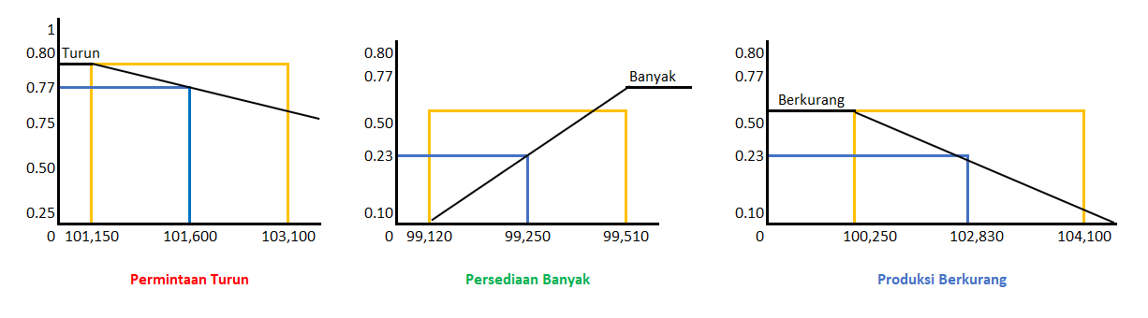

* **R2**

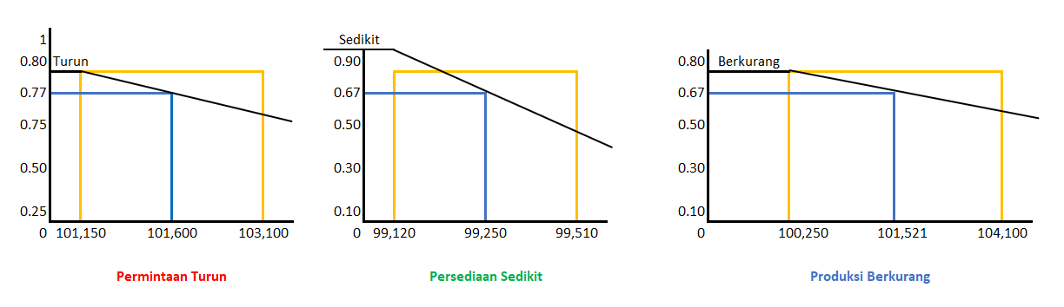

* **R3**

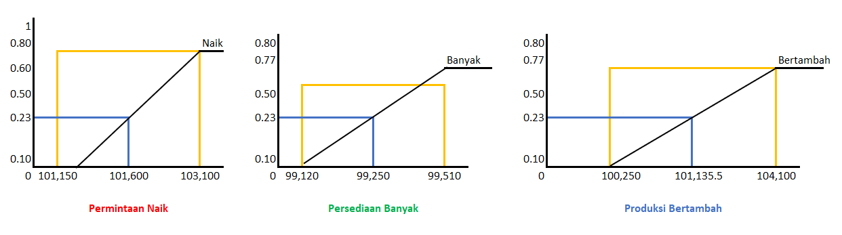

* **R4**

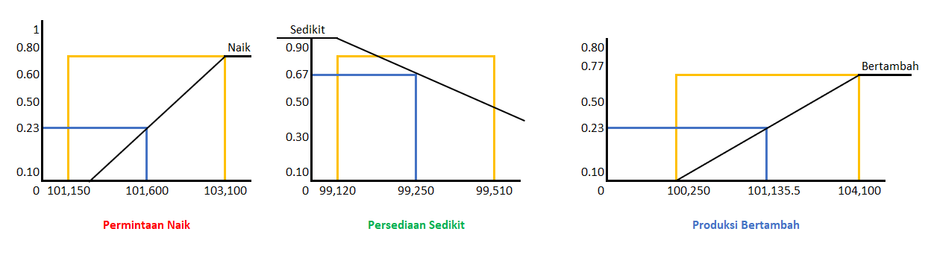

1. **Berapakah Nilai Produksi (z) ?**

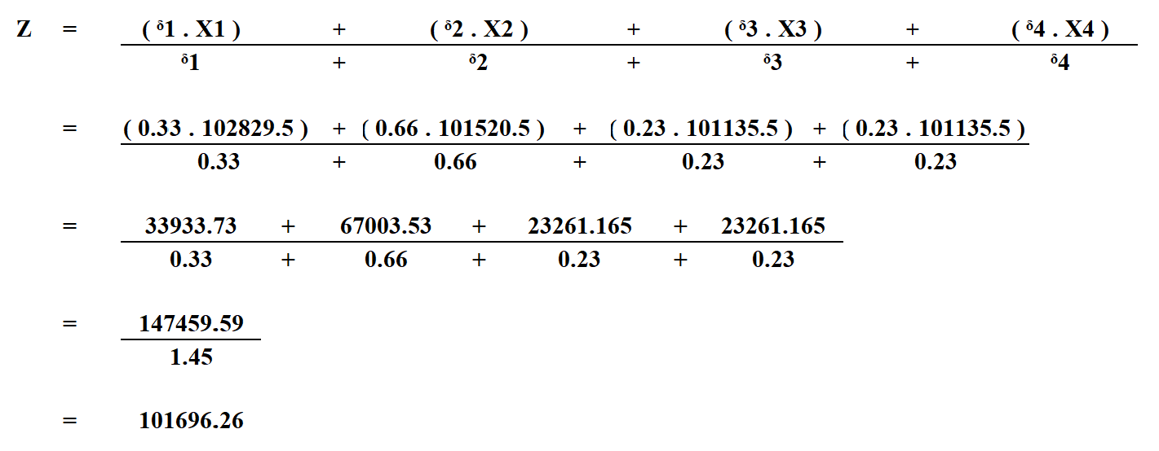

1. **Kesimpulan**

|  |  |  |  |  |
| --- | --- | --- | --- | --- |
|  |  |  |  |  |
|  | I | Diketahui : |  |  |
|  |  | PERMINTAAN TERBESAR (pb1) | 103,100 |  |
|  |  | PERMINTAAN TEKECIL (pb2) | 101,150 |  |
|  |  | PERSEDIAAN BANYAK (py3) | 99,510 |  |
|  |  | PERSEDIAAN SEDIKIT (ps4) | 99,120 |  |
|  |  | PRODUKSI BERKURANG (pk5) | 100,250 |  |
|  |  | PRODUKSI BERTAMBAH (ph6) | 104,100 |  |
|  | II | Pertanyaan : |  |  |
|  |  | PERMINTAAN (pmt) | 101,500 |  |
|  |  | PERSEDIAAN (psd) | 99,250 |  |
|  | III | Permintaan : |  |  |
|  |  | uPERMINTAAN_TURUN (ptx) | 0.77 |  |
|  |  | uPERMINTAAN_NAIK (pnx) | 0.23 |  |
|  | IV | Persediaan (y) |  |  |
|  |  | uPERSEDIAAN_SEDIKIT (psy) | 0.67 |  |
|  |  | uPERSEDIAAN_BANYAK (pby) | 0.33 |  |
|  | V | Predikat (a) |  |  |
|  |  | [R1]=IF PERMINTAAN TURUN And  PERSEDIAAN BANYAK THEN PRODUKSI BERKURANG | 102829.5 |  |
|  |  | [R2]=IF PERMINTAAN TURUN And  PERSEDIAAN SEDIKIT THEN PRODUKSI BERKURANG | 101,520.5 |  |
|  |  | [R3]=IF PERMINTAAN NAIK And  PERSEDIAAN BANYAK THEN PRODUKSI BERTAMBAH | 101,135.5 |  |
|  |  | [R4]=IF PERMINTAAN NAIK And  PERSEDIAAN SEDIKIT THEN PRODUKSI BERTAMBAH | 101,135.5 |  |
|  | VI | Perhitungan Nilai (z) |  |  |
|  |  | Total | 101696.26 |  |
|  |  |  |  |  |