**Lab 3**

**PseudoCode**

Purpose - Using if else & case statements , loops to print number within range of 1 through 10

Input - Integer

Processing - CASE statement to determine corresponding roman numeral

Output - Display a correct message or error message

**Flowchart**



**Output**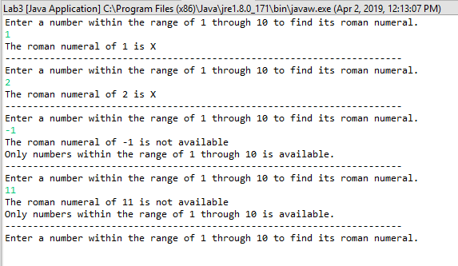

**Code**

**import** java.util.Scanner;

**public** **class** Lab3 {

**public** **static** **void** main(String[] args) {

Scanner number = **new** Scanner(System.***in***);

**for** (**int** i = 0; i <= 10 ; i ++) {

System.***out***.println("Enter a number within the range of 1 through 10 to find its roman numeral.");

**int** input = number.nextInt();

**if** (input >= 1 || input <= 10) {

String romanNumeral = "";

**switch** (input) {

**case** 1:

romanNumeral = "I";

**case** 2:

romanNumeral = "II";

**case** 3:

romanNumeral = "III";

**case** 4:

romanNumeral = "IIII";

**case** 5:

romanNumeral = "V";

**case** 6:

romanNumeral = "VI";

**case** 7:

romanNumeral = "VII";

**case** 8:

romanNumeral = "VIII";

**case** 9:

romanNumeral = "IX";

**case** 10:

romanNumeral = "X";

**case** 1-10:

System.***out***.println("The roman numeral of " + input + " is " + romanNumeral);

System.***out***.println("-----------------------------------------------------------------------");

**break**;

}

**if** (input < 1 || input >10) {

System.***out***.println("The roman numeral of " + input + " is not available" );

System.***out***.println("Only numbers within the range of 1 through 10 is available.");

System.***out***.println("-----------------------------------------------------------------------");

}

// Using only If Else Statement

//

// if (input == 1) {

// romanNumeral = "I";

// System.out.println("The roman numeral of " + input + " is " + romanNumeral);

// System.out.println("-----------------------------------------------------------------------");

// } else if(input == 2) {

// romanNumeral = "II";

// System.out.println("The roman numeral of " + input + " is " + romanNumeral);

// System.out.println("-----------------------------------------------------------------------");

// } else if(input == 3) {

// romanNumeral = "III";

// System.out.println("The roman numeral of " + input + " is " + romanNumeral);

// System.out.println("-----------------------------------------------------------------------");

// } else if(input == 4) {

// romanNumeral = "VI";

// System.out.println("The roman numeral of " + input + " is " + romanNumeral);

// System.out.println("-----------------------------------------------------------------------");

// } else if(input == 5) {

// romanNumeral = "VI";

// System.out.println("The roman numeral of " + input + " is " + romanNumeral);

// System.out.println("-----------------------------------------------------------------------");

// } else if(input == 6) {

// romanNumeral = "VI";

// System.out.println("The roman numeral of " + input + " is " + romanNumeral);

// System.out.println("-----------------------------------------------------------------------");

// } else if(input == 7) {

// romanNumeral = "VII";

// System.out.println("The roman numeral of " + input + " is " + romanNumeral);

// System.out.println("-----------------------------------------------------------------------");

// } else if(input == 8) {

// romanNumeral = "VIII";

// System.out.println("The roman numeral of " + input + " is " + romanNumeral);

// System.out.println("-----------------------------------------------------------------------");

// } else if(input == 9) {

// romanNumeral = "IX";

// System.out.println("The roman numeral of " + input + " is " + romanNumeral);

// System.out.println("-----------------------------------------------------------------------");

// } else if(input == 10) {

// romanNumeral = "X";

// System.out.println("The roman numeral of " + input + " is " + romanNumeral);

// System.out.println("-----------------------------------------------------------------------");

// }

}

}

System.*exit*(0);

}

}