QCLs BAND STRUCTURE CALCULATION GUIDE
QEBS 1.0

- Simulation Tasks

  - The initial task of any QCLs design is subband structure engineering.
  - Given the quantum cascade structure, all quantum states are solved.
  - Energy levels and corresponding wave functions are computed for all quantum states.
  - Identify critical states according to design ideas such as the so-called 3-level design, bound-to-continuum design, two phonon resonance design …
- Procedures
      - Step 1: Setup the 1D band structure profile
        - Choose the solution domain. You should choose an “injector/active/injector” region of QCLs structure.
        - Go to the mode.m file. Declare the width of the barriers as well as the wells for whole solution domain.

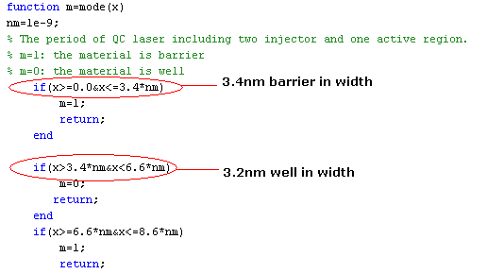

      - Step 2: Parameters declaration
        - Band offset and bias applied field: Go to V.m file to input the band offset V0 and bias field F of the simulated QCLs.

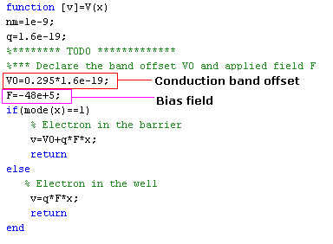
        - Electron effective mass: Declare the electron effective mass of the barrier and the well in mass.m file.
      - Step 3: Number of node points and simulation implementation
        - Go to the EigSolve.m file to declare the number of node points n and the length of solution domain L.

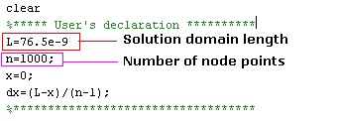
        - Run the simulation.
      - Step 4: Quantum states identification
        - Identify and label states belonging to injector or active region, based on the shape and location of wave functions and their respective energy levels.

