Title Page

Agua: a cloud bioinformatics workflow platform

Abstract

The increasing availability of huge volumes of genomic data has given rise to a crisis of reliance upon computational approaches that are scarcely reproducible and barely accessible. A lack of bioinformatics tools, personnel, workflow standards and computational power hinders the execution and replication of experiments by genomics researchers. This problem is exacerbated as genomic analysis spreads to life sciences disciplines where researchers are even less accustomed to high-throughput approaches. Agua http://www.aguadev.org lowers these technology barriers by providing a flexible, end-to-end cloud bioinformatics workflow solution, from data provenance and management to genomic visualization.

Keywords

NGS, cloud, bioinformatics, workflows, visualization, version control, JSON.

Article subdivisions

Introduction

Bioscience is increasingly a quantitative analysis activity requiring the computational processing and interpretation of massive data sets. Biological data sets have multiplied to over 1,380 major Internet data sources in 2012. These sources are mostly simple websites with limited data format compatibility between them even though researchers often need to combine data from multiple sites to generate bioinformatics analyses. Workflow-based tools solve this problem by generating large and complex systems from collections of programs, data sources and structured data services. As the $1,000 genome approaches, genomic data volumes will increase and the bottleneck will shift to data integration, e.g., clinical with genomic, and responding to the question: How can we understand this data? Agua helps address this problem by providing a user-centric open-source platform that facilitates sharing of workflows and interpretation of results.

The availability of common tools to enable the comparison of results from different data sets paradoxically underscores the difficulty faced by scientists without programming experience. Software libraries such as Bioperl, Biopython and Bioconductor, and bioinformatics toolkits such as EMBOSS are valuable contributions in terms of content and approach. They do not provide a more generalized solution to allow scientists with little or no informatics skills to run well-defined workflows or generate novel workflows with new computational tools.
Workflow Standards
BioExtract, KNIME, Galaxy, GenePattern, GeneProf, Mobyle, and Pegasus are among the most noteworthy attempts to provide a generalized solution for automated bioinformatics workflows. They are standalone or web applications that provide interactive tools for scientists to execute workflows using predefined tools and view their results in real-time. Galaxy and BioExtract also allow the user to save workflows and share data by providing web access to application-specific data objects. These data object formats are not widely adopted nor are they interchangeable with workflow data from other applications.
It is also important to note that the need for 'industry standard' workflows may have been overestimated. Genome scientists appear to be resisting the imposition of canonical data analysis methods. For example, the 1000 Genomes Project is a multinational effort to map genetic variation in major population groups around the world and is arguably the most celebrated large-scale NGS project to date. The project provides well-documented procedures for data analysis. However, only ten out of 299 papers published in 2011 that explicitly cite the project actually used the tools recommended by the consortium for mapping and variant discovery. This suggests a more pressing need for establishing standards for reporting workflows than for establishing standard workflows.
Agua proposes a standardized workflow description format based on JSON and leveraging the Git version control system to provide workflow provenance. Using Agua, scientists can develop a workflow from scratch to finish while generating a series of snapshots of the workflow in the form of a JSON-format workflow file. These workflow creation steps are synchronized to a repository on Github, BitBucket or a similar Git repository service provider. This version history can be stored as desired to a private repository or published to a public repository which can be referenced in a scientific paper. This simplifies the process of sharing and reusing workflows, maximizes transparency and allows scientists to easily evaluate and reproduce each other's research.

In the response to this tendency towards a heterogeneity of computational approaches, Agua provides a smooth, user-centric interface that enables scientists to easily add new applications and use these applications to create workflows and share their own custom workflows.

The User-Centric Experience
Previous workflow GUIs had drawbacks such as difficulty navigating and searching, having to navigate back and forth between forms and results, user difficulty keeping track of past actions, insufficient documentation of application options and ambiguities concerning data storage. Agua is designed to minimize these drawbacks and maximize 'traction' in the user experience by providing a highly intuitive and transparent interface.
Agua's design focuses on empowering the domain-specific view of scientists rather than enforcing canonical workflows or optimizing job scheduling. This paradigm focuses allowing the scientist easy access to import the data types, tools and distributed resources that are most suitable for their particular research domain.

EMBOSS Ajax Command Definition file defines which parameters and qualifiers can appear on the command line.

Galaxy helps to address this crisis by providing an open, web-based platform for performing accessible, reproducible, and transparent genomic science. Not following tested practices undermines the quality of biomedical research, limiting its potential. Perplexingly,

The problem of accessibility of computational tools has long been recognized. Without programming or informatics expertise, scientists needing to use computational approaches are impeded by problems ranging from tool installation; to determining which parameter values to use; to efficiently combining multiple tools together in an analysis chain. The severity of these problems is evidenced by the numerous solutions to address them. Tutorials [4,5], software libraries such as Bioconductor [6] and Bioperl [7], and web-based interfaces for tools [8,9] all improve the accessibility of computation. These approaches each have advantages, but do not offer a general solution that enables a computational tool to be easily included in an analysis chain and run by scientists without programming experience.

Genomics plays a part in nine of the ten leading causes of death in the United States.

However, the majority of bioinformatics workflow tools only partially realize the potential of the available data and application resources.

Workflow tools enable users to automate well-defined processes and explore data using ad-hoc analyses.

and sharing of rof on increasingly the quantitative analysis of the results of complex computational pipelines.

Let us address these three requirements: access, reproducibility and ease of use.

Invented the Agua (Automated Genomics Utilities Agent) cloud workflow platform for NextGen sequencing bioinformatics in the Amazon Elastic Compute Cloud (EC2) to enable researchers to conduct sequencing experiments. Re

Completed beta release of Agua cloud workflow platform, significantly augmenting its functionality with the addition of an automated upgrade system, GitHub synchronization using a novel generic workflow annotation format, improved web application responsiveness, a streamlined user interface and an integrated package management system based on a proposed Open Package Schema.

The Galaxy analysis environment is made possible by the model Galaxy uses for integrating tools. A tool can be any piece of software (written in any language) for which a command line invocation can be constructed. To add a new tool to Galaxy, a developer writes a configuration file that describes how to run the tool, including detailed specification of input and output parameters. This specification allows the Galaxy framework to work with the tool abstractly, for example, automatically generating web interfaces for tools as described above. Although this approach is less flexible than working in a programming language directly (for researchers that can program), it is this precise specification of tool behavior that serves as a substrate for making computation accessible and addressing transparency and reproducibility, making it ideal for command-line averse biomedical researchers.

Aqwa provides a complete environment for data input and management, custom workflow generation and data sharing. Users can manage workflows (create/delete/copy workflows, add applications, set application parameters) and run them as automated pipelines that are saved to their project folders. Access to each project folder is configurable by the individual users. Output such as predicted SNPs, reference alignments and other genome-related data can be filtered using the configurable Report tool and viewed in the Ajax-based genome viewer designed to cope with large volumes of NextGen data and allow interactive interrogation of the data to determine patterns and relations with previously identified genomic features.

Introduction

Agua is a data analysis workflow tool designed to run on the Amazon EC2 cloud. Agua is a bioinformatics analysis platform for Next Generation Sequencing but can be used as a workflow tool for all Linux-supported command-line applications.

Users can flexibly create groups, add members to groups and share data analysis pipelines and results with group members. Multi-level access privileges can be allocated to group members and to users in the general public.

Users can also add new applications easily to the existing suite of applications. These custom applications can be configured to 'recognize' their inputs from the outputs of preceding applications in a workflow.

Agua workflows can be run locally on the head node (where Agua is installed) or on StarCluster cloud node clusters. Once a cluster workflow is started, the StarCluster begins to auto-scale itself, adding new nodes to the cluster when the number and average duration of jobs is high and removing nodes when demand slacks off. The user can preconfigure the minimum and maximum number of nodes for each StarCluster tailored to each workflow. The user can also change the minimum and maximum number of nodes while the workflow is in progress to best suit their budget and time constraints.

Using Agua's default pipelines, Next Generation Sequencing data can be processed and viewed in the built-in JBrowse genome viewer. JBrowse employs the same technology as Google-Maps to allow the user to scan through the genome, zooming in and out in real time.

Development of a NextGen workflow and visualization tool
As bioscience becomes increasingly a quantitative analysis activity, workflow tools enable users to accomplish two main tasks: 1) automating well-defined, repetitive processes and 2) exploring data with ad-hoc analyses (16). The few studies on common bioinformatics tasks and usability of bioinformatics tools (17) identified an urgent need among bioscience researchers for workflow-based tools. There are over 200 major Internet biological data sources however these sites are mostly simple GUIs (Graphical User Interfaces) with limited data compatibility between them despite the fact that researchers often need to combine the outputs of multiple sites to generate bioinformatics analyses. These resources may be underexploited if users feel too much time is used navigating the sites, selecting among appropriate sources, downloading and uploading files. Workflow tools can solve this problem by generating large and complex systems from collections of programs, data sources and even structured data services. However, the majority of bioinformatics workflow tools only partially realize the potential of the available data and application resources (Figure 2). With notable exceptions (18), there has been limited progress in connecting different sites with the client as the intermediary. Another approach is to use a central site as a service directory lookup such as BioMOBY and TAVERNA with the limitation that service discovery relies upon the accurate and uniform description of biological data types and relations between them, for which there is no commonly-accepted ontology (19-21) or language, despite some developments (22).
Data visualization and interpretation become paramount as the bioinformatics challenge shifts from mastering the basic tools to gaining biological insights from huge amounts of data. Three commercial software packages by DNAStar, SoftGenetics and CLC Bio provide data viewers that allow the user to see read alignments, coverage depth, genome annotations, and variant analysis. However, they lack the capability for viewing data sets as large as a whole human chromosome and show poor performance even on sub-chromosome data sets. The three major publicly available genome viewers, UCSC Genome Browser, Ensembl genome browser and GBrowse, are based on the traditional client-server model where the user’s requested data is reloaded as an image file delivered from the server. Java-based applications such as Apollo are more interactive but lack a concerted approach to data sharing. Most do not allow the user to filter the displayed data set based on biological criteria, although some newer applications such as IGV (http://www.broad.mit.edu/igv/) allow for limited filtering of the displayed features. Figure 2 lists the capabilities that a fully functional workflow tool and genome viewer must possess and shows the gaps in functionality of the currently available tools. We propose to provide all of this functionality in an integrated workflow tool and genome viewer.
The Approach
We propose to address the abovementioned bioinformatics challenges, namely the development of 1) improved NextGen sequence assembly workflows, 2) optimized genomic variation and expression workflows, and 3) a NextGen workflow and visualization tool with the following approaches:
Specific Aim 1: Develop and implement an optimized NextGen assembly workflow
We propose carrying out an objective evaluation of current NextGen assemblers/aligners using artificial data sets based on human biological samples in which each read’s position is known a priori in order to accurately compare results between different algorithms. Performance criteria will be established before testing based on the particular difficulties of assembling short reads derived from human genomic material. One or more optimized assembly workflows maximizing the performance criteria will be created as push-button tools to generate assemblies and associated quality control information. These workflows will also be customizable by the biologist/researcher to suit particular desired quality metrics or to meet any necessary tradeoffs between different quality metrics.
A combination of different assemblies may provide more reliable estimates of genetic aberrations by flagging dubious assembly regions that are not represented in a majority of the different assemblies. Conversely, regions that are matched identically by a majority of the different algorithms might be accorded greater confidence with regard to their predicted SNPs, indels and breakpoints. We will attempt to prove or disprove these hypotheses in the second step of specific aim 1 by using artificial reads generated from approximately 100 human sequence samples selected from the SRA (Short Read Archive http://www.ncbi.nlm.nih.gov/Traces/sra/sra.cgi). A comparison study of this scale has never before been attempted. Samples from individuals with sequences from all three NextGen sequencing platforms will be selected based on coverage depth, the presence of family member samples and the availability of additional genomic analyses such as microarrays in order to detect anomalies and discriminate between differing sequence assembly results.
Specific Aim 2: Develop and implement NextGen genomic variation and expression analysis workflows
To meet the need for comprehensive diagnostic evaluations of genomic variation in multiple genes, we propose the development of discovery and annotation workflows for three kinds of variation: SNPs, CNVs and large-scale genomic variation (chromosomal indels, inversions and dislocations). We will conduct three consecutive studies using biological samples from several human diseases to determine optimal methods for the prediction, filtering and verification of these different genomic variations. The novelty of our approach lies in the fact that these workflows will include defined quality control/assurance algorithms, and the use of pedigree information and statistical techniques for predicting heterozygote/homozygote calls. We will develop a methodology for estimating erroneous SNP calls and predicting homozygote and heterozygote genotypes using Roche/454 reads derived from Nimblegen exome capture samples (Figure 3). The initial experimental subjects are an extended family of 8 individuals, including 4 with a heritable neurodegenerative disorder. Initial SNP filtering and annotation will be carried out using read quality, read coverage, presence of read coverage in other sample members, presence in dbSNP, HapMap and the Venter and Watson genomes. We will validate our approach with a sample of 1,000 individuals on a smaller subset of captured genomic regions. This analysis is being carried out in partnership with the MIHG (Miami Institute for Human Genomics). Further joint studies with the MIHG are anticipated involving the analysis of SNPs, large-scale variation and copy number variation in metabolic disorders, cancer, and cardiovascular disease.
We propose enabling the integration into the variation analysis workflows of existing algorithms for determining the relationship between genomic variation and disease. These include GWAS studies and combinations of SNP, CNV and gene expression data with disease phenotypes in different human tissues and for different disease states. Many of these methods have not yet been applied to NextGen data and comparing the results of several methods will allow us to confirm associations between cis- or trans-acting genomic variations, expression phenotypes and disease.
In addition to the variation workflows, we propose the development of an optimized workflow for expression analysis. This workflow will be integrated with current expression analysis packages such as ERANGE (4) and will include new expression analysis algorithms to improve quantization of transcript counts (Figure 3). One approach that will be evaluated for inclusion in the workflow is the use of ‘standard gene sets’ or other transcribed regions with stable copy numbers across tissue types that can be used to calibrate the relative expression levels of genes and estimate absolute copy numbers per cell between different tissue samples.

Another unique feature of our approach is that, as part of the reporting and visualization of results, data filters will be designed based on user requirements to extract result subsets and provide genome-level views of the results integrated with external genomic features. Results will also be exportable to downstream analysis applications (Cytoscape, Genespring, R, etc.).
Specific Aim 3: Develop a NextGen workflow and visualization tool
Based on the requirements in Aims 1 and 2, we propose the implementation of a novel bioinformatics tool providing end-to-end integrated NextGen analysis workflows, reporting and real-time visualization of huge genomic data sets. The tool, named Aqwa (Automated Query and Workflow Agent), will provide pre-optimized workflows for NextGen assembly, genomic variation and expression analysis, and will also allow users to create their own customized workflows. The software development process will implement a user-centric approach including extensive user testing at each project milestone and intervening iterations. Our emphasis on user testing and user-centric development, which differs from all previous bioinformatics workflow tools, is designed to ensure that the user interface is as intuitive as possible.
Aqwa is designed so that only a basic familiarity with web page navigation and drag and drop user interfaces is required of the user. Unlike other existing workflow systems, Aqwa will also support the addition of new Linux-platform applications in a “plug ‘n play” and scalable manner in order to flexibly adapt to changing computational needs and rapidly evolving bioinformatics challenges. The following list of requirements and functional criteria encompasses the functionality envisaged for Aqwa.

Functional Requirements
- Low barriers to usage
  - Web access
  - User-friendly, intuitive interface
  - “Plug ‘n play” applications for rapid deployment
  - Searchable project annotations
- Workflows
  - Predefined workflows (transcriptome, variation annotation, gene networks, file conversion utilities, ID conversion utilities, etc.)
  - Customizable workflows
  - Drag ‘n drop workflows
  - Persistent data and workflow configurations
  - Loops, conditional branching
- Reports - customizable report extraction from workflow output
- Views
  - Customizable genomic views of report data
  - Interactive display with rich context menu
  - Integrated, extensible genomic features
  - Multiple feature views – nucleotide level to aggregate high-level view
  - Fast view update
  - User can filter view based on data
  - Genomic feature-level annotation by user
- Sharing
  - User-defined groups with customizable permissions
  - Workflow, report and view sharing among groups
- Input/Output and execution
  - Import external biological data and genomic features into workflow
  - Integration with external software (e.g., Cytoscape, R, GeneSet Analyzer)
  - Programmatic remote access (API and Web Service)
  - Cluster execution
  - Grid execution
- Maintain state (action history)
- Data management – direct user access to input and output files
Information regarding data provenance is retained in the system to identify the source of data throughout the workflow such as the owner, author application, creation and modification dates, and content type. In addition, a log is kept of all project changes and updates. The user can also annotate the project at all levels and search these annotations. Aqwa is similar to the laboratory notebook paradigm employed by the BCJ (Bioinformatics Computational Journal) workflow tool but has a wider the range of functionality. Aqwa’s functional requirements largely encompass those for a proposed ‘genome wiki’ (23) intended to facilitate cooperative genome annotation by a community of experts, reflecting Aqwa’s utility to the wider genomics community as an accurate, continually updated source of genome annotation. Aqwa’s genome viewer functionality incorporates the AJAX-enabled JBrowse genome viewer (http://jbrowse.org) to provide a fast, fluid and responsive genome browser interface (Figure 4).

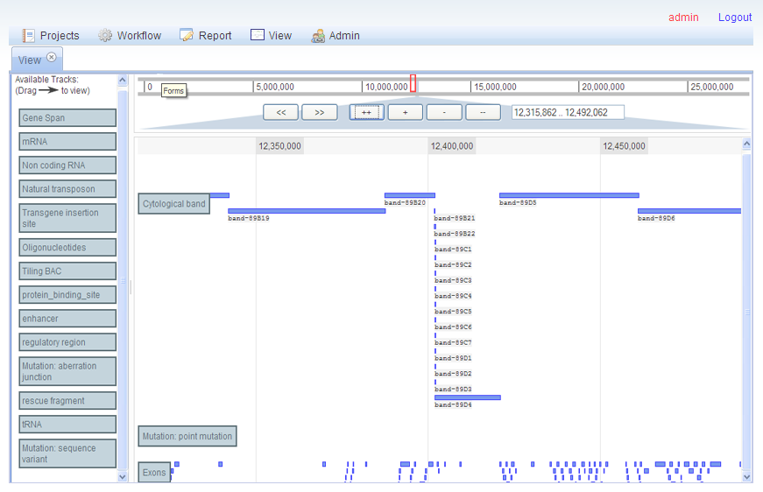
Figure 4. Aqwa’s Jbrowse-based allows drag ‘n drop feature selection and real-time zooming and panning.
From the user’s perspective, designing customizable workflows can be a daunting prospect due to the complexity of inputs for bioinformatics applications. Help information is displayed for each application linked to the University of Miami’s online bioinformatics information services portal (http://bio.ccs.miami.edu/ibis) and an automatic syntax checker ensures that application inputs are sufficient and correct. In addition, each application object contains methods that automatically derive its input arguments from the resources and outputs of preceding applications in the workflow. In the web interface, each application in a workflow is represented as a block with required input parameters and outputs (Figure 5).
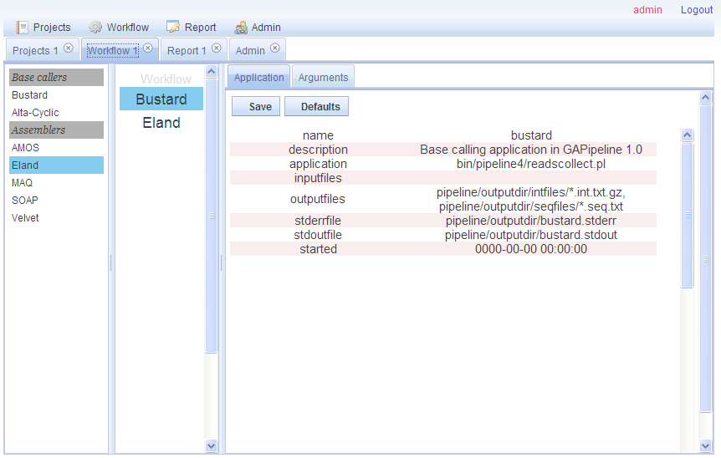
Figure 5. Workflows are created by dragging applications from the left toolbar into the center pane. Users can choose to use the default automated argument settings or manually configure applications in the right pane.

For advanced users, Aqwa provides a file manager which allows direct access and drag ‘n drop manipulation of the file system of each workflow (Figure 6), rather than solely an abstract data interface such as in the BCJ. This is an optional function, which provides the benefits of fine control of workflows for power users without the burden of increased complexity for less advanced users.
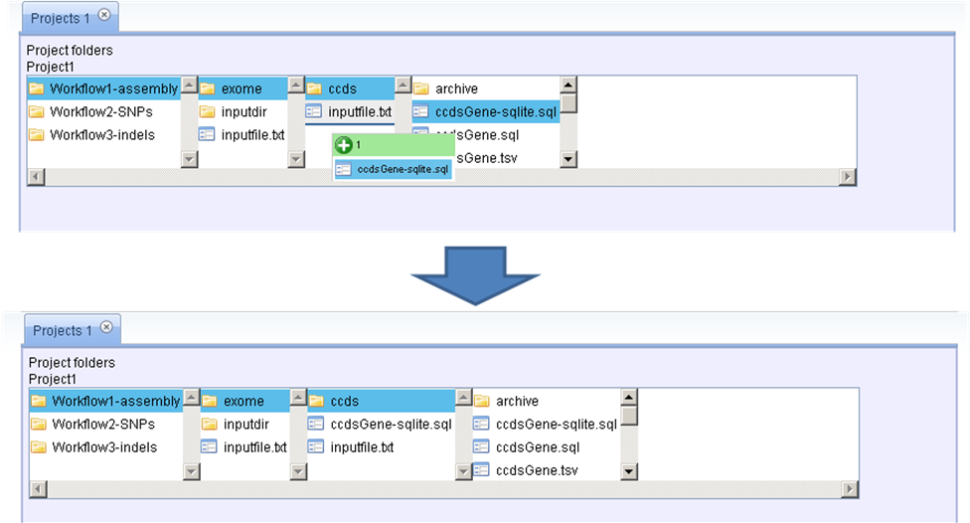
Figure 6. Aqwa’s file manager allows drag ‘n drop manipulation of workflow file systems.

The various activities involved in Aqwa’s development are detailed in the following summarized software design document.
Architectural design
Guided by the software engineering strategy of separation of concerns for ease of development and maintenance, the system is essentially embodied by the Model-View-Controller design pattern. The Model represents the data objects of the system (i.e., database tables on the server), the View is the display the user sees representing the Model and the Controller takes care of processing user-initiated events like mouse clicks and key presses to change the Model and the representation of the Model in the View (Figure 7). The Controller is composed of several MVC components that interact with a single Model to accomplish specific tasks such as authentication, project management and workflow. By adhering to a loose coupling between the system components, this component-based approach promotes ease of maintenance and reuse of architectural elements. Each controller component is represented at the file level by a plugin directory containing Javascript class files, templates and other resources required to perform one particular function. The core files of the Controller, found in the plugins/core directory, complete the task of loading all of the required modules, which can then load the rest of the system. This involves, for each plugin:
- Locating the plugin descriptor files 'info.json' in the plugin directory
- Determining whether the requirements for the plugin are already loaded
- Loading the plugin
- Registering the plugin and its version number
Once a plugin is loaded it may request information from the backend using asynchronous dojo.xhrGet/xhrPost requests. The additional resources included in each plugin (templates, css files, json files, images, etc.) represent the 'View' portion of the application.
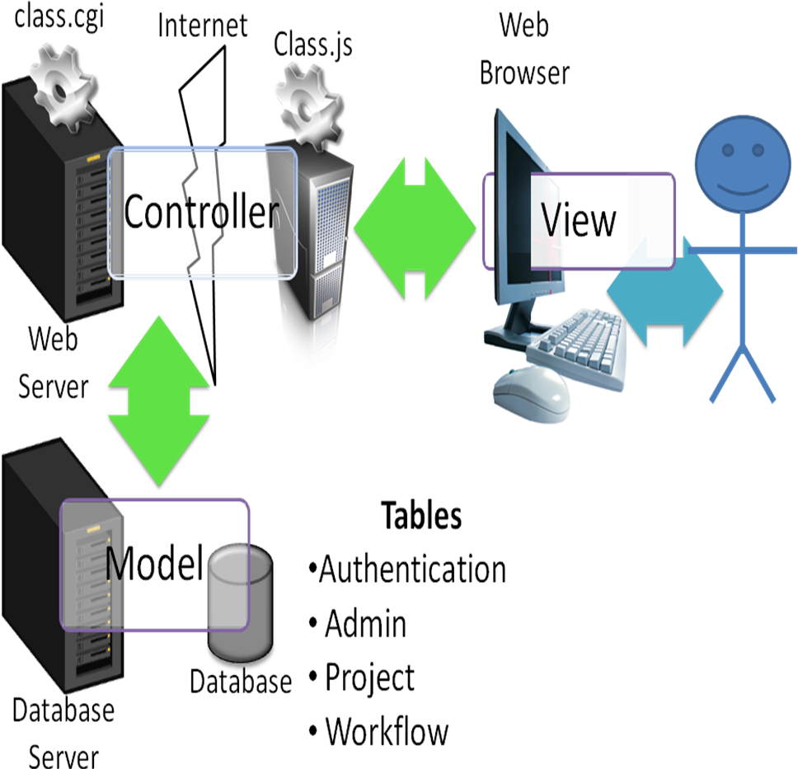
Figure 7. Breakdown of Model-View-Controller architectural design. The user interacts with the View, sending AJAX messages to the Web server via the particular MVC component (e.g., ‘Workflow.js’ represents the browser-side Controller component and it communicates with the server-side Controller component ‘workflow.cgi’). The Controller effects any necessary transactions with the Model (i.e., changes in database tables) and changes the state of the View accordingly.
User Interface (View)
The central metaphor of the user interface is that of a project folder containing one or more workflows (customized or standard). Each workflow contains one or more applications and their input data. Each application has inputs, resources (which are similar to inputs but are not specified as command line arguments) and outputs (Figure 4). The user interface is a web application implemented in Javascript and based on the Dojo Javascript toolkit (http://www.dojotoolkit.org) which contains a rich assortment of web application components and utilities. Implementing the View as a web interface also allows for the eventual incorporation of three-dimensional graphical viewers directly inside the View for molecular dynamics simulation outputs. In addition, the user will be able to customize the View by specifying the default viewer for a particular data type. When the user elects to view a file with the specified data type, a copy of the file is downloaded to the client machine and the associated application is invoked with this input.
Data design (Model)
The database tables residing on the server and their relationships make up the Model. These include tables for user authentication, project ownership and permissions, workflow content and execution status, and data provenance. Conversion of data into a unified data model in a standard format, such as in Pegasys, is not part of the functional requirements of the system, although the system will present different export and processing options for data based on its type. Individual applications are represented by JSON, similar to the resource definition XML files commonly used in systems such as GPIPE/PISE and Pegasys. The data design is distinct from the API (Application Programming Interface), which is presented as a web service with relatively stable inputs and outputs.
Low-level design (Controller)
The Controller, or so-called ‘business logic’ of the application, which interacts with the View and Model is composed of Javascript classes on the client and corresponding Perl modules on the server. The choice of Perl as the backend programming language was influenced by its large user community, abundance of bioinformatics tools such as BioPerl (http://www.bioperl.org), ease of accessibility for novice programmers and wide range of applications from text manipulation to system administration.
The system will use existing or novel syntactic structures and algebraic operators for describing bioinformatics workflows to achieve fully customizable workflows with forks, conditional statements and loops, and construct treelike workflows composed of multiple workflows linked together with logical commands. JSON (JavaScript Object Notation) is used as the data interchange format because, unlike XML, JSON-encoded objects need no additional parsing to define them at the object level, which allows them to be easily chained together in complex workflows. Following the evaluation of existing workflow control methods and their applicability to the Aqwa system, a core set of operators will be implemented in the release version of Aqwa.
The first two versions of Aqwa will support execution on the local server or on a cluster using the PBS (Portable Batch System) queue scheduler. An abstraction layer separates the workflows and the execution method for ease of extension in later versions to execution on a grid and eventually as web service requests. The latter two execution modes will require a more sophisticated pipe component and conditional operator due to the need to check for service availability before jobs can be dispatched for execution on a remote host. Failure management of jobs executed on a local server or cluster is accomplished by job monitoring scripts and wrappers to distinguish between error and normal exit modes. Failure management of jobs executed as web services or on a grid may require the development of additional tools.
The project uses an iterative/incremental development model, starting with a simple implementation of the basic functions (workflow, data management, reporting and genome view) and iteratively enhancing at each build with design modifications and new functional capabilities until the release version. Each iteration includes an examination of both the functional and quality requirements, the latter defined by user feedback and user testing (17) and interaction with other stakeholders. The alpha version will be used by a selected group of ‘power users’ within the University of Miami and the source code will be freely available for academic users. For the beta release, the user group will be expanded to all NextGen data users within the University of Miami and registered external users. Extensive user testing will be carried out at regular intervals and the results of the tests will be used to inform any additions or changes to the system’s functional requirements.
Timeline and Milestones
The project timeline and milestones are shown in Figure 8, with projected stage start and end dates in months. The project has four stages – the inception, elaboration, construction and transition stages. The inception stage (-3 to 0 months) has already been completed. This stage included identifying the stakeholders, determining the project requirements and implementation options, and conducting preliminary studies for specific aims 1 and 2. This stage also involved the preparation of this research plan and a detailed timeline.
In the elaboration stage (0 to 6 months) we will elaborate Aqwa’s project design and architecture, and develop prototype assembly, genomic variation and expression analysis workflows. The majority of the work for specific aim 1 will be done in this stage and work will begin in earnest on specific aim 2. Prototypes of the developing workflows will be implemented in the Aqwa alpha version (Milestone 1) at the midpoint of this stage. Significant risks will also be identified and risk mitigation procedures put in place and the first of six, four-month user testing cycles will begin in this stage.
During the one-year construction stage, the software design will be further refined through interaction with testers into the Aqwa beta version (Milestone 2). Specific Aim 1 will be completed at the midpoint of the construction stage and specific aim 2 will be completed at the end of the stage. Three user testing cycles will be carried out and the bulk of the software implementation work will be accomplished during this stage.

Specific Aim 1: Develop and implement an optimized NextGen assembly workflow
We have started investigating the performance of the following short read assembly tools: Eland (GAPipeline v0.30, Illumina), Velvet v0.7.16, Mira v2.9.25, Genomics Workbench (CLC Bio) v1.2, Seqman NGen (DNAStar) 1.1, NextGene (Soft Genetics) 1.0 and MAQ v 0.6.8. The input data sets are: human mtDNA, human whole-genome mRNA, E. coli DNA, Herpes simplex and bacteriophage PhiX. The assemblers are being assessed for assembly speed and capacity in terms of the maximum number of reads that can be effectively assembled using relatively high-end computer hardware. We are comparing the assemblies produced by the different programs and determining a consensus based on read identity and divergence from the relevant reference sequence. Thus far in our analysis, there are significant differences in the sequence capacities of the different reference alignment and de novo short read assembly tools, and the reference aligner outputs show significant differences in reads matching against the reference sequence in particular locations.
Specific Aim 2: Develop and implement NextGen genomic variation and expression analysis workflows
The Nimblegen exome capture of an eight-person pedigree sample set has been successfully concluded and sequencing of up to 15-fold average coverage is currently underway. Based on the initial shallow sequencing data, the framework of a SNP validation workflow has been completed, including filtering based on read quality, read depth and presence in dbSNP followed by the incorporation of pedigree information such as the presence/absence of non-SNP calls at identical chromosomal locations in parent-offspring trios. We will shortly evaluate the use of an expectation-maximization approach to predicting heterozygotes and homozygotes. In the final stage of this experiment, we will validate our approach with a sample of 1,000 individuals on a smaller subset of the captured genomic regions.
Specific Aim 3: Develop a NextGen workflow and visualization tool
A working prototype of Aqwa (pre-alpha) will soon be deployed, providing most of the core functionality of the project Aqwa alpha version. Power users are currently being recruited for the initial testing phase to assess the usability of the interface and the suitability of the current requirements specification.

<entry [Wed 2012:01:18 10:06:19 EST] WHY VERSION CONTROL?>

http://source.ggy.bris.ac.uk/mediawiki/index.php?title=Subversion&redirect=no

Introduction

Why is Version Control useful?
It removes confusion about versions, e.g. blah.old, blah.sav, blah.older, blah.newest2
It makes collaborative working easier--no confusion about versions, highlights conflicts, independent working copies, log messages etc.
It makes distributing your code easier--a Subversion repository can be visible to the world, but with highly specific access controls.
It makes reproducing experiments easier--you can always get a specific version of your model.
It aids disaster recovery--you computer is fried? No problem, just checkout your code to another!

Install
=======

The scripts for installation and configuration, along with other utility scripts, are found in this directory:

INSTALLDIR/VERSION/bin/scripts

To install Agua, you must run AS ROOT the following two scripts in succession:

1. install.pl Installs dependencies and sets up directory hierarchy

EXAMPLE:

sudo ./install.pl

2. config.pl Configures Agua database, configures load balancer monitor
and creates 'admin' user.

OPTIONS:

[--mode config] Default 'config' mode: do all the following config tasks
--mode mysql Install Agua mysql database and DB user
--mode cron Create cron job to monitor StarCluster load balancer
--mode user Create 'admin' user

EXAMPLE:

sudo ./config.pl

Conclusion

4.3 Current developments
Workflows and protocols: Mobyle already embeds a prototype dataflow-oriented workflow engine, enabling the chaining of successive or parallel tasks to be automated. It runs on top of the Mobyle core library, exploiting the Mobyle network to execute tasks distributed between local and remote servers, and orchestrates the tasks to synchronize their execution with the availability of all their input data.
Mobyle workflows modelize a set of tasks, but in contrast with existing workflow languages such as SCUFL in Taverna (Oinn et al., 2004) or MoML in Kepler (Altintas et al., 2004), do not specify explicitly some low-level data format detection and transformation tasks. Authors are, whenever possible according to local configuration, not asked to specify these steps. Hence, the storage of workflow definitions is planned to be based on an extension of the current Mobyle XML language, as they are based on a higher level perspective on the analyses they describe. An interesting outcome is the possibility to save an interactively designed program chaining as a reusable composite service. This perspective provides a gateway towards the publication of user-acknowledged protocols on a community-based platform such as myexperiment.org (De Roure et al., 2007). Future end-user access to the workflow definitions and workflow engine will be integrated to the current web interface.
Web services: the PlayMOBY system already allows the automated publication of BioMOBY web services using Mobyle program definitions. Future work also includes enabling the use of other approaches such as custom SOAP or REST interfaces, and SoapLab. Enabling the integration of such services as remote programs, for which the Mobyle Web Portal acts as a client will also be considered.
Didactic tutorials: further developments will encompass the design of tutorials. As explained by Cattley and Arthur (2007), integrated web portals are a very efficient learning and teaching tool. Mobyle additionally provides technical support for implementing interactive tutorials. A major issue to be incorporated in its design is to make more interactive components available: as shown by user studies, workflows should be available as semi-automatic protocols, with interactive components enabling the biologist to customize the visualization of the result from an analysis (e.g. a 3D molecule or an alignment).
Previous SectionNext Section

5 CONCLUSIONS
The design of Mobyle, which provides an effective way to make a large panel of curated bioinformatics tools available in a homogeneous environment, has been driven with the concern to meet the requirements of different audiences—biologists and bioinformaticians, mostly. Our objective was thus to facilitate the access to complex features and advanced technologies by a design that suits the work of biologists, which we were able to observe and understand during a number of interviews and workshops.

List of abbreviations used (if any)

GUI: Graphical User Interface; JSON: Javascript Object Notation; NGS: next-generation sequencing.

Authors' contributions

SY and JG designed the approach, acquired the data, interpreted the results and wrote the manuscript. SY implemented the Agua framework and maintains its website, repository and cloud presence.

Authors' information
Acknowledgements
References

“AJAX Command Definition (ACD Files).” European Molecular Biology Laboratory (European Bioinformatics Institute). Accessed August 5, 2013. http://emboss.sourceforge.net/developers/acd/.
Berthold, Michael R., Nicolas Cebron, Fabian Dill, Thomas R. Gabriel, Tobias Kötter, Thorsten Meinl, Peter Ohl, Christoph Sieb, Kilian Thiel, and Bernd Wiswedel. “KNIME: The Konstanz Information Miner.” In Data Analysis, Machine Learning and Applications, edited by Christine Preisach, Professor Dr Hans Burkhardt, Professor Dr Lars Schmidt-Thieme, and Professor Dr Reinhold Decker, 319–326. Studies in Classification, Data Analysis, and Knowledge Organization. Springer Berlin Heidelberg, 2008. http://link.springer.com/chapter/10.1007/978-3-540-78246-9_38.
Bolchini, Davide, Anthony Finkelstein, Vito Perrone, and Sylvia Nagl. “Better Bioinformatics through Usability Analysis.” Bioinformatics 25, no. 3 (February 1, 2009): 406–412. doi:10.1093/bioinformatics/btn633.
Deelman, Ewa, James Blythe, Yolanda Gil, and Carl Kesselman. Pegasus: Planning for Execution in Grids, 2002.
“FASTSTATS - Deaths and Mortality.” Accessed August 5, 2013. http://www.cdc.gov/nchs/fastats/deaths.htm.
Galperin, Michael Y., and Xose M. Fernandez-Suarez. “The 2012 Nucleic Acids Research Database Issue and the Online Molecular Biology Database Collection.” Nucleic Acids Research 40, no. D1 (January 2012): D1–D8. doi:10.1093/nar/gkr1196.
Goecks, Jeremy, Anton Nekrutenko, and James Taylor. “Galaxy: a Comprehensive Approach for Supporting Accessible, Reproducible, and Transparent Computational Research in the Life Sciences.” Genome Biology 11, no. 8 (2010): R86. doi:10.1186/gb-2010-11-8-r86.
Huang, Yunda, and Raphael Gottardo. “Comparability and Reproducibility of Biomedical Data.” Briefings in Bioinformatics 14, no. 4 (July 1, 2013): 391–401. doi:10.1093/bib/bbs078.
Kedes, Larry, and Grant Campany. “The New Date, New Format, New Goals and New Sponsor of the Archon Genomics X PRIZE Competition.” Nature Genetics 43, no. 11 (November 2011): 1055–1058. doi:10.1038/ng.988.
Lushbough, Carol, Michael K. Bergman, Carolyn J. Lawrence, Doug Jennewein, and Volker Brendel. “BioExtract Server&#x2014;An Integrated Workflow-Enabling System to Access and Analyze Heterogeneous, Distributed Biomolecular Data.” IEEE/ACM Transactions on Computational Biology and Bioinformatics 7, no. 1 (2010): 12–24. doi:10.1109/TCBB.2008.98.
Mesirov, Jill P. “Accessible Reproducible Research.” Science 327, no. 5964 (January 22, 2010): 415–416. doi:10.1126/science.1179653.
Nekrutenko, Anton, and James Taylor. “Next-generation Sequencing Data Interpretation: Enhancing Reproducibility and Accessibility.” Nature Reviews Genetics 13, no. 9 (September 2012): 667–672. doi:10.1038/nrg3305.
Néron, Bertrand, Hervé Ménager, Corinne Maufrais, Nicolas Joly, Julien Maupetit, Sébastien Letort, Sébastien Carrere, Pierre Tuffery, and Catherine Letondal. “Mobyle: a New Full Web Bioinformatics Framework.” Bioinformatics 25, no. 22 (November 15, 2009): 3005–3011. doi:10.1093/bioinformatics/btp493.
Reich, Michael, Ted Liefeld, Joshua Gould, Jim Lerner, Pablo Tamayo, and Jill P. Mesirov. “GenePattern 2.0.” Nature Genetics 38, no. 5 (May 2006): 500–501. doi:10.1038/ng0506-500.
Taylor, James, Ian Schenck, Dan Blankenberg, and Anton Nekrutenko. “Using Galaxy to Perform Large-Scale Interactive Data Analyses.” In Current Protocols in Bioinformatics. John Wiley & Sons, Inc., 2002. http://onlinelibrary.wiley.com/doi/10.1002/0471250953.bi1005s19/abstract.

Illustrations and figures (if any)
Tables and captions (if any)

Galperin and Fernandez-Suarez, “The 2012 Nucleic Acids Research Database Issue and the Online Molecular Biology Database Collection.”
Bolchini et al., “Better Bioinformatics through Usability Analysis.”
Kedes and Campany, “The New Date, New Format, New Goals and New Sponsor of the Archon Genomics X PRIZE Competition.”
Mesirov, “Accessible Reproducible Research”; Goecks, Nekrutenko, and Taylor, “Galaxy”; Huang and Gottardo, “Comparability and Reproducibility of Biomedical Data.”
Lushbough et al., “BioExtract Server&#x2014;An Integrated Workflow-Enabling System to Access and Analyze Heterogeneous, Distributed Biomolecular Data.”
Berthold et al., “KNIME.”
Taylor et al., “Using Galaxy to Perform Large-Scale Interactive Data Analyses.”
Reich et al., “GenePattern 2.0.”
Néron et al., “Mobyle.”
Deelman et al., Pegasus.
Nekrutenko and Taylor, “Next-generation Sequencing Data Interpretation.”
Néron et al., “Mobyle”; Bolchini et al., “Better Bioinformatics through Usability Analysis.”
“AJAX Command Definition (ACD Files).”
“FASTSTATS - Deaths and Mortality.”

