Senior Software Developer with AI Native SDLC
Context: Upgrading the project "Add2Num" #sym:MyBigNumber by adding a submodule with Spring to provide API #sym:MyBigNumber
Task: Suggest me next steps to generate prompts to generate acceptable source code. For example, next step is to prepare prompts to generate a spec.md from the requirement but I am sure, pls give a guide.
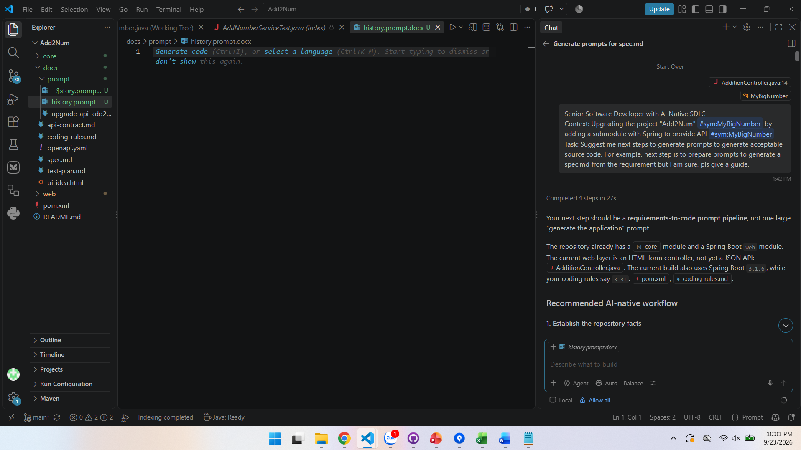

Prompt 1: Establish the repository facts
You are analyzing an existing Maven multi-module Java project.
Repository facts:
  - Java version: 21
  - Modules: core and web
  - core contains MyBigNumber, which adds arbitrarily long positive integer strings.
  - web is a Spring Boot application using Thymeleaf.
  - The current web controller supports an HTML form POST at /add.
  - We want to add a JSON REST API without breaking the existing HTML UI.
  - Follow docs/coding-rules.md.
  - Do not modify source code yet.
Tasks:
  - Inspect the repository structure and relevant source files.
  - Identify existing behavior and public APIs.
  - Identify contradictions between the repository and coding rules.
  - List ambiguities that must be decided before implementation.
  - Recommend the smallest API design that fits the current project.
Return:
  - Existing behavior
  - Risks and ambiguities
  - Decisions required
  - Recommended next artifacts
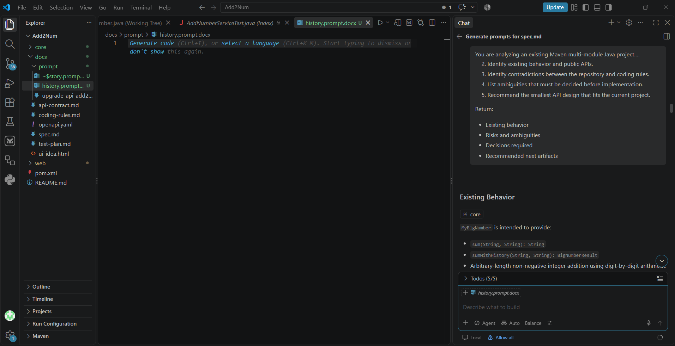

Prompt 2: Generate spec.md
Implement the API tests described in docs/test-plan.md.
Constraints:
  - Use the repository's existing test framework and style.
  - Add focused controller/API tests and service/domain tests where appropriate.
  - Do not modify production code to make tests pass.
  - Run the narrowest relevant Maven test command after editing.
  - Report failing tests and classify each failure as:
    - expected because production code is not implemented yet,
    - test defect,
    - specification ambiguity.
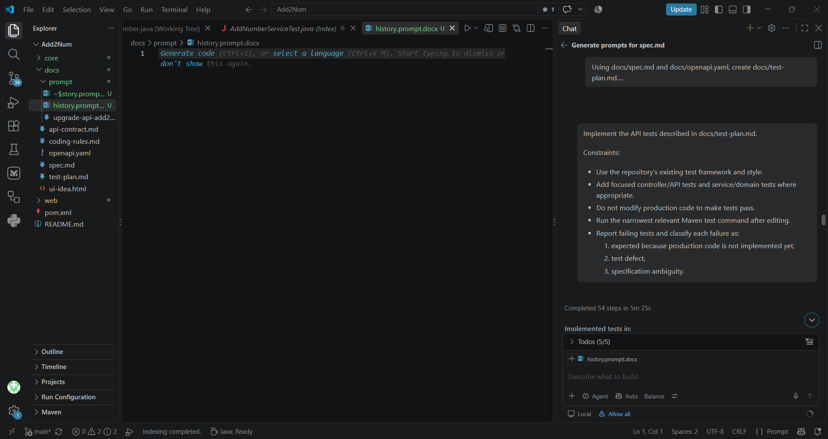
Prompt 3: Ask for a contract before implementation
Using docs/spec.md, generate docs/api-contract.md.
Include:
  - HTTP method and path
  - Request and response JSON examples
  - Success status
  - Validation error status
  - Malformed JSON behavior
  - Error response schema
  - Field-level validation messages
  - Content-Type requirements
  - Correlation/request ID behavior, if needed
Then generate an OpenAPI 3.0 YAML contract at docs/openapi.yaml.
Do not implement Java code.
Ensure the contract matches the specification exactly.
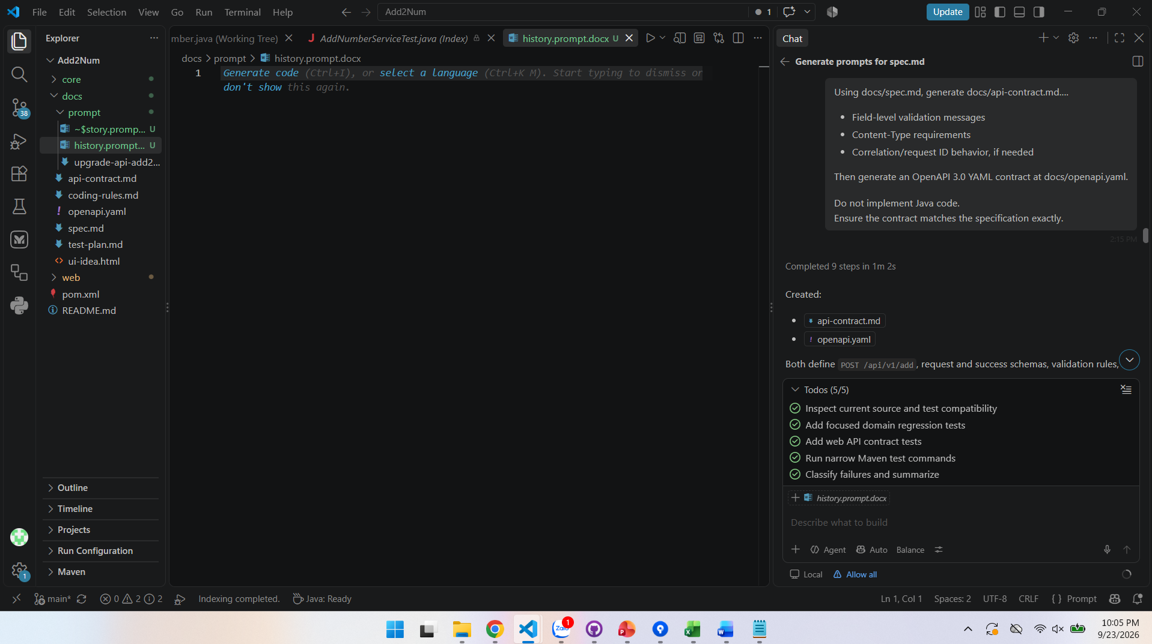
Prompt 4: Generate a test plan first
Using docs/spec.md and docs/openapi.yaml, create docs/test-plan.md.
Define tests for:
  - Normal addition
  - Different-length numbers
  - Carry propagation
  - Leading zeros
  - Zero values
  - Very large values
  - Null and blank inputs
  - Non-digit input
  - Negative input
  - Input exceeding the configured digit limit
  - Malformed JSON
  - Unsupported HTTP methods
  - Concurrent requests
  - Existing HTML UI regression
For every test, specify:
  - Given
  - When
  - Then
  - Expected HTTP status
  - Expected response body
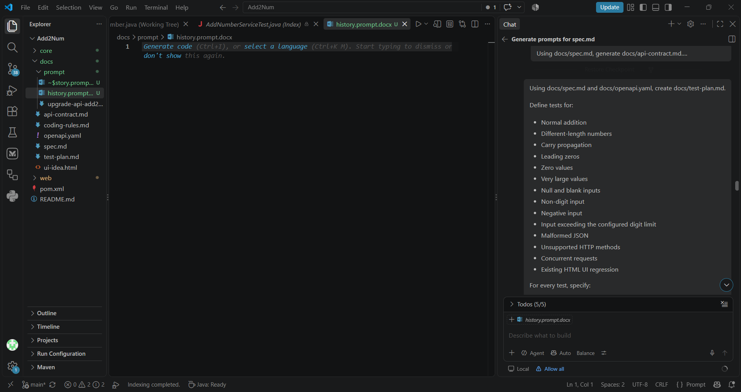

Prompt 5: Ask the AI to implement tests before production code:
Implement the API tests described in docs/test-plan.md.
Constraints:
  - Use the repository's existing test framework and style.
  - Add focused controller/API tests and service/domain tests where appropriate.
  - Do not modify production code to make tests pass.
  - Run the narrowest relevant Maven test command after editing.
  - Report failing tests and classify each failure as:
    - expected because production code is not implemented yet,
    - test defect,
    - specification ambiguity.
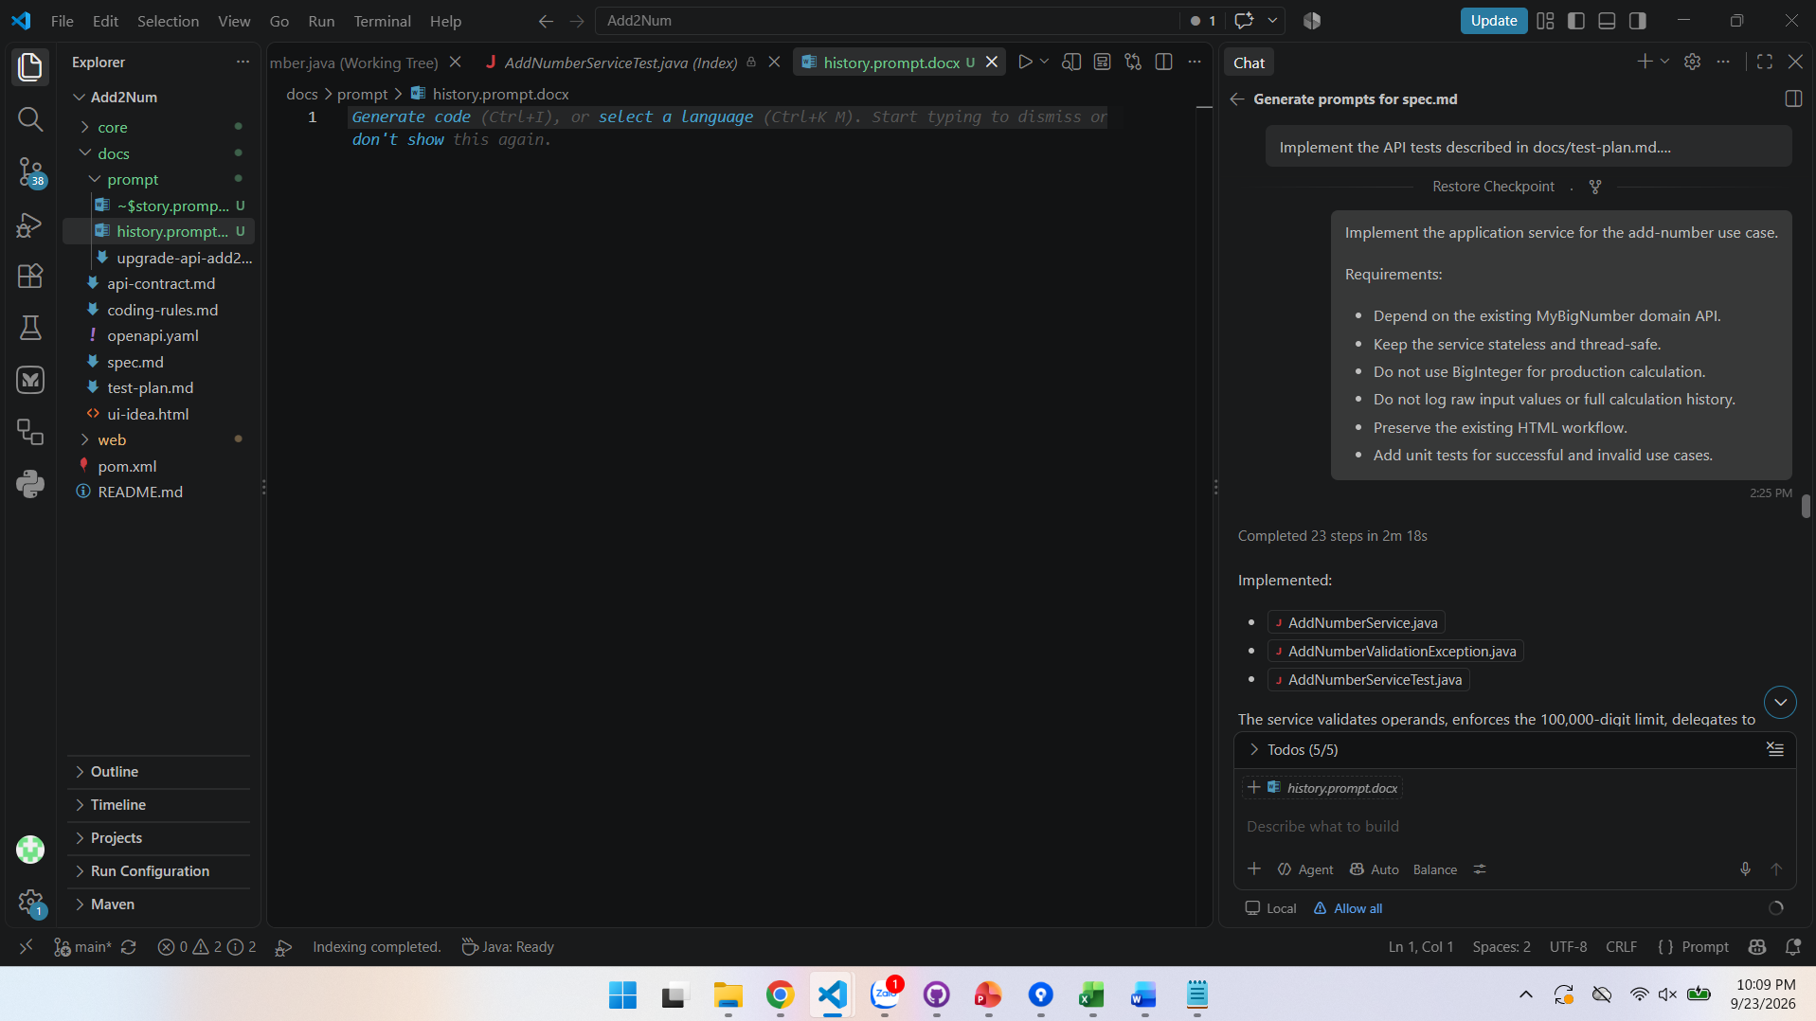
Prompt 6: Generate the implementation in vertical slices
DTOs and validation
Implement the request and response DTOs required by docs/spec.md and docs/openapi.yaml.
Requirements:
  - Use explicit validation annotations where appropriate.
  - Use constructor injection in Spring components.
  - Keep DTOs separate from domain classes.
  - Do not change MyBigNumber yet.
  - Add focused tests for validation behavior.
  - Follow docs/coding-rules.md.

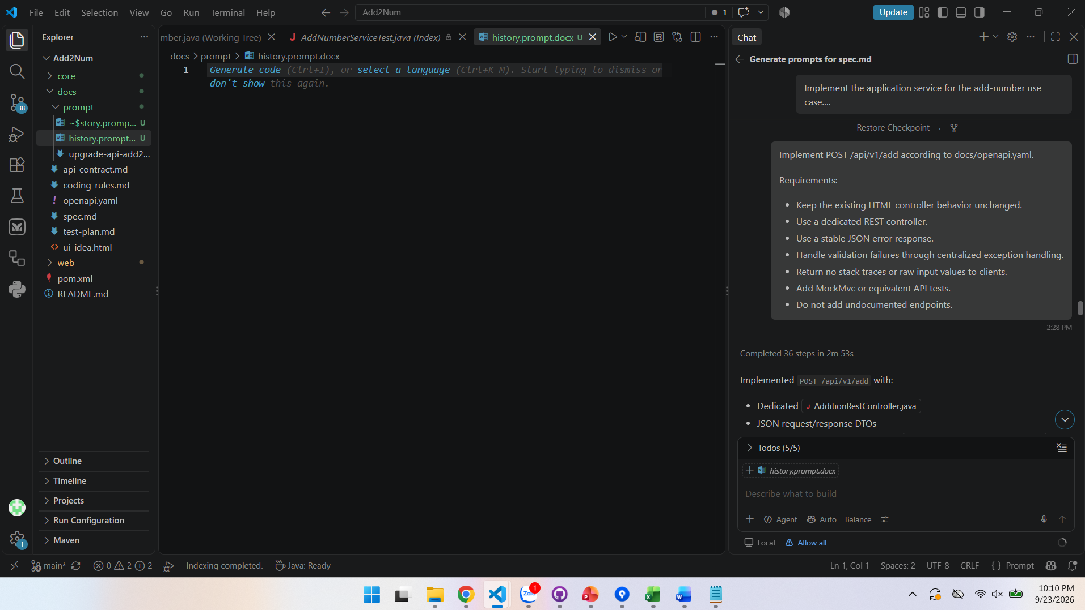
Prompt 7: Generate the implementation in vertical slices
Application service
Implement the application service for the add-number use case.
Requirements:
  - Depend on the existing MyBigNumber domain API.
  - Keep the service stateless and thread-safe.
  - Do not use BigInteger for production calculation.
  - Do not log raw input values or full calculation history.
  - Preserve the existing HTML workflow.
  - Add unit tests for successful and invalid use cases.
Prompt 8: REST controller and exception handling
Implement POST /api/v1/add according to docs/openapi.yaml.
Requirements:
  - Keep the existing HTML controller behavior unchanged.
  - Use a dedicated REST controller.
  - Use a stable JSON error response.
  - Handle validation failures through centralized exception handling.
  - Return no stack traces or raw input values to clients.
  - Add MockMvc or equivalent API tests.
  - Do not add undocumented endpoints.
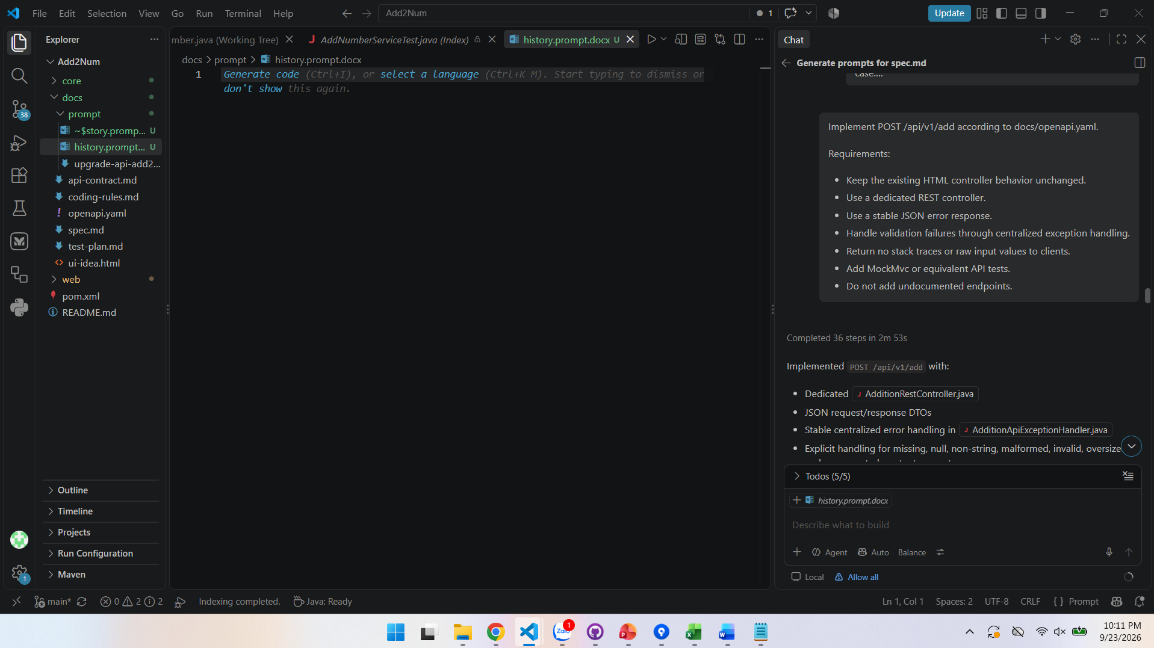
Prompt 9: Ask for a review pass, after implementation
Review the implementation against:
  - docs/spec.md
  - docs/openapi.yaml
  - docs/test-plan.md
  - docs/coding-rules.md
Do not modify files yet.
Findings must be ordered by severity:
  - Functional defects
  - Security or denial-of-service risks
  - Thread-safety problems
  - Contract mismatches
  - Missing tests
  - Maintainability issues
For every finding include:
  - File
  - Symbol or approximate location
  - Problem
  - Concrete failure scenario
  - Recommended fix
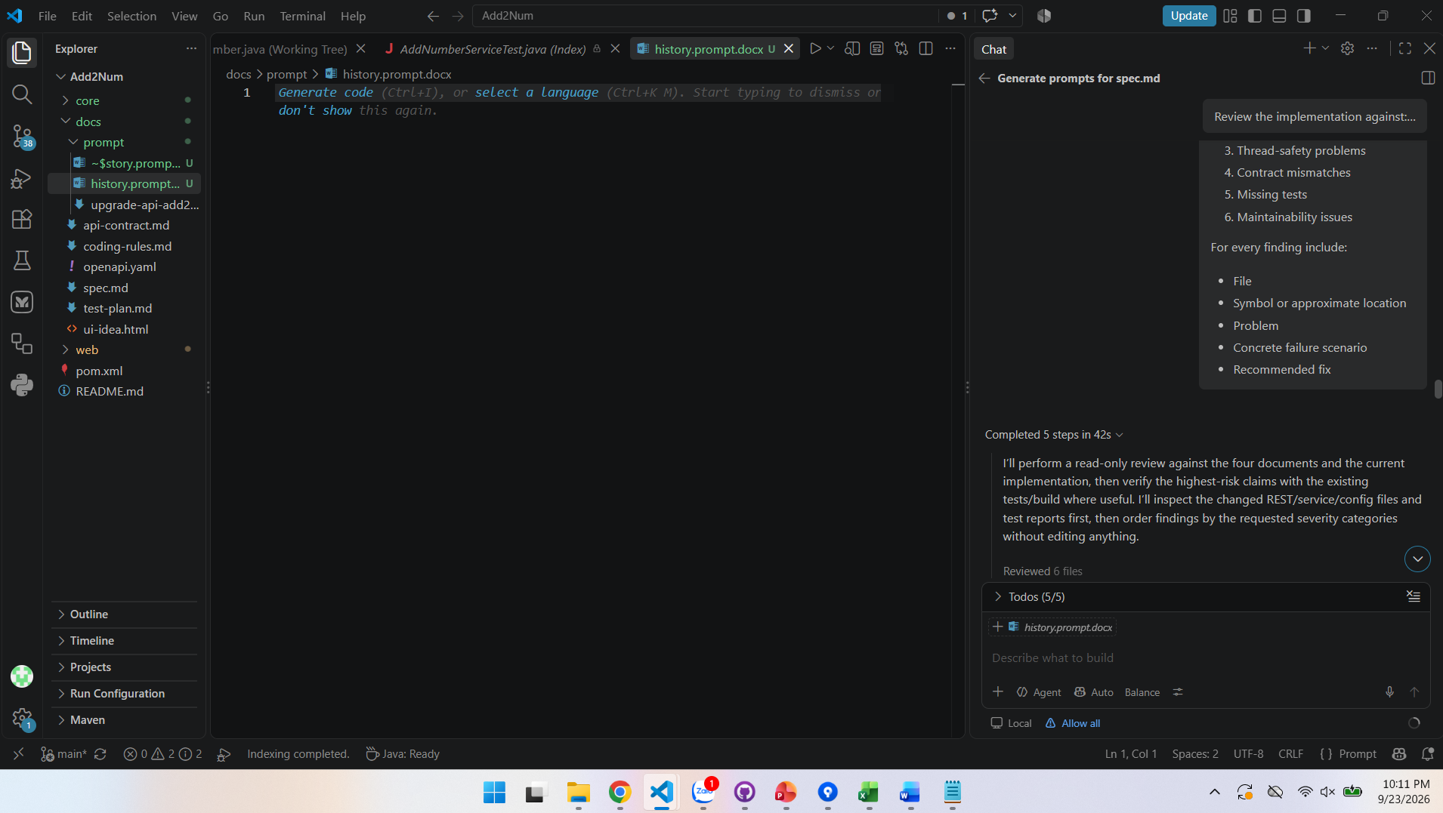

Prompt 10: Run a verification prompt
Validate the completed feature.
Run:
  - mvn -pl core test
  - mvn -pl web test
  - mvn clean package
  - Any API integration tests
  - Static analysis configured by the project
Then verify:
  - Existing core tests still pass.
  - Existing HTML behavior still works.
  - POST /api/v1/add follows the OpenAPI contract.
  - Invalid requests return the documented errors.
  - Concurrent requests do not mix calculation histories.
  - No production calculation uses BigInteger.
Return the exact commands run, results, and any remaining risks.
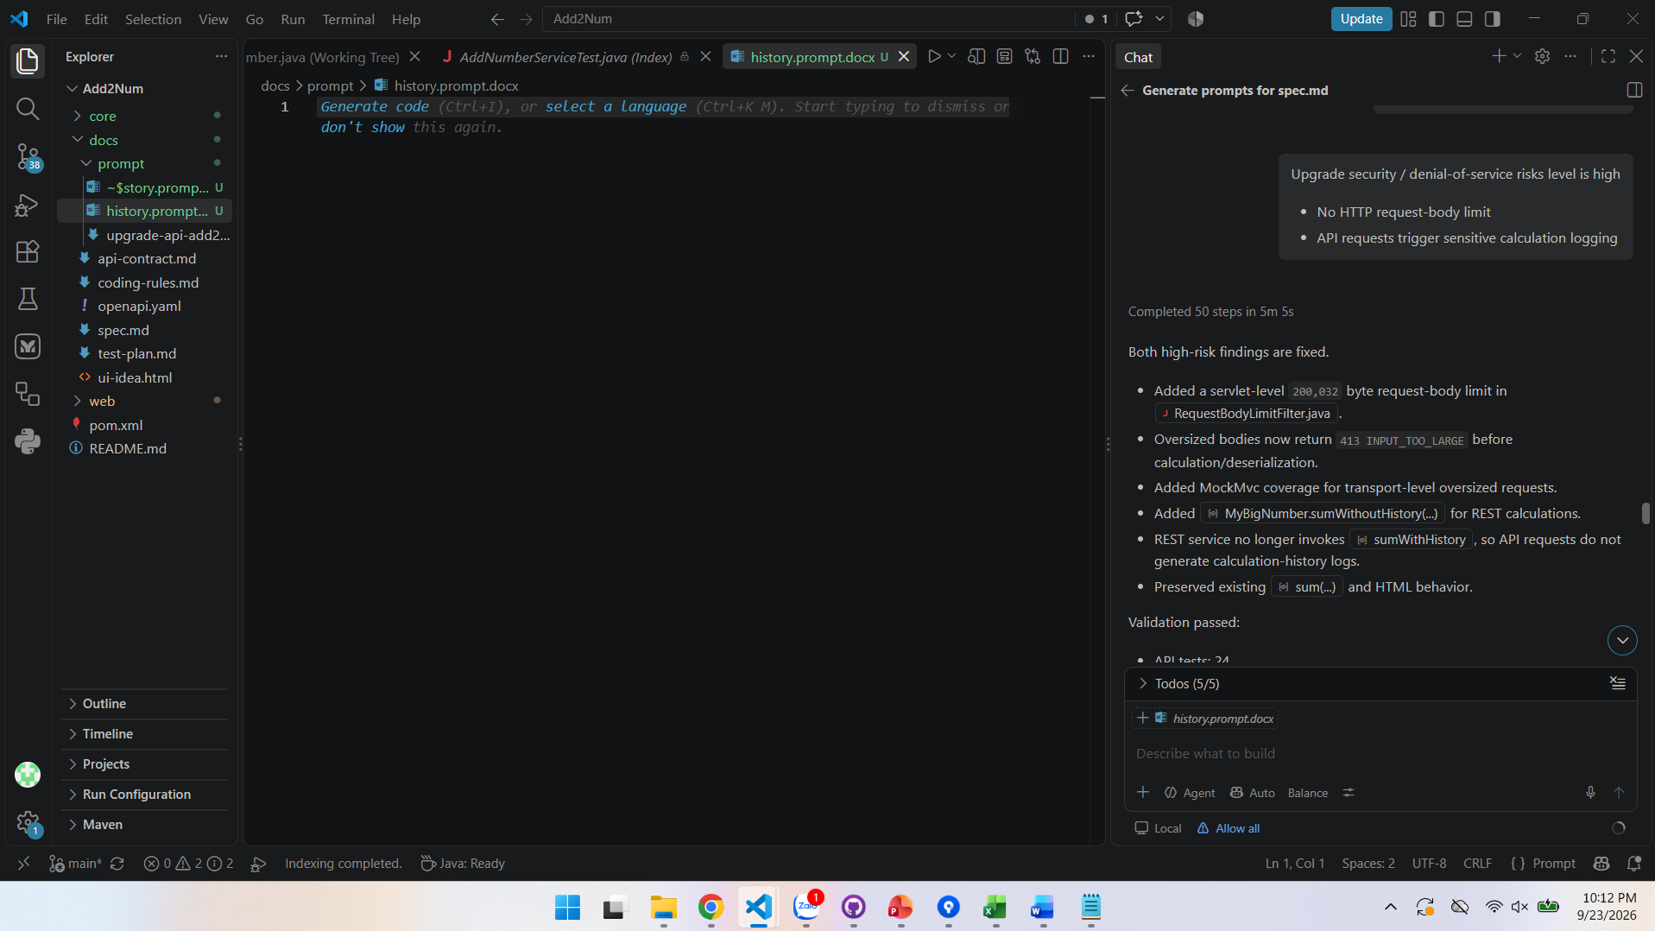
Prompt 11: Upgrade security / denial-of-service risks level is high
  - No HTTP request-body limit
  - API requests trigger sensitive calculation logging
