Timothy
Vikram
Ajith
Team 2
Project Phase 1 - Crater network
For this project first phase, we want to train a neural network for crater images. We used the Martian surface images as the input dataset. The images were separated as images and the ground-truth (gt) images. It was important that we already had the gt images as that meant that craters were already identified by a crater scientist. This is important for neural networks, as you have to have good, identified data to use to train the network.
First, we had to preprocess the images. We did this by using the MINMAX method. We chose the MINMAX method over the padding method because we felt that this would better capture the image. We wanted the input image into our network as grayscale 200x200 pixels and normalizing the images seemed like the obvious choice. We had some trouble storing the data in a pickle file since the pictures were too large. So we skipped that and we are just directly running the network by passing it the pixel data.
We then wrote a loader function to add the class labels to the images. We used the normalized images and created a list of tuples with the image data and the label, crater or non-crater. This function also randomly split the data for training and testing. The training set was 70% of the original, and the test set was the remaining 30%.
We ran into a Runtime Math Error: Overflow in exp. The Sigmoid function trying to calculate the exponential values overflowed. We suspect this was due to our grayscale images being a value between 0-255. Thus, we further normalized the images by dividng by 255. This gave us a value between 0 and 1 that represented how dark the images were. This also has the benefit of not causing overflow when calculated exponentials.
We used the training set and the test set to train and check our network. In order to evaluate how well the network did, we made use of several parameters. We calculated the detection rate, the false rate, and the quality rate by using the true positive, false positives, and false negatives of the network.
For our final configuration we chose [40000, 10, 4, 1] layers and [60, 5, 0.2] epochs, minibatches and learning rate. We had a 98.9% detection, and 97.6% quality rate.
We tried several different configurations. We tried using 3 layers instead of 4 but only hit around 95% quality average. We also noticed that the quality rate wasn't stable with 30 epochs. The network continued to get better rates until around 50-60 epochs. The picture shows the final configuration with 4 layers with [40000, 10, 4, 1] neurons where we got 97% detection.
Average Values for the our final configuration was: 281 TP, 4 FP, 8 FN, 97.24% detection, 1.53% false, 95.78% quality.

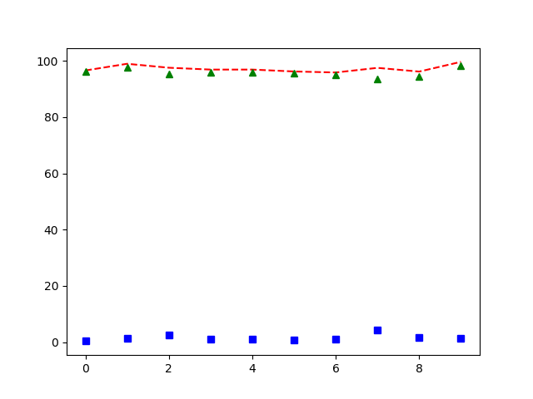

The red line graphs the detection rate across the 10 iterations. The final iteration was 98.9%. The blue squares graph the false rate. The green triangle graph the quality rate.
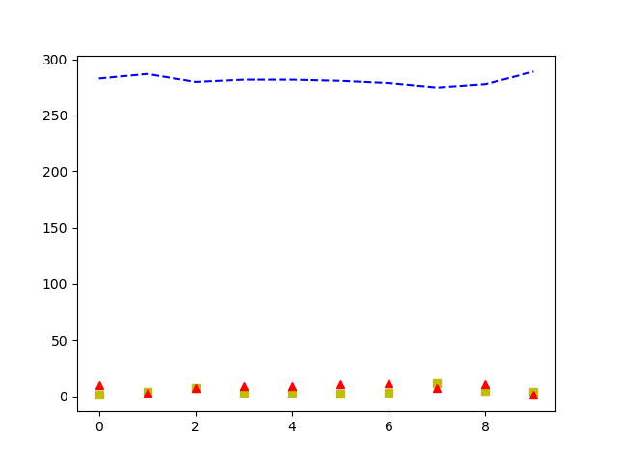

This graph shows the change in the TP, FP, FN over the 10 iterations. The FP are the yellow squares, and the FN are the red triangles.

We wrote a bit more code to look at the images that were falsely classified. We suspect that the network has trouble recognizing the craters that have low resolution and/or irregular shapes. One of the images, tile3_24_062 is both low resolution and an irregular shape (heart shaped). This is likely causing the network to not recognize it as it is not similar to the other craters. More examples of such craters would be needed to train the network. The network takes the image pixels and reduces them to 10 neurons in our second hidden layer. These 10 neurons are then reduced to 4 neurons that give our final output layer. Perhaps the network is recognizing the shape of the crater, and the presence of the crater walls along with two other aspects, maybe the color and shadow. The low resolution and irregular shape would not trigger these neurons and thus return a false negative.

It is also possible that we are not using enough neurons in our hidden layers. Using too few neurons would constrict the network into maybe a too strict definition of a crater. We tried using a configuration with more neurons in the second hidden layer. We still observed only 95-97% detection rate, with the average being 96%. So increasing neurons didn’t affect the detection rate that much.

The network identified craters well at 98.9% detection. We could improve this by improving the amount of features we consider. This network considers the pixel values of the pictures to identify craters. Higher resolution images would help. We might be able to incorporate more parameters such as location and radius of the crater in the image. This requires more complete and comprehensive data as input though.

