Table S1

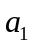 | 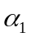 | 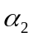 |  | 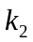 | 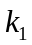 | 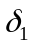 | 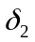 | 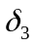 | 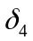
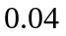 | 0.5 | 1.0 |  | 0.5 | 0.1 | 1 | 1.0 | 0.1 | 0.1

Table S1: Parameter values used for Figure S4 and Figure S5, with 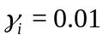, for 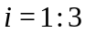. For Figure S5, 

