APPENDIX 2

Exact analytic expressions derived from the 4-step model:

(II-A)

(II-A-1)

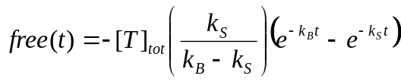 (II-A-2)

(II-A-3)

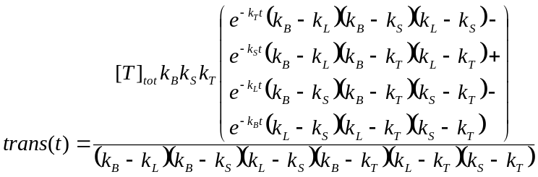 (II-A-4)

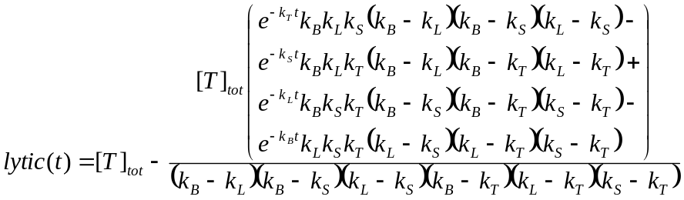 (II-A-5)

