Supplementary Material

Modelling and experimental analysis of hormonal crosstalk in Arabidopsis
Junli Liu^{1†}, Saher Mehdi¹, Jennifer Topping¹,
Petr Tarkowski², and Keith Lindsey^{1†}

¹The Integrative Cell Biology Laboratory and The Biophysical Sciences Institute, School of Biological and Biomedical Sciences, Durham University, South Road, Durham DH1 3LE, UK

²Umea Plant Science Centre, Swedish University of Agricultural Science, Umea S-0901-83, Sweden

Table of Contents:
- Hormonal crosstalk network in the systems biology graphical notation
- Rate equations and parameter values
- Differential equations
- Other example analysis for interactions between PLS and ethylene signalling
- Kinetics of auxin and ethylene biosynthesis
- Time scale for establishing steady states
- Effects of total receptor concentrations
- Root growth rate
- Root growth rate relating to exogenously applying hormones
- Simultaneous applications of different exogenous hormones
- Further discussion
- References

- Hormonal crosstalk network in the systems biology graphical notation

The hormonal crosstalk network shown in Figure 1 in the main text can be described in the systems biology graphical notation, Figure s1.
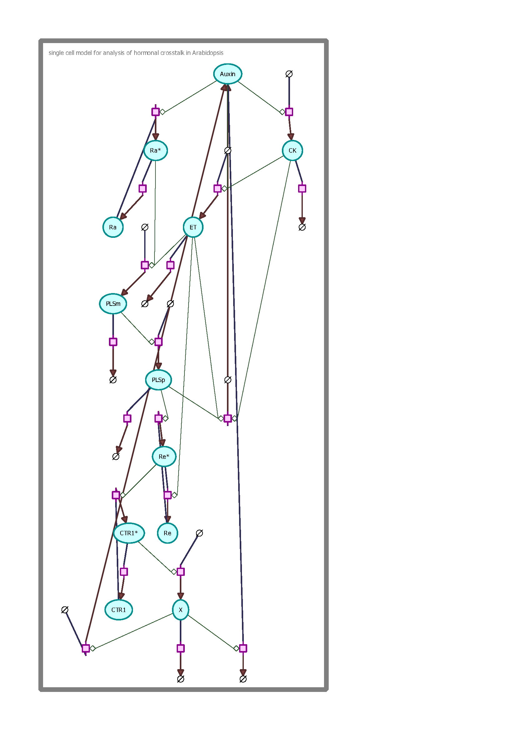
Figure s1. The hormonal crosstalk network described using Arcadia (http://arcadiapathways.sourceforge.net/).

The interactions described in Figure s1 are described in detail in the main text and in the following sections.
μMs⁻¹
- Rate equations and parameter values
Rate equation | Description | Parameter value
 | Auxin transport to the cell. | μMs⁻¹ μM
 | Auxin biosynthesis in the cell.  describes background auxin biosynthesis which is not related to ethylene, cytokinin or POLARIS regulation | μMs⁻¹ s⁻¹ 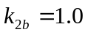μMs⁻¹
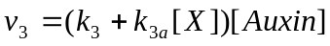 | Removal of auxin from the cell. | 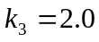s⁻¹ 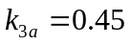μM⁻¹s⁻¹
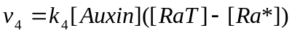 | Conversion of the inactivated form of auxin receptor to its activated form. | 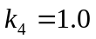 μM⁻¹s⁻¹
 | Conversion of the activated form of auxin receptor to its inactivated form. | 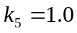s⁻¹
 | Transcription of POLARIS gene. | s⁻¹ μM
 | Decay of mRNA of POLARIS gene. | s⁻¹
 | Translation of POLARIS gene. | s⁻¹
 | Decay of protein of POLARIS gene. | s⁻¹
 | Conversion of the inactivated form of ethylene receptor to its activated form by PLSp.  describes the background rate of converting inactivated state of ethylene receptor to its activated state, which is independent of PLSp. | s⁻¹  μM⁻¹s⁻¹
 | Conversion of the activated form of ethylene receptor to its inactivated form. | μM⁻¹s⁻¹
 | Ethylene biosynthesis.  describes the background ethylene  biosynthesis which is not related to auxin and cytokinin regulation. | μMs⁻¹  μM⁻¹s⁻¹
 | Removal of ethylene. | s⁻¹
 | Conversion of the inactivated form of CTR1 protein to its activated form by Re*. | μM⁻¹s⁻¹
 | Conversion of the activated form of CTR1 protein to its inactivated form. | s⁻¹
 | Activation of the downstream of ethylene signalling response is inhibited by CTR1*. | μMs⁻¹  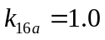s⁻¹
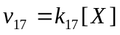 | Removal of the unknown molecule X. | 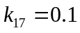s⁻¹
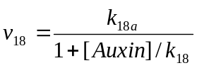 | Biosynthesis of cytokinin. | 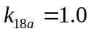μMs⁻¹ 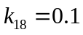 μM
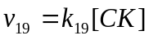 | removal of cytokinin. | 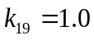s⁻¹
 | Total concentration of auxin receptor. | 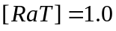 μM
 | Total concentration of ethylene receptor. | 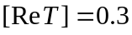 μM
 | Total concentration of CTR1 protein. | 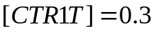 μM
Exogenous application of hormones
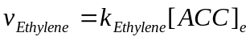 | Uptake rate of exogenous ACC (1-aminocyclopropane-1-carboxylic acid) | 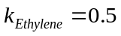s⁻¹
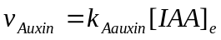 | Uptake rate of exogenous auxin (indole-3-acetic acid, IAA) | 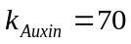s⁻¹
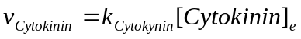 | Uptake rate of exogenous cytokinin. | 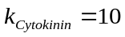s⁻¹

- Differential equations
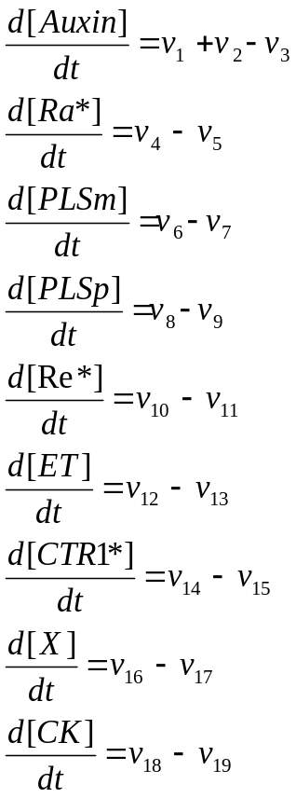 (s1)

When hormones are exogenously applied, the mass-balance equations for three endogenous hormones become
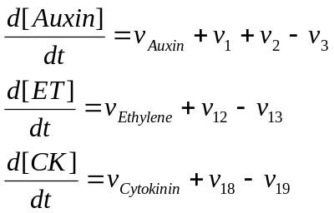 (s2)
All other equations remain unchanged.
- Other example analysis for interactions between PLS and ethylene signalling

- PLS protein inhibits the conversion of ethylene receptor from the activated form to the inactivated form

If the PLS protein interacts with the ethylene receptor, with a function of inhibiting the conversion of the active form of ethylene receptor Re*, into its inactivated form Re, 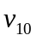 and 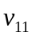 in the Figure 1 of the main text become:

(s3)
The kinetics of the ethylene receptor and CTR1 protein are described as follows.
(s4)
At a steady state,
(s5)

The relationship between [PLSp], [Re*] and [CTR1*] reveals the following scenario. If [PLSp] decreases, both [Re*] and [CTR1*] decreases. Since CTR1* negatively regulates the downstream ethylene response, X, then X increases. This, in turn, leads to a lower transport rate of auxin from shoot to root and therefore to a lower auxin concentration in the root. The trend qualitatively agrees well with experimental observations: the pls mutant has a lower transport rate of auxin from shoot to root , a lower root auxin concentration and a shorter root length (Chilley et al. 2006). Moreover, Chilley et al. (2006) observed that for [PLSp] = 0 (i.e. the pls mutant), reducing the functional interaction between ethylene and the ethylene receptor by genetic or pharmacological methods restores wild-type auxin concentration in the root. In equation (s5), this corresponds to the decrease of . Equation (s5) predicts that decreasing increases [CTR1*]. Consequently, auxin concentration increases. Therefore, the lower auxin concentration of the pls mutant can be rescued in the model by reducing ethylene responses, as observed experimentally (Chilley et al. 2006).

The analysis shows that this interaction (i.e. PLS protein inhibits the conversion of the ethylene receptor from the active form to the inactivated form) leads qualitatively to the same results as the case where PLS protein activates the conversion of ethylene receptor from the inactive form to the active form (Figure 1). It is also a candidate for explaining experimental observations.

The same analysis was applied to the interactions between PLSp and CTR1 proteins. If PLSp is able to interact with CTR1 and either activate the conversion of CTR1 into CTR1* or inhibit the conversion of CTR1* to CTR1, these interactions are also candidates for theoretically explaining experimental observations.

Given that the PLS peptide has a predicted endoplasmic reticulum (ER) retention signal (Casson et al. 2002), consistent with the location of the ethylene-binding face of the ethylene receptor protein ETR1 (Chen et al. 2002), we favour a model in which PLSp interacts with the ethylene receptor, (Fig. 1 in the main text).

- PLS protein binds with the activated form of ethylene receptor to form another inactivated form

If the PLS protein binds with the activated form of ethylene receptor to form another inactivated form, the ethylene receptor has three forms, the inter-conversion of which is described as follows.

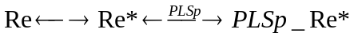 (s6)
with .

Following the methodology shown above, at a steady state,
(s7)
In equation (s7), is the equilibrium constant for the conversion between Re* and PLSp_Re*. The relationship between [PLSp], [Re*] and [CTR1*] reveals the following scenario. If [PLSp] decreases, both [CTR1*] and [Re*] increase. Since CTR1* negatively regulates the downstream ethylene response, X, then X decreases. This in turn leads to a higher transport rate of auxin from shoot to root and therefore to a higher auxin concentration in the root. The trend is qualitatively opposite to experimental observations: the pls mutant has a lower transport rate of auxin from shoot to root and a lower root auxin concentration and a shorter root length (Chilley et al. 2006). Therefore, this possibility is discarded.

This kind of analysis has also been applied to the following interactions: a) PLSp activates the conversion from Re* to Re; b) PLSp binding with Re and forming another inactive state. It was found that these interactions cannot lead to the results that agree with experimental observations. Therefore, these possibilities are discarded.
- Kinetics of auxin and ethylene biosynthesis
For auxin biosynthesis, it is evident that ethylene activates the biosynthesis of auxin locally in the
root tip (Swarup et al. 2007; Stepanova et al. 2007), and it is known that cytokinin inhibits subsets of auxin responses (including hypocotyl elongation and lateral root growth; Casson and Lindsey 2003; Coenen et al. 2003) and the biosynthesis of auxin (Eklof et al. 1997). Our study has shown that PLSp also plays a role in auxin biosynthesis (see the main text of this work). However, the molecular basis for auxin biosynthesis is largely unknown. In the following, we analyse the effects of possible kinetics on auxin biosynthesis.
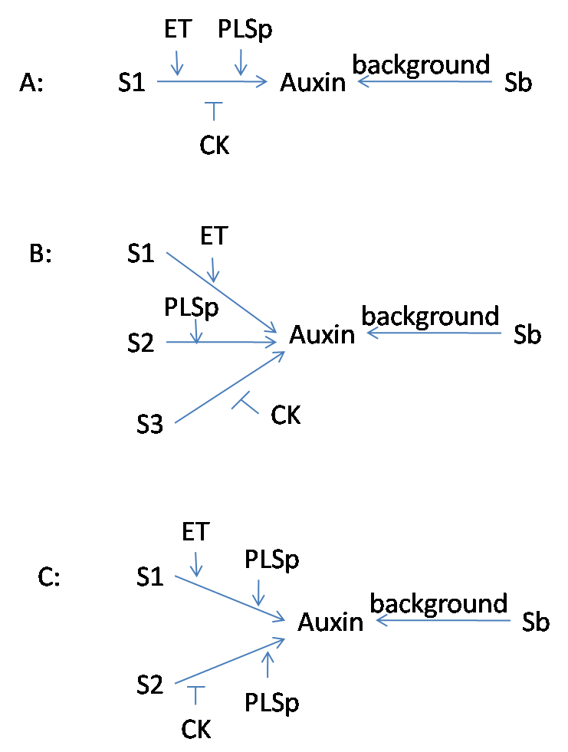

Figure s2. Three different reaction schemes for auxin biosynthesis. Our analysis shows that schemes A and C can be used to explain all experimental results, but scheme B cannot be used to explain all experimental results (see figure s3 for details).

If ethylene, cytokinin and PLSp act on a single pathway for auxin biosynthesis, the auxin biosynthesis can be schematically described in figure s2A. For this case, the kinetics of auxin biosynthesis can be described using the equation (5) in the main text.

If ethylene, cytokinin and PLSp act on three different pathways for auxin biosynthesis, the auxin biosynthesis can be schematically described in figure s2B. For this case, the kinetics of auxin biosynthesis can be described using equation (s8).

(s8)

If ethylene and cytokinin act on two different pathways for auxin biosynthesis and PLSp simultaneously act on both pathways, the auxin biosynthesis can be schematically described in figure s2C. For this case, the kinetics of auxin biosynthesis can be described using equation (s9).
(s9)

We have studied the effects of different types of kinetics. It was found that the reaction schemes described by Figure s2A and s2C can be used to explain all experimental observations (Figure s3). However, the reaction scheme described by Figure s2B is in conflict with some experimental observations (Figure s3B). Figure s3 shows the numerical results for the three different types of kinetics for auxin biosynthesis.

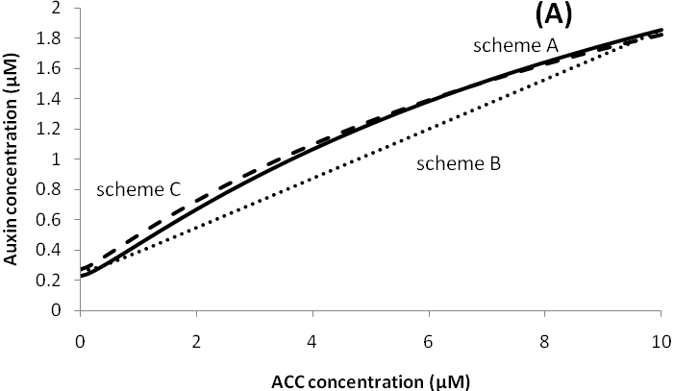

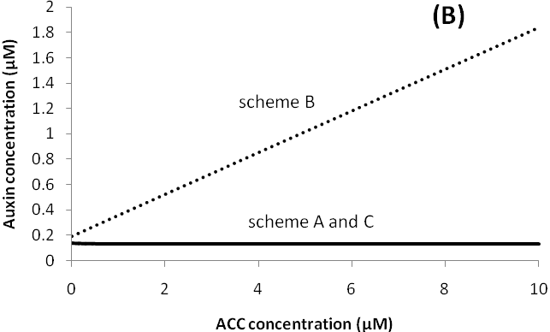

Figure s3. Comparison of three different types of kinetics for auxin biosynthesis. A): wild type; B) pls mutant. Parameters: scheme A: same as in the table s1 and in the main text; scheme B: 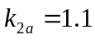s⁻¹, 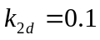μMs⁻¹,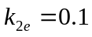μMs⁻¹; scheme C: 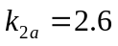s⁻¹; μMs⁻¹. For schemes B and C, all other parameters are the same as in scheme A. In schemes A and C in figure s3B, auxin concentraton decreases from 0.14 μM to 0.12 μM as exogenous ACC concentration increases from 0 to 10 μM.

Figure s3A shows that, for wild type, all three types of kinetics for auxin biosysnthesis can qualitatively lead to the same results for auxin concentration, which are in agreement with the experimental onservations (Ruzicka et al. 2007; Swarup et al. 2007). However, only schemes A and C can explain the experimental observations for pls mutant (figure 4B in main text). In scheme B in figure s2, increasing exogenous ACC concentration always lead to the increase in auxin concentration in pls mutant independently of the choice of parameter values. This modelling result is in confict with experimental observation (Figure 4B in the main text).

The above analysis reveals that, although the molecular basis for auxin biosynthesis is largely unknown, the regulation of PLSp on auxin biosynthesis is realised through its compounded effects with ethylene and cytokinin: PLSp cannot regulate auxin biosynthesis independently of the regulation of ethylene and cytokinin.

In addition, following the methodology described above, other possibilities relating to the interplay of ethylene, cytokinin and PLSp in auxin biosynthesis can be analysed.

Similarly, it is known that both auxin and cytokinin can synergistically activate the biosynthesis of ethylene (Vogel et al. 1998; Stepanova et al. 2007). If both auxin and cytokinin act on a single pathway for ethylene biosynthesis, the kinetics of auxin biosynthesis can be described using the equation 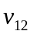 in the table s1. However, if auxin and cytokinin act on different pathways for ethylene biosynthesis, the kinetics for ethylene biosynthesis can be expressed in the following form:

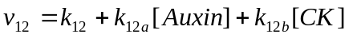 (s10)

Our study shows that the kinetics shown in equation (s10) can also be used to explain all experimental observations (data not shown).

- Time scale for establishing steady state
Numerical tests reveal that the model developed in this work is able to establish a steady state within 50s in general, when different initial conditions are applied. Figure s4 shows that when initial condition of endogenous auxin concentration changes from 0.01μM to 10 μM, the system establishes a steady state with 20s. Therefore, in this work, our analysis concentrates on steady-state analysis. However, we note that the model developed in this work is capable of studying dynamic response when the system is subjected to a perturbation.

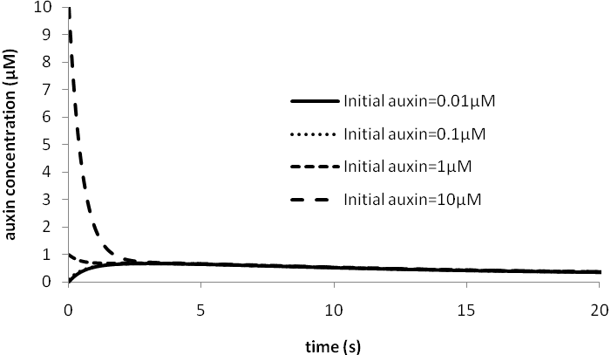
Figure s4. Evolution of the system when initial endogenous auxin concentration changes. The initial values of all other variables are zero.

- Effects of different total concentrations of receptors

When a signalling network is studied, the total concentration of a receptor is usually considered to be a constant (Klipp et al. 2004, Diaz et al. 2006). This assumption is based on the fact that all receptor protein concentrations usually establish a steady state. In this work, the total concentrations of auxin, ethylene, and CTR1 receptors are fixed. We therefore examine the effects of different total receptor concentrations on the results.

Qualitatively, different total receptor concentrations lead to the similiar results. Quantitatively, if total receptor concentrations change and other parameters remain unchanged, the concentrations of all species in the model (Figure 1 in the main text) change. Figure s5 shows the effects of total auxin and ethylene receptor concentrations on endogenous auxin concentration.

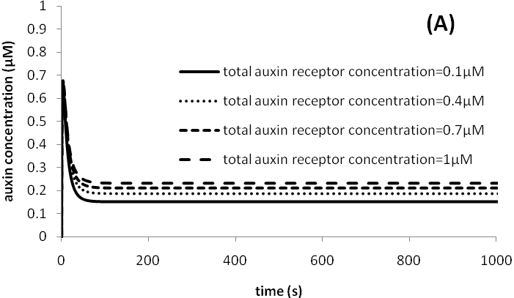
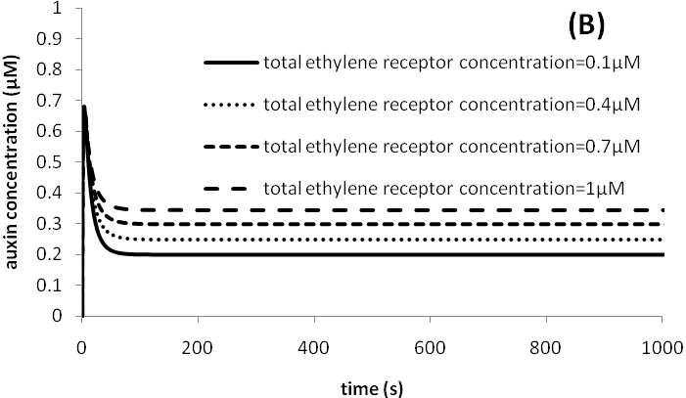
Figure s5. Effects of total auxin and ethylene receptor concentrations on endogenous auxin concentration. (A) auxin receptor; (B) ethylene receptor.

Figure s5 shows that increasing either total auxin or ethylene receptor concentrations increases the endogenous auxin concentration. However, when a total receptor concentration changes, if the kinetic parameters controlling the conversion between the inactivated form and the activated form of the receptor also changes in such a way that the concentration of the activated form of the receptor does not change, all modelling results for the new parameter set are the same as those of the original parameter set. For example, if the total concentration of ethylene receptor increases from 0.3 μM to 1.0 μM and 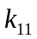simulatenously increases from 5.0 μM⁻¹s⁻¹ to 17.1 μM⁻¹s⁻¹, all modelling results remain the same.

- Root growth rate

A recent study suggests that auxin concentration distribution plays a major role in regulating root growth (Grieneisen et al. 2007). Auxin affects root growth in turn by modulating the stability of the growth-inhibitory DELLA proteins (Fu and Harberd, 2003). Ethylene in turn regulates root growth through effects on auxin biosynthesis and transport (Ruzicka et al. 2007). Furthermore, cytokinin biosynthesis, known to be active in root tips (Miyawaki et al. 2004) and a promoter of cell division via activation of D-type cyclins (Riou-Khamlichi et al. 1999), can be modulated by auxin (Nordström et al. 2004). Previous modelling data demonstrate that root growth can be analysed by establishing a relationship between auxin concentration at the root tip and growth rate (Grieneisen et al. 2007).

In general, the dose-response relationship between growth rate and auxin concentration is considered to be bell-shaped (Taiz and Zeiger 1991). When the endogenous auxin concentration is low, increasing auxin concentration enhances growth rate. However, when endogenous auxin concentration is high, any further increase in auxin concentration results in a reduced growth rate.

It is evident that PLS is required to define a bell-shaped curve that describes the relationship between endogenous auxin and root growth rate. For the experimental system relating to the function of the PLS gene, it was found that an increased auxin supply (up to ca. 1 nM 2,4-D or 10 nM NAA) or auxin concentration in the root is associated with an increased root length in the pls mutant seedling (Casson et al. 2002; Chilley et al. 2006). A linear regression for the pls mutant and wild type, based on Figure 2B in Chilley et al. (2006), shows that the growth rate ratio for the two cases is 0.55; while the auxin concentration ratio for the two cases is 0.60 (Figure 4C, Chilley et al. 2006). PLS overexpression (PLSox) also leads to an increase in root auxin concentration and root length simultaneously (Chilley et al. 2006). Therefore, the experimental system relating to the function of the PLS gene corresponds to the left side of a bell-shaped dose-response curve. When PLS transcription increases from pls to PLSox, the increase of auxin concentration leads to the increase of root growth rate.

Based on experimental observations, we can assume the following linear relationship for the lefthand side of the bell-shaped dose-response relation:

(if ) (s11)

where is the root length, is a function of auxin concentration; the relationship is assumed to be linear for the range of auxin concentration used in the experiments relating to PLS gene. is the growth rate constant. Based on the experimental results described in Figure 2B in Chilley et al. (2006), μm μM⁻¹s⁻¹, μM, which is the auxin concentration corresponding to PLSox.

For the righthand side of the bell-shaped dose-response curve between auxin concentration and root growth rate, increasing auxin concentration decreases root growth rate. There are insufficient data to fit a quantitative relationship between auxin concentration and root growth rate, and so the following relationship is assumed:

(if ) (s12)

where is a parameter describing how fast root growth rate decreases with auxin concentration. Here we set =1. Figure s6 shows the bell-shaped dose-response curve relating auxin concentration to root growth rate.
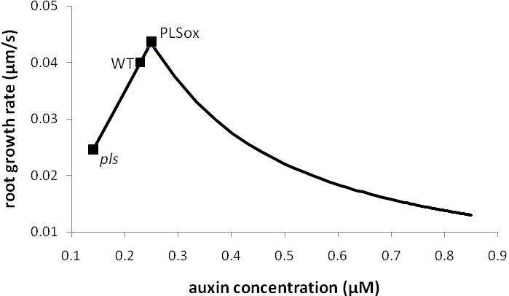
Figure s6. Bell-shaped dose-response relationship between auxin concentration and root length.

Following the dose-response curve Figure s6, if auxin concentration is less than 0.256 μM, increasing auxin concentration increases root growth rate. This trend has been observed for the experimental system relating to the function of the PLS gene (Chilley et al. 2006). Moreover, if auxin concentration is larger than 0.256 μM, increasing auxin concentration decreases root growth rate.
- Root growth rate relating to exogenously applying hormones

The bell-shaped curve that describes the relationship between endogenous auxin and root growth rate (Figure s6) is used to model root growth rate when hormones are exogenously applied. When ACC is exogenously applied, model analysis shows that auxin concentration in both wild-type and PLSox can increase to a sufficiently high level (>0.256 μM) that it inhibits root growth. Therefore, modeling an increase in ACC predicts a decreased root growth rate, as is experimentally observed (Casson et al. 2002; Ruzicka et al. 2007; Stepanova et al. 2007; Swarup et al. 2007). However, for pls, auxin concentration is low (0.14 μM, Chilley et al. 2006), and the model shows that increasing ACC concentration decreases auxin concentration (Figs. 4B and 5B in main text). However, since auxin concentration is low in pls (0.14 μM) and it is located at the left side of the bell-shaped curve (Figure s6), decreasing auxin concentration is predicted to result in a decrease in root growth rate. It is clear that, although experimental observations have shown that increasing ACC decreases root growth rate for wild-type, pls and PLSox (Casson et al. 2002, Chilley et al. 2006), model analysis shows that the underlying mechanism relating to the change in auxin concentration is different.

Similarly, modelling predicts that root elongation rate in both wild-type and pls monotonically decreases as exogenous cytokinin concentration increases. Model analysis reveals that this trend is due to the decrease of auxin concentration in both wild-type and pls (data not shown). This result agrees well with experimental observations (Casson et al. 2002).

Figure s7 models the predictions for the effects of exogenously applied auxin on root growth. Relative root growth rate in Figure s7 is defined as the root growth rate relative to that for a zero exogenous auxin concentration in wild-type. As exogenous auxin concentration increases, root growth rate in wild-type monotonically decreases. However, root growth rate in pls increases initially, then decreases. When the exogenous auxin concentration is large, the trend for the decrease of root growth rate in both wild-type and pls is similar.

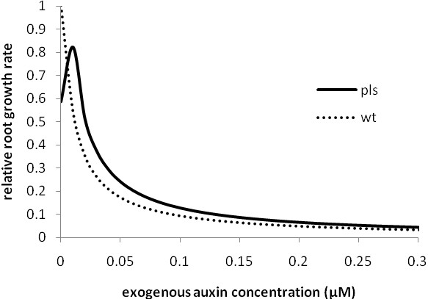
Figure s7. Effects of exogenous auxin on root growth rate is in agreement with experimental measurements (Casson et al. 2002). wt: 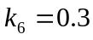s⁻¹, pls: 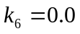s⁻¹.

For both wild-type and pls, endogenous auxin concentration is located at the left side of the bell-shaped curve (Figure s6) when exogenous auxin concentration is modelled to be zero. Model analysis reveals that, as exogenous auxin concentration increases, endogenous auxin concentration monotonically increases for both wild-type and pls (data not shown). When exogenous auxin concentration is increased incrementally by 0.01 μM, the endogenous auxin concentration for wild-type increases immediately to a high level, such that auxin inhibits root growth. Therefore, increasing exogenous auxin concentration monotonically reduces root growth rate. However, for pls, when exogenous auxin concentration is increased by 0.01 μM incrementally, endogenous auxin concentration initially stays at the left side of the bell-shaped curve where auxin promotes root growth. However, as the exogenous auxin concentration continues to increase, the endogenous auxin concentration will reach a level at which auxin inhibits root growth. Therefore, increasing exogenous auxin concentration initially increases root growth rate, then decreases it. If exogenous auxin concentration is increased by 0.1 μM incrementally, root growth rate in both wild-type and pls monotonically decreases. The analysis models how root growth rate sensitively depends on the change in the concentration of exogenous hormones, and the results are in agreement with experimental observations (Casson et al. 2002).

- Simultaneous applications of different exogenous hormones
We have demonstrated that the developed model is capable of analysing different mutants and reproducing all known mutants relating to the applications of individual hormone in the main text and in Supplementary Material. The model is also able to examine how simultaneous applications of different exogenous hormones impact on endogenous hormonal level, gene expression, and their interplays.

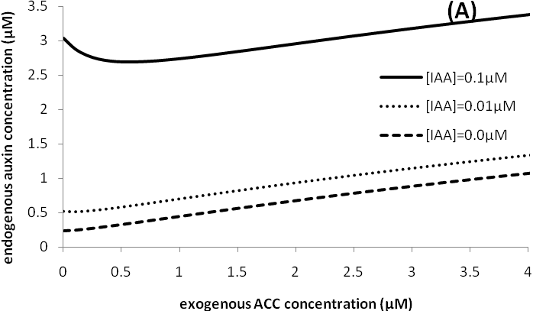
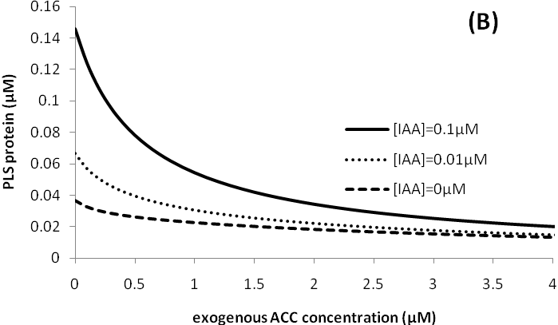
Figure s8. Effects of simultanous applications of both exogenous IAA and ACC on endogenous auxin and PLS protein level.
Figure s8 shows the effects of simultaneous applications of exogenous ACC and IAA on PLS gene expression and endogenous auxin level. In Figure s8A, when [IAA] is low, increasing exogenous ACC concentration monotonically increases endogenous auxin concentration. However, when [IAA] is high, increasing exogenous ACC concentration firstly decreases then increases endogenous auxin concentration. In figure s8B, although increasing [IAA] increases PLS protein, increasing exogenous ACC concentration always reduces PLS protein. The responses of endogenous auxin concentration and PLS protein to both exogenous IAA and ACC reflect the overall results of the complicated interplay shown in Figures 1 and 9 in the main text. Increasing exogenous ACC increases endogenous ethylene, leading to the changes in ethylene-related signalling. Similarly, increasing exogenous IAA increases endogenous auxin and further leads to the changes in auxin-related signaling. The compounded effects result in the results shown in Figure s8.

- Further discussion
In this work, we have developed the first hormonal crosstalk model by integrating modelling and experimental analysis. This combined approach has provided new insight into how PLS regulates auxin concentration in the root, by controlling the relative contribution of auxin transport into and out of the root and auxin biosynthesis in the root, and by integrating auxin, ethylene and cytokinin signalling.
First, model development shows there are two candidates for the interaction between the PLS peptide and ethylene signalling module at or close to ETR1/the ethylene receptor: a) PLSp activates the conversion of Re into Re* and b) PLSp inhibits the conversion of Re* into Re. The two candidates qualitatively lead to the same experimental observations. In order to distinguish between the two candidates, further quantitative experiments are required to determine kinetic parameters for the two interactions. Since the kinetic parameters for those interactions are unknown, it is not possible to distinguish the two candidates at this stage. However the two candidates for the interaction between PLSp and ethylene receptor lead to the same results: namely PLSp increases Re*. Moreover, model development reveals that the observed regulatory effects of ethylene on PLS transcription must be independent of auxin. Second, the model, which is based on known molecular interactions and experimental evidence, is able to reproduce all relevant mutants, and it is therefore used to make predictions. Model prediction for endogenous cytokinin concentration in wild type and pls mutant seedlings is in agreement with experimental measurements.
Moreover, the discrepancy between modelling and experimental results for auxin concentration in pls reveals an additional role for PLS in auxin accumulation, through effects on auxin biosynthesis ain the root. The model further reveals how PLS regulates auxin concentration in the root by controlling the relative contribution of auxin transport and biosynthesis. Experimental analysis of the effects of exogenously applying ACC, and the inhibition of ethylene responses either genetically or pharmacologically, on auxin concentration can be understood in terms of the effect of PLS on ethylene signalling and ethylene-regulated auxin biosynthesis and transport.
Third, model analysis reveals that a bell-shaped dose-response relationship exists between endogenous auxin and root length, and is dependent on the PLS gene to function correctly. This model analysis therefore provides new insight into how exogenous hormones influence root growth rate. Although exogenously applying auxin, cytokinin and ACC generally reduces root growth rate, the underlying mechanisms may be different.
In the model, it is proposed that the interaction between ethylene signalling responses and auxin transport involves a molecule or molecules X, since the molecular mechanism is currently unknown. The model is able to quantitatively predict the response of the molecule X to external auxin and ethylene. The results can be used to search experimentally for the molecule or molecules in the future. One possibility is that a PIN-dependent process is represented by X, as functional PIN protein levels change in response to ethylene, and potentially they change differently in different tissues – for example PIN2 is upregulated in the root tip in response to ethylene (Ruzicka et al. 2007).
It is clear that a bell-shaped dose-response relationship between endogenous auxin and root length is established via the PLS gene. The left side of the bell-shaped curve is quantitatively established using experimental data relating to PLS. The right side of the bell-shaped curve is only semi-quantitative due to lack of the data linking endogenous auxin concentration and root length. In general, a bell-shaped curve can be quantitatively described by two sigmoidal functions. However, such a description requires many parameters. At present, there are insufficient experimental data to fit those parameters. In this work, we use equations (s11) and (s12) to describe a bell-shaped dose-response relationship between endogenous auxin and root growth rate. The bell-shaped curve is sufficient to understand how root growth rate changes when endogenous auxin concentration changes. Model analysis reveals that a reduction in root growth rate by exogenously applying cytokinin is due to a decrease of endogenous auxin concentration. When ACC is exogenously applied, although root growth rate in both wild type and pls decreases, the underlying mechanism is different. In wild type, the increase in auxin concentration causes a decrease in root growth rate. However in pls, the decrease of auxin concentration plays the same role.
Experimental data show that when auxin is exogenously applied to wild-type seedlings, PLS transcription increases. However, when ACC is exogenously applied, PLS transcription decreases (Casson et al. 2002, Chilley et al. 2006). Since both exogenous auxin and ACC lead to the increase of endogenous auxin, but result in an opposite response in terms of PLS transcription, ethylene must regulate PLS transcription independently of auxin signalling. The molecular basis of this regulation is currently unknown.

- References
Casson SA, Chilley PM, Topping JF, Evans IM, Souter MA, Lindsey K (2002) The POLARIS gene of Arabidopsis encodes a predicted peptide required for correct root growth and leaf vascular patterning. Plant Cell 14: 1705–1721

Casson SA, Lindsey K (2003) Genes and signalling in root development. New Phyt 158: 11-38

Chen YF, Randlett MD, Findell JL, Schaller GE (2002) Localization of the ethylene receptor ETR1 to the endoplasmic reticulum of Arabidopsis. J Biol Chem 277: 19861-19866

Chilley PM, Casson SA, Tarkowski P, Wang KLC, Hawkins N, Hussey PJ, Beale M, Ecker JR, Sandberg GK, Lindsey K (2006) The POLARIS peptide of Arabidopsis regulates auxin transport and root growth via effects on ethylene signaling. Plant Cell 18: 3058–3072.

Coenen C, Christian M, Luthen H, Lomax TL (2003) Cytokinin inhibits a subset of Diageotropica-dependent primary auxin responses in tomato. Plant Physiol 131: 1792-1704

Diaz J, Alvarez-Buylla E (2006) A model of the ethylene signalling pathway and its gene response in Arabidopsis thaliana: pathway cross-talk and noise-filtering properties. Chaos 16: 023112-11-023112-16

Eklof S, Astot C, Blackwell J, Moritz T, Olsson O, Sandberg G (1997) Auxin-cytokinin interactions in transgenic tobacco. Plant Cell Physiol 38: 225-235

Fu X, Harberd NP (2003) Auxin promtes Arabidopsis root growth by modulating gibberellin response. Nature 421: 740-743

Grieneisen VA, Xu J, Marée AFM, Hogeweg P, Scheres B (2007) Auxin transport is sufficient to generate a maximum and gradient guiding root growth. Nature 449: 1008-1013

Klipp E, Herwig R, Kowald A, Wierling C, Lehrach H (2004) Systems biology in practice. WILEY-VCH Verlag GmbH & Co. KGaA

Miyawaki K, Matsumoto-Kitano M, Kakimoto T (2004) Expression of cytokinin biosynthetic isopentenyltransferase genes in Arabidopsis: tissue specificity and regulation by auxin, cytokinin, and nitrate. Plant J 37: 128–138

Nordstrom A, Tarkowski P, Tarkowska D, Norbaek R, Astot C, Dolezal K, Sandberg G (2004) Auxin regulation of cytokinin biosynthesis in Arabidopsis thaliana: A factor of potential importance for auxin-cytokinin-regulated development. Proc Natl Acad Sci USA 101: 8039–8044

Riou-Khamlichi C, Huntley R, Jacqmard A, Murray JAH (1999) Cytokinin activation of Arabidopsis cell division through a D-type cyclin. Science 283: 1541-1544

Ruzicka K, Ljung K, Vanneste S, Podhorska R, Beeckman T, Friml J, Benkova E (2007) Ethylene regulates root growth through effects on auxin biosynthesis and transport-dependent auxin distribution. Plant Cell 19: 2197–2212

Stepanova AN, Jun J, Likhacheva AV, Alonso JM (2007) Multi-level interactions between ethylene and auxin in Arabidopsis roots. Plant Cell 19: 2169-2185

Swarup R, Perry P, Hagenbeek D, Van Der Straeten D, Beemster GTS, Sandberg G, Bhalerao R, Ljung K, Bennett MJ (2007) Ethylene up-regulates auxin biosynthesis in Arabidopsis seedlings to enhance inhibition of root cell elongation. Plant Cell 19: 2186-2196

Taiz L, Zeiger E, (1991) Plant Physiology. The Benjamin/Cummings Publishing Company, Inc.

Vogel JP, Woeste KE, Theologis A, Kieber, JJ (1998) Recessive and dominant mutations in the ethylene biosynthetic gene ACS5 of Arabidopsis confer cytokinin insensitivity and ethylene overproduction, respectively. Proc Natl Acad Sci USA 95: 4766-4771

