Supplementary Information

Table of Contents
Supplementary Figures and Legends : Figs S1 to S19
Supplementary Tables: Tabs. S1 to S3
Supplementary Movie SM1 (legend and video)
1. Supplementary Figures and Legends

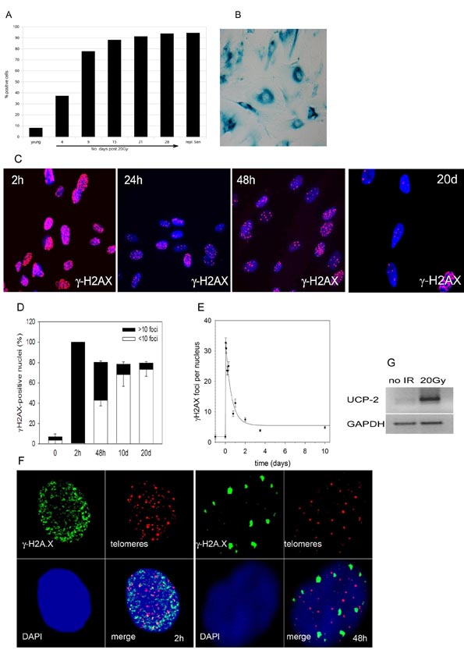
Fig. S1: Ionizing radiation induces telomere-independent senescence in human MRC5 fibroblasts. A) Frequencies of Sen-β-Gal-positive cells at the indicated times after 20Gy IR. Data are percentage of all cells stained positive from 2 experiments (mean 42 cells per timepoint). B) Representative sen-β-Gal staining micrograph of MRC5 cells at 21 days after IR. C) γH2A.X foci formation (red) at the indicated times after irradiation (blue: DAPI). Micrographs are representative for 5 experiments. D) Frequencies of γH2A.X foci-positive nuclei at the indicated times after irradiation. Data are mean ± s.e.m. from 3 experiments. E) Average frequencies of γH2A.X foci per nucleus. Data are mean ± s.e.m. from 3 experiments. F) ImmunoFISH images of γH2AX foci (green) and telomeres (red) in typical nuclei at 2 h (left) and 48 h (right) after IR, showing absence of telomere-foci co-localisation. G) UCP2 expression in MRC5 cells before (no IR) and 48 h after 20Gy irradiation as measured by RT-PCR using GAPDH as loading control. Experiments were repeated 3 times with identical results.

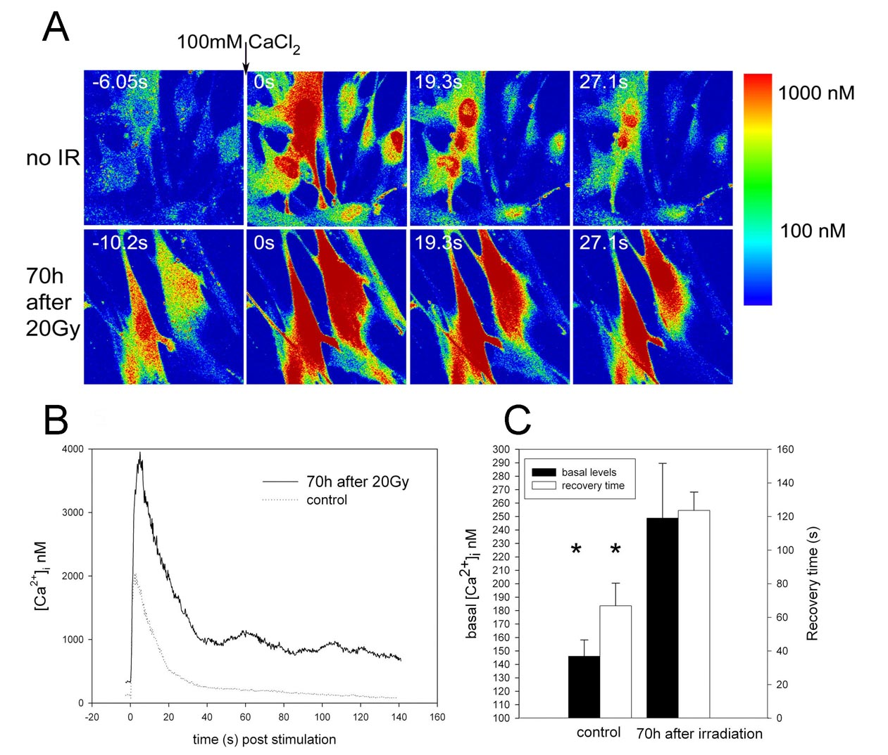

Fig. S2: Cytoplasmic Ca²⁺ regulation is compromised after ionizing radiation. A) MRC5 cells were irradiated with 20Gy (bottom) or not (top) and 70h later, basal [Ca²⁺]_{i} levels and [Ca²⁺]_{i} dynamics following challenge with 100 mM extracellular Ca²⁺ was measured by Fluo3 fluorescence before (left) and at the indicated times after challenge. Colour code is shown on the right. B) Characteristic response curves in unirradiated control and irradiated cell. C) Quantification of basal [Ca²⁺]_{i} levels (filled bars) and recovery time (open bars) in controls and irradiated cells. Data for basal [Ca²⁺]_{i} levels are mean ± s.e.m. from 60 young and 41 irradiated cells (P=0.006, Students t test), data for recovery time are from 11 control cells and 5 irradiated cells (P=0.02, Students t test).

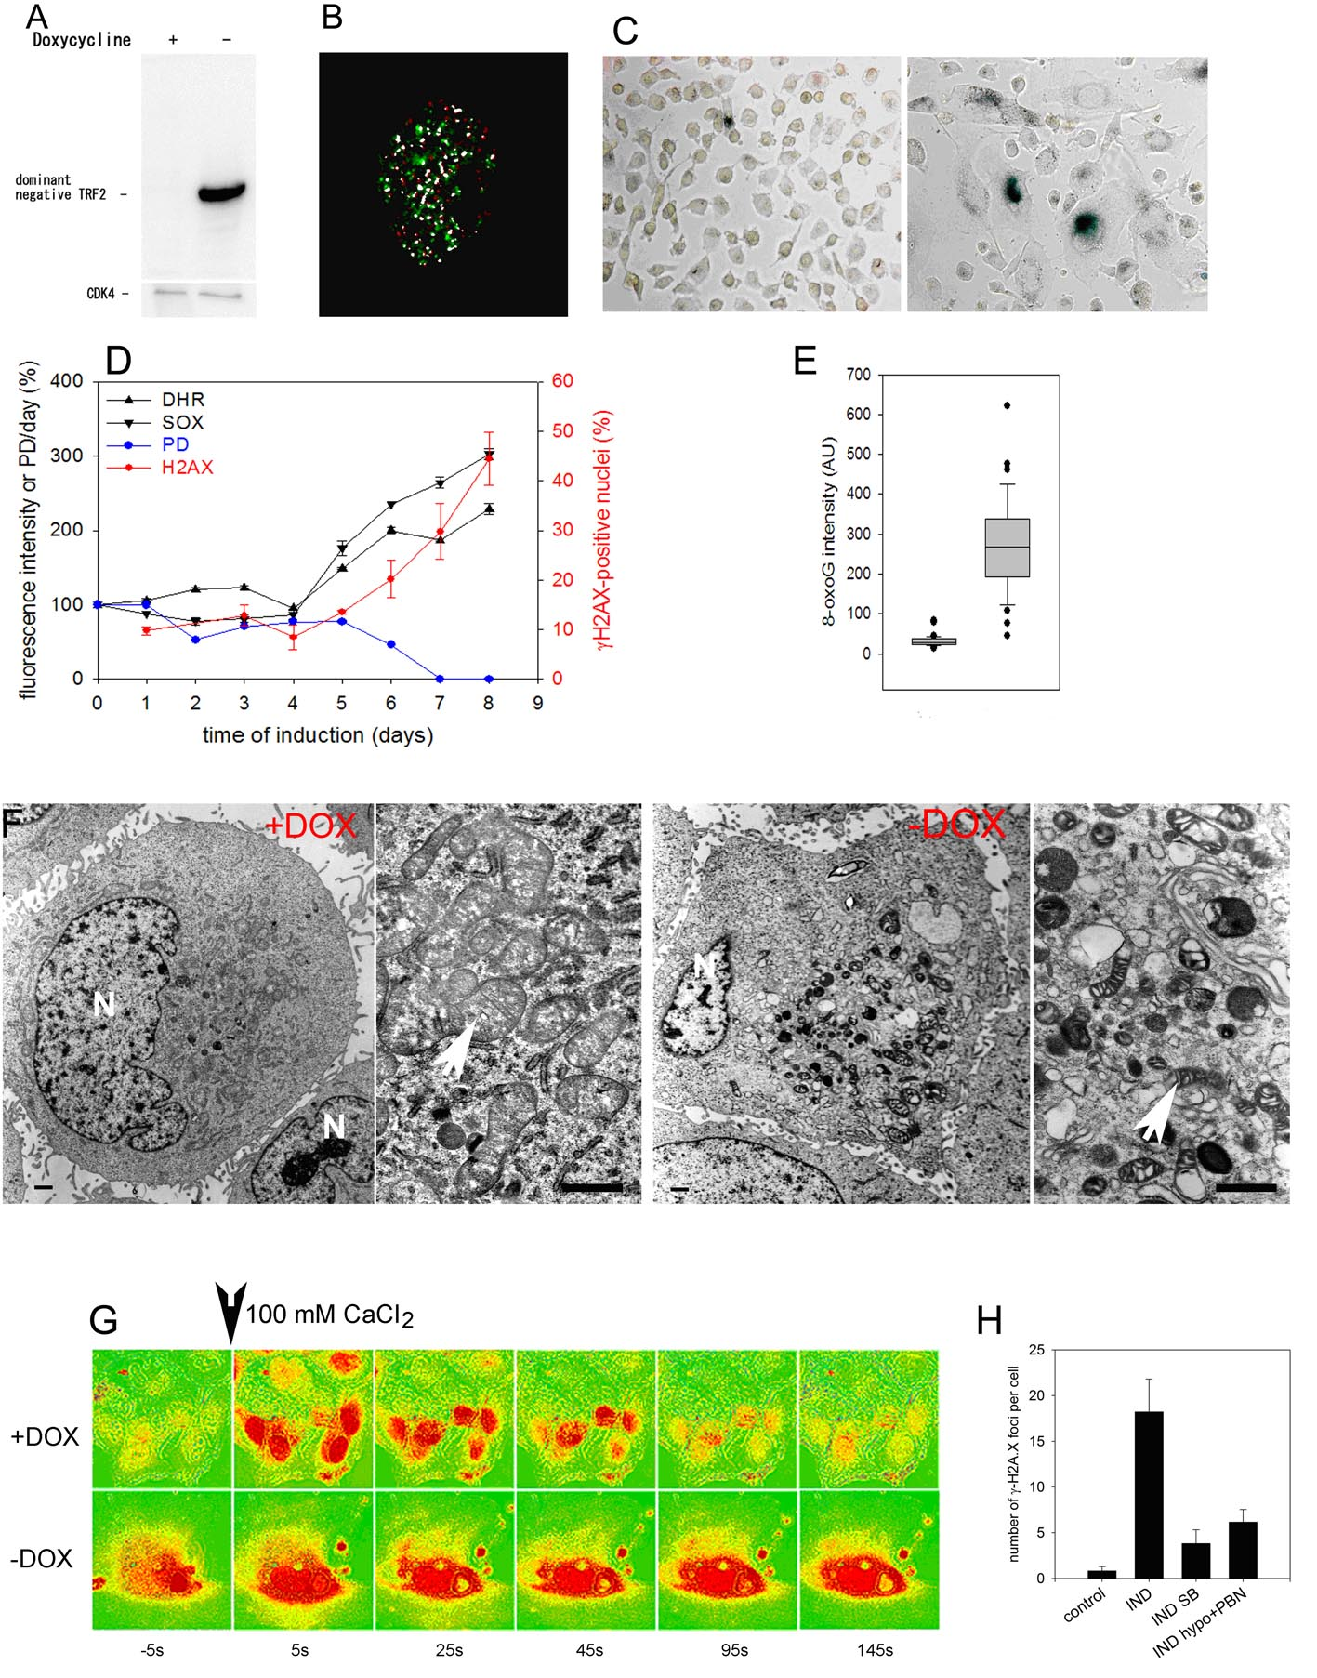

Fig S3: TRF2^{ΔBΔM} induction induces telomere-dependent senescence and markers of mitochondrial dysfunction. A) Expression of TRF2^{ΔBΔM} after 8 days doxycycline removal in T19 human fibrosarcoma cells. CDK4 was used as loading control. B) Co-localisation of telomeres (red) and γH2AX foci (green) after 8 days doxycycline removal. White indicates significant overlap according to a pixel-by-pixel Pearson correlation analysis. C) Representative sen-β-Gal staining micrographs of T19 cells at days 0 (left) and 8 (right) after doxycycline removal. D) Kinetics of population doublings per day (PD), MitoSOX fluorescence, DHR fluorescence and percentage of γH2A.X-positive nuclei after doxycycline removal. Data are mean ± s.e.m. from triplicate measurements (days 1 – 7) or from 3 independent experiments (days 0 and 8). E) Intensity of nuclear 8oxodG immunofluorescence. F) Representative electron micrographs of T19 control cells (+DOX) and at day 8 after doxycycline removal (-DOX). Bars denote 1 μm, N: nucleus. Arrowheads indicate normal mitochondria in controls (left) and typical mitochondria after TRF2^{ΔBΔM} induction (right), showing swollen intermembrane space and disorganized cristae. G) T19 cells were grown for 8 days with (+DOX) or without (-DOX) doxycycline, challenged with 100mM CaCl₂ and [Ca²⁺]_{i} levels at the indicated times before and after challenge were visualised by Fluo3. Micrographs are representative of 3 experiments. H) γH2A.X foci frequencies after doxycycline removal in T19 cells (IND) under control conditions, under antioxidant treatment (5% ambient O₂, 0.4mM PBN) and p38 inhibitor SB203580 (SB).

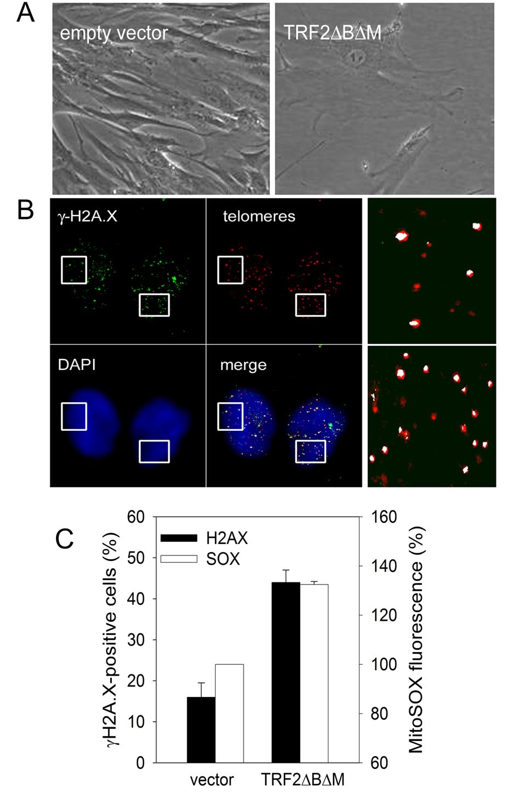

Fig. S4: Overexpression of TRF2^{ΔBΔM} in human MRC5 fibroblasts induces telomere-dependent senescence and ROS production. A) MRC5 fibroblasts were infected with empty vector (left) or pLPCNMyc-TRF2^{ΔBΔM} (right). Representative micrographs of infected cells are shown. B) ImmunoFISH images of typical pLPCNMyc-TRF2 ^{ΔBΔM} –infected human primary MRC5 fibroblasts showing γH2A.X foci (green) and telomeres (red). Blue: DAPI. White indicates significant overlap according to a pixel-by-pixel Pearson correlation analysis. Boxed areas are shown at higher magnification at the right. C) Quantification of γH2A.X-positive nuclei and MitoSOX fluorescence in empty vector- and pLPCNMyc-TRF2 ^{ΔBΔM} –infected MRC5 fibroblasts. Data are mean ± s.e.m. from 3 experiments. P< 0.01 (Students t test).

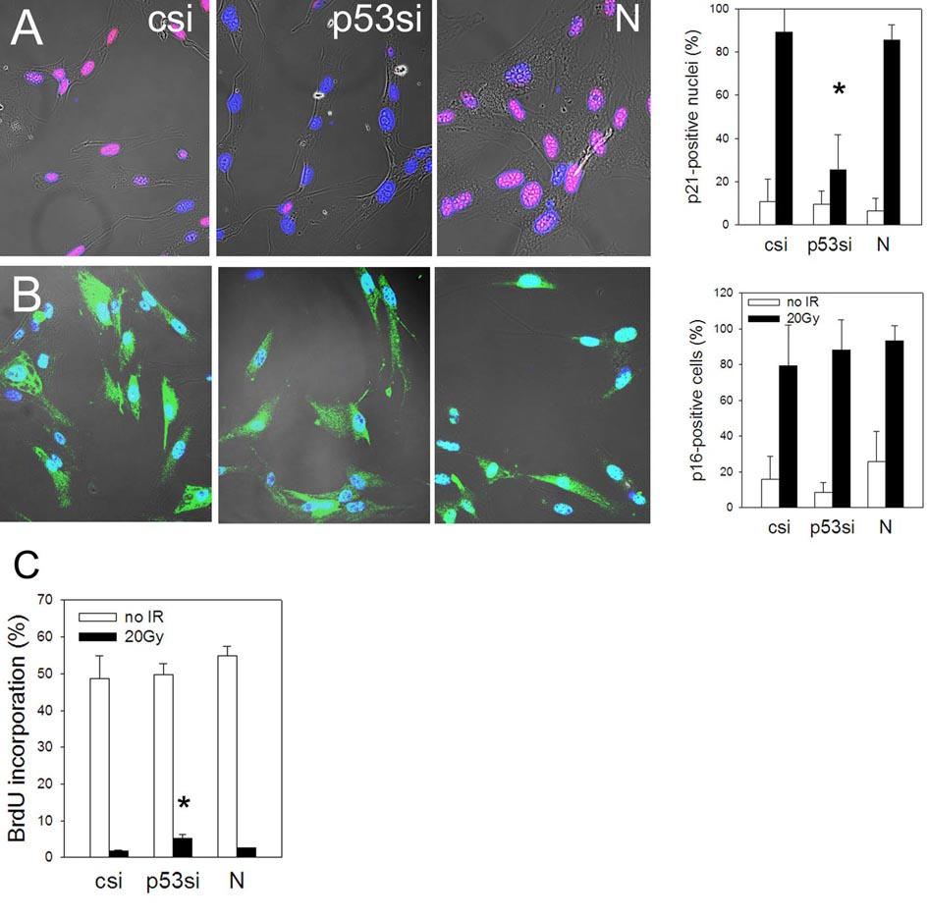

Fig. S5: Knockdown of p53 ablates CDKN1A induction, but not CDKN2A (p16^{ARF}) induction after 20Gy IR. MRC5 cells were transfected with anti-p53 (p53si), control (csi) or no (N) siRNA, irradiated with 20 Gy, and CDKN1A (A) and CDKN2A (B) levels were analysed by immunofluorescence 24 h after IR. Representative phase contrast/confocal images are shown on the left. Percentages of positive cells are given on the right. All quantitative data are mean ± s.e.m. from 3 experiments. P values compare irradiated p53si to irradiated csi (P_{C}) and N (P_{N}) controls (ANOVA/Tukey). Differences with P<0.05 are marked with an asterisk. A) both P<0.0001. B) P_{C}=0.490, P_{N}=0.784. C) Percentage of BrdU-positive cells at 72 h after IR. P_{C}=0.007, P_{N}=0.034.

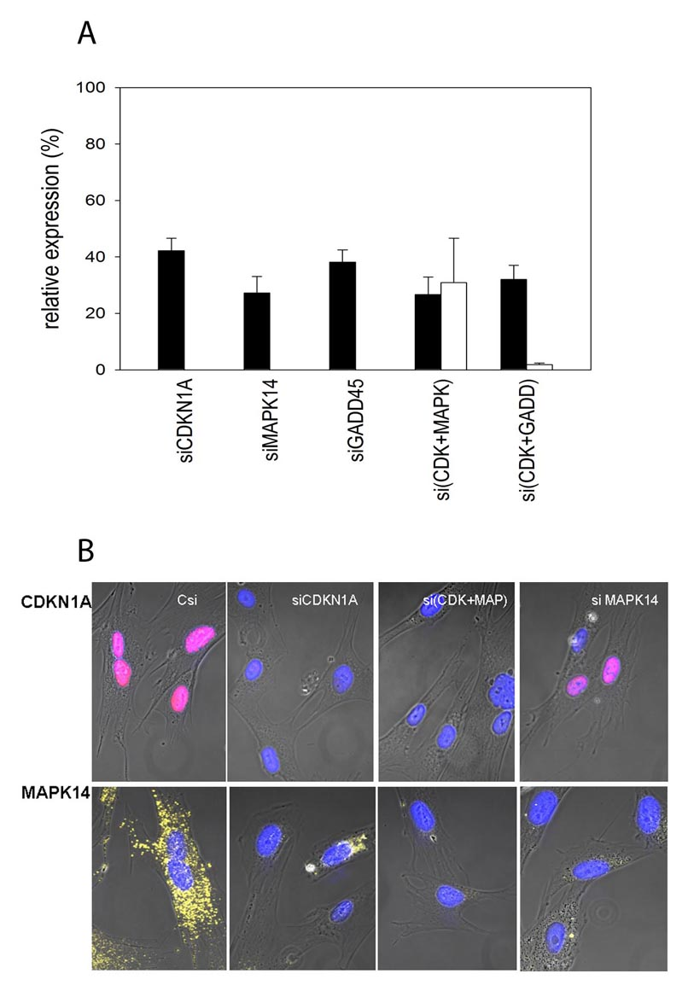

Fig. S6: Efficiencies of siRNA knock-downs. A) mRNA levels for CDKN1A, MAPK14 and GADD45A as measured after single and combined knockdowns using the indicated siRNAs. Levels are relative to GAPDH and are mean ± s.e.m. from 3 replicates. For combined treatments, black bars refer to the first and open bars to the second named species. B) Representative immnunofluorescence images for CDKN1A and MAPK14 after treatment with the indicated siRNAs.

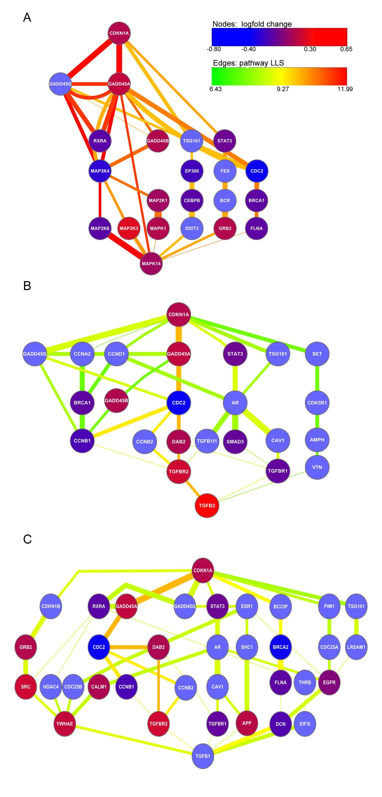

Fig. S7. Most probable pathways connecting CDKN1A with MAPK14 (A), TGFB2 (B) or TGFB1 (C) according to an interactome query. Edge thickness indicates the LLS for any individual interaction, edge colour gives the pathways LLS, and node colour indicates the average log fold change in mRNA levels in senescent vs young MRC5.

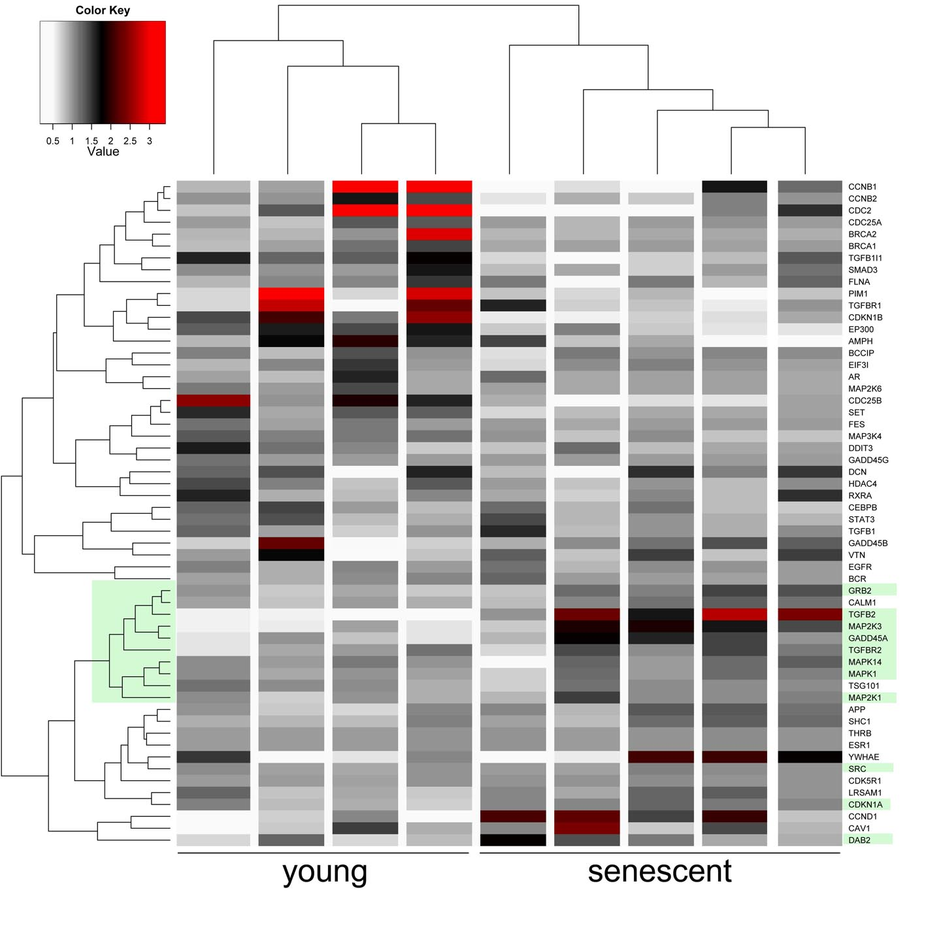

Fig. S8: Hierarchical unsupervised cluster map of relative mRNA expression levels of all candidate genes identified by the interactome queries in Fig. S9 in young and senescent MRC5 fibroblasts. Data are from ³¹. Colour code indicates fold expression changes. GADD45A, MAPK14, GRB2, TGFBR2 and TGFB2 belong to a single tightly co-regulated cluster (marked in light green).
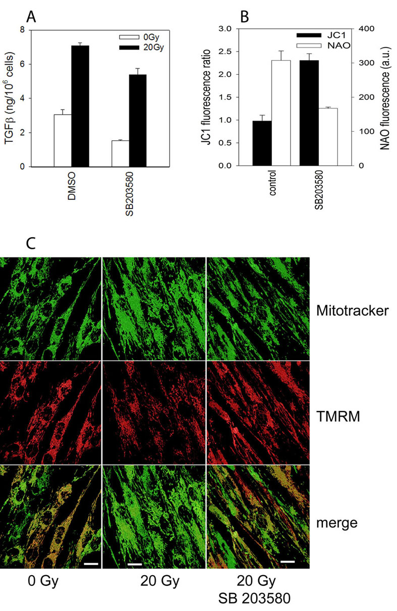
Fig. S9: Inhibition of MAPK14 reduces TGFβ secretion and mitochondrial mass and increases MMP. A) MRC5 cells were irradiated with 20Gy and treated with SB203580 or vehicle afterwards. Data are mean ± s.e.m from 3 independent culture dishes. Differences are significant with P = 0.007 (0 Gy) and P = 0.014 (20 Gy, Students t-test). B) Inhibition of MAPK14 using SB203580 increases the JC1 fluorescence ratio (P <0.001, Mann-Whitney Rank Sum test) and decreases mitochondrial mass (NAO fluorescence, P = 0.007) at 48h after IR. Data are mean ± s.e.m. from 30 cells (JC1) or 3 experiments (NAO). C) Confocal pseudocolor images (deconvolved surface projections) of MRC5 fibroblasts at 48 h after IR showing mitochondrial mass (by Mitotracker Green staining, top) and MMP (by TMRM fluorescence, middle). Fluorescence intensity per unit area is higher for Mitotracker Green (green) and lower for TMRM (red) after IR as compared to either unirradiated controls or irradiated cells treated with the MAPK14 inhibitor SB203580. Bar equals 20 μm.
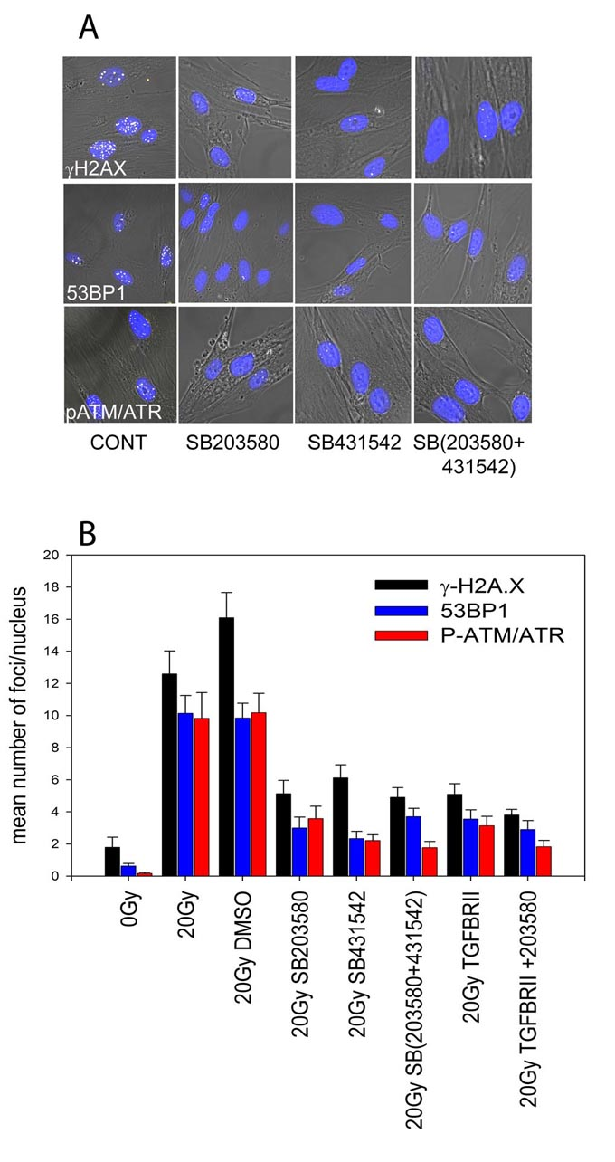

Fig. S10: Inhibition of MAPK14 and TGFβ reduces DNA damage foci frequencies. MRC5 cells were irradiated with 20Gy (CONT) and treated with the MAPK14 inhibitor SB203580, the TGFβ inhibitor SB431542, or both. A) Representative immunofluorescence/phase contrast micrographs for γH2A.X (top), 53BP1 (middle) and p-ATM/ATR foci (bottom) at 48h after IR. Blue: DAPI, white: foci. B) Quantisation of results. Data are M±SEM, n=3. Reductions are significant for all treatments.

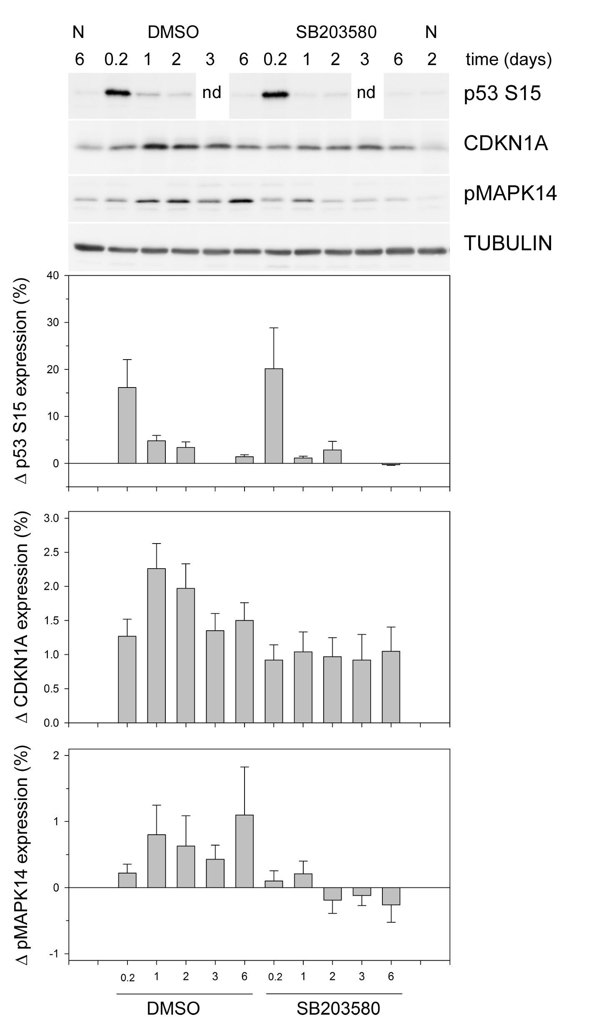

Fig. S11: SB203580 treatment lowers the levels of activated TP53 (p53-S15), CDKN1A and phosphorylated MAPK14. MRC5 cells were treated with SB203580 or DMSO (vehicle) and lysates for Western blotting were prepared at the indicated times after 20Gy IR. N, not irradiated. Bar graphs show relative expression differences to non-irradiated controls. Data are M±SEM, n= 7 (CDKN1A) or n=4 (pMAPK14 and p53 S15) except for p53 S15 day 3, where n = 2 and the error bar indicates the difference between means.
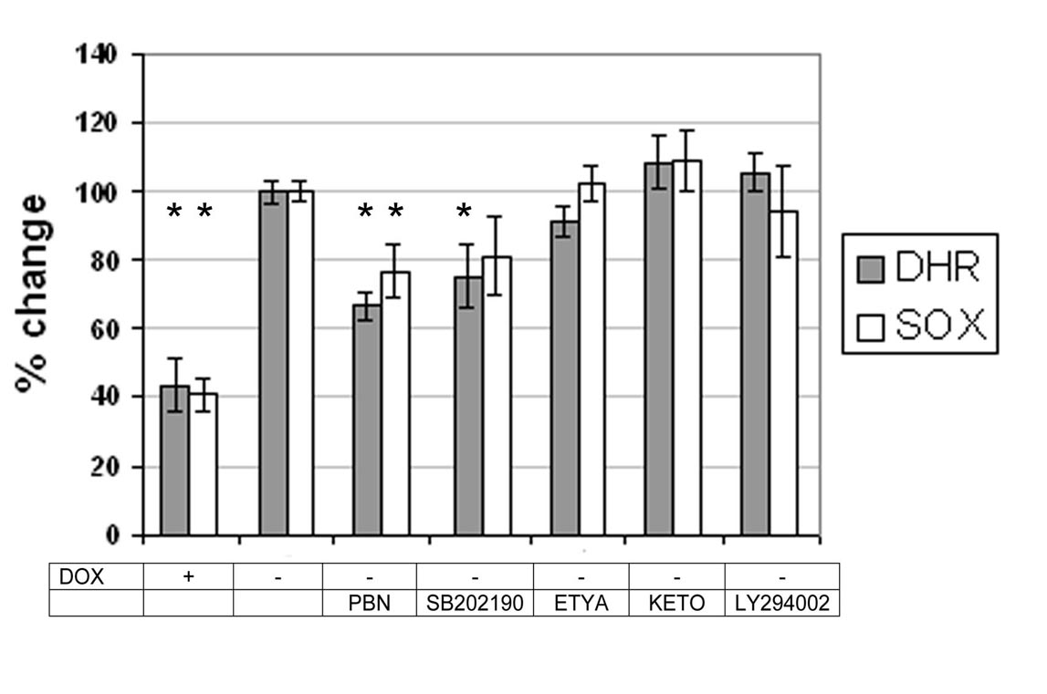

Fig. S12: Extramitochondrial sources or PI3K signalling do not impact on ROS production in induced T19 cells. TRF2^{ΔBΔM} expression was induced by removal of DOX for 8 days (DOX-). Fluorescence values in DOX- cells were set at 100%. Treatments were: 400 μM PBN (ROS scavenger), 20 μM SB202190 (MAPK14 inhibitor), 30 μM Eicosatetraynoic acid (ETYA, inhibits arachidonic acid metabolism), 5 μM Ketokonazole (inhibits cytochrome P450 enzymes), or 12 mM LY294002 (inhibits PI3K). Stars indicate a significant difference to 100% (P<0.05, ANOVA/TUKEY).

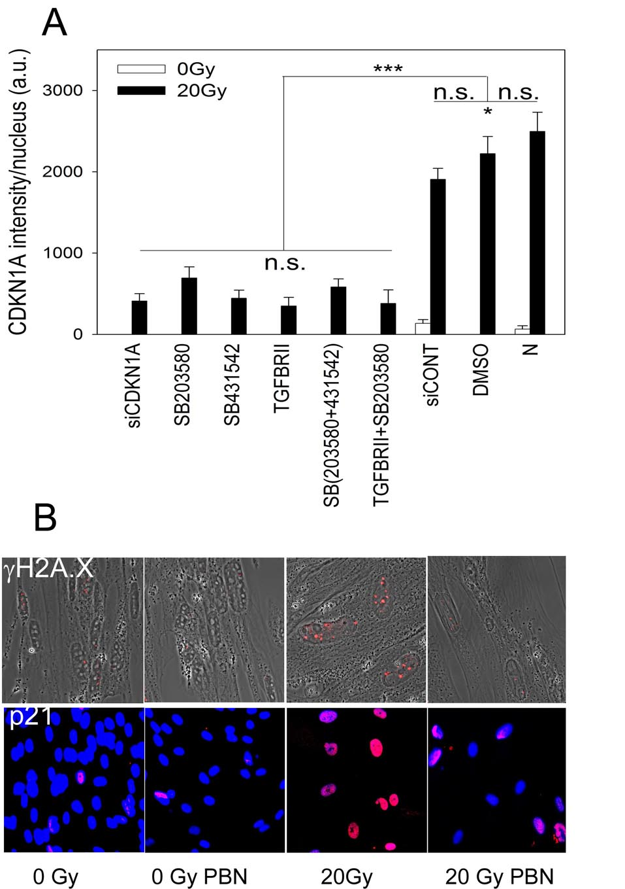
Fig. S13: Feedback loop inhibition reduces γH2A.X foci and CDKN1A induction in irradiated MRC5 cells. A) CDKN1A staining intensity per nucleus after the indicated treatments. M±SEM, n=3. *P<0.05, ***P<0.001 (ANOVA). B) 800 μM PBN reduced γH2A.X foci frequency (top) and CDKN1A immunofluorescence (bottom) at 48h after IR. Micrographs are representative for 3 experiments.
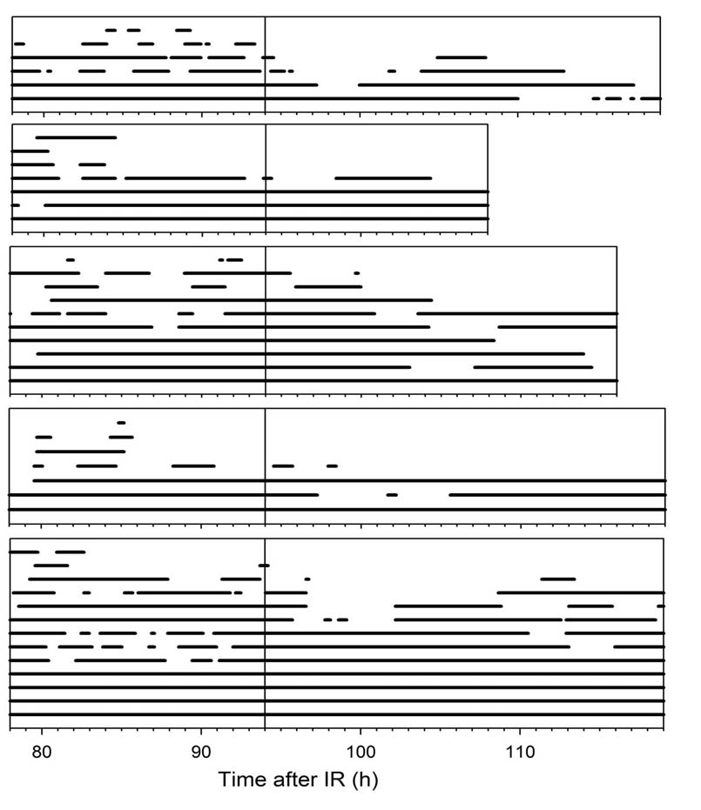

Fig. S14: Inhibition of feed-back signalling by SB203580 treatment preferentially reduces the frequency of short-lived DNA damage foci. Traces of AcGFP-53BP1c foci in five individual MRC5 cells over the indicated time interval after 20Gy IR. The vertical bar indicates the start of treatment with SB203580. Each bar represents the track of one individual focus recorded for the indicated time interval. Individual bars drawn at the same level indicate independent foci.
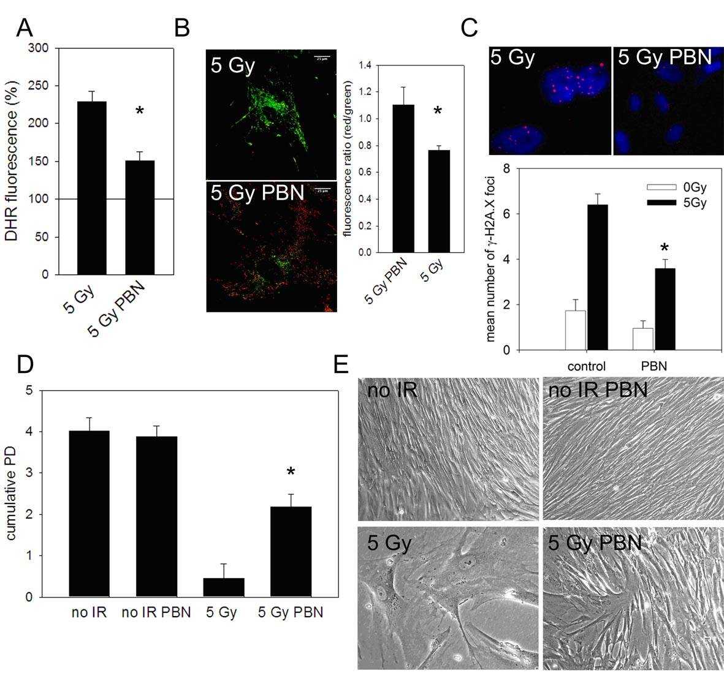

Fig. S15: Immediate treatment of MRC5 cells with the free radical scavenger PBN after low-dose irradiation reduces post-irradiation ROS and allows resumption of growth. MRC5 cells were treated with 400μM of PBN after 5 Gy IR for 2 days. A) DHR fluorescence (in % of unirradiated controls). P< 0.001. B) Representative image of mitochondrial membrane potential measured by JC-1 (left) and quantification of red/green ratio of JC-1 staining (right). C) Effect of PBN on mean γH2A.X foci number 2 days after 5Gy irradiation. Top: representative image of γH2A.X foci (red), DAPI (blue) D) Cumulative PD at 7 days after IR. Data are mean ± s.e.m from 3 replicates from a representative experiment out of 5. C) Representative micrographs of cells 7 days after seeding at clonal density.
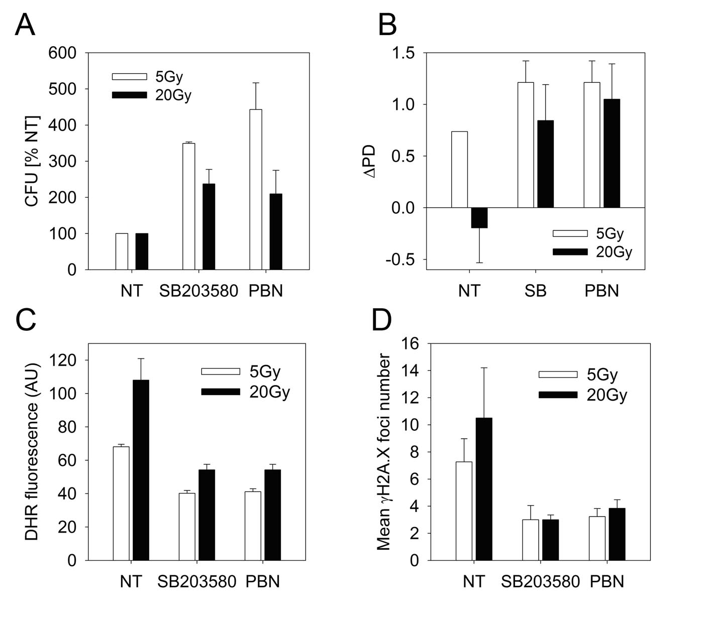
Fig. S16 Late treatment of MRC5 cells with the free radical scavenger PBN or the p38 MAPK inhibitor SB203580 at 6 days after IR reduces post-irradiation ROS, DDR and allows resumption of growth irrespective of irradiation dose. Cells were treated with 5Gy or 20 Gy IR at day 0 and with SB203580 or PBN (or not treated, NT) at day 6. A) Quantification of colony forming units (CFU, % of untreated cells) at day 13 after IR. B) Cumulative PD at day 10 after IR. Data are mean ± s.e.m from 3 replicates. C) DHR fluorescence at day 8 (mean ± s.e.m from 3 independent experiments). D) γH2A.X foci at day 8 (mean ± s.e.m from 3 independent experiments).

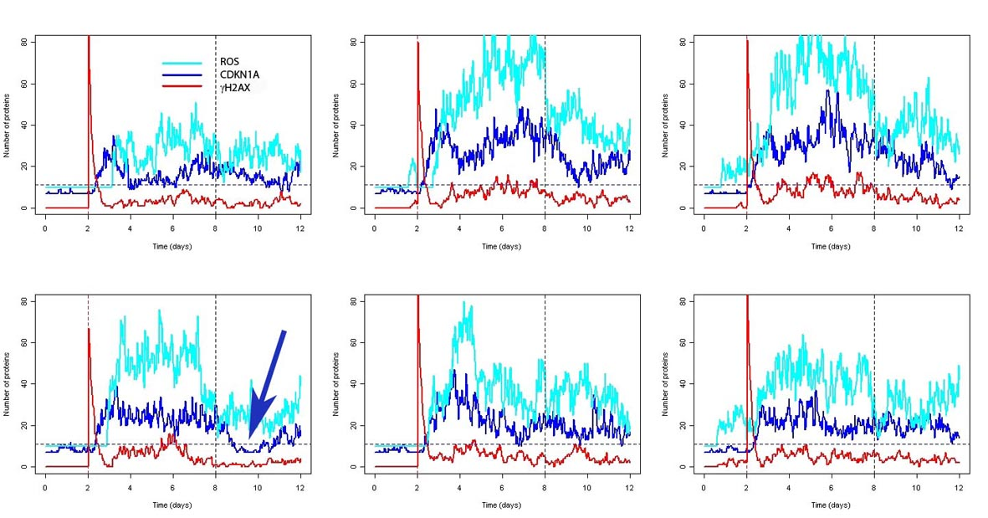

Fig. S17: Kinetic random model tracks for six randomly selected cells. Shown are traces for ROS levels (light blue), CDKN1A levels (dark blue) and DNA damage foci frequencies (red) assuming induction of DNA damage at day 2 and treatment with SB203580 from day 8. The blue arrow indicates one cell with CDKN1A levels below threshold for more than 24h under SB203580 treatment.

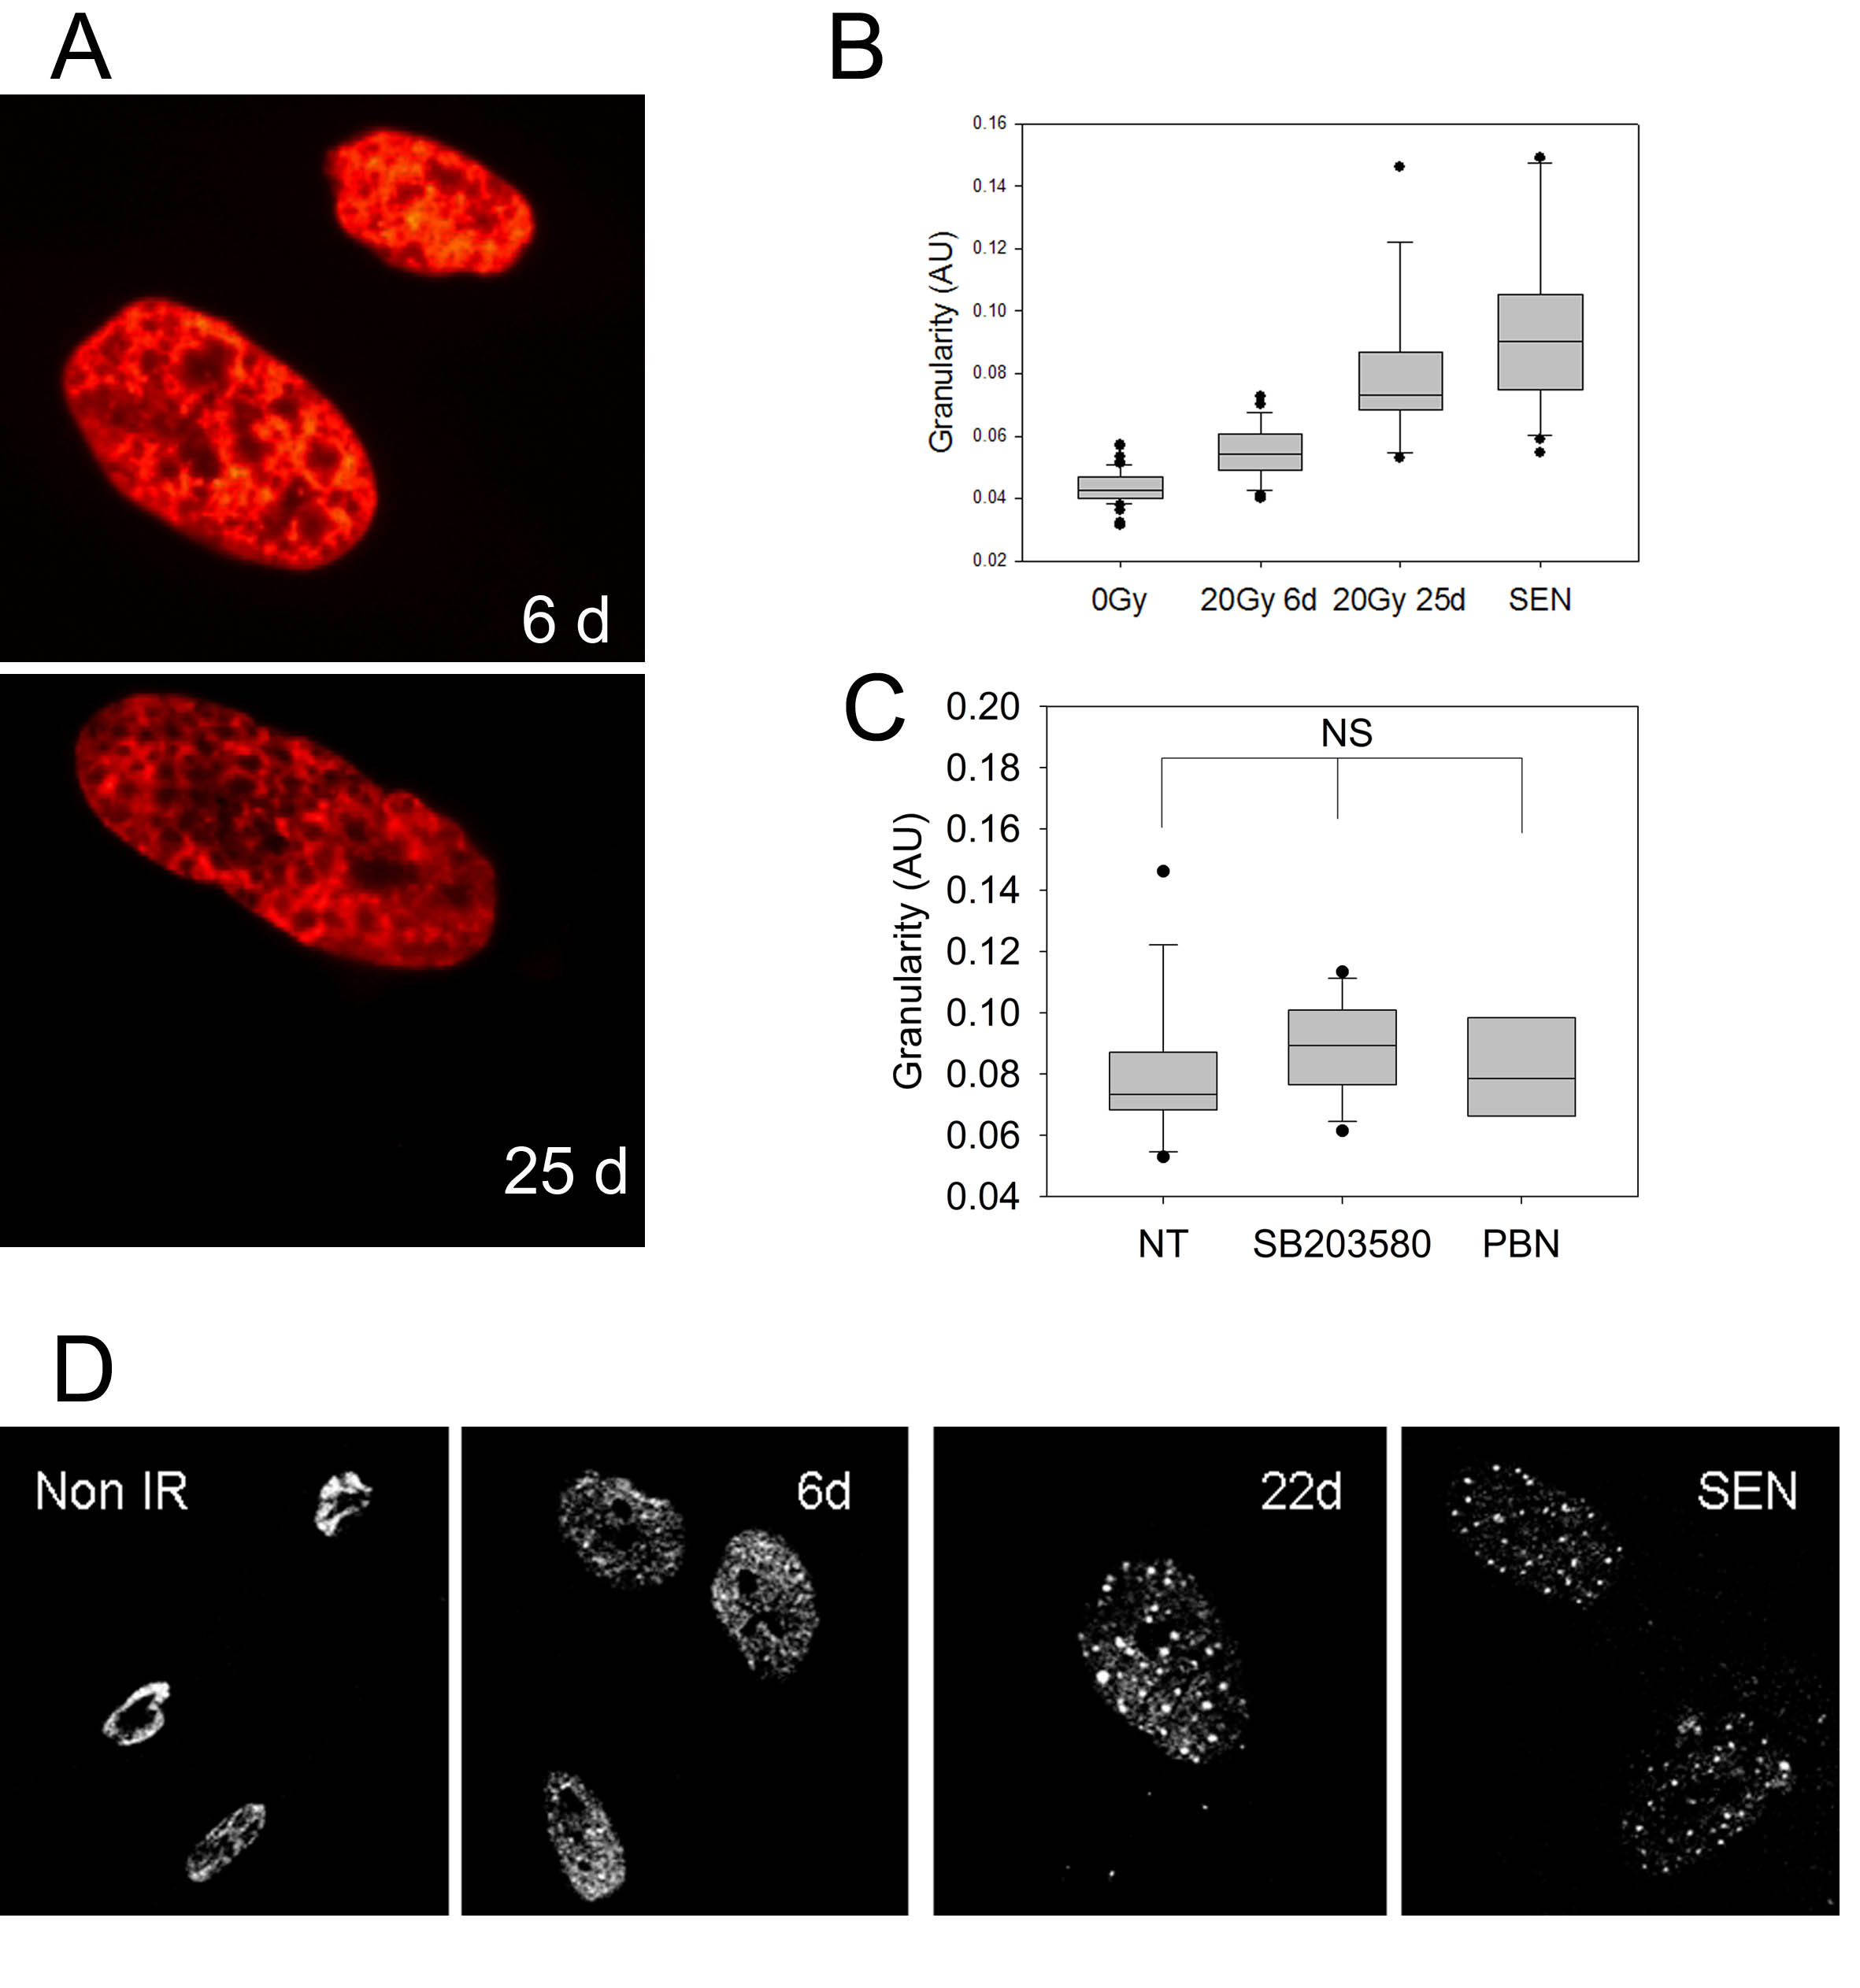

Fig. S18: Chromatin remodelling is a late event following induction of senescence by IR. MRC5 cells were irradiated with 20Gy and analysed at the indicated times (in days) thereafter. A) Representative DAPI fluorescence images. B) Quantification of DAPI fluorescence granularity. Box plots indicate median, upper and lower quartiles (boxes) and percentiles (whiskers) and outliers from 20 to 60 cells per group. C) At 10d after IR, cells were treated with SB203580 or PBN and granularity was measured at day 25. NT: not treated. NS: not significant (ANOVA). D) Representative HP-1γ immunofluorescence images.

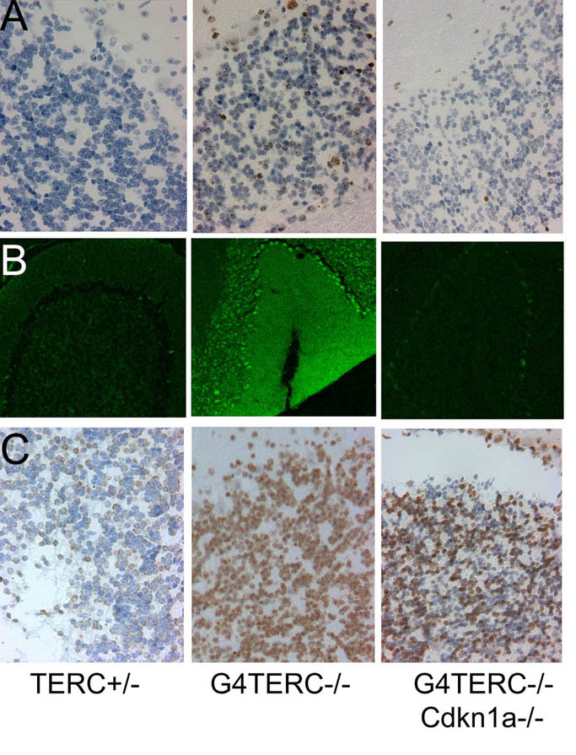
D
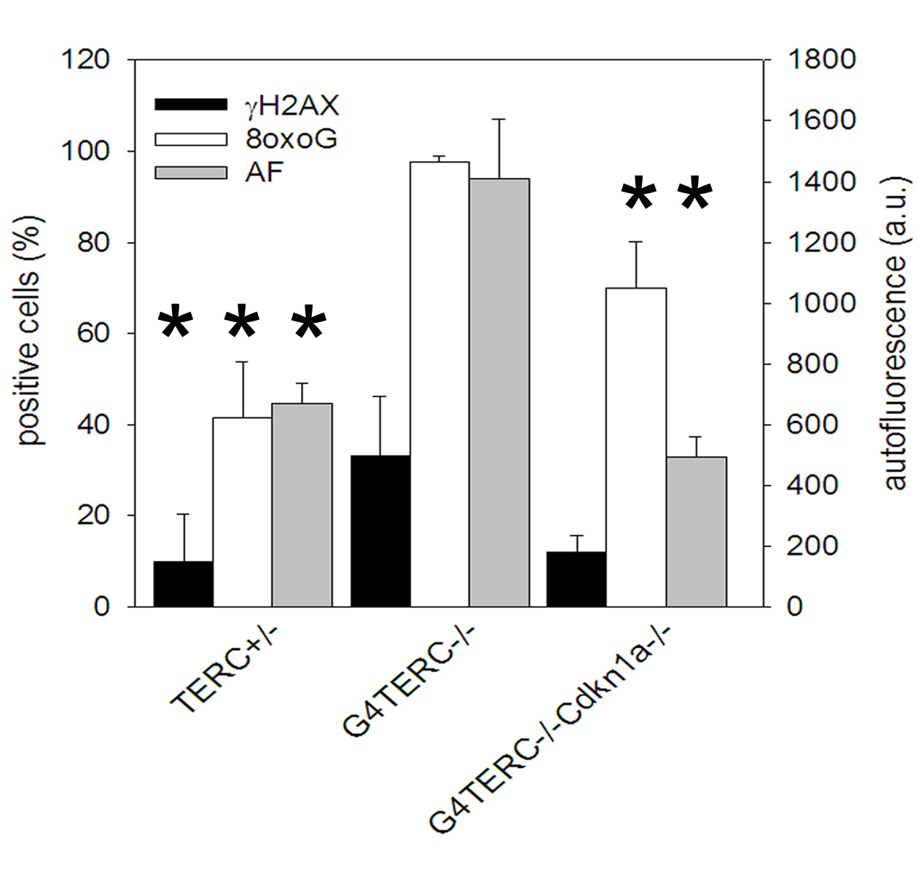

Fig. S19: CDKN1A knockout rescues DDR and oxidative damage in the cerebellum of late generation TERC-/- mice. Representative micrographs (from 3 -5 mice/group) of the cerebellum in the indicated genotypes. A) γH2AX immunohistochemistry. B) Broad-band autofluorescence. C) 8oxodG immunohistochemistry. D) Frequencies of cells positive for γH2A.X (black bars), 8oxodG (white bars) and autofluorescence intensity (grey bars). M ± SEM, n = 3 – 4. Asterisks indicate significant differences to G4TERC-/- (p < 0.05, ANOVA/Tukey).

2. Supplementary Tables
Supplementary Tab. S1: Log likelihood scores (LLS) for the 20 most probable pathways connecting CDKN1A, TGFBR2, TGFB1/2 and MAPK14

S1A) CDKN1A to MAPK14 via TGFBR2 and TGFB1/2:
pathway |  |  |  |  |  |  |  | LLS
CDKN1A | CDKN1B | YWHAE | TGFB1 | TGFBR2 | SMAD7 | MAP2K6 | MAPK14 | 6.924269
CDKN1A | GADD45G | CCNB1 | TGFBR2 | TGFB2 | TGFBR1 | SMAD7 | MAPK14 | 6.861284
CDKN1A | GADD45G | CCNB1 | TGFBR2 | TGFB1 | YWHAE | KRT18 | MAPK14 | 6.843361
CDKN1A | GADD45G | CCNB1 | TGFBR2 | TGFB1 | YWHAE | CDC25A | MAPK14 | 6.786907
CDKN1A | PIM1 | SNX6 | TGFBR2 | TGFB2 | TGFBR1 | SMAD7 | MAPK14 | 6.515935
CDKN1A | PIM1 | SNX6 | TGFBR2 | TGFB1 | YWHAE | KRT18 | MAPK14 | 6.498012
CDKN1A | CDKN1B | YWHAE | TGFB1 | EIF3I | TGFBR2 | SMAD7 | MAPK14 | 6.448104
CDKN1A | PIM1 | SNX6 | TGFBR2 | TGFB1 | YWHAE | CDC25A | MAPK14 | 6.441558
CDKN1A | CHEK1 | CDC25A | YWHAE | TGFB1 | TGFBR2 | SMAD7 | MAPK14 | 6.424022
CDKN1A | GADD45G | CCNB1 | TGFBR2 | TGFB1 | DCN | FLNA | MAPK14 | 6.418128
CDKN1A | GADD45G | CCNB1 | TGFBR2 | TGFB1 | TGFBR1 | SMAD7 | MAPK14 | 6.39999
CDKN1A | GADD45A | CCNB1 | TGFBR2 | TGFB2 | TGFBR1 | SMAD7 | MAPK14 | 6.338444
CDKN1A | GADD45A | CCNB1 | TGFBR2 | TGFB1 | YWHAE | KRT18 | MAPK14 | 6.320521
CDKN1A | GADD45A | CCNB1 | TGFBR2 | TGFB1 | YWHAE | CDC25A | MAPK14 | 6.264067
CDKN1A | PIM1 | SNX6 | TGFBR1 | TGFB2 | TGFBR2 | SMAD7 | MAPK14 | 6.078072
CDKN1A | PIM1 | SNX6 | TGFBR2 | TGFB1 | DCN | FLNA | MAPK14 | 6.072779
CDKN1A | PIM1 | SNX6 | TGFBR2 | TGFB1 | TGFBR1 | SMAD7 | MAPK14 | 6.054641
CDKN1A | CDKN1B | YWHAE | TGFB1 | TGFBR2 | SMAD7 | MAP2K3 | MAPK14 | 5.992504
CDKN1A | CDKN1B | YWHAE | TGFB1 | ENG | TGFBR2 | SMAD7 | MAPK14 | 5.98681
CDKN1A | STAT3 | EGFR | DCN | TGFB1 | TGFBR2 | SMAD7 | MAPK14 | 5.975809

Tab. S1B) CDKN1A to TGFB1 via MAPK14:
pathway |  |  |  |  |  |  |  | LLS
CDKN1A | GADD45A | MAP3K4 | MAP2K6 | MAPK14 | SMAD7 | TGFBR2 | TGFB1 | 8.716039
CDKN1A | GADD45G | MAP3K4 | MAP2K6 | MAPK14 | SMAD7 | TGFBR2 | TGFB1 | 8.692408
CDKN1A | GADD45A | MAPK14 | MEF2C | EP300 | SMAD7 | TGFBR2 | TGFB1 | 8.577094
CDKN1A | GADD45A | MAPK14 | GRB2 | SRC | DAB2 | TGFBR2 | TGFB1 | 8.559092
CDKN1A | GADD45G | RXRA | GADD45A | MAPK14 | SMAD7 | TGFBR2 | TGFB1 | 8.386931
CDKN1A | GADD45A | MAPK14 | ATF2 | SMAD3 | DAB2 | TGFBR2 | TGFB1 | 8.20351
CDKN1A | GADD45A | MAPK14 | ATF2 | SMAD3 | STRAP | TGFBR2 | TGFB1 | 8.20351
CDKN1A | GADD45A | MAPK14 | MAP3K7IP1 | SMAD7 | TGFBR2 | EIF3I | TGFB1 | 8.182325
CDKN1A | GADD45A | MAPK14 | ELK1 | EP300 | SMAD7 | TGFBR2 | TGFB1 | 8.099707
CDKN1A | GADD45G | GADD45A | MAPK14 | SMAD7 | TGFBR2 | EIF3I | TGFB1 | 8.07946
CDKN1A | GADD45A | MAPK14 | CDC25C | PIN1 | DAB2 | TGFBR2 | TGFB1 | 8.012622
CDKN1A | GADD45A | MAPK14 | MEF2A | EP300 | SMAD7 | TGFBR2 | TGFB1 | 7.976333
CDKN1A | GADD45A | MAPK14 | CSNK2A2 | PIN1 | DAB2 | TGFBR2 | TGFB1 | 7.9254
CDKN1A | GADD45A | MAPK14 | SMAD7 | TGFBR2 | EIF3I | TGFB1 |  | 7.874974
CDKN1A | GADD45A | MAP3K4 | MAP2K3 | MAPK14 | SMAD7 | TGFBR2 | TGFB1 | 7.784273
CDKN1A | GADD45G | MAP3K4 | MAP2K3 | MAPK14 | SMAD7 | TGFBR2 | TGFB1 | 7.760643
CDKN1A | GADD45A | MAPK14 | CREB1 | BRCA1 | CCNB1 | TGFBR2 | TGFB1 | 7.751891
CDKN1A | GADD45A | MAPK14 | MEF2C | SMAD2 | DAB2 | TGFBR2 | TGFB1 | 7.744461
CDKN1A | GADD45A | MAPK14 | MEF2C | SMAD2 | STRAP | TGFBR2 | TGFB1 | 7.744461
CDKN1A | GADD45A | MAPK14 | MEF2A | SMAD2 | DAB2 | TGFBR2 | TGFB1 | 7.744461

Tab S1C) CDKN1A to TGFB2 via MAPK14:
pathway |  |  |  |  |  |  |  | LLS
CDKN1A | GADD45A | MAP3K4 | MAP2K6 | MAPK14 | SMAD7 | TGFBR2 | TGFB2 | 9.177332
CDKN1A | GADD45G | MAP3K4 | MAP2K6 | MAPK14 | SMAD7 | TGFBR2 | TGFB2 | 9.153702
CDKN1A | GADD45A | MAPK14 | MEF2C | EP300 | SMAD7 | TGFBR2 | TGFB2 | 9.038388
CDKN1A | GADD45A | MAPK14 | GRB2 | SRC | DAB2 | TGFBR2 | TGFB2 | 9.020386
CDKN1A | GADD45G | RXRA | GADD45A | MAPK14 | SMAD7 | TGFBR2 | TGFB2 | 8.848224
CDKN1A | GADD45A | MAPK14 | ATF2 | SMAD3 | DAB2 | TGFBR2 | TGFB2 | 8.664804
CDKN1A | GADD45A | MAPK14 | ATF2 | SMAD3 | STRAP | TGFBR2 | TGFB2 | 8.664804
CDKN1A | GADD45A | MAPK14 | ELK1 | EP300 | SMAD7 | TGFBR2 | TGFB2 | 8.561001
CDKN1A | GADD45A | MAPK14 | CDC25C | PIN1 | DAB2 | TGFBR2 | TGFB2 | 8.473916
CDKN1A | GADD45A | MAPK14 | MEF2A | EP300 | SMAD7 | TGFBR2 | TGFB2 | 8.437627
CDKN1A | GADD45A | MAPK14 | CSNK2A2 | PIN1 | DAB2 | TGFBR2 | TGFB2 | 8.386694
CDKN1A | GADD45A | MAP3K4 | MAP2K3 | MAPK14 | SMAD7 | TGFBR2 | TGFB2 | 8.245567
CDKN1A | GADD45G | MAP3K4 | MAP2K3 | MAPK14 | SMAD7 | TGFBR2 | TGFB2 | 8.221937
CDKN1A | GADD45A | MAPK14 | CREB1 | BRCA1 | CCNB1 | TGFBR2 | TGFB2 | 8.213185
CDKN1A | GADD45A | MAPK14 | MEF2C | SMAD2 | DAB2 | TGFBR2 | TGFB2 | 8.205755
CDKN1A | GADD45A | MAPK14 | MEF2C | SMAD2 | STRAP | TGFBR2 | TGFB2 | 8.205755
CDKN1A | GADD45A | MAPK14 | MEF2A | SMAD2 | DAB2 | TGFBR2 | TGFB2 | 8.205755
CDKN1A | GADD45A | MAPK14 | MEF2A | SMAD2 | STRAP | TGFBR2 | TGFB2 | 8.205755
CDKN1A | GADD45A | MAPK14 | ATF2 | SMAD4 | TGFBRAP1 | TGFBR2 | TGFB2 | 8.20351
CDKN1A | GADD45A | MAPK14 | MEF2C | SMAD2 | ZFYVE9 | TGFBR2 | TGFB2 | 8.182325

Supplementary Table S2. Model variables with initial amounts for the quantitative
stochastic model of the signalling loop (See Tabs. 2 and 5 in Proctor & Gray 200839 for other reactions).
Name | Description | Initial amount  (number of molecules) | Database  term
p21 | protein product of CDKN1A | 0 | Q6FI05
p21_basal | basal pool of inactive p21 | 7 | Q6FI05
p21mRNA | messenger RNA of CDKN1A | 1 | SBO:0000278
p21step1, p21step2 | dummy species to represent intermediate step in p21 synthesis | 0,0 | -
GADD45 | protein produce of GADD45 | 0 | P24522
p38 | protein product of MAPK14 | 100 | Q16539
p38_P | phosphorylated p38 | 0 | Q16539
basalROS | basal pool of ROS | 10 | CHEBI:26523

P and Q terms are from UniProtKB/Swiss-Prot (http://www.ebi.uniprot.org/index.shtml)
SBO term is from Systems Biology Ontotology (http://www.ebi.ac.uk/sbo/)
CHEBI term is from Chemical Entities of Biological Interest database
(www.ebi.ac.uk/chebi )

Supplementary Table S3. Model reactions, kinetic laws and parameter values

Name | GO Term | Reactants and products | Kinetic law | Parameter values
p21mRNASynthesis1 | GO:0009299 | p53→p53+p21_mRNA | k_{synp21mRNAp53} * p53 | 6.0e-8s⁻¹
p21mRNASynthesis2 | GO:0009299 | p53_P→p53_P+p21_mRNA | k_{synp21mRNAp53P} * p53_P | 6.0e-6s⁻¹
p21mRNADegradation | GO:0006402 | p21_mRNA→Sink | k_{degp21mRNA} * p21_mRNA | 2.4e-5s⁻¹
p21synthesisStep1 | GO:0006412 | p21_mRNA→p21_mRNA+p21step1 | k_{synp21step1} * p21_mRNA | 4.0e-4s⁻¹
p21synthesisStep2 | GO:0006412 | p21step1→p21step2 | k_{synp21step2} * p21step1 | 4.0e-5s⁻¹
p21synthesisStep3 | GO:0006412 | p21step2→p21 | k_{synp21step3} * p21step2 | 4.0e-5s⁻¹
p21degradation | GO:0043161 | p21→Sink | k_{degp21} * p21 | 1.9e-4s⁻¹
GADD45activation | GO:0006412 | p21→p21+GADD45 | k_{GADD45} * p21 | 4.0e-6s⁻¹
GADD45degradation | GO:0043161 | GADD45→Sink | k_{degGADD45} * GADD45 | 1.0e-5s⁻¹
p38MAPKactivation | GO:0006468 | GADD45+p38→GADD45+p38_P | k_{phosp38} * GADD45 * p38 | 8.0  e-3molecules⁻¹.s⁻¹
p38MAPKinactivation | GO:0006470 | p38_P→p38 | k_{dephosp38} * p38_P | 1.0e-1s⁻¹
p38ROSgeneration | GO:0006800 | p38_P→p38_P+ROS | k_{genROSp38} * p38_P * k_{p38ROS} | 4.5e-4s⁻¹, 1.0
ROSremoval | GO:0016209 | ROS→Sink | k_{remROS} * ROS | 3.83e-4s⁻¹
ROSDNAdamage | GO:0006974 | ROS→ROS+damDNA | k_{damROS} * ROS | 1.0e-5s⁻¹
BasalROSDNAdamage | GO:0006974 | basalROS→basalROS+damDNA | k_{damBasalROS} * basalROS | 1.0e-9s⁻¹
GO terms are from the Gene Ontology database (www.geneontology.org)

Further description of the model
As in our previous model (Proctor & Gray, 2008), we assume that DNA damage activates ATM which then phosphorylates both p53 and Mdm2 to interrupt their binding. This leads to stabilisation of p53. Since p53 is a transcription factor for Mdm2, there is also an increase in Mdm2 levels, which then binds to p53 and targets it for degradation. The model was extended to include the signalling pathway downstream of p53 which starts with the p53-dependent transcription of p21.
The experimental data shows a delay between p53 phosphorylation and p21 protein levels rising. This delay is due to the time required for protein synthesis which needs the completion of several steps in transcription, translation and folding. Therefore we include some intermediate steps to represent the processes involved so that the model predictions match the observed data. We assume that when p21 rises above basal levels it activates GADD45 which then activates p38MAPK. We chose not to add any intermediate steps for GADD45 synthesis, as this does not affect the model outcome and we aim to keep the model as simple as possible. We assume that activated p38MAPK increases the generation of ROS. The rate of damage by ROS is controlled by the parameter k_{damROS} and was set at a value that would produce the amount of DNA damage foci that are observed in the experiments. However, the rate of DNA damage production is itself dependent on ROS concentration: At low ROS production rates in mitochondria, the probability of reaching the nuclear DNA is very low and most ROS will be scavenged or might be used up in signalling reactions. Only at higher production rates, ROS will be able to overwhelm cellular defences and reach the nucleus. We approach this problem by assuming that there is a threshold above which ROS is likely to damage DNA. The simplest way to incorporate this into the model is to have a basal pool (basalROS) with a low rate of damage and a separate pool (ROS) to represent ROS levels above this threshold.
3. Supplementary video legend

Supplementary video SV1: Kinetics of DNA damage foci in MRC5 in IR-induced senescence and under treatment with the MAK14 inhibitor SB203580. MRC5 cells expressing AcGFF-53BP1c were irradiated with 20Gy at t = 0 and were followed over the indicated time window (in h after IR). From t = 94h onwards, cells were treated with SB203580 (SB). Each frame is a MIP (Maximum Intensity Projection) from three slice z stacks, and frames were taken at 10 minute intervals. Fluorescence intensities are pseudocoloured with a range from black (lowest) via blue, red, yellow to white (highest).

