List of supplementary material

- Supplementary text and figures: This file; contains additional text and figures.

- Supplementary file 1 CD model: A Simbiology project file that can be opened with the Simbiology toolbox in Matlab. This project file contains the models that are used in the paper.

- Supplementary_file_2_Sample_Matlab_code: Example Matlab code that can be used to run the models contained in the sbproj file and draw time courses of chosen markers.

- Supplementary files 3-6: These files contain models from “Supplementary file 1 CD model” converted to SBML (Systems Biology Markup Language) format. Free and open source programs are available to read SBML files.

Supplementary text S1: Assumptions used to simplify the IL-6 signaling model
The Jak family of kinases (Jak1, Jak2 and Tyk2) involved in IL-6 mediated STAT3 activation are thought to be constitutively associated with gp130^{1,2}. We grouped all the Jak isoforms together and treated the gp130-Jak/Tyk complex as a single molecule and called it gp130. We also used a simplified structure of the activated IL-6 receptor complex in our model. The complete active receptor complex is a hexamer formed by homodimerization of the IL-6/IL6-R/gp130 heterotrimer³. To simplify the model, we treated the IL-6/IL6-R/gp130 trimer as the active complex and ignored its further dimerization. A number of existing models of Jak-STAT signaling assume that nuclear translocation of STAT requires its phosphorylation and homodimerization^{4,5}. However, more recent studies indicate that phosphorylation and dimerization may not be a prerequisite for nuclear access⁶. We therefore ignored the subcellular compartmentalization of STAT3 and treated phosphorylated STAT3 as a measure of IL-6 signaling activity. STAT3 induced SOCS3 expression is thought to be an important negative feedback mechanism for downregulating IL-6-STAT3 signaling⁷ and SOCS3 expression is known to be upregulated in multiple types of cells derived from human subjects of Crohn's disease as well as mouse models of colitis^{8,9}. Despite the increased expression of SOCS3, high level of STAT3 phosphorylation was maintained and it required over expression of SOCS3 in an intestinal epithelial cell line to suppress STAT3 phosphorylation^{8,9}. These studies indicate that the baseline expression of SOCS3 in Crohn's disease is probably not effective at downregulating IL-6 signaling. Therefore, SOCS3 mediated negative feedback was ignored in our model.

In the model, IL-6 signaling in liver cells induced expression of CRP, which was secreted into circulation. Increased levels of CRP accelerated the rate of IL-6Rα shedding increasing sIL-6Rα concentration (Fig. 1c). A large variety of cell types reside in GI tract mucosa with each type reacting differently to IL-6; for example, IL-6 signaling increases survival of T cells by activating expression of anti-apoptotic proteins¹⁰ and increases expression of adhesion molecules in intestinal epithelial cells facilitating recruitment of lymphocytes to inflammation site¹¹. Due to lack of sufficient information about the cell-type specific kinetics of signaling and specific biomarkers of its outcomes, we decided not to distinguish between these variations in the current model. However, we note that implementing multiple cell types and even different signaling pathways within an organ compartment is relatively simple in our modeling framework. Given that IL-6Rα is known to be expressed by hepatocytes¹², we included both classic- and trans-signaling mechanisms in the liver. On the other hand, the complex cellular composition of the GI tract mucosa makes it difficult to determine what fraction of cells express IL-6Rα and hence are affected by the classic signaling mechanism. In addition, at least with respect to the contribution of mucosal T cells, it has been suggested that trans IL-6 signaling may be the dominating signaling mechanism in chronic intestinal inflammation¹⁰. We therefore made a simplifying assumption to only include the trans-signaling mechanism in the GI tract compartment.

Supplementary Text S2: Estimation of IL-6 concentration in GI tract interstitium
IL-6 levels in the gut mucosa of healthy subjects and subjects with active CD were measured in colonic mucosal biopsies by Mitsuyama et al and the values reported as pg of IL6 per mg of protein in the tissue¹³. To obtain an estimate of IL-6 concentration in the interstitial volume of the gut (mass of IL6/interstitial volume), we converted the value reported by Mitsuyama et al as follows:

The following estimates were used for the variables on the right hand side:
x | 3.4 pg IL6/mg protein (healthy subject)¹³ 63.1 pg IL6/mg protein (Crohn's subject)¹³
P | 700 pg/cell¹⁴
N | 10⁶ cell/mL (estimate)
V_{interstitial} | 373.2 mL¹⁵
V_{total} | 2147 mL¹⁵

Supplementary Text S3: Considerations in parameter fitting
Parameter estimation was done using a combination of fitting by hand and local minimization functions from the Matlab Optimization toolbox. Specifically, initial values of parameters were determined from literature or the best estimate was used; if no estimate was available, the value was adjusted by hand to get an approximate fit to the data. Local optimization functions fminsearch and patternsearch from Matlab were then used to minimize the fitness score. The fitness score,, was defined as
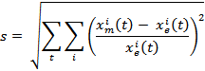
where, is the model predicted value of species at time and is its experimentally determined value at the same time point. For fitting steady state measurements the model was run to steady state and the fitness score was modified by removing the time dependence of the s. Goodness of fit was evaluated using the ratio of fitted value to measured value for each data point being fitted. Parameter sets that produced the ratio
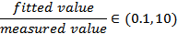
for all data points were accepted. This ensured that there were no biased fits where the error was very low for some data points but much higher for others. If the optimization algorithm resulted in parameters that failed to satisfy this criterion, the parameters were rejected and the optimization was repeated from a different starting point in the parameter space.

The cell signaling module of the hepatocytes was split into IL-6 receptor dynamics and cytosolic signaling. The receptor dynamics model (Supplementary Fig. S7) was fitted to in vitro measurements in HepG2 cell line¹⁶. Initial estimates for the parameters of the intracellular part of IL-6 signaling were obtained from previously published studies^{3–5}. The cell signaling model was embedded into the organ compartments and the whole model was assembled. With the network structure so obtained, two models were created representing a typical healthy subject (HS model) and a typical Crohn's disease patient (CD model). The parameters of the two models were constrained so that they were identical, except the rates of IL-6 production (in GI tract and from other sources in serum), which were assumed to be higher in the CD model. The parameters of the models were then optimized to fit the steady state outputs of HS and CD models to baseline measurements obtained from healthy and Crohn's disease subjects, respectively.

Since our study was focused on assessing the effects of treatment with monoclonal antibodies, we built our antibody PK module based on the general PK model of therapeutic monoclonal antibodies (Supplementary Fig. S1) as reviewed by Dirks et al¹⁷. The initial estimate of the PK parameters in our model was fixed to the median population estimates for therapeutic monoclonal antibodies as reported by Dirks et al, with V₁ of 3.1 L, V₂ of 2.8L, Q of 0.033 L/hr, and Cl of 0.00875 L/hr for monoclonal antibodies with linear clearance or saturated target-mediated drug disposition characteristics. These estimates were refined after assembling the PK model with the biological system model.

To estimate the distribution parameters of the antibody across organs we relied on published studies¹⁵ and expert opinion approximating steady state concentration of drug in the liver at 100% of the serum concentration, and at 50% in the GI tract (Fig. 2d in main text).

Supplementary Text S4: Sensitivity analysis
Starting with the optimized parameter vector p, 10,000 points were randomly generated in the range [p/10, 10p] using latin hypercube sampling. The model was simulated (without drug treatment) at all these points and the steady state value of the following markers were recorded: IL-6 in serum, liver and GI tract mucosa; soluble IL-6Rα and phospho-STAT3 in liver and GI tract; serum CRP; and serum soluble IL-6R. This set includes molecules that are related to the activity of IL-6 signaling and the state of systemic inflammation. Partial rank correlation coefficients were calculated between steady state value of the chosen output statutes and the input parameters¹⁸.
Supplementary figures
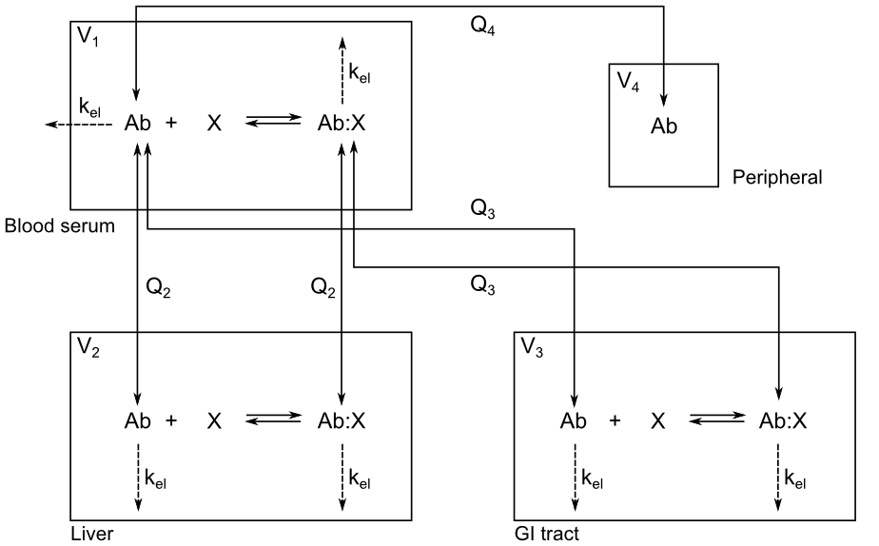
Supplementary Figure S1. Schematic of module 3 (PK model) in isolation. Ab indicates therapeutic antibody, X is the antibody target. V_{i}'s (L) indicate apparent compartment volume, Q_{i}'s (L/hr) are inter-compartmental clearances, k_{el} (1/hr) is rate of elimination. First order rate of transfer from compartment i to j is k_{ij} = Q_{j}/V_{i} (1/hr). These parameters were optimized to get the drug PK profile in serum to match the median behavior of monoclonal antibodies and to approximate liver concentration of drug at 100% of serum concentration and that in the gut at 50% of serum concentration (see Parameter fitting in main text).

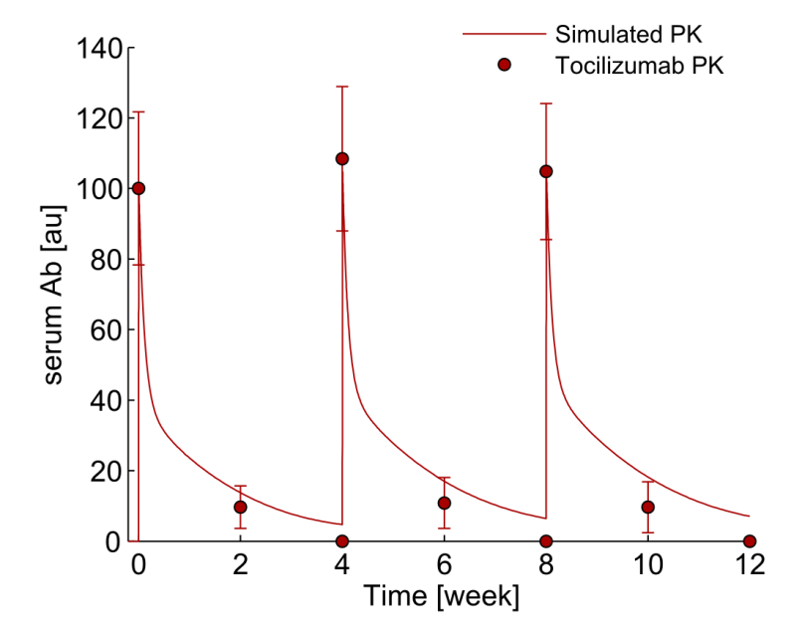
Supplementary Figure S2. Comparison of simulated PK of anti-IL-6R antibody with measured PK of tocilizumab in Crohn's disease patients. The simulation was done for Q4W IV dosing of 560 mg anti-IL-6R antibody at a K_{d} of 1 nM using PK parameters of typical monoclonal antibody. Tocilizumab PK was measured for Q4W IV dosing at 8 mg/kg¹⁹. Since the PK of the simulated anti-IL-6R antibody was optimized to match the PK of the typical monoclonal Ab and not specifically to the PK of Tocilizumab, an exact match with Tocilizumab PK was not expected. Accordingly, in order to establish a common point for comparison, the simulated PK profile as wells as the reported Tocilizumab profile were normalized so that both had their first maxima at 100 arbitrary units (au).

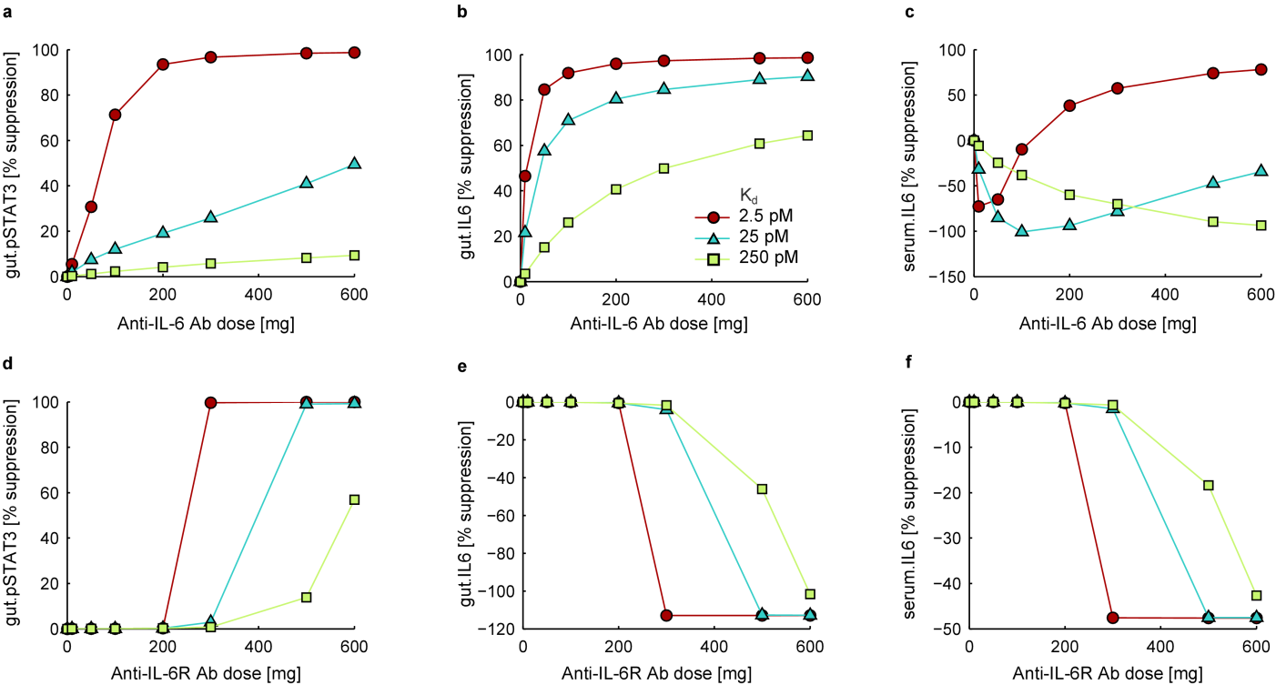
Supplementary Figure S3. Dose-response curves for anti-IL-6 antibody (a, b, c) and anti-IL-6R antibody (d, e, f) for gut pSTAT3, gut IL-6 and serum IL-6, under target binding affinity ranging from 2.5 pM to 250 pM. The y-axis shows percentage decrease from base line at the end of a 12 week treatment period with a 4-weekly dosing schedule. Negative values on the y-axis imply an increase from baseline. Characteristic graded and switch-like suppression of gut pSTAT3 activity specific to anti-IL6 and anti-IL-6R antibodies, respectively, are observed (a, d). Similar graded suppression in gut IL-6 levels for anti-IL-6 antibody is seen (b). In contrast, as has been reported for tocilizumab, elevated free IL-6 levels are predicted by the model after anti-IL-6R antibody administration as IL-6/IL-6R binding is inhibited by the unavailability of antibody-free IL-6R (e, f). Despite the increased free IL-6, signaling activity is reduced (d) as the anti-IL-6R antibody sequesters IL-6R. The predicted dose-response profile of serum IL-6, a surrogate marker of IL-6 modulation at the target site for Crohn’s, does not exactly mirror gut IL-6 response profile for anti-IL-6 antibody (c). Low circulating IL-6 levels in the model are further reduced by the anti-IL-6 antibody causing release of the sequestered IL-6 from the IL-6/Ab complex (with much longer half-life than free IL-6) into its free form. This is most apparent when binding affinity and antibody exposure are low; increased serum IL-6 levels are seen for all but the highest doses and binding affinities. We note that since the basal concentration of serum IL-6 is very low, the percent changes signify small absolute changes. The gut on the other hand, has approximately 25 times more IL-6 than the serum at basal level (Table 1), which is attained in the model by a greater production rate of IL-6 in the gut than in the serum under disease condition. The higher production rate of IL-6 in the gut guarantees high enough IL-6 concentration in the compartment ensuring that the net flux of the Ab/IL-6 binding reaction is in the forward direction that IL-6 sequestered by the Ab can remain sequestered (contrast b against c).

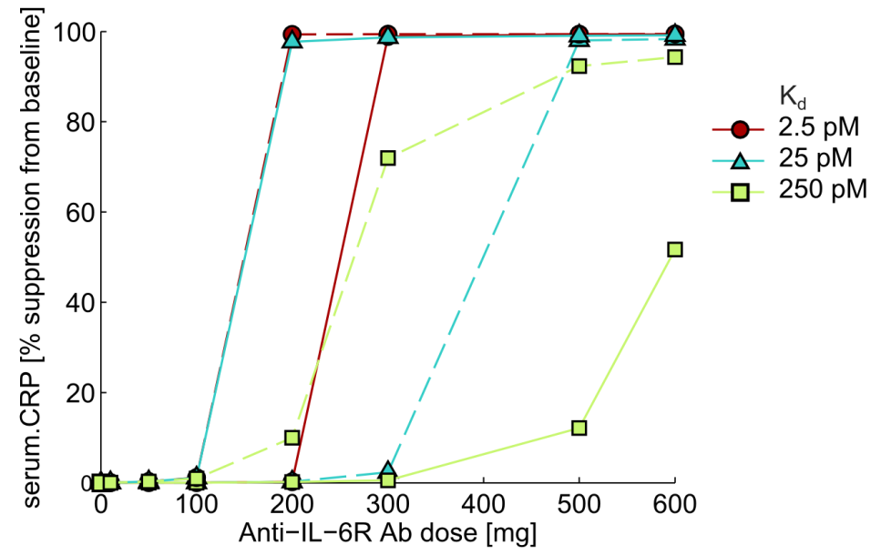
Supplementary Figure S4. The dose-response characteristics of anti-IL-6R antibody improve if the dosing frequency is increased. Percent decrease in serum CRP after 12 week treatment with a Q4W (solid lines) or Q2W (dashed lines) schedule are shown. More frequent dosing leads to greater efficacy at lower doses.

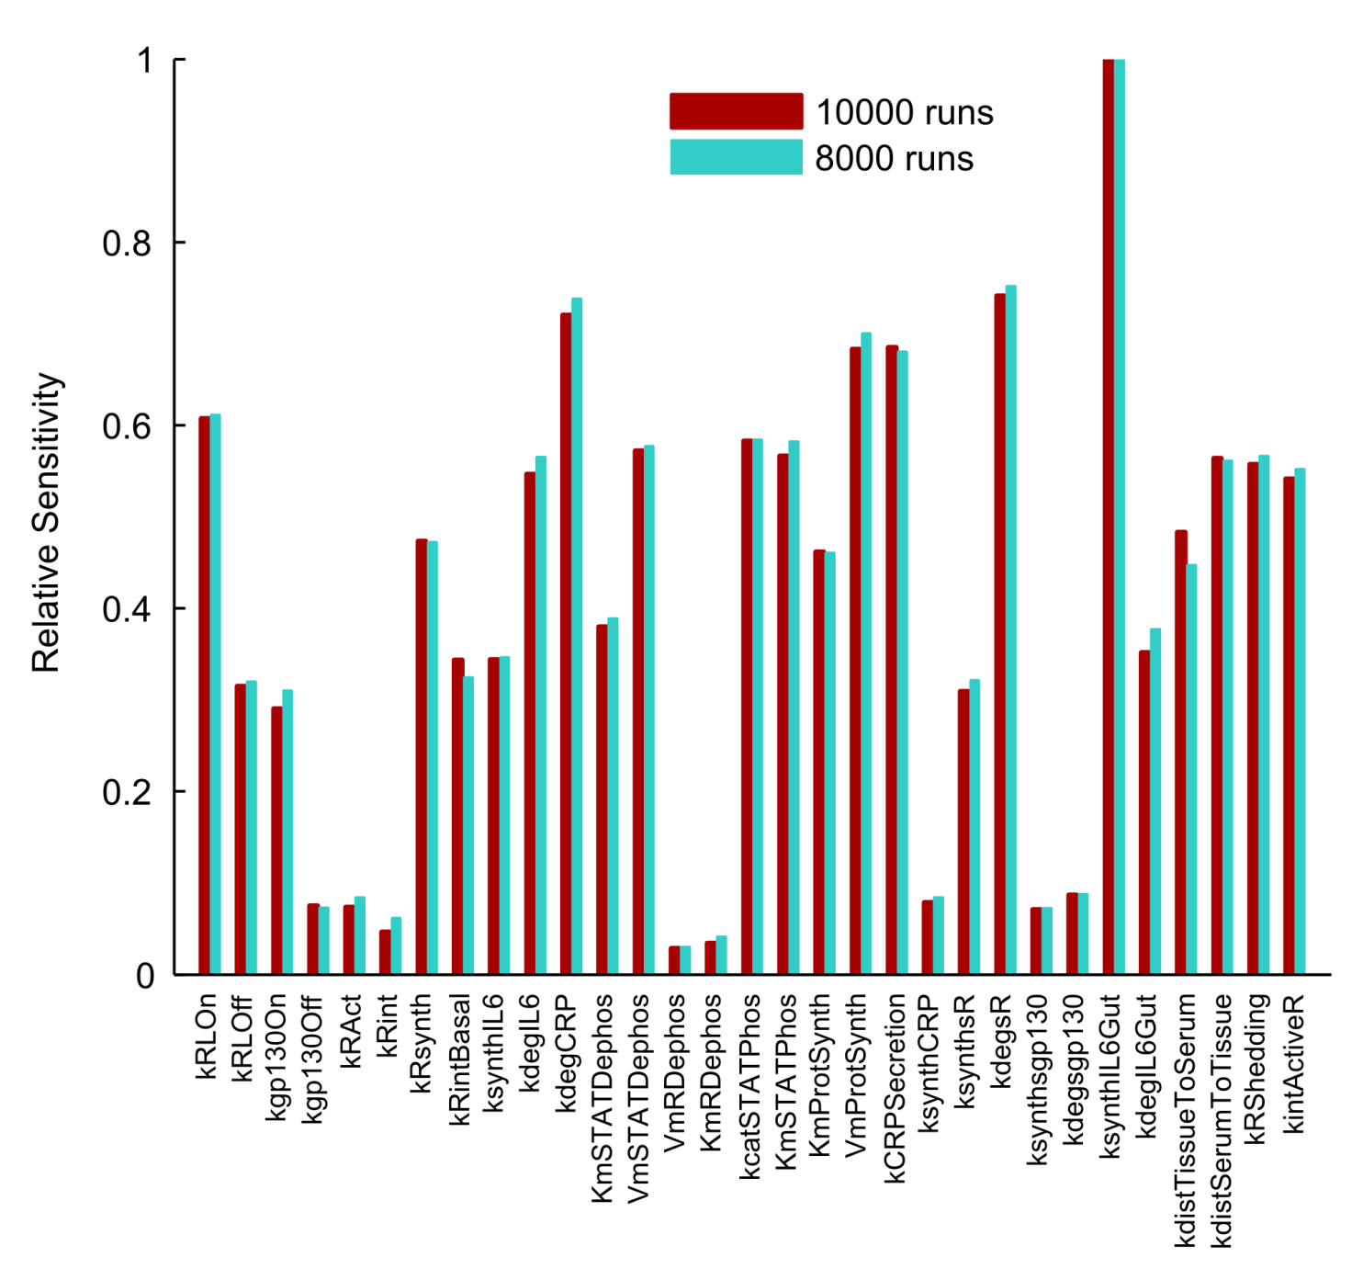Supplementary Figure S5. Summed and normalized PRCC values representing relative sensitivities to parameters. For each parameter, absolute PRCC values were summed over all outputs and divided by a constant so that the largest value scales to 1. Random sampling over 8,000 and 10,000 points in the parameter space yielded similar PRCC values suggesting that 10,000 runs were sufficient to get stable PRCC values. Sensitivities to all parameters of the biological system are shown here.

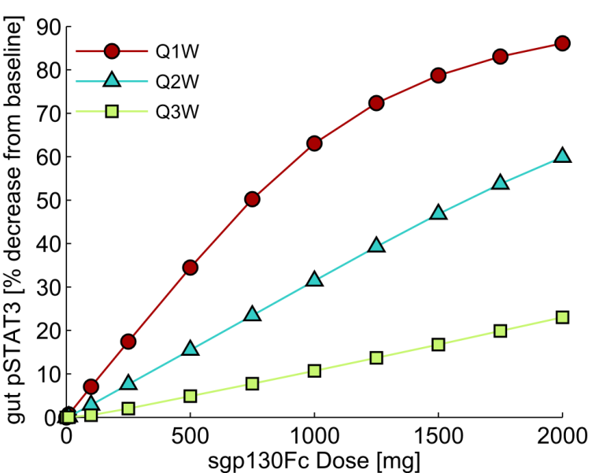
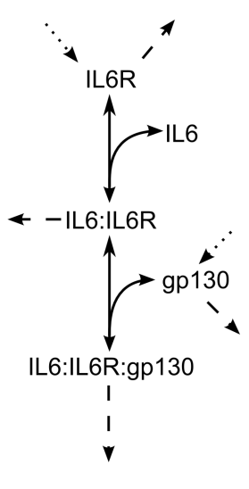
Supplementary Figure S6. Dose-response for sgp130Fc measured in terms of pSTAT3 suppression from baseline in the gut. The response is similar to that for serum CRP (Fig. 6b in the main text).

Supplementary Figure S7. Schematic of the cell-surface receptor dynamics model. The receptor dynamics model was used to optimize parameters of the cell membrane part of the cell signaling module. Dashed arrows represent internalization and degradation of membrane bound molecules, dotted arrows represent synthesis of new molecules.

Supplementary References
1. Stahl, N. et al. Association and activation of Jak-Tyk kinases by CNTF-LIF-OSM-IL-6 beta receptor components. Science 263, 92–95 (1994).
2. Giese, B. et al. Long term association of the cytokine receptor gp130 and the Janus kinase Jak1 revealed by FRAP analysis. J Biol Chem 278, 39205–39213 (2003).
3. Boulanger, M. J., Chow, D., Brevnova, E. E. & Garcia, K. C. Hexameric structure and assembly of the interleukin-6/IL-6 alpha-receptor/gp130 complex. Science 300, 2101–2104 (2003).
4. Yamada, S., Shiono, S., Joo, A. & Yoshimura, A. Control mechanism of JAK/STAT signal transduction pathway. FEBS Lett 534, 190–196 (2003).
5. Singh, A., Jayaraman, A. & Hahn, J. Modeling regulatory mechanisms in IL-6 signal transduction in hepatocytes. Biotechnol Bioeng 95, 850–862 (2006).
6. Cimica, V., Chen, H. C., Iyer, J. K. & Reich, N. C. Dynamics of the STAT3 transcription factor: nuclear import dependent on Ran and importin-beta1. PLoS One 6, e20188 (2011).
7. Croker, B. A. et al. SOCS3 negatively regulates IL-6 signaling in vivo. Nat Immunol 4, 540–545 (2003).
8. Lovato, P. et al. Constitutive STAT3 activation in intestinal T cells from patients with Crohn’s disease. J Biol Chem 278, 16777–16781 (2003).
9. Suzuki, A. et al. CIS3/SOCS3/SSI3 plays a negative regulatory role in STAT3 activation and intestinal inflammation. J Exp Med 193, 471–481 (2001).
10. Atreya, R. et al. Blockade of interleukin 6 trans signaling suppresses T-cell resistance against apoptosis in chronic intestinal inflammation: evidence in crohn disease and experimental colitis in vivo. Nat Med 6, 583–588 (2000).
11. Wang, L., Walia, B., Evans, J., Gewirtz, A. T., Merlin, D. & Sitaraman, S. V IL-6 induces NF-kappa B activation in the intestinal epithelia. J Immunol 171, 3194–201 (2003).
12. Maggio, M., Guralnik, J. M., Longo, D. L. & Ferrucci, L. Interleukin-6 in aging and chronic disease: a magnificent pathway. J Gerontol A Biol Sci Med Sci 61, 575–584 (2006).
13. Mitsuyama, K. et al. Colonic mucosal interleukin-6 in inflammatory bowel disease. Digestion 50, 104–111 (1991).
14. Sims, C. E. & Allbritton, N. L. Analysis of single mammalian cells on-chip. Lab Chip 7, 423–440 (2007).
15. Baxter, L. T., Zhu, H., Mackensen, D. G., Butler, W. F. & Jain, R. K. Biodistribution of monoclonal antibodies: scale-up from mouse to human using a physiologically based pharmacokinetic model. Cancer Res 55, 4611–4622 (1995).
16. Zohlnhofer, D., Graeve, L., Rose-John, S., Schooltink, H., Dittrich, E. & Heinrich, P. C. The hepatic interleukin-6 receptor. Down-regulation of the interleukin-6 binding subunit (gp80) by its ligand. FEBS Lett 306, 219–222 (1992).
17. Dirks, N. L. & Meibohm, B. Population pharmacokinetics of therapeutic monoclonal antibodies. Clin Pharmacokinet 49, 633–659 (2010).
18. Marino, S., Hogue, I. B., Ray, C. J. & Kirschner, D. E. A methodology for performing global uncertainty and sensitivity analysis in systems biology. J Theor Biol 254, 178–196 (2008).
19. Ito, H. et al. A pilot randomized trial of a human anti-interleukin-6 receptor monoclonal antibody in active Crohn’s disease. Gastroenterology 126, 989–996 (2004).

