Table S2. Complete List of Model Parameters of the Wnt-Signal Transduction Model
The rate constants marked with (#) play a role only in stimulated states where 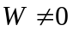. Note that some of the numerical values are given in a higher precision compared to Table S1.

Parameter | Value

Conservation quantities
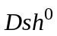 | 100 | nM
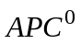 | 100 | nM
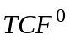 | 15 | nM
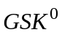 | 50 | nM

Dissociation constants
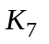 | 50 | nM
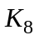 | 120 | nM
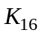 | 30 | nM
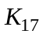 | 1200 | nM

Rate constants
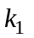 (#) | 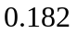 | 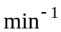
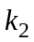 (#) | 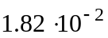
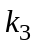 (#) | 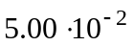 | 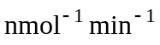
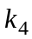 | 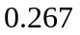
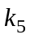 | 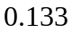
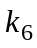 | 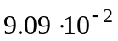
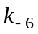 | 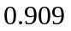 | 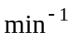
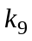 | 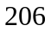
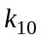
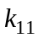 | 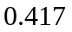
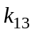 | 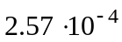
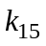 | 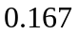

Synthesis fluxes
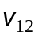 | 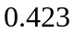 | 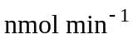
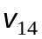 | 