Abbreviations and synonyms used in this additional file are as follows: 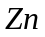(free zinc ion); 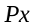(apo-ZntR); 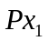(active ZntR, i.e., ZnZntR); 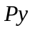( the Zur dimer which contains two zinc ions per dimer, here we denote it as Zn₂Zur and it is denoted as Zn₁Zur in [26]); 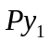(active Zur, i.e., the Zur dimer which contains four zinc ions per dimer, here we denote it as Zn₄Zur and it is denoted as Zn₂Zur in [26]); (ZntA); 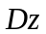(DNA of ZntA); 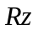(RNA polymerase for zntA transcription); 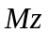(mRNA of ZntA); 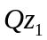(transcription initiation complex formed by and ); 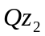(ZnZntR-DNA complex); 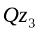(transcription initiation complex formed by and ); 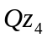(apo-ZntR-DNA complex); 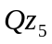(transcription initiation complex formed by and ); (ZnuC);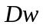(DNA of ZnuC); 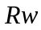(RNA polymerase for znuC transcription); 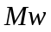(mRNA of ZnuC); 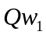(transcription initiation complex of ZnuC); 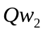(Zn₄Zur-DNA complex which can not further bind with ); 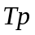(free TPEN not bounded by zinc); 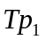(zinc-bound TPEN).

Equations for Zur-DNA interaction

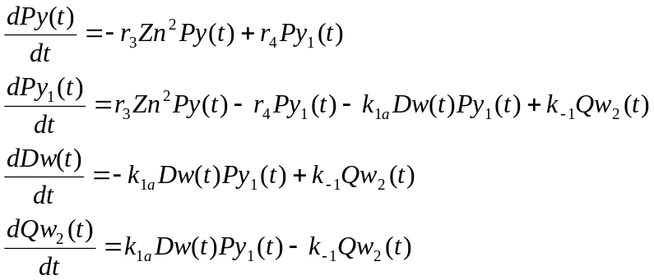

By imposing all the derivatives to be 0, we get four steady state equations which contain only two independent equations. Therefore, in order to derive the steady state values, two conservation restraints need to be included:

By solving the two independent steady state equations with the above conservation restraints, we can get the steady state concentration value of Zn₄Zur-DNA complex (i.e., 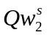) as a function of parameter as follows:
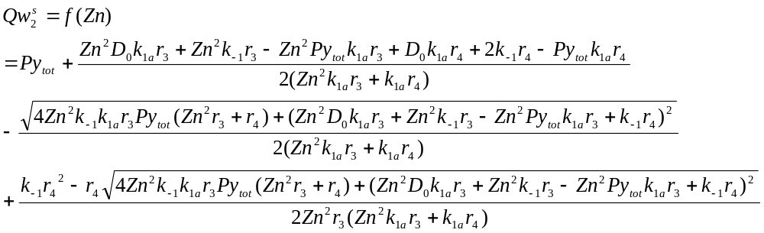

Equations for Zur transcription assay

(1) Equations for preliminary equilibrium of reactants before NTPs were added
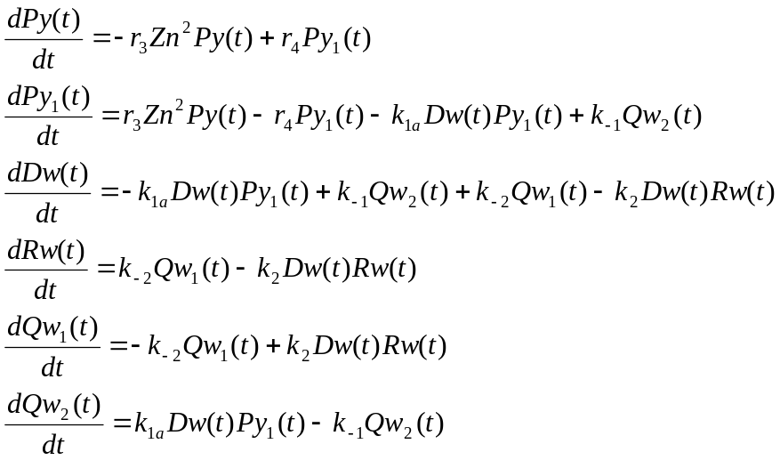

(2) Equations for Zur run-off transcription after NTPs were added 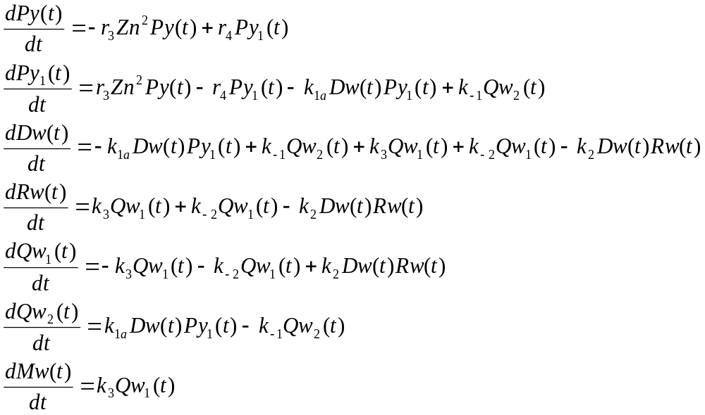

Equations for ZntR transcription assay (I)

(1) Equations for preliminary equilibrium of reactants before NTPs were added

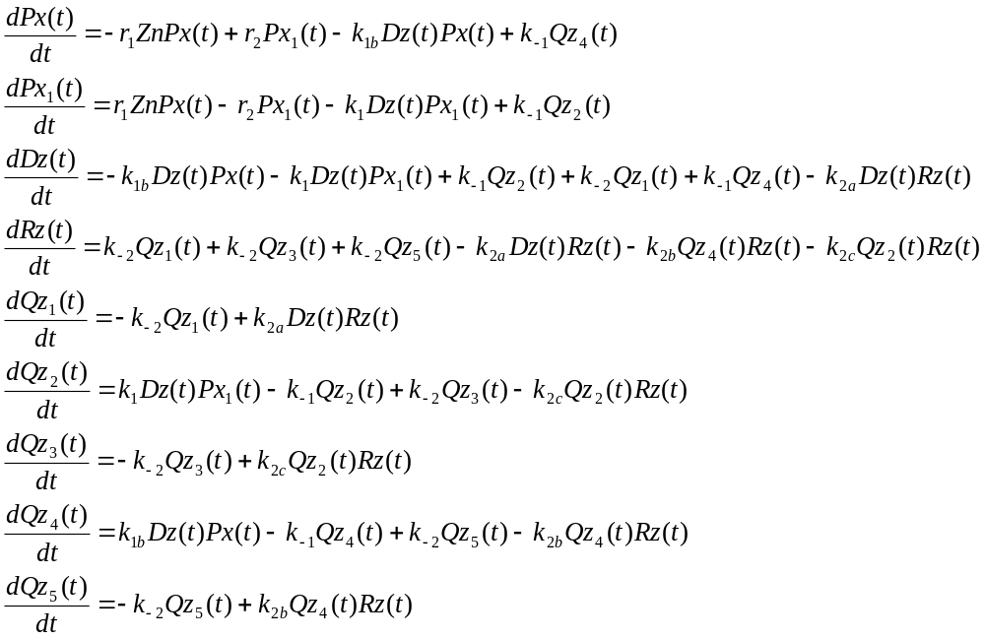
(2) Equations for ZntR run-off transcription (I) after NTPs were added
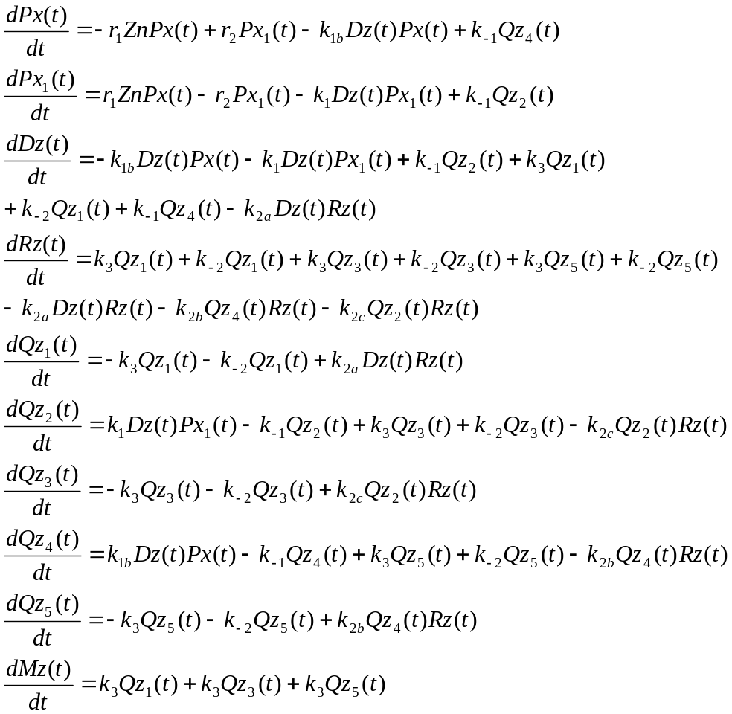

Equations for ZntR transcription assay (II) - including TPEN reaction

(1) Equations for preliminary equilibrium of reactants before NTPs were added

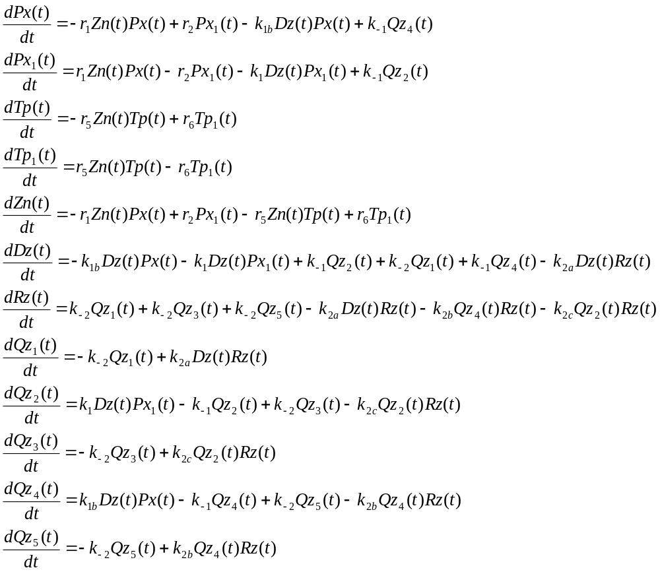

(2) Equations for ZntR run-off transcription (II) after NTPs were added

