Transient curves of simulated Zur transcription assay for parameter 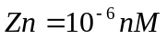:

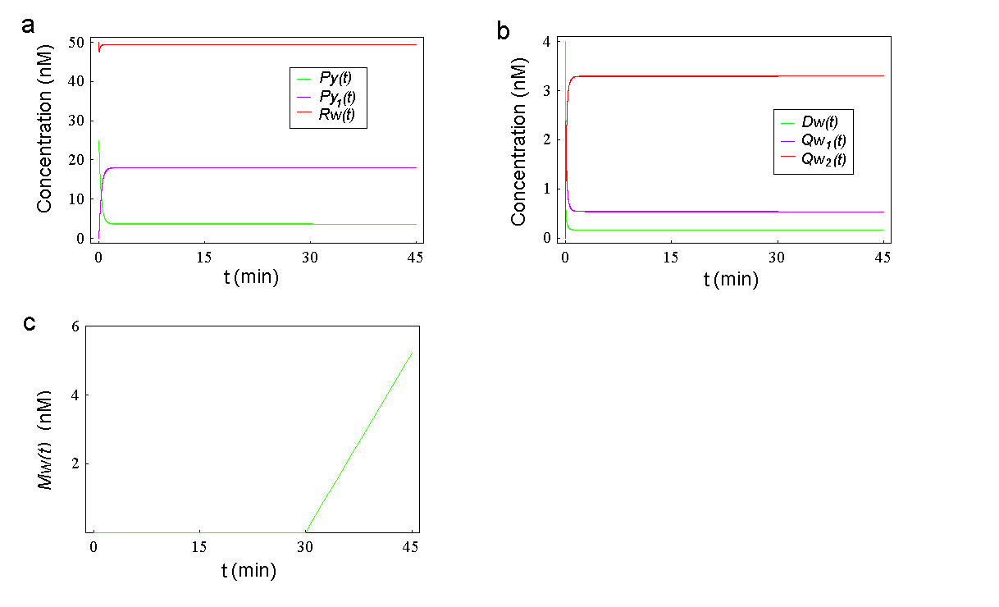

Transient curves of simulated Zur transcription assay for parameter 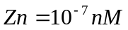:
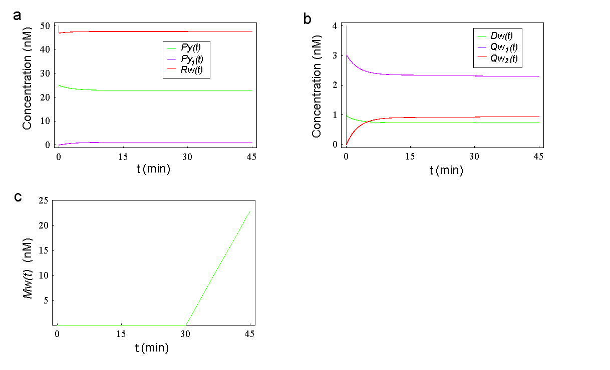
Transient curves of simulated ZntR transcription assay (I) for parameter :

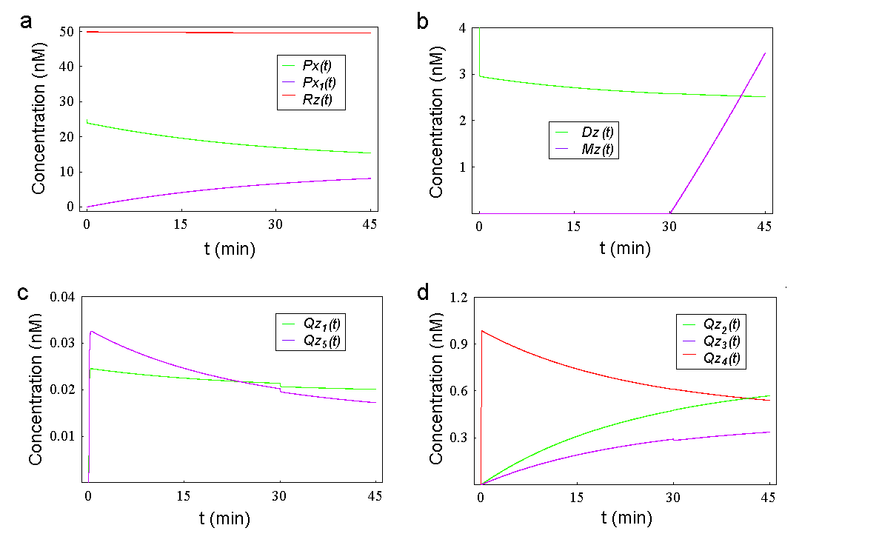

Transient curves of simulated ZntR transcription assay (I) for parameter :
