Table S1: Kinetic equations used in the model

The rate of reaction i is noted v_i.

v_1=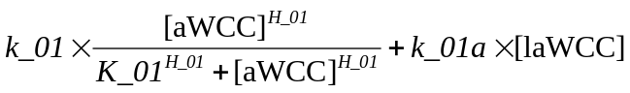

v_2=

v_3=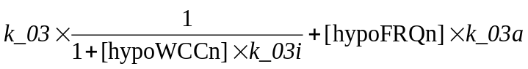

v_4=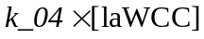

v_5=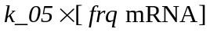

v_6=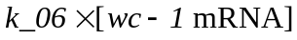

v_7=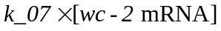

v_8=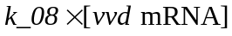

v_9=

v_10=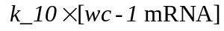

v_11=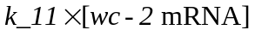

v_12=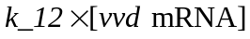

v_13=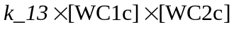

v_14=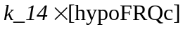

v_15=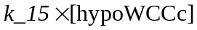

v_16=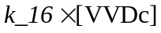

v_17=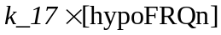

v_18=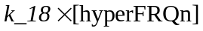

v_19=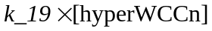

v_20=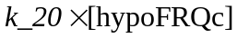

v_21=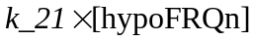

v_22=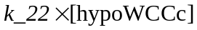

v_23=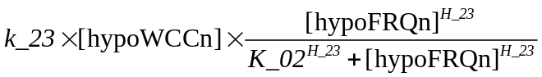

v_24=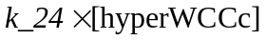

v_25=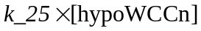

v_26=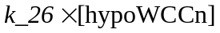

v_27=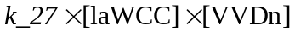

v_28=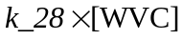

v_29=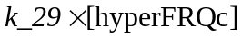

v_30=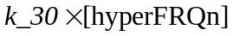

v_31=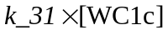

v_32=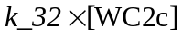

v_33=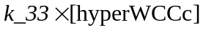

v_34=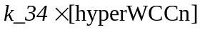

v_35=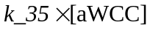

v_36=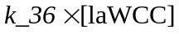

v_37=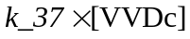

v_38=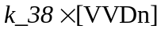

v_39=