Supplementary Information for Zi et al., 2011
Table of Contents
1. Model Development and Major Assumptions 2
2. Parameter Estimation 3
2.1 Deriving parameter values from experimental data 3
2.2 Estimation of the unknown parameters 5
2.3 Experimental data sets for parameter estimation 5
2.4 Statistical analysis of the estimated parameters 6
3. Mathematical Model Information 6
4. Supplementary Model and Figure Source Data Files 7
5. Supplementary Tables 8
Table S1: Summary of the derived parameter values based on published models and experimental data 8
Table S2: Statistical analysis of the estimated parameters 9
Table S3: Summary of model initial conditions 10
Table S4: Equations of the mathematical model 11
6. References 12
7. Supplementary Figures 14
Figure S1: Experimental analysis of TGF-β amount in medium after washout. 14
Figure S2: Comparison of model fitting to experimental datasets 1-8 that were used for parameter estimation. 15
Figure S3: Model analysis of the activated ligand-receptor complex (LRC) and Smad2 phosphorylation in response to periodic short pulses of TGF-β stimulation. 16
Figure S4: Model prediction and experimental validation of the P-Smad2 response when the type I receptor kinase is inhibited or medium TGF-β is washed out at 1 hour. 17
Figure S5: Representative images of BrdU assay for HaCaT cell proliferation with different doses of TGF-β. 18
Figure S6: Model analysis of the ultrasensitivity of the long-term P-Smad2 dose response with respect to parameter perturbations. 19
Figure S7: P-Smad2 dose response of the model with and without ligand depletion. 20
Figure S8: Model comparison for signaling responses to different doses of TGF-β stimulations. 21
Figure S9: Contour landscape of the time-dependent medium TGF-β depletion profile to different doses of TGF-β stimulation in HaCaT cells. 22

1. Model Development and Major Assumptions
The model includes the following signaling steps involved in the TGF-β signaling pathway: (1) receptor trafficking and activation; (2) Smad2 nucleo-cytoplasmic shuttling, phosphorylation and dephosphorylation; (3) negative feedback on the degradation of ligand receptor complex; (4) reversible binding of TGF-β to the cell surface. The modeling of Smad2 nucleo-cytoplasmic shuttling, phosphorylation and dephosphorylation is mainly based on the published model by Schmierer et al (Schmierer et al, 2008). Our new model integrates the sub-modules of Schmierer's model with additional simplified receptor trafficking sub-modules based on our previous model (Zi & Klipp, 2007b). Different from the models developed by Schmierer et al. and Vilar et al. (Schmierer et al, 2008; Vilar et al, 2006), this new model has taken into account TGF-β depletion. The detailed model scheme is described in Figure 2.
For the development of the mathematical model, we made the following assumptions:
1. Previous studies indicate that TGF-β signaling activity is proportional to the amount of ligand-receptor complexes that are internalized in early endosomes (Di Guglielmo et al, 2003; Vilar et al, 2006). We assume that the phosphorylation rate of Smad2 is proportional to the concentrations of Smad2 and the activated TGF-β receptors complex in early endosomes (LRC_endo). It is also worth noting that the model simulations and predictions in this work are similar with a relaxed assumption that the phosphorylation rate of Smad2 is proportional to the concentrations of Smad2 and the total amount of activated TGF-β receptor complexes.
2. Similar to the previous models (Schmierer et al, 2008; Zi & Klipp, 2007b), we do not take into account of Smad3, and assume that Smad3 undergoes the same reactions as Smad2.
3. Although, Smad2 protein is degraded by the regulation of ubiquitination, the variation of total Smad2 is very small, which is not affected by TGF-β stimulation in the time scale of our investigation. We assume that the total Smad2 amount is constant. Smad2 degradation and production are in balance and they are not explicitly modeled in the model. This is in agreement with recent evidence that phospho-Smad2/3 but not total Smad2/3 are regulated by proteasomal degradation (Gao et al, 2009).
4. For Smad7 or other proteins that are induced in negative feedback loops to regulate the receptor turn over, the model lumps these reactions into one reaction corresponding to the ligand-induced degradation of ligand-receptor complex due to the unavailability of the quantitative datasets for the individual reactions. The model assumes that degradation induced by the negative feedback loop is proportional to the total concentration of nuclear phosphorylated Smad2. We also tested versions of the models that explicitly include the intermediated steps for the negative feedback. However, we found that such model extensions introduce more parameters and cause uncertainty of the model parameters based on our available experimental data sets.
Mass action kinetics is used in this model. We tested other possible kinetics (Hill kinetics, Michaelis-Menten kinetics) for some of the reaction steps, for example, the phosphorylation of Smad2 and the negative feedback on the ligand-receptor degradation. We found that choosing other kinetics for these reactions introduces more parameters and uncertainty of the parameters, while it did not improve the model fitting to the observed experimental data.

2. Parameter Estimation

2.1 Deriving parameter values from experimental data
Cell volume and cell density: Our previous theoretical and experimental analyses indicate that cell density will affect the signaling responses (Clarke et al, 2009; Zi & Klipp, 2007a). In the experiments of this work, we controlled the number of TGF-β molecules per cell for different doses of TGF-β: ~1200 TGF-β molecules/cell, which corresponds to 1 pM TGF-β in the model. In our experimental setup, we stimulated about 1×10⁶ cells with 2 mL TGF-β-containing medium. Correspondingly, we set cell density to 5×10⁵ cells/ml in our model and the medium volume per cell (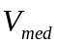) is 2×10⁻⁹ L. The volume of cytoplasm and nucleus are set as 2.3 pL (2.3×10⁻¹² L) and 1 pL (1×10⁻¹² L), respectively according to previous reports (Schmierer et al, 2008).
Our experimental data show that the HaCaT cell number increases about 45% after 24 hours of TGF-β stimulation (). In addition, our previous theoretical analysis indicated that the increase of cell density might cause a shift of the signaling dose response curve to the right, but it does not change its ultrasensitivity or sigmoid property (Zi & Klipp, 2007a). Therefore, in our model, we take into account the cell number increase for long-term time scale (time course of 24 hours). In this case, the medium volume per cell () is changed by the exponential growth of cell numbers with the following equation:
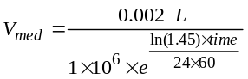 (1)
In the case of the experimental setup where cells are stimulated with 10 mL TGF-β-containing medium, the average medium volume per cell is about 5 times as that for the experiments with 2 mL TGF-β-containing medium. The corresponding in the model simulation for 10 mL medium is calculated with the following equation:
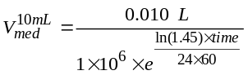 (2)
Receptor internalization and recycling rate constants: It is known that most of TGF-β receptors are internalized in endosomes and about 10% of TGF-β receptors are located on the cell surface (Di Guglielmo et al, 2003). Vilar et al., derived the internalization and recycling rate constant of the TGF-β receptors based on previous experimental data (Vilar et al, 2006). Here, we chose the same receptor internalization and recycling rate constant values from Vilar's model: 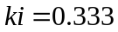 min⁻¹, 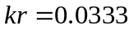 min⁻¹.
Receptor production and degradation rate constants: Similar to our previous study (Zi & Klipp, 2007c), we can perform steady state analysis of the TGF-β receptor trafficking network. We derive the steady state of the receptor distributions at the cell surface and internalized endosome before TGF-β stimulation. The initial conditions of TGF-β receptors are determined by the receptor production, internalization, recycling and degradation rate constants. For the initial steady state of receptors before TGF-β stimulation, we derive the following equations:
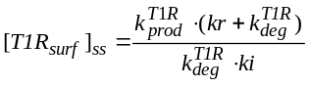 (3)
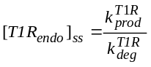 (4)
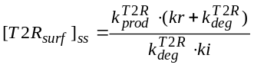 (5)
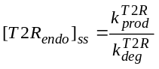 (6)
Previous experimental data indicates that type I TGF-β receptor (T1R) is more stable than type II TGF-β receptor (T2R). Without TGF-β stimulation, the half-life for T1R and T2R in normal epithelial cells is about 4-6 hours and 1 hour, respectively (Kavsak et al, 2000). By rescaling the distribution of internalized receptors in endosomes, we can derive the degradation rate constants for T1R: 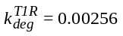 min⁻¹ (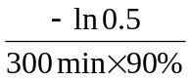), for T2R: 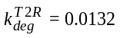 min⁻¹ (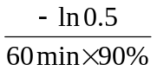). Since TGF-β ligand receptor complexes have similar distribution and half-life as the T1R receptor (Di Guglielmo et al, 2003), we set 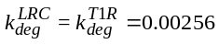 min⁻¹.
For simplicity, we fixed the number of total T1R to 10000 molecules per cell, which is a reasonable number based on previous reported values (Wakefield et al, 1987). Based on the equations (3) and (4), we estimated the corresponding production rate constant for T1R: 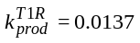nM/min. The production rate constant for T2R is estimated later based on experimental time course data sets. Our parameter estimation and model analyses indicate that the model simulations and model predictions were not sensitive to the choice of total number of T1R molecules per cell.
Previous studies indicated that active TGF-β molecules are rapidly degraded with a short half-life about 2 min (Kaminska et al, 2005; Wakefield et al, 1990). Based on this information, we derived the degradation rate constant for internalized free TGF-β: 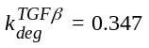 min⁻¹.
Smad2/Smad4 dissociation, nuclear import/export and Smad2 dephosphorylation rate constants: The nuclear import and export rate constants for Smad2 and Smad4 can be derived based on their nuclear-cytoplasmic distributions and the experimentally measured nuclear import rate constants (Schmierer & Hill, 2005; Schmierer et al, 2008; Zi & Klipp, 2007b). We chose these parameter values based on the published work and set the distribution of Smad2 and Smad4 in cytoplasm and nucleus in steady state before TGF-β stimulation (Schmierer et al, 2008; Zi & Klipp, 2007b). Using a mathematical modeling approach, Schmierer et al. identified an enhanced nuclear import rate constant for Smad complexes. We took the nuclear import, the dissociation rate constants for Smad complexes and the dephosphorylation rate constants from the model developed by Schmierer et al (Schmierer et al, 2008). The detailed values for these parameters and references are shown in Table S1.

2.2 Estimation of the unknown parameters
For estimation of other unknown parameters, we used a parallel parameter estimation tool SBML-PET-MPI (Zi, 2011; Zi & Klipp, 2006), which includes a global optimization algorithm (SRES) using weighted least squares to minimize the sum of squares of differences between model simulations and the corresponding experimental datasets. SRES is a stochastic ranking evolution strategy based on an evolutionary optimization algorithm and has a good optimization performance, according to previous studies (Moles et al, 2003; Runarsson & Yao, 2000). We estimated the values of 8 parameters in the model with 92 experimental data points from different TGF-β stimulation conditions. In addition, the model developed by Schmierer showed that about 30% of total Smad2 molecules are phosphorylated with high doses of TGF-β (Schmierer et al, 2008). During the parameter estimation, we optimized the parameters with one constrain that about 20%-40% of Smad2 molecules are phosphorylated for stimulation with 60000 TGF-β molecule/cell.

2.3 Experimental data sets for parameter estimation
We used the following experimental datasets ("in-sample datasets") for the parameter estimation of the 8 unknown parameter values. Other experimental data sets presented in this work were not employed for parameter estimation, but they were used for model validation and testing of model predictions.
(1) Datasets 1-3: time course of total Smad2 phosphorylation level (P-Smad2) to different doses of TGF-β stimulations: 1200, 6000 and 60000 TGF-β molecules per cell.
(2) Dataset 4: time course of TGF-β concentration in the medium after TGF-β stimulation with a dose of 30000 TGF-β molecules per cell
(3) Dataset 5: time course of P-Smad2 response to 30 seconds of TGF-β stimulation (TGF-β dose: 60000 molecules per cell). Cells were first stimulated with TGF-β for 30 seconds. Then TGF-β was washed out at 30 seconds and cells were incubated with fresh medium without TGF-β. Our experimental data indicated that the P-Smad2 signal at 45 min with 30 seconds of TGF-β stimulation is about 40% of that at 45 min with sustained TGF-β stimulation (TGF-β dose: 60000 molecules per cell, Figure 1A).
(4) Dataset 6: time course of P-Smad2 response to periodic pulses of TGF-β stimulation (TGF-β dose: 60000 molecules per cell). Cells were stimulated with TGF-β for 3 hours (T_{on} = 3 hour). Then TGF-β was washed out and fresh medium without TGF-β is added for 3 hours (T_{off} = 3 hour). At 6 hours, TGF-β was added again for 3 hours and was washed out at 9 hours.
(5) Dataset 7: time course of P-Smad2 response to 80 pM TGF-β stimulation.
(6) Dataset 8: time course of nuclear Smad2 concentration change. Cells were stimulated with 80 pM TGF-β, in which TGF-β type I receptor kinase inhibitor SB431542 was added at 45 min.
Datasets 1-6 were measured with several replicates, which were the new datasets generated in this work. Datasets 7-8 come from the reference (Schmierer et al, PNAS, 2008) and were kindly provided by Dr. Caroline Hill.

2.4 Statistical analysis of the estimated parameters
For statistical analysis of the estimated parameters, we employed the bootstrap approach (Press et al, 1992) to generate new synthetic data sets D_{s} from the original experimental data sets D₀
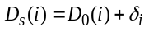 (7)
where δ_{i} is randomly taken from a normal distribution N(0, σ_{i}), σ_{i} corresponds to the standard deviation in the i-th experimental data.
We performed independent parameter estimations with 500 new synthetic data sets. The 500 new estimated parameter sets for the synthetic data sets were saved and were used for calculating the distribution and standard deviations of the estimated parameter values, which are shown in Table S2. The estimated 8 parameter values have small variations judged from their standard deviations and the parameter values from the best fit are approximate to the corresponding mean values of the 500 parameter sets.
Further profile likelihood analysis (Raue et al, 2009) was implemented in our customized tool SBML-PET-MPI (Zi, 2011) to calculate 95% confidence intervals for the estimated parameters in the model and those in the fitted Hill equations.

3. Mathematical Model Information
The model is composed of 19 species and 29 reactions with 22 kinetic parameters. As described in Section 2.1, the initial conditions of TGF-β receptors are determined by the receptor production, internalization, recycling and degradation rate constants. We set the initial assignments for different pools of receptors with equations (3)-(6). Schmierer et al estimated that, in HaCaT cells, the ratio of cytoplasmic to nuclear Smad2 concentration is about 2.1, while the ratio of cytoplasmic to nuclear Smad4 is about 1 (Schmierer & Hill, 2005; Schmierer et al, 2008). In addition, in HaCaT cells Smad2 and Smad4 were estimated to be about 1.0×10⁵ molecules per cell, respectively (Schmierer et al, 2008). Based on this information, we can derive the initial concentrations of Smad2 and Smad4 in cytoplasm or nucleus, which are the same as the values reported by Schmierer et al. (Schmierer et al, 2008). The initial conditions, parameter values, and equations are described in Table S1-S4.

4. Supplementary Model and Figure Source Data Files
The Systems Biology Markup Language (SBML) file for the model is available in the online Supplementary Material "SBML Model files". The SBML model is also deposited in BioModels database (Li et al, 2010), which can be retrieved using the following link:
http://www.ebi.ac.uk/biomodels-main/MODEL1104050000
The CellDesigner file for Figure 2 is also available in the online Supplementary Material. Please note that current version of CellDesigner 4.1 does not support compartment variation, therefore, it cannot run simulation for this model. We recommend the readers to use the accompany SBML model to run simulations with the software tools that support compartment variation.
In addition, the source experimental data for the figures are available in the online Supplementary Material "Figure source data". It is worth noting that some of the experimental data shown in the figures are scaled to compare with the model simulation results (see the Figure legends for more details). The corresponding source experimental data (not scaled, normalized to the maximum P-Smad2 signal) are provided in the "Figure source data".

5. Supplementary Tables

Table S1: Summary of the derived parameter values based on published models and experimental data
Parameter | Value and Unit | Annotation | Reference
kdeg_T1R | 0.00256 min⁻¹ | constitutive degradation rate constant for type I receptor (T1R) | (Kavsak et al, 2000; Zi & Klipp, 2007b)
kdeg_T2R | 0.0132 min⁻¹ | constitutive degradation rate constant for type II receptor (T2R) | (Kavsak et al, 2000; Zi & Klipp, 2007b)
kdeg_LRC | 0.00256 min⁻¹ | constitutive degradation rate constant for ligand receptor complex (LRC) | (Di Guglielmo et al, 2003; Zi & Klipp, 2007b)
kdeg_TGF_beta | 0.347 min⁻¹ | constitutive degradation rate constant for internalized TGF-β | (Kaminska et al, 2005; Wakefield et al, 1990)
kprod_T1R | 0.0137 nM⁻¹min⁻¹ | cell surface type I receptor production rate constant | (Wakefield et al, 1987)
ki | 0.333 min⁻¹ | internalization rate constant for receptors | (Vilar et al, 2006)
kr | 0.0333 min⁻¹ | recycling rate constant for receptors | (Mitchell et al, 2004; Vilar et al, 2006)
kimp_Smad2 | 0.156 min⁻¹ | Smad2 nuclear import rate constant | (Schmierer et al, 2008; Zi & Klipp, 2007b)
kexp_Smad2 | 0.739 min⁻¹ | Smad2 nuclear export rate constant | (Schmierer et al, 2008; Zi & Klipp, 2007b)
kimp_Smad4 | 0.156 min⁻¹ | Smad4 nuclear import rate constant | (Schmierer et al, 2008; Zi & Klipp, 2007b)
kexp_Smad4 | 0.355 min⁻¹ | Smad4 nuclear export rate constant | (Schmierer et al, 2008; Zi & Klipp, 2007b)
kimp_Complex | 0.889 min⁻¹ | Smad complexes nuclear import rate constant | (Schmierer et al, 2008)
koff_Smads | 1 min⁻¹ | Smad complexes dissociation rate constant | (Schmierer et al, 2008)
kdepho_Smads | 0.394 min⁻¹ | Phospho-Smad2 dephosphorylation rate constant | (Schmierer et al, 2008)
Note: The derived parameters were rounded with 3 effective digits

Table S2: Statistical analysis of the estimated parameters
Parameter (Unit) | Best fit | 95% confidence interval | Mean ± 1 standard deviation | Bounds in parameter estimation
kprod_T2R (nM/min) | 0.0190076 | (0.0174869; 0.0193877) | 0.0194482 ± 0.00233725 | 0.001 ~ 1
ka_LRC (nM⁻²min⁻¹) | 117.897 | (117.823; 127.329) | 117.417 ± 22.1622 | 0.001 ~ 1000
kdiss_LRC (min⁻¹) | 0.0438111 | (0.0368014; 0.047316) | 0.0444806 ± 0.00722633 | 0.001 ~ 1
klid (nM⁻¹min⁻¹) | 0.0233678 | (0.0224330; 0.0233824) | 0.0244277 ± 0.00550235 | 0.001 ~ 1000
kpho_Smad2 (nM⁻¹min⁻¹) | 0.0488268 | (0.0468738; 0.052733) | 0.0492042 ± 0.00512906 | 0.001 ~ 1000
kon_Smads (nM⁻¹min⁻¹) | 0.198472 | (0.198348; 0.198596) | 0.200210 ± 0.0255975 | 0.001 ~ 1000
kon_ns (min⁻¹) | 0.0505413 | (0.0464980; 0.0505730) | 0.118830 ± 0.201645 | 0.001 ~ 1
KD_ns | 40.2257 | (38.6167; 40.2509) | 41.8396 ± 13.2817 | 0.001 ~ 1000
Note: The estimated parameters were rounded with 6 effective digits. The second and third column display estimated parameter values and their 95% confidence intervals derived from the profile likelihood analysis. The 4th column is the mean and 1 standard deviation of the estimated parameters calculated from 500 optimizations with bootstrap method.

Table S3: Summary of model initial conditions
Species | Initial Conditions (Unit: nM) | Annotation
TGF_beta_ex (x1) | to be specified | TGF-β concentration in the medium, 0.001 nM corresponds to 1200 TGF-β molecules per cell in the model
T1R_surf (x2) | 0.702494 | type I receptor at plasma membrane (cell surface)
T1R_endo (x3) | 6.52344 | type I receptor in early endosome
T2R_surf (x4) | 0.201077 | type II receptor at plasma membrane (cell surface)
T2R_endo (x5) | 1.43997 | type II receptor in early endosome
LRC_surf (x6) | 0 | LRC at plasma membrane (cell surface)
LRC_endo (x7) | 0 | LRC in early endosome
Smad2c (x8) | 60.6 | Smad2 in cytoplasm
Smad2n (x9) | 28.5 | Smad2 in nucleus
Smad4c (x10) | 50.8 | Smad4 in cytoplasm
Smad4n (x11) | 50.8 | Smad4 in nucleus
PSmad2c (x12) | 0 | phosphorylated Smad2 monomer in cytoplasm
PSmad2_PSmad2_c (x13) | 0 | phosphorylated Smad2 dimer in cytoplasm
PSmad2_Smad4_c (x14) | 0 | phosphorylated Smad2-Smad4 complex in cytoplasm
PSmad2n (x15) | 0 | phosphorylated Smad2 monomer in nucleus
PSmad2_PSmad2_n (x16) | 0 | phosphorylated Smad2 dimer in nucleus
PSmad2_Smad4_n (x17) | 0 | phosphorylated Smad2-Smad4 complex in nucleus
TGF_beta_endo (x18) | 0 | TGF-β in early endosome
TGF_beta_ns (x19) | 0 | non-specific bound TGF-β
Note: The estimated parameters were rounded with 3 effective digits. The initial conditions of receptors (x2-x5) are determined by initial assignments with equations (3)-(6) during parameter estimation.

Table S4: Equations of the mathematical model
Ordinary differential equations
dx1/dt = -Vcyt*ka_LRC*x1*x4*x2/Vmed - kon_ns*x1 + koff_ns*x19
dx2/dt = kprod_T1R - ki*x2 + kr*x3 - ka_LRC*x1*x4*x2
dx3/dt = ki*x2 - kr*x3 - kdeg_T1R*x3 + kdiss_LRC*x7
dx4/dt = kprod_T2R - ki*x4 + kr*x5 - ka_LRC*x1*x4*x2;
dx5/dt = ki*x4 - kr*x5 - kdeg_T2R*x5 + kdiss_LRC*x7
dx6/dt = ka_LRC*x1*x4*x2 - ki*x6 - klid*x6*totalNuclearPSmad2
dx7/dt = ki*x6 - kdiss_LRC*x7 - kdeg_LRC*x7
dx8/dt = Vnuc*kexp_Smad2*x9/Vcyt - kpho_Smad2*x8*x7 - kimp_Smad2*x8
dx9/dt = Vcyt*kimp_Smad2*x8/Vnuc - kexp_Smad2*x9 + kdepho_Smad2*x15
dx10/dt = Vnuc*kexp_Smad4*x11/Vcyt - kon_Smads*x12*x10 + koff_Smads*x14 - kimp_Smad4*x10
dx11/dt = Vcyt*kimp_Smad4*x10/Vnuc - kexp_Smad4*x11 + koff_Smads*x17 - kon_Smads*x15*x11
dx12/dt = kpho_Smad2*x8*x7 - kimp_Smad2*x12 + Vnuc*kexp_Smad2*x15/Vcyt
- kon_Smads*x12*x10 + koff_Smads*x14 - 2*kon_Smads*x12*x12 +2* koff_Smads*x13
dx13/dt = kon_Smads*x12*x12 - koff_Smads*x13 - kimp_Smads*x13
dx14/dt = kon_Smads*x12*x10 - koff_Smads*x14 - kimp_Smads*x14
dx15/dt = Vcyt*kimp_Smad2*x12/Vnuc - kexp_Smad2*x15 + koff_Smads*x17
- kon_Smads*x15*x11 - kdepho_Smad2*x15 + 2* (koff_Smads*x16-kon_Smads* x15*x15)
dx16/dt = Vcyt *kimp_Smads*x13/Vnuc - koff_Smads*x16 + kon_Smads*x15*x15
dx17/dt = Vcyt*kimp_Smads*x14/Vnuc - koff_Smads*x17 + kon_Smads*x15*x11
dx18/dt = kdiss_LRC*x7 - kdeg_TGF_beta*x18
dx19/dt = kon_ns*x1-koff_ns*x19
Assignment rules and compartment parameters
totalNuclearPSmad2 = x15+2*x16+x17
totalNumPSmad2 = (x12+x13*2+x14)*2.3*602+(x15+x16*2+x17) *602 (molecules/cell)
totoalNuclearSmad2 = x9+x15+2*x16+x17
koff_ns = kon_ns*KD_ns
Vcyt = 2.3e-12 (liter) , Vnuc = 1e-12 (liter)
Vmed = 0.002/(1e6*exp(log(1.45)*time/1440))
(for long-term TGF-β stimulation, about 1×10⁶ cells in 2 mL TGF-β containing medium)
Vmed_10mL = 0.010/(1e6*exp(log(1.45)*time/1440))
(for long-term TGF-β stimulation, about 1×10⁶ cells in 10 mL TGF-β containing medium)
TGF_beta_dose = [TGF_beta_ex]₀* 1e-9*Vmed*6e23 (molecules/cell)
TGF_beta_dose_10mL = [TGF_beta_ex]₀* 1e-9*Vmed_10mL*6e23 (molecules/cell, 10 mL medium)
Other parameter values and initial conditions are listed in Table S1-S3

6. References
Clarke DC, Brown ML, Erickson RA, Shi Y, Liu X (2009) Transforming growth factor beta depletion is the primary determinant of Smad signaling kinetics. Mol Cell Biol 29: 2443-2455

Di Guglielmo GM, Le Roy C, Goodfellow AF, Wrana JL (2003) Distinct endocytic pathways regulate TGF-beta receptor signalling and turnover. Nature cell biology 5: 410-421

Gao S, Alarcon C, Sapkota G, Rahman S, Chen PY, Goerner N, Macias MJ, Erdjument-Bromage H, Tempst P, Massague J (2009) Ubiquitin ligase Nedd4L targets activated Smad2/3 to limit TGF-beta signaling. Mol Cell 36: 457-468

Kaminska B, Wesolowska A, Danilkiewicz M (2005) TGF beta signalling and its role in tumour pathogenesis. Acta Biochim Pol 52: 329-337

Kavsak P, Rasmussen RK, Causing CG, Bonni S, Zhu H, Thomsen GH, Wrana JL (2000) Smad7 binds to Smurf2 to form an E3 ubiquitin ligase that targets the TGF beta receptor for degradation. Mol Cell 6: 1365-1375

Li C, Donizelli M, Rodriguez N, Dharuri H, Endler L, Chelliah V, Li L, He E, Henry A, Stefan MI, Snoep JL, Hucka M, Le Novere N, Laibe C (2010) BioModels Database: An enhanced, curated and annotated resource for published quantitative kinetic models. BMC Syst Biol 4: 92

Mitchell H, Choudhury A, Pagano RE, Leof EB (2004) Ligand-dependent and -independent transforming growth factor-beta receptor recycling regulated by clathrin-mediated endocytosis and Rab11. Mol Biol Cell 15: 4166-4178

Moles CG, Mendes P, Banga JR (2003) Parameter estimation in biochemical pathways: a comparison of global optimization methods. Genome Res 13: 2467-2474

Press WH, Teukolsky SA, Vetterling WT, Flannery BP (1992) Numerical recipes in C : the art of scientific computing, 2nd ed. edn. Cambridge: Cambridge University Press.

Raue A, Kreutz C, Maiwald T, Bachmann J, Schilling M, Klingmuller U, Timmer J (2009) Structural and practical identifiability analysis of partially observed dynamical models by exploiting the profile likelihood. Bioinformatics (Oxford, England) 25: 1923-1929

Runarsson TP, Yao X (2000) Stochastic ranking for constrained evolutionary optimization. Ieee Transactions on Evolutionary Computation 4: 284-294

Schmierer B, Hill CS (2005) Kinetic analysis of Smad nucleocytoplasmic shuttling reveals a mechanism for transforming growth factor beta-dependent nuclear accumulation of Smads. Mol Cell Biol 25: 9845-9858

Schmierer B, Tournier AL, Bates PA, Hill CS (2008) Mathematical modeling identifies Smad nucleocytoplasmic shuttling as a dynamic signal-interpreting system. Proc Natl Acad Sci U S A 105: 6608-6613

Vilar JM, Jansen R, Sander C (2006) Signal processing in the TGF-beta superfamily ligand-receptor network. PLoS Comput Biol 2: e3

Wakefield LM, Smith DM, Masui T, Harris CC, Sporn MB (1987) Distribution and modulation of the cellular receptor for transforming growth factor-beta. J Cell Biol 105: 965-975

Wakefield LM, Winokur TS, Hollands RS, Christopherson K, Levinson AD, Sporn MB (1990) Recombinant latent transforming growth factor beta 1 has a longer plasma half-life in rats than active transforming growth factor beta 1, and a different tissue distribution. J Clin Invest 86: 1976-1984

Zi Z (2011) SBML-PET-MPI: a parallel parameter estimation tool for Systems Biology Markup Language based models. Bioinformatics (Oxford, England) 27: 1028-1029

Zi Z, Klipp E (2006) SBML-PET: a Systems Biology Markup Language-based parameter estimation tool. Bioinformatics (Oxford, England) 22: 2704-2705

Zi Z, Klipp E (2007a) Cellular signaling is potentially regulated by cell density in receptor trafficking networks. FEBS Lett 581: 4589-4595

Zi Z, Klipp E (2007b) Constraint-based modeling and kinetic analysis of the Smad dependent TGF-beta signaling pathway. PloS one 2: e936

Zi Z, Klipp E (2007c) Steady state analysis of signal response in receptor trafficking networks. Genome Inform 18: 100-108

7. Supplementary Figures
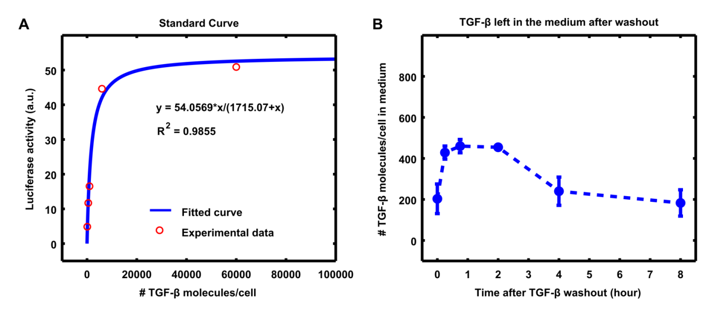

Figure S1: Experimental analysis of TGF-β amount in medium after washout.
(A) Standard curve of luciferase reporter analysis with different doses of TGF-β. (B) Experimental measurement of TGF-β left in the medium after washout. The data is calibrated with standard curves and standard deviations are shown from 2 replicates. Cells were stimulated with TGF-β for 30 seconds (at 60000 TGF-β molecules per cell) and then washed three times with D-PBS. Fresh medium without TGF-β was added after washout.

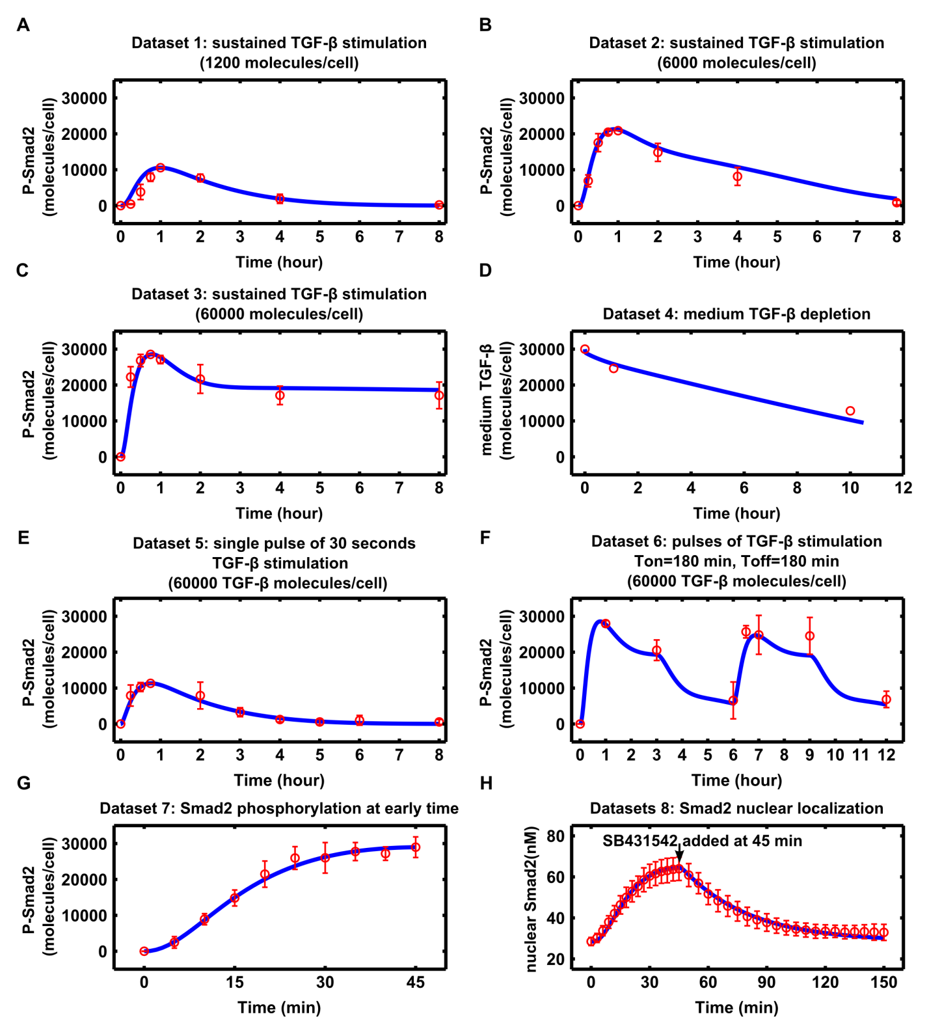

Figure S2: Comparison of model fitting to experimental datasets 1-8 that were used for parameter estimation.
Corresponding experimental datasets are denoted with circle points, which are scaled for the comparison to model simulation results. Details about the experimental data sets are described in the section "2.3 Experimental data sets for parameter estimation" of the Supplementary Information.
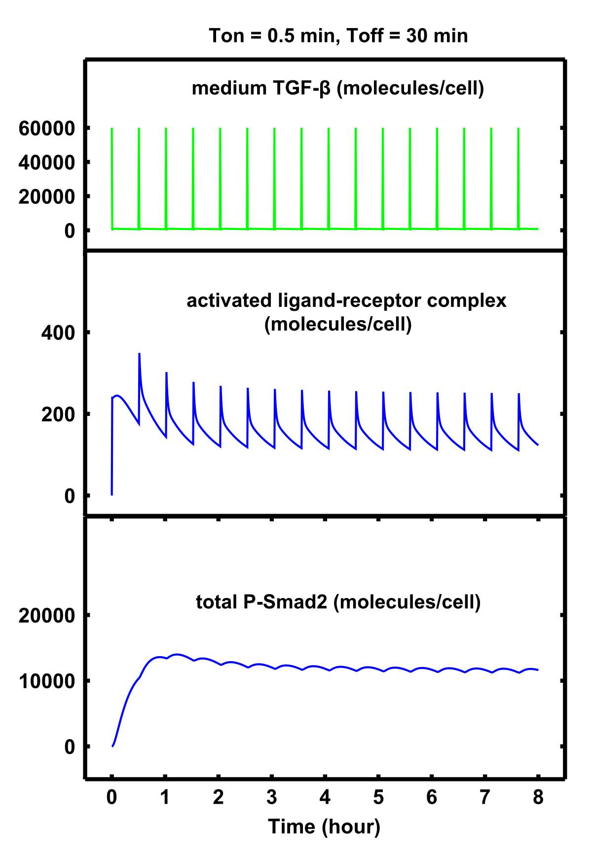

Figure S3: Model analysis of the activated ligand-receptor complex (LRC) and Smad2 phosphorylation in response to periodic short pulses of TGF-β stimulation.

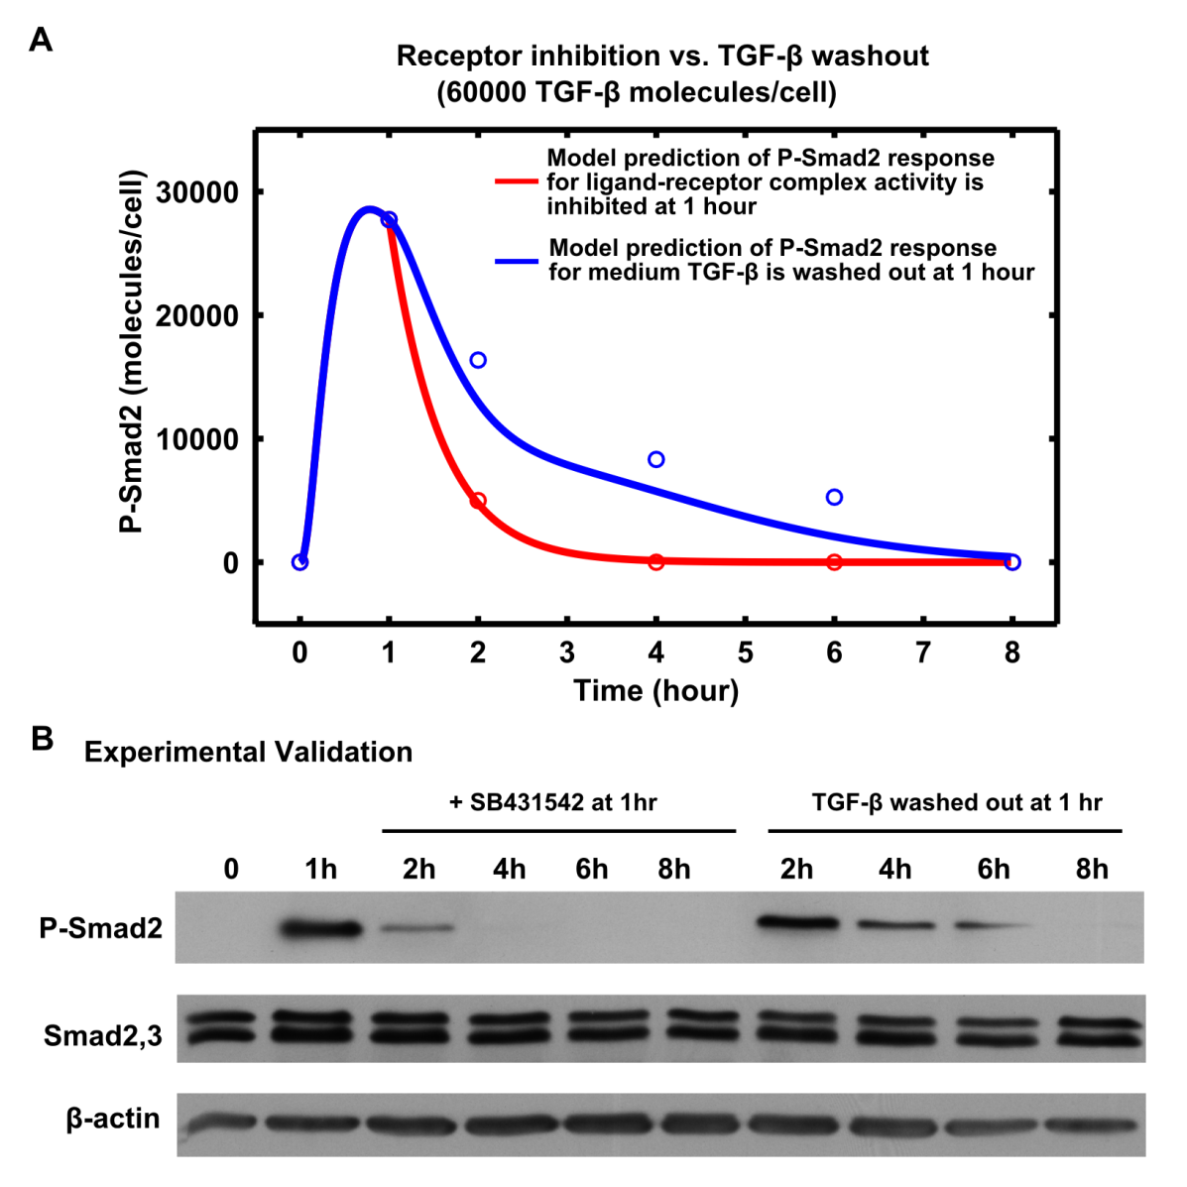

Figure S4: Model prediction and experimental validation of the P-Smad2 response when the type I receptor kinase is inhibited or medium TGF-β is washed out at 1 hour.
(A) Model predictions. For simulation of ligand-receptor complex activity inhibition (corresponding Smad2 phosphorylation is inhibited), the kpho_Smad2 was rest from 0.0488268 to 0 after 1 hour TGF-β stimulation. The blue and red circle points are the scaled experimental data for SB431542 added at 1 hour and TGF-β washed out at 1 hour, respectively. The experimental data was quantified from the blot shown in panel B. (B) Western blot analysis of P-Smad2, Smad2/3 and β-actin.
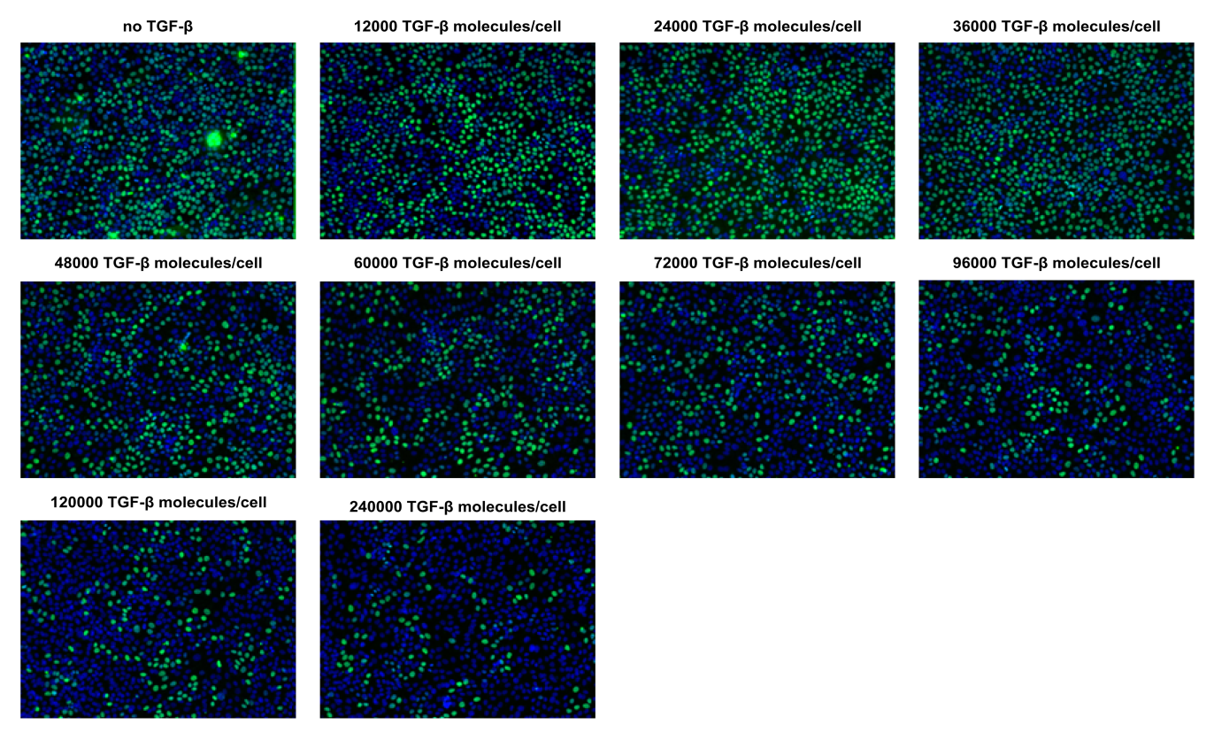

Figure S5: Representative images of BrdU assay for HaCaT cell proliferation with different doses of TGF-β.
Green color indicates BrdU incorporated into nuclei. Blue color indicates nuclear DNA.

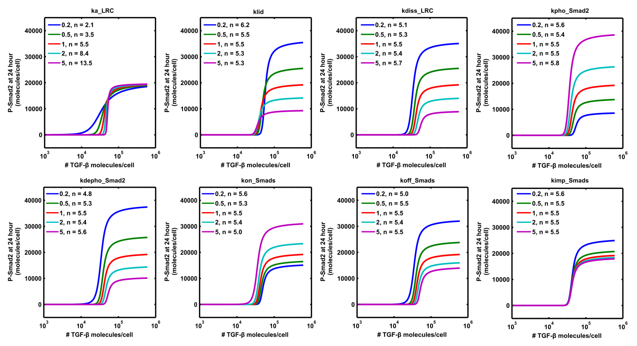

Figure S6: Model analysis of the ultrasensitivity of the long-term P-Smad2 dose response with respect to parameter perturbations.
The parameters indicated on the top-left of each panel are set to be 0.2, 0.5, 1, 2 and 5 fold of their original values in the model, respectively. Apparent Hill coefficients (n) are calculated from the model simulation results.

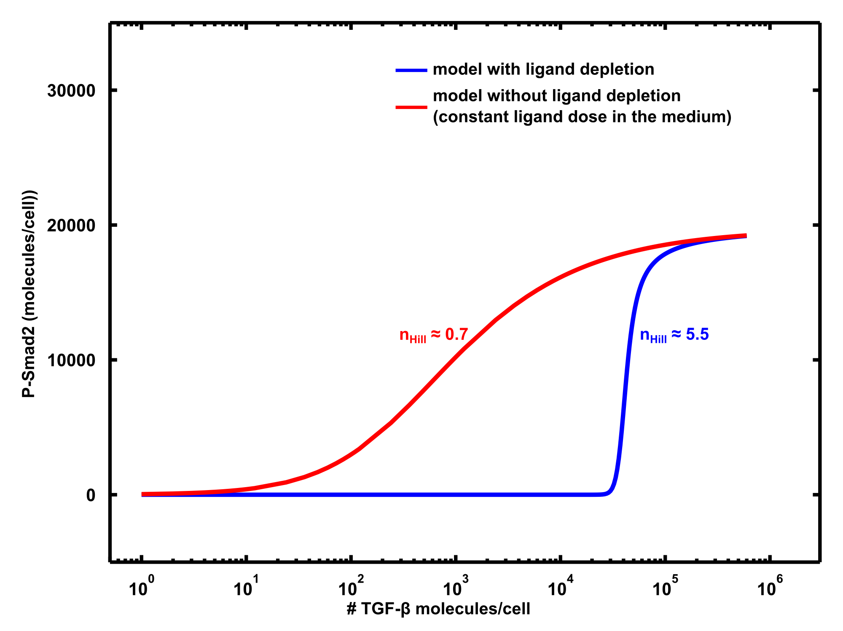

Figure S7: P-Smad2 dose response of the model with and without ligand depletion.
The model without ligand depletion has the same initial conditions and parameter set as the original model, but it keeps the ligand in the medium being constant without depletion.

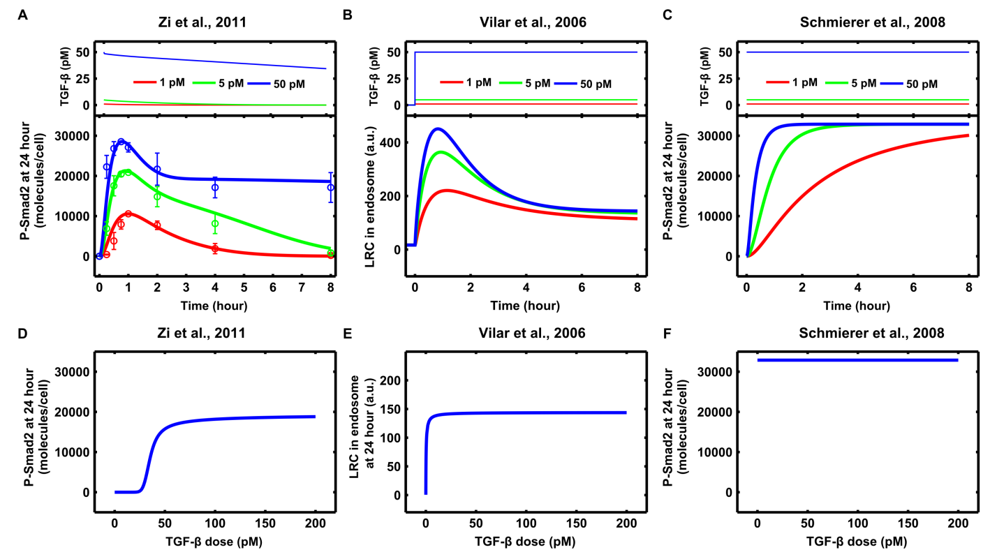

Figure S8: Model comparison for signaling responses to different doses of TGF-β stimulations.
(A-C) Predictions for time course of signaling response to different doses of TGF-β stimulation with different models. (D-F) Predictions for long-term signaling response to different doses of TGF-β stimulation with different models. TGF-β doses are converted to medium concentration in order to be comparable in different models.
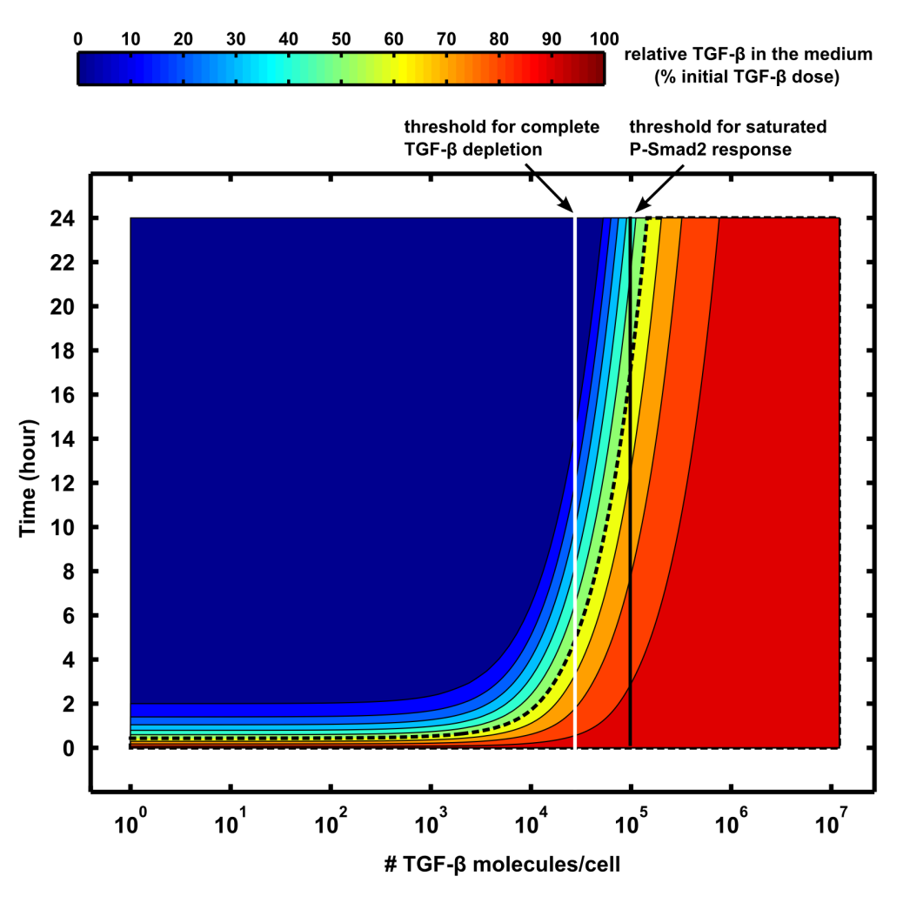

Figure S9: Contour landscape of the time-dependent medium TGF-β depletion profile to different doses of TGF-β stimulation in HaCaT cells.
Model simulations indicate that the different doses of TGF-β stimulations have different half-lives for medium TGF-β depletion (the black dashed curve roughly denotes 50% of initial medium TGF-β doses). When the TGF-β is lower than a certain threshold (denoted as vertical white line), medium TGF-β has short half-life times, which results in complete depletion at long-term time scales. Due to the complete depletion of TGF-β, cells will have very low long-term Smad2 phosphorylation levels for low doses of TGF-β. Therefore, the low doses of TGF-β stimulation will be filtered out by ligand depletion. On the other hand, the half-lives of high doses of TGF-β are significantly increased when the TGF-β dose is larger than another threshold (denoted as vertical black line). At this time scale (time at 24 hour), medium TGF-β will be still at a very high level that corresponds to a saturated Smad2 phosphorylation level due to the limited amount of steady state TGF-β receptors. The filtering of low doses of TGF-β by depletion and the saturation of Smad2 phosphorylation for high doses of TGF-β make cells generate long-term ultrasensitive responses for cell fate decisions making.

