SUPPLEMENTARY INFORMATION
Asymmetric positive feedback loops reliably control biological responses
Alexander V. Ratushny, Ramsey A. Saleem, Katherine Sitko, Stephen A. Ramsey, John D. Aitchison*
Institute for Systems Biology, Seattle, WA 98109, USA
Seattle Biomedical Research Institute, Seattle, WA 98109, USA

*To whom correspondence should be addressed. E-mail: John.Aitchison@systemsbiology.org

Table of Contents
Supplementary Figure 1 page 3
Supplementary Figure 2 page 4
Supplementary Figure 3 page 5
Supplementary Figure 4 page 6
Supplementary Figure 5 page 7
Supplementary Figure 6 page 8
Supplementary Figure 7 page 9
Supplementary Figure 8 page 10
Supplementary Figure 9 page 11
Supplementary Figure 10 page 12
Supplementary Figure 11 page 13
Supplementary Figure 12 page 14
Supplementary Figure 13 page 16
Supplementary Figure 14 page 17
Supplementary Table 1 page 18
Supplementary Table 2 page 19
Supplemental model files SBMLmodels.zip

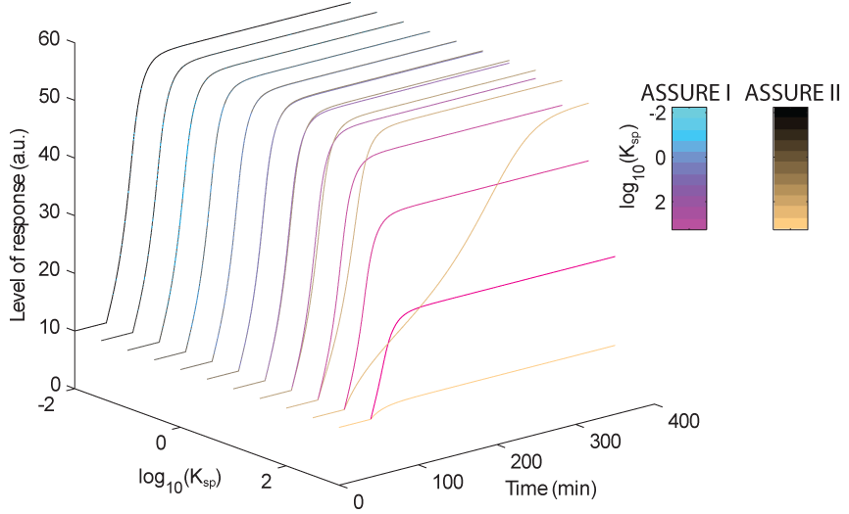
Supplementary Figure 1. Exploration of the ASSURE I and ASSURE II model responses to the stimulus in the context of changing K_{sp} parameters. Parameter values for results presented here were used as follows: k_{s} = 10 min⁻¹, k_{u} = 0.1 min⁻¹, k₀ = 0.1, k_{a} = 40 a.u., h = 2, high K_{d} = 10⁻¹ a.u., low K_{d} = 10⁻³ a.u., s = 10³ a.u., P₁^{level} in ASSURE I and P₂^{level} in ASSURE II = 40 a.u..

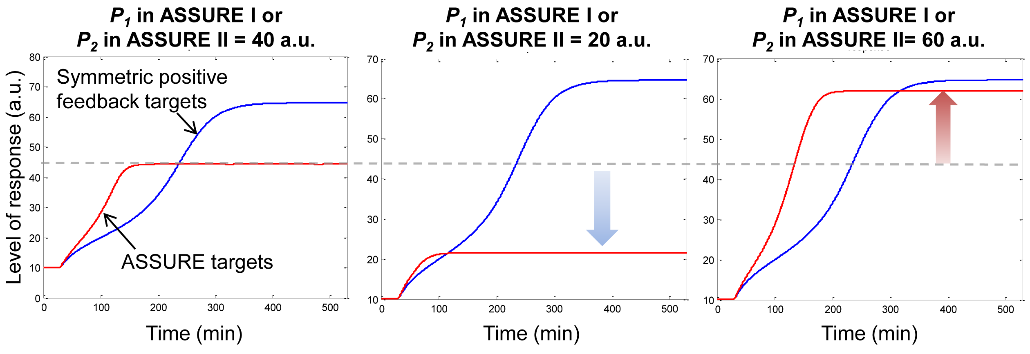
Supplementary Figure 2. Tunability of the ASSURE model with high K_{d} or low affinity between P₁ and P₂. The level/activity of P₂ in ASSURE II or P₁ in ASSURE I defines the level of the system response. Parameter values for results presented in this figure were used as follows: k_{s} = 10 min⁻¹, k_{u} = 0.1 min⁻¹, k₀ = 0.1, k_{a} = 50 a.u., h = 2, K_{sp} = 10⁻¹ a.u., K_{d} = 10⁻¹ a.u., s = 10⁷ a.u..

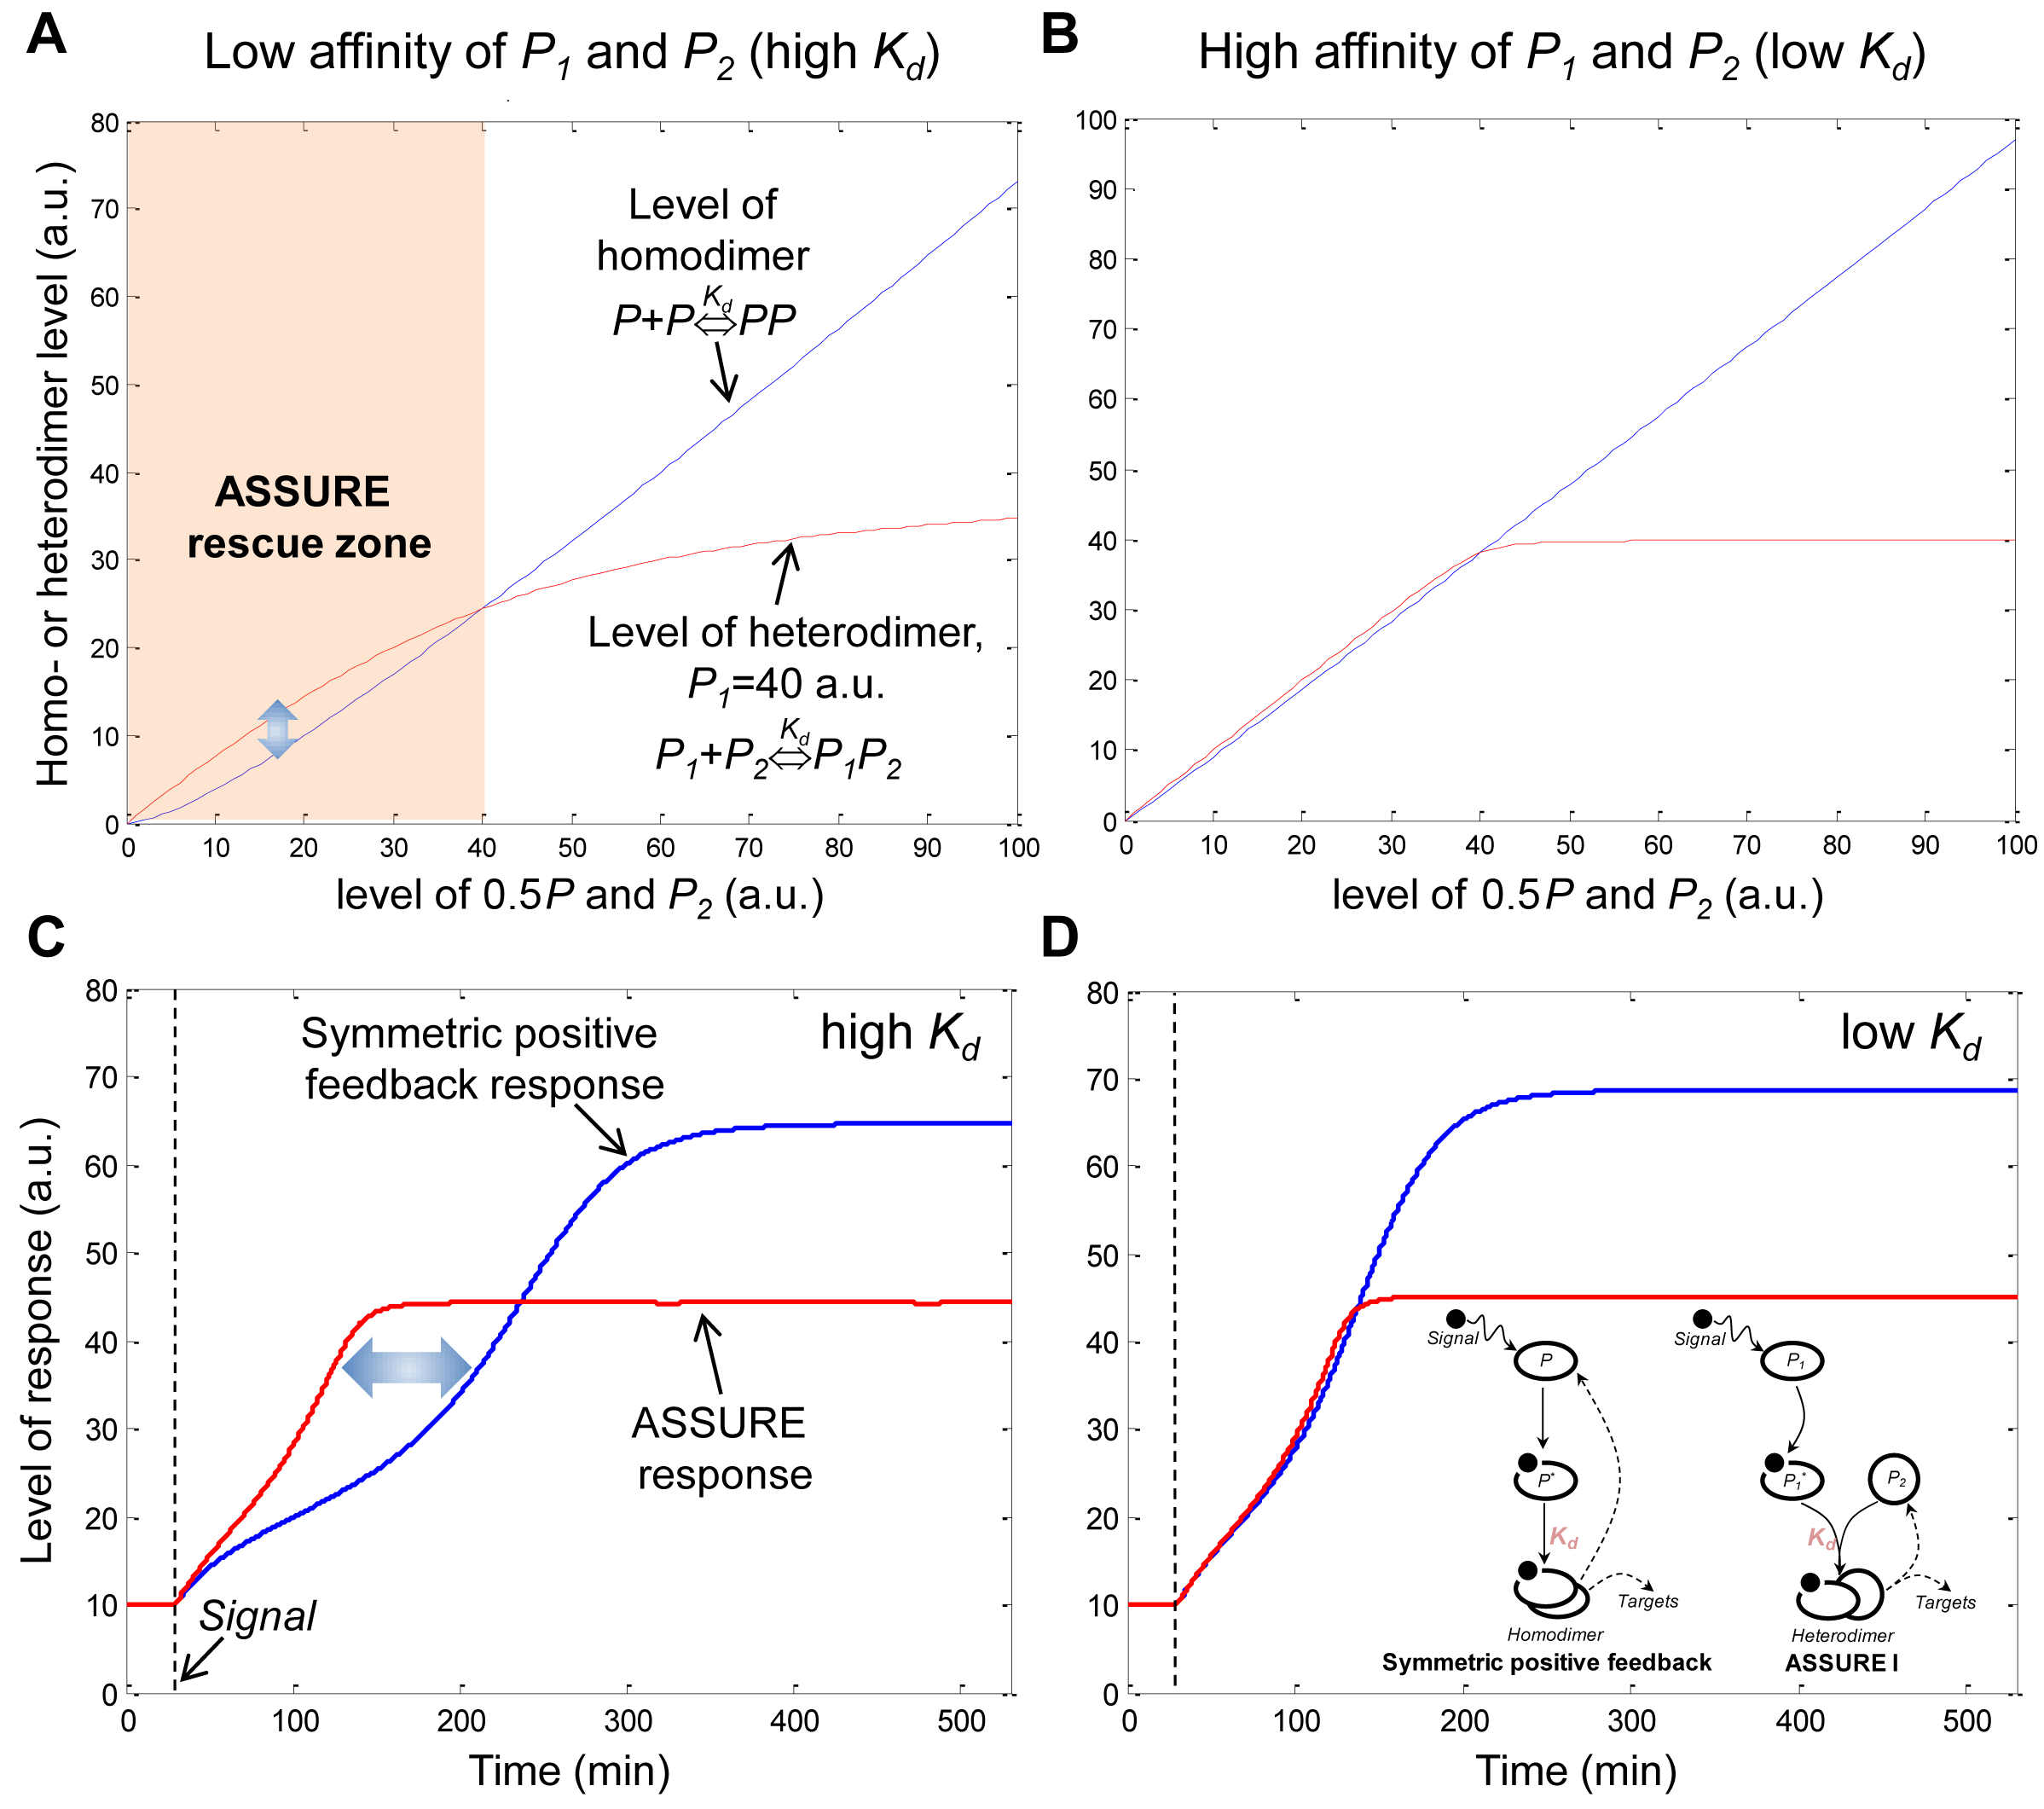
Supplementary Figure 3. ASSURE model responses to the stimulus are robust to K_{d} changing. (A and B) The effect of high K_{d} = 10 a.u. and low K_{d} = 0.1 a.u., respectively, on the dependence of homo- (PP) and heterodimer (P₁P₂) levels on the concentration of P and P₂ (when P₁ is constant and equal to 40 a.u.) in the quasi-equilibrium model 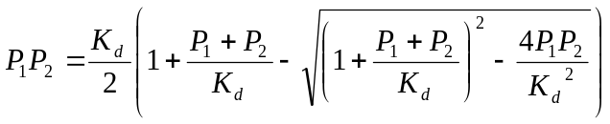. (C and D) The effect of high and low K_{d}, respectively, on the symmetric positive feedback and ASSURE model responses to the stimulus. Parameter values for results presented here were used as follows: k_{s} = 10 min⁻¹, k_{u} = 0.1 min⁻¹, k₀ = 0.1, k_{a} = 50 a.u., h = 2, K_{sp} = 10⁻¹ a.u., high K_{d} = 10⁻¹ a.u., low K_{d} = 10⁻³ a.u., s = 10⁷ a.u., P₁^{level} in ASSURE I (or P₂^{level} in ASSURE II) = 40 a.u..
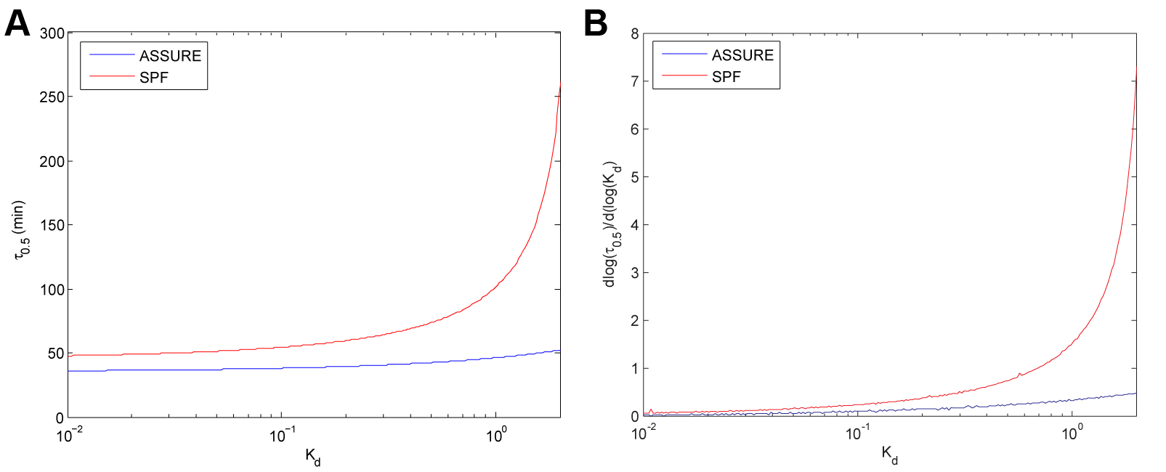
Supplementary Figure 4. Sensitivity analysis of the SPF and ASSURE model response time dependence on K_{d} values. (A) Dependence of the SPF and ASSURE τ_{0.5} on K_{d} values. (B) Effect of varying K_{d} on the sensitivity of τ_{0.5} with respect to K_{d} (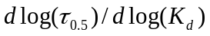), for the SPF and ASSURE models. Parameter values for results presented here were used as follows: k_{s} = 10 min⁻¹, k_{u} = 0.1 min⁻¹, k₀ = 0.1, k_{a} = 40 a.u., h = 2, s = 10³ a.u., P₁^{level} in ASSURE I (or P₂^{level} in ASSURE II) = 40 a.u..

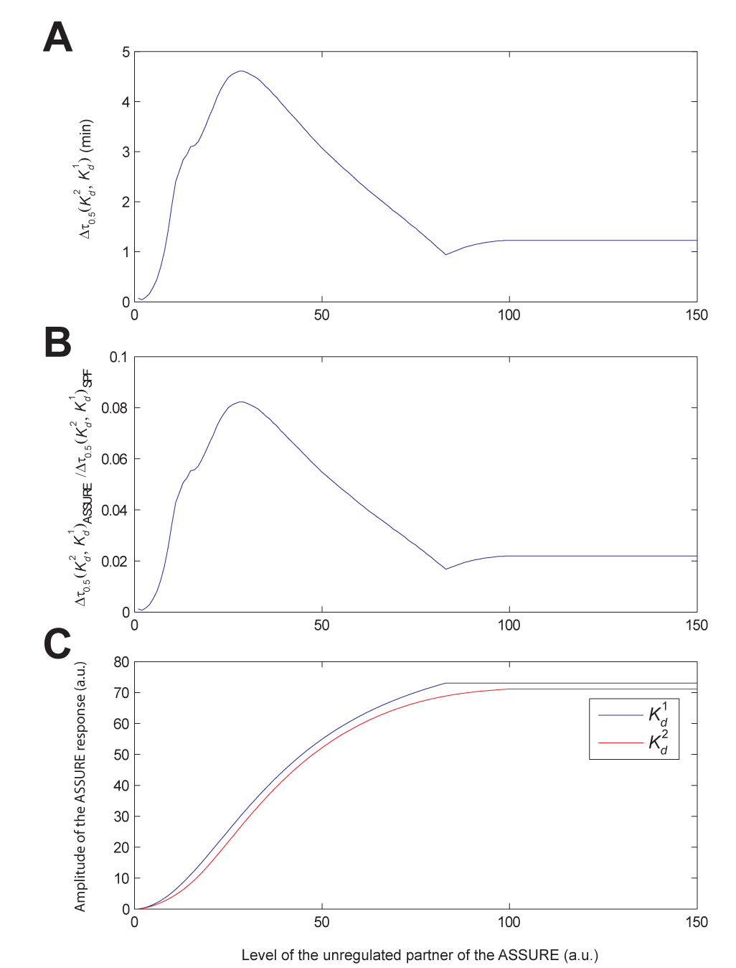
Supplementary Figure 5. Dependence of the ASSURE model response time to K_{d} changes on the level of the unregulated component of the ASSURE heterodimer. (A) Dependence of the difference in τ_{0.5} between the ASSURE models with high (K_{d}²) and low (K_{d}¹) K_{d} values (Δτ_{0.5}(K_{d}², K_{d}¹)) on the level of the unregulated component of the ASSURE heterodimer (P₁ in ASSURE I and P₂ in ASSURE II). (B) The same dependence as in (A) but relative to Δτ_{0.5}(K_{d}², K_{d}¹) for the SPF system. (C) Dependence of the amplitude of the ASSURE system response on the level of the unregulated ASSURE partner for high (K_{d}²) and low (K_{d}¹) K_{d} values. Parameter values for results presented here were used as follows: k_{s} = 10 min⁻¹, k_{u} = 0.1 min⁻¹, k₀ = 0.1, k_{a} = 40 a.u., h = 2, K_{d}¹ = 10⁻⁵ a.u., K_{d}² = 1 a.u., s = 10³ a.u..
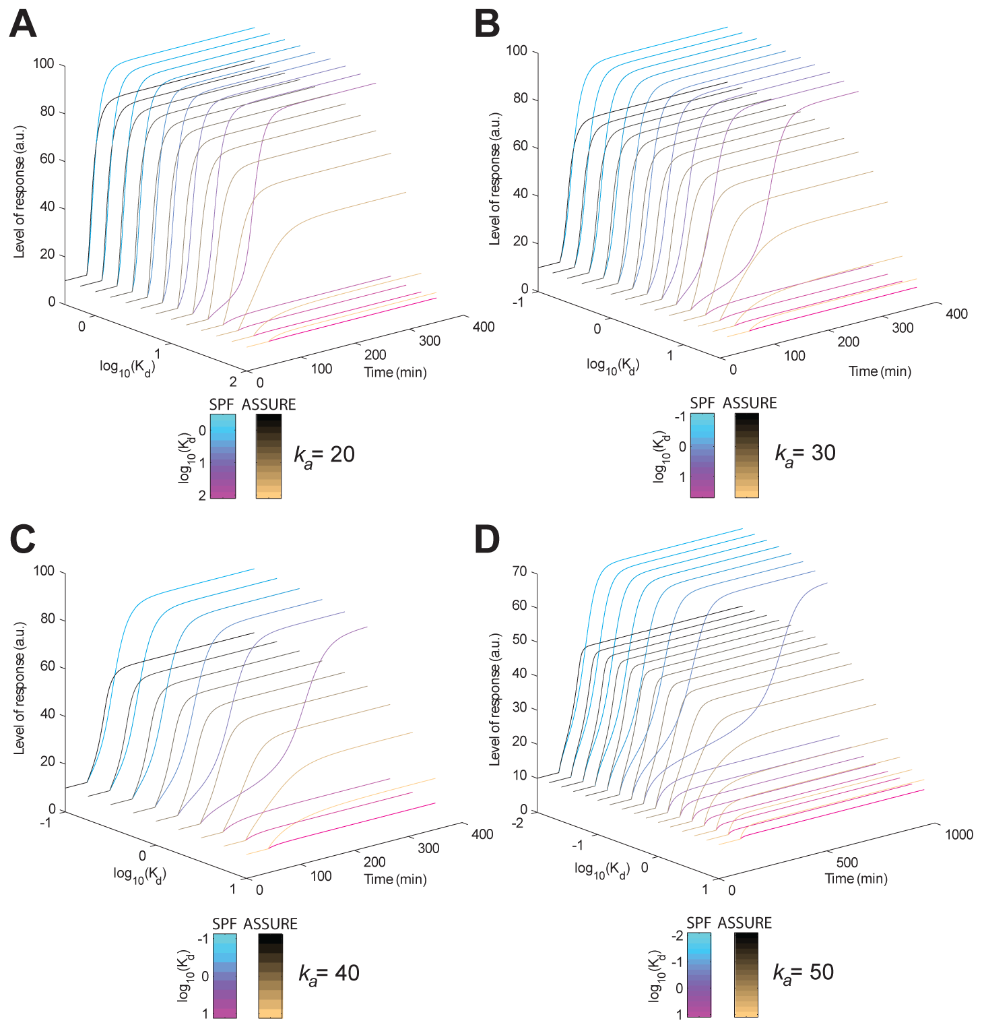
Supplementary Figure 6. Exploration of the SPF and ASSURE model responses to the stimulus in the context of changing k_{a} and K_{d} parameters. (A) The effect of the corresponding K_{d} changes the SPF and ASSURE model responses to the stimulus for k_{a} = 20 a.u. (B) k_{a} = 30 a.u. (C) k_{a} = 40 a.u. (D) k_{a} = 50 a.u.. Other parameter values for results presented here were used as follows: k_{s} = 10 min⁻¹, k_{u} = 0.1 min⁻¹, k₀ = 0.1, h = 2, K_{sp} = 10⁻³ a.u., s = 10³ a.u., P₁^{level} in ASSURE I (or P₂^{level} in ASSURE II) = 40 a.u..

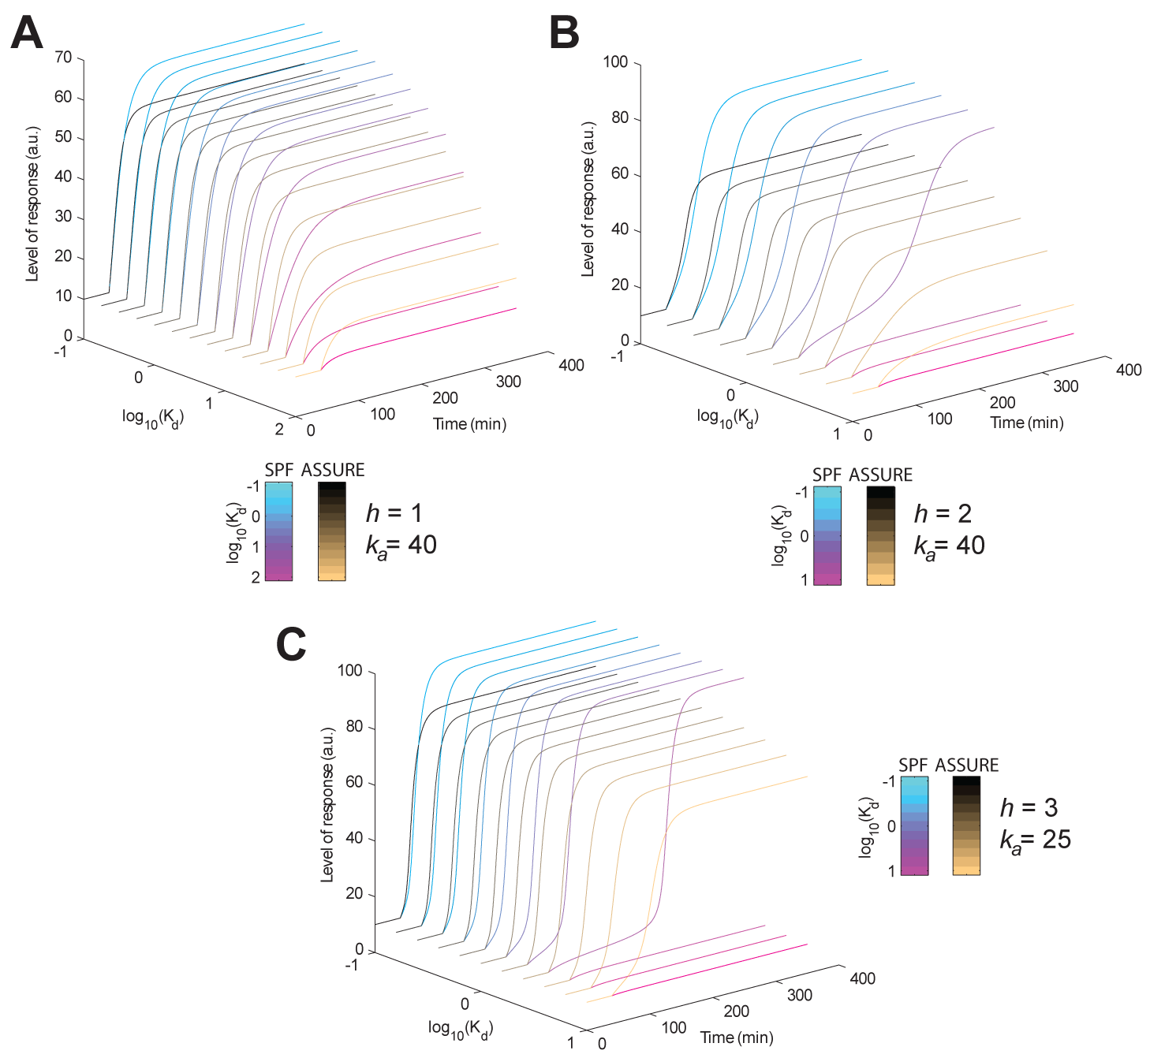
Supplementary Figure 7. Exploration of the SPF and ASSURE model responses to the stimulus in the context of changing h and K_{d} parameters. (A) The effect of the corresponding K_{d} changes the SPF and ASSURE model responses to the stimulus for h = 1 and k_{a} = 40 a.u. (B) h = 2 and k_{a} = 40 a.u. (C) h = 3 and k_{a} = 40 a.u. Other parameter values for results presented here were used as follows: k_{s} = 10 min⁻¹, k_{u} = 0.1 min⁻¹, k₀ = 0.1, K_{sp} = 10⁻³ a.u., s = 10³ a.u., P₁^{level} in ASSURE I (or P₂^{level} in ASSURE II) = 40 a.u..

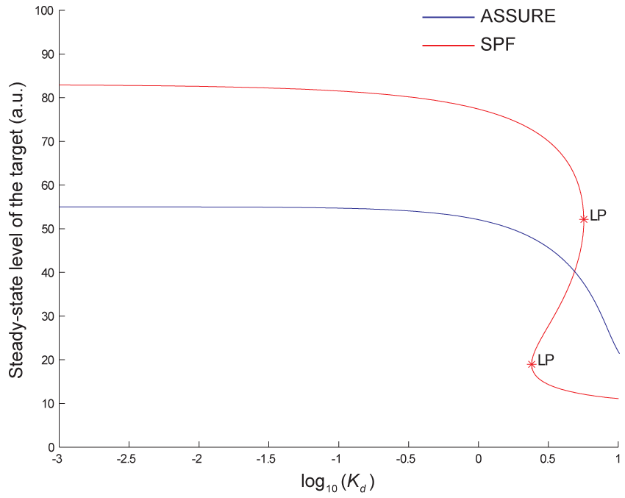
Supplementary Figure 8. Dependence of steady-state level of the SPF and ASSURE model responses on K_{d} values. LPs denote limit points (folds). Parameter values for results presented here were used as follows: k_{s} = 10 min⁻¹, k_{u} = 0.1 min⁻¹, k₀ = 0.1, k_{a} = 40 a.u., h = 2, s = 10³ a.u., P₁^{level} in ASSURE I (or P₂^{level} in ASSURE II) = 40 a.u..

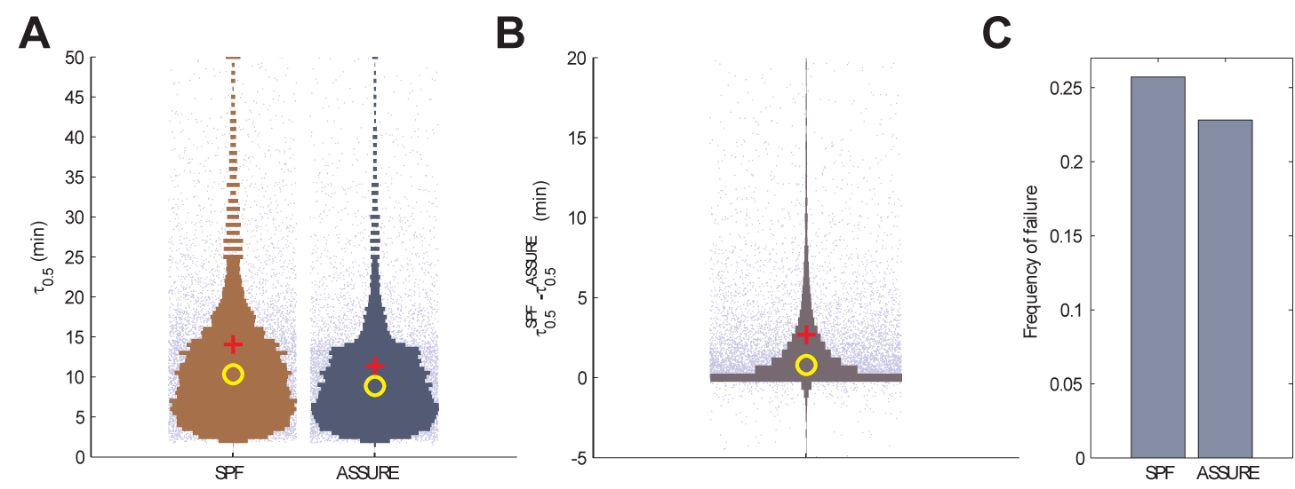
Supplementary Figure 9. Randomly parameterized SPF and ASSURE models. (A) Response time ranges for the SPF and ASSURE models. Each point represents the response time (τ_{0.5}) of the corresponding model for one of the 10⁴ random parameter sets (Supplementary Table 1). Bars represent violin plots (or reflected histograms) of τ_{0.5} distributions. Mean and median of the response time are shown as red crosses and yellow circles, respectively. (B) Range of the response time difference between the SPF and ASSURE models (τ_{0.5}^{SPF} - τ_{0.5}^{ASSURE}). (C) The frequency of failure to respond for the SPF and ASSURE models. The failure to respond is defined as inability of the system to induce the target more than 20% above the constitutive level. The additional failure to respond for the SPF model is defined as inability to induce its target more than 70% of the maximum ASSURE target induction level for the current random parameter set. Violin plots were constructed using the distributionPlot MATLAB routine (http://www.mathworks.com/matlabcentral/fileexchange). P-values for the comparison of the distributions of τ_{0.5} values for the SPF and ASSURE models were calculated based on the two-sample Kolmogorov-Smirnov test using the kstest2 MATLAB routine.
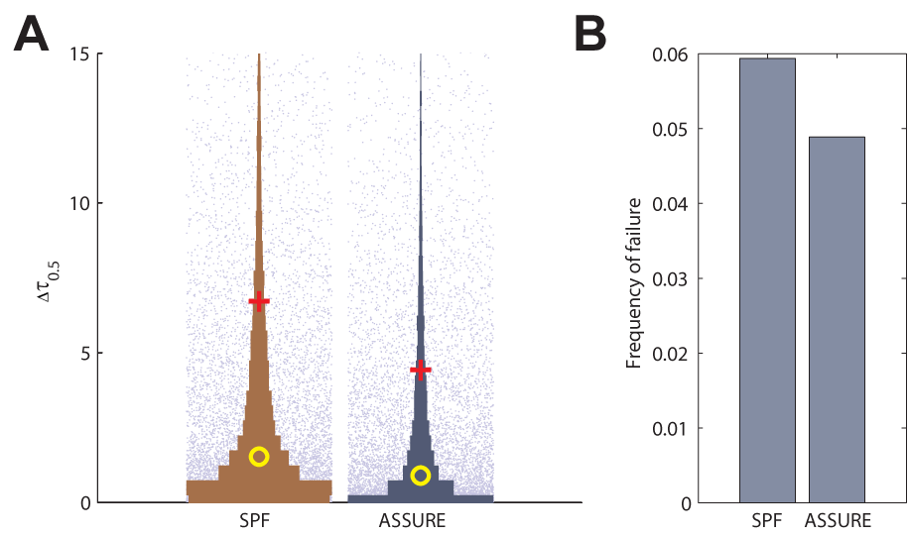
Supplementary Figure 10. Evolution of the randomly parameterized SPF and ASSURE models. (A) Range of the response time difference between the corresponding models with two parameter sets (τ_{0.5}(k_{i}) - τ_{0.5}(k_{i}’), where k_{i} are randomly selected model parameters (Supplementary Table 1) and k_{i}’ is the parameter set that differs from k_{i} by one randomly chosen and newly randomized parameter). The level of the ASSURE unregulated partner (P₁ in ASSURE I or P₂ in ASSURE II) was fixed and not randomized to obtain the k_{i}’ parameter set. (B) The frequency of failure to respond for the SPF and ASSURE models after the k_{i}→k_{i}’ model evolution. For the additional information see Supplementary Figure 9.

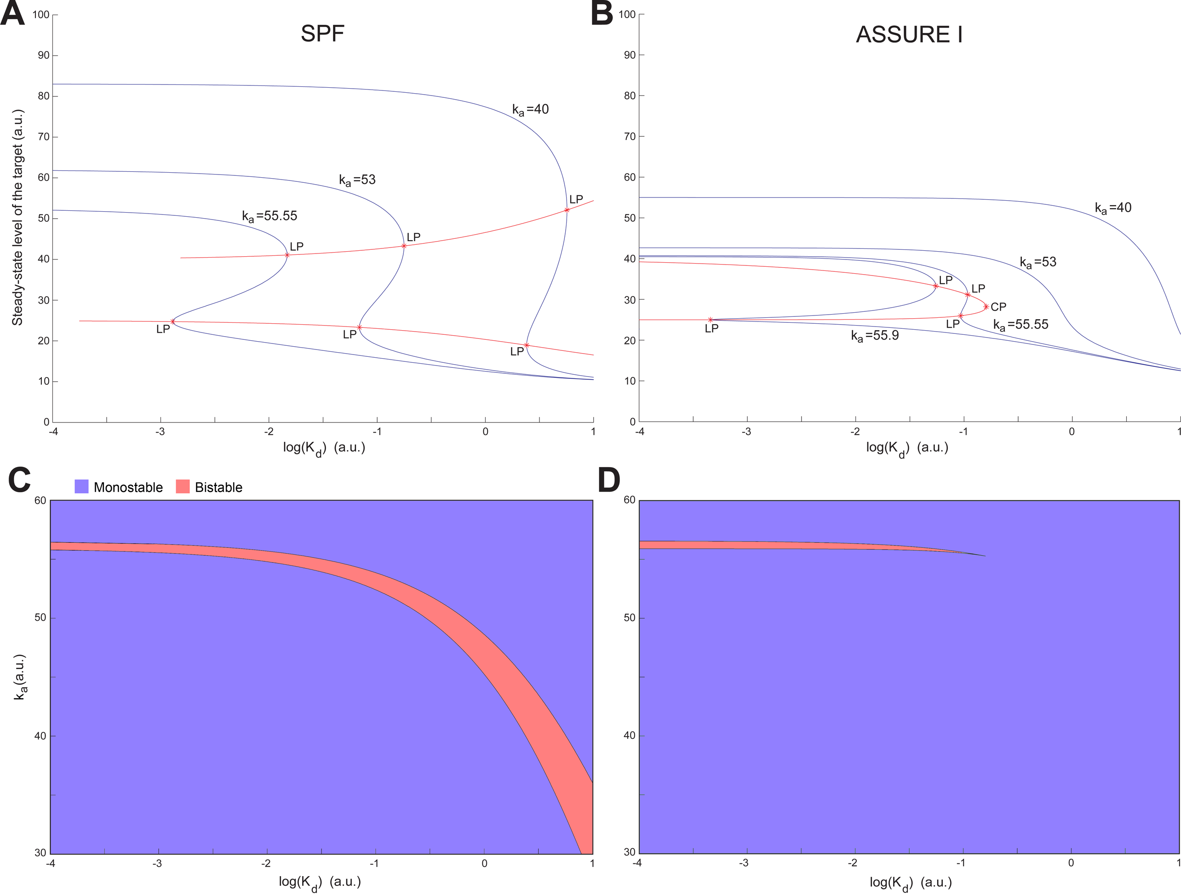
Supplementary Figure 11. Bifurcation analysis of the SPF and ASSURE models. (A and B) Equilibrium manifolds of the SPF and ASSURE I models, respectively, in the (K_{d}, Target)-plane for different k_{a} parameter values (blue curves). LPs denote limit points (folds). CP denotes a cusp bifurcation point. Red curves represent a fold (LP-LP) continuation with respect to k_{a} and K_{d} model parameters. (C and D) SPF and ASSURE I model behaviors, respectively, as a function of k_{a} and K_{d} parameter values. Blue and red areas represent parameter ranges for mono- and bistable behavior of the corresponding model, respectively. Other parameter values for results presented here were used as follows: k_{s} = 10 min⁻¹, k_{u} = 0.1 min⁻¹, k₀ = 0.1, h = 2, K_{sp} = 10⁻³ a.u., s = 10³ a.u., P₁^{level}=40 a.u.. The bifurcation analysis was performed using the MatCont MATLAB toolbox (http://www.matcont.ugent.be/).

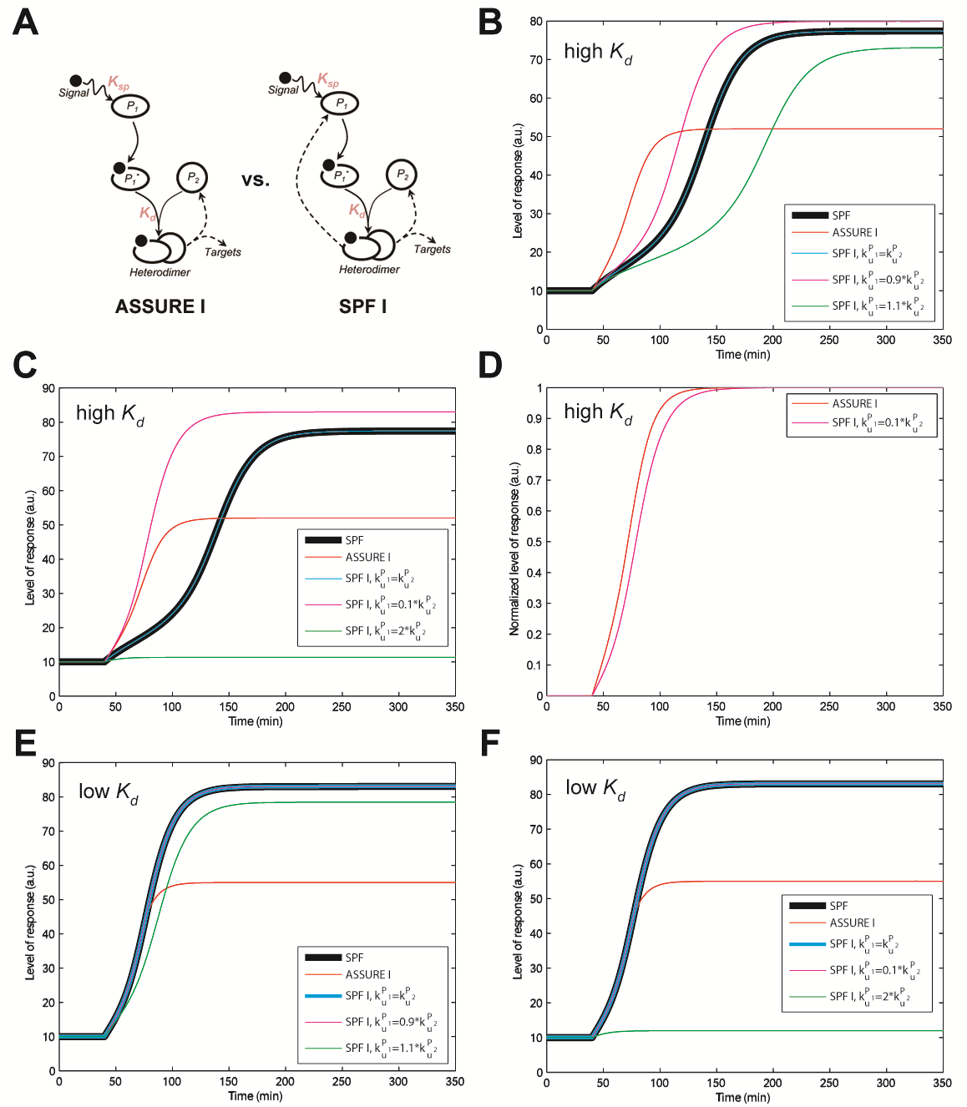
Supplementary Figure 12. Comparison of the SPF, ASSURE I and symmetric positive feedback type I (SPF I) model responses. (A) Schematic representations of the ASSURE I and SPF I systems. (B) SPF, ASSURE I and SPF I (k_{u}^{P1} = k_{u}^{P2}, k_{u}^{P1} = 0.9×k_{u}^{P2}, k_{u}^{P1} = 1.1×k_{u}^{P2}) model responses with high K_{d}. (C) SPF, ASSURE I and SPF I (k_{u}^{P1} = k_{u}^{P2}, k_{u}^{P1} = 0.1×k_{u}^{P2}, k_{u}^{P1} = 2×k_{u}^{P2}) model responses with high K_{d}. (D) ASSURE I and SPF I (k_{u}^{P1} = 0.1×k_{u}^{P2}) normalized model responses with high K_{d}. (E) SPF, ASSURE I and SPF I (k_{u}^{P1} = k_{u}^{P2}, k_{u}^{P1} = 0.9×k_{u}^{P2}, k_{u}^{P1} = 1.1×k_{u}^{P2}) model responses with low K_{d}. (F) SPF, ASSURE I and SPF I (k_{u}^{P1} = k_{u}^{P2}, k_{u}^{P1} = 0.1×k_{u}^{P2}, k_{u}^{P1} = 2×k_{u}^{P2}) model responses with low K_{d}. The SPF I model was derived from the ASSURE I model (see the main text) by adding a differential equation for P₁ that differs from the equation for P₂ by k_{u} kinetic parameter. Parameter values for results presented here were used as follows: k_{s} = 10 min⁻¹, k_{u} = 0.1 min⁻¹, k_{u}^{P2} = k_{u}, k₀ = 0.1, h = 2, high K_{d} = 1 a.u., low K_{d} = 10⁻⁵ a.u., K_{sp} = 10⁻¹ a.u., s = 10³ a.u., P₁^{level}=40 a.u..
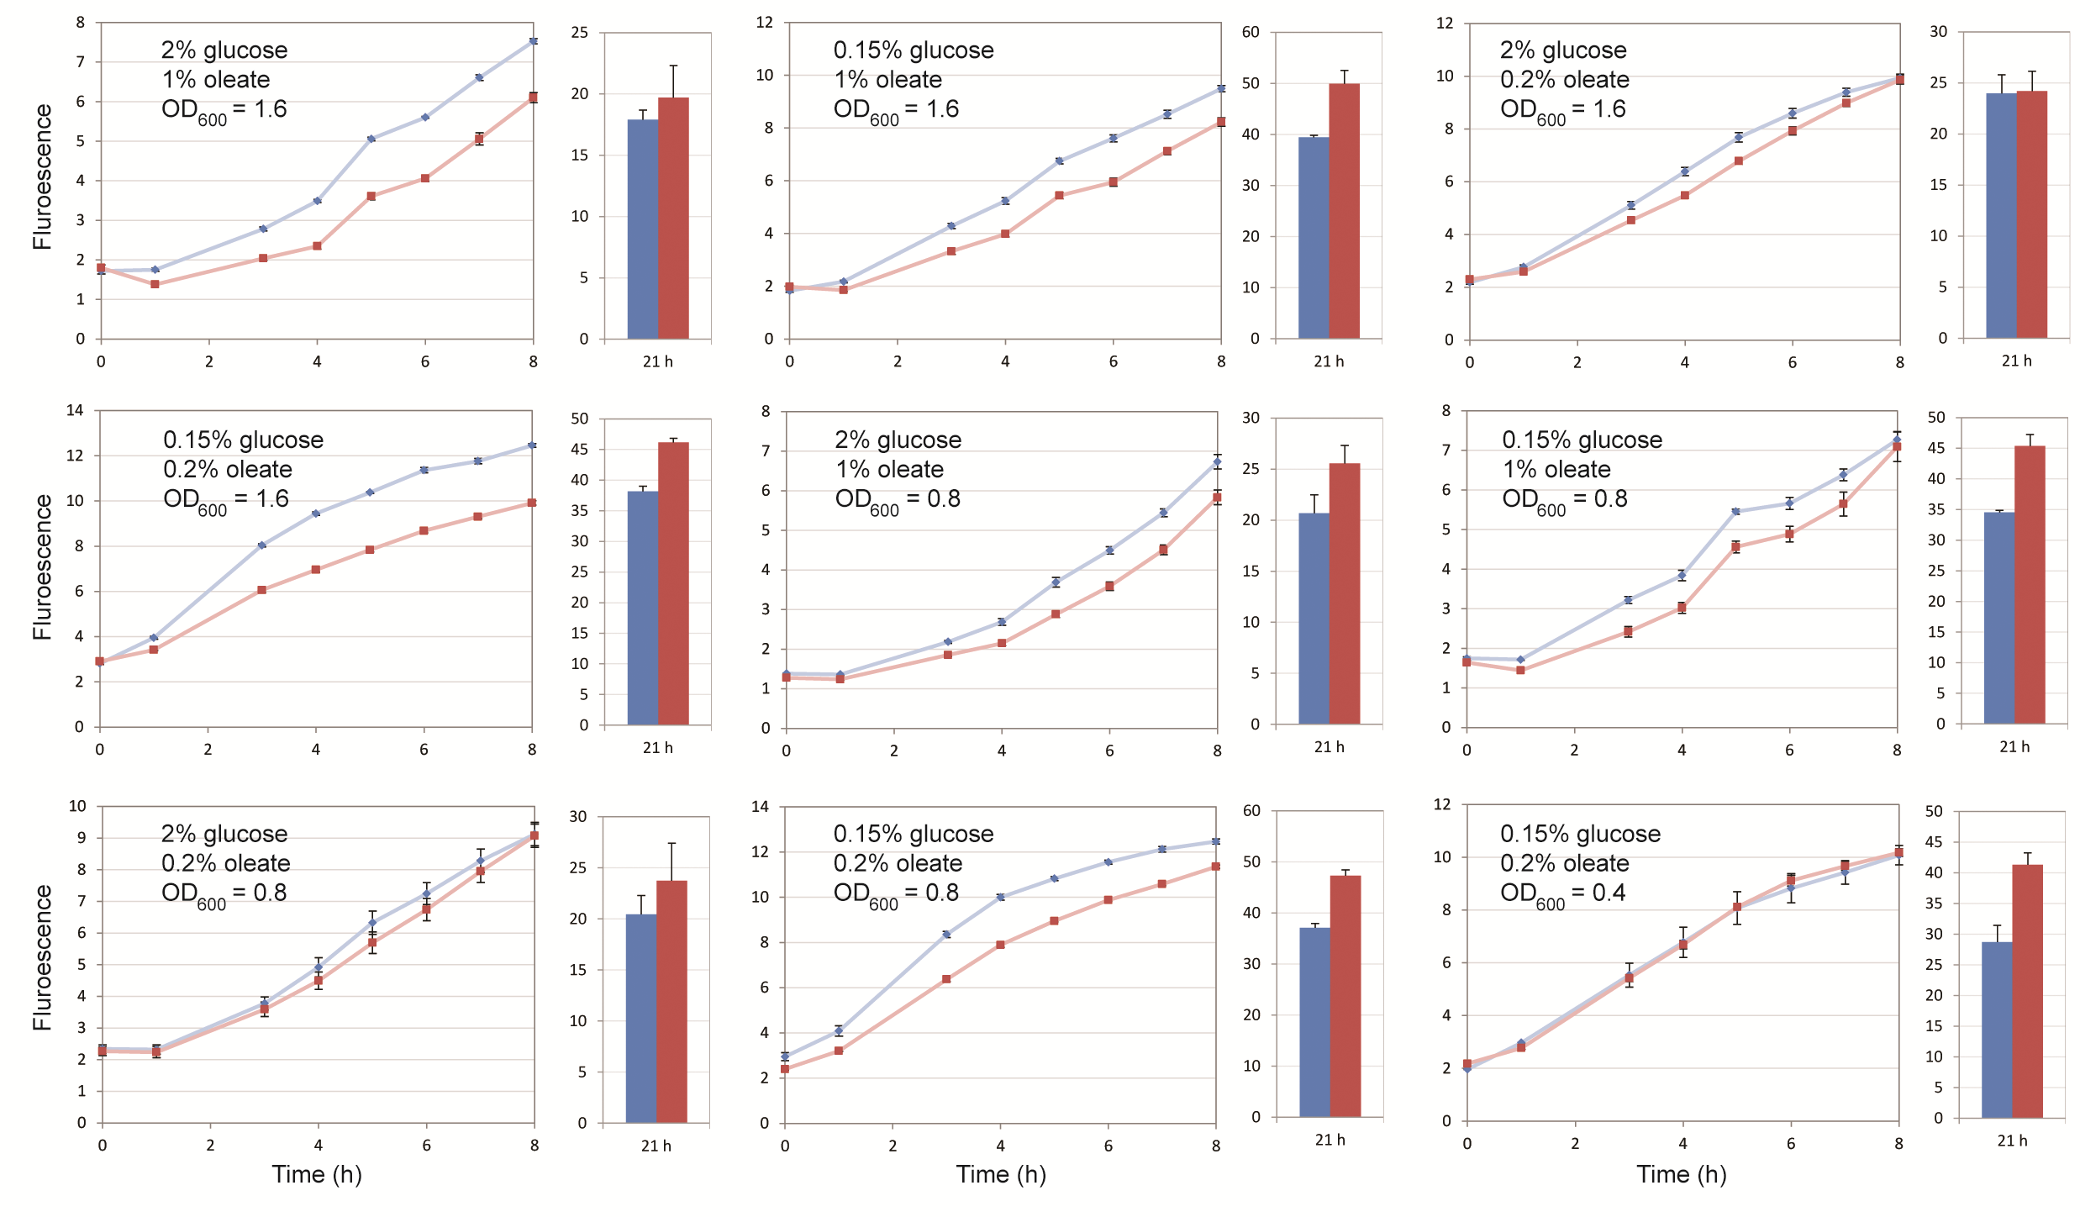Supplementary Figure 13. Response of the wild-type (blue) and engineered (red) budding yeast cells to oleate induction over a matrix of indicated experimental conditions. Shown are line plots of the early time points of induction and bar plots for the 21 h time point. The percentage glucose used for preculture, the percentage of oleate used during induction, and the optical density (OD₆₀₀) of the culture at the start of oleate incubation are indicated in the panel. OD₆₀₀ values of 0.4, 0.8 and 1.6 represent early, mid and late log phase growth of the cultures. The time course of Pot1p protein level was measured in individual cells using flow cytometry in the wild-type strain with a Pot1p-GFP reporter and in the engineered strain with the same reporter under oleate growth conditions. The y-axis is the log₁₀ level of fluorescence. Error bars represent standard error of means of Pot1p-GFP protein level from six independent replicates.
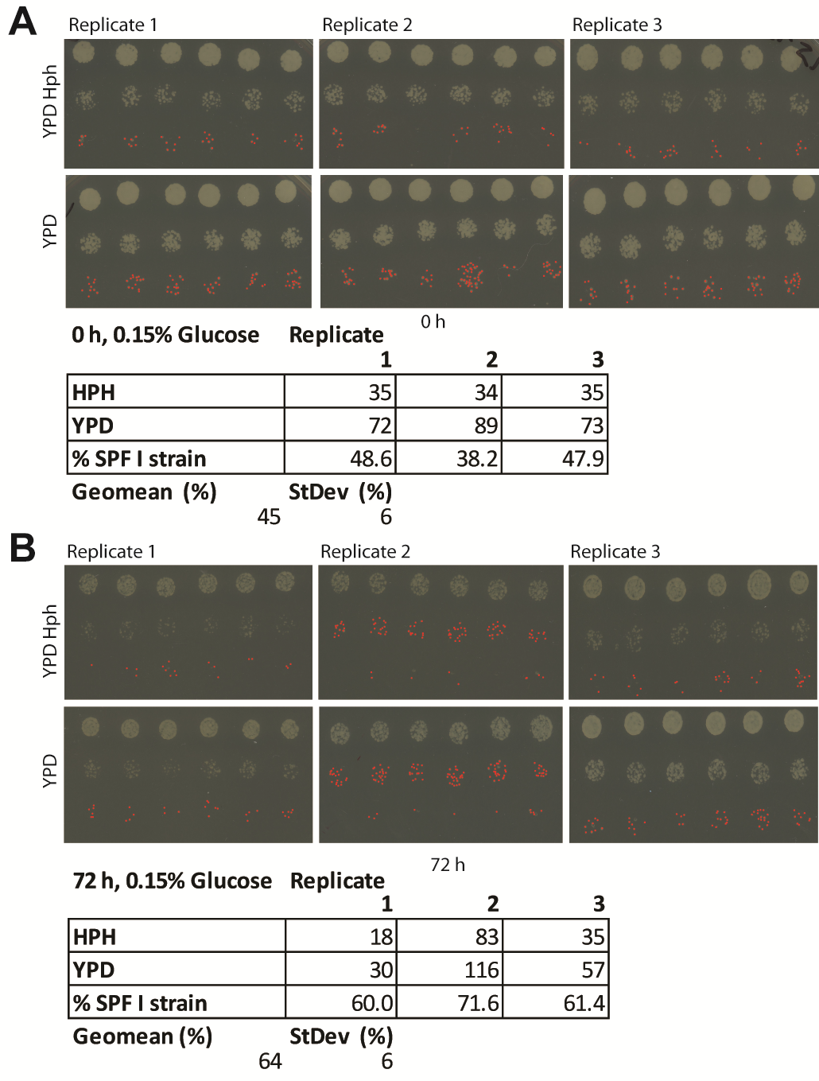
Supplementary Figure 14. The SPF I engineered strain shows no competitive fitness disadvantage. (A) At 0 h, the engineered strain represents approximately 50% of the total population. (B) At 72 h, the engineered strain shows no competitive growth defect, representing more than 60% of the population. Three biological replicates of cells from wild type and engineered strains were mixed 1:1 and grown under constant 0.15% glucose conditions. Multiple replicates of equal volumes of dilutions were plated onto YPD and YPD with 400 ug/ml Hygromycin B (Sigma) medium, to select for the engineered strain.
Supplementary Table 1. Ranges of the random parameter sets
Parameter | Description | Units | Range | Log₁₀ scale | Distribution
k_{s} | Synthesis constant | min⁻¹ | 5 – 20 | No | Uniform
k_{u} | Degradation constant | min⁻¹ | -1.3 – -0.3 | Yes | Uniform
k₀ | Basal portion of the expression level | dimensionless | -1.3 – -0.3 | Yes | Uniform
k_{a} | Dimer activity constant | a.u. | 10 – 50 | No | Uniform
h | Hill coefficient | dimensionless | 1 – 3 | No | Uniform
K_{sp} | Dissociation constant for Signal binding to protein sensor | a.u. | -3 | Yes | Fixed
K_{d} | Dissociation constant for protein dimer | a.u. | -5 – 0 | Yes | Uniform
s | Signal level | a.u. | 10³ | No | Fixed
P₁ (ASSURE I) or P₂ (ASSURE II) | Concentration of P₁ (ASSURE I) or P₂ (ASSURE II) | a.u. | 10 – 100 | Yes | Uniform
The parameters refer to the ordinary differential equation models presented in the main text.
Supplementary Table 2. PCR primers used for strain construction
Primers | Sequence | Direction
HPH_Oaf1 5' UTR S1 | GGC AGC TTC TTG TCT CCA CAG TAC CAA CGT GCG TCA TCT GCT TCT CGT ACA TGC GTA CGC TGC AGG TCG AC | F
HPH_Oaf1 5' UTR S2 | GGG TGT TTG TAG TAT ATT GCC ATC GTA AAG CAT ATC AAT ATG AAA ATG AAT AAA TCG ATG AAT TCG AGC TCG | R
PIP2 Prom 5’ | TTC ATT TTC ATA TTG ATA TGC TTT ACG ATG GCA ATA TAC TAC AAA CAC CCT GAT ACA AGA | F
Pip2 Prom 3’+ Oaf1 5’ ORF | TTC CGG CAT GTG GGG CCT TCT GCG TAC TAT TTT CGA CCA TCT TTT ATC GAA GAA ATT TTG | R
Oaf1 Myc 1 | GGT TAT TTT GGA GGT TTG GAT TTA TTT GAT TAT GAC TTT TTG TTT GGC AAT GAC TTT GCT GGC GGC GGC CGG ATC CCC GGG TTA ATT AA | F
Oaf1 Myc 2 | TTC GAA TGT TTA AGA GGG AAG AGC TCT TCT TAC GTT AAC CGT TAT ATA CAT ATA TAG AAT TCG AGC TCG TTT AAA C | R

