Supplementary Information
Supplementary Table S1 Mathematical Equations for the Detailed Mechanistic Model of the glucose PTS
Module Name Equation Equation
Number
Plant 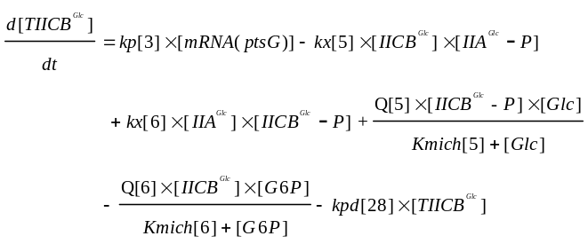 (1.1)
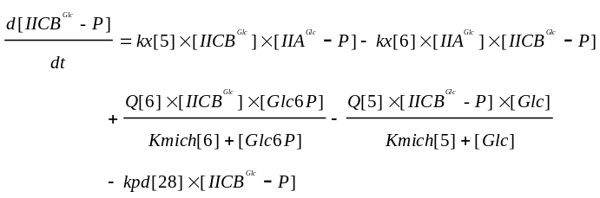 (1.2)
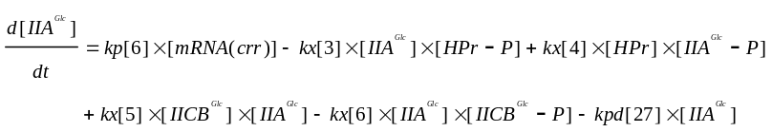 (1.3)
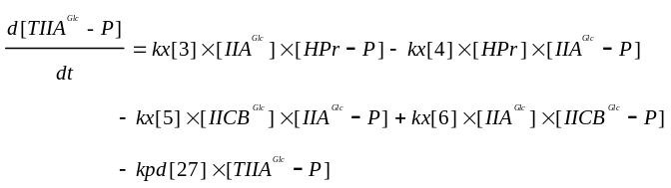 (1.4)
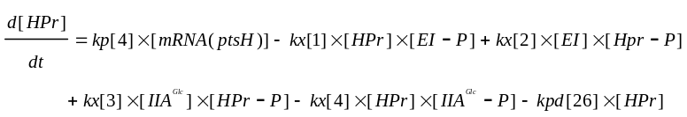 (1.5)
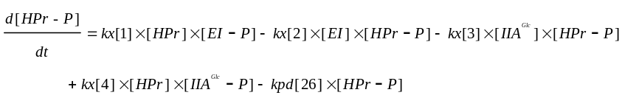(1.6)
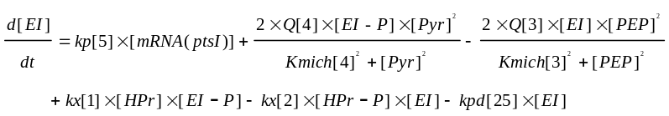 (1.7)
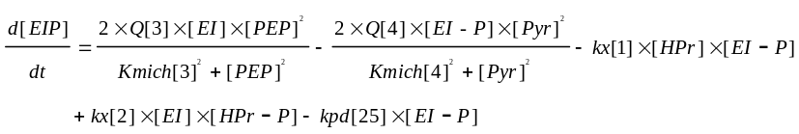 (1.8)
Feedback 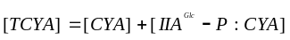
Sensor 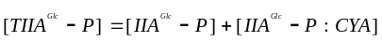
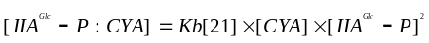
Computer 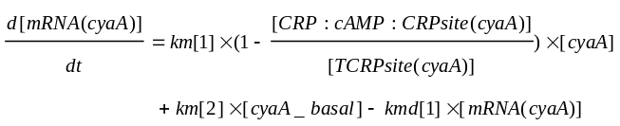
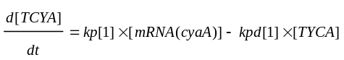
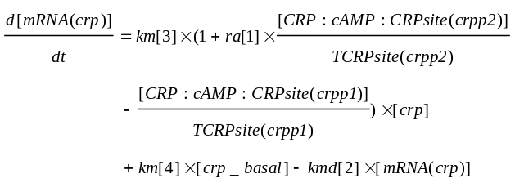
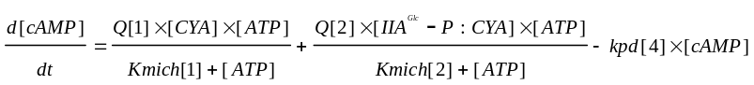
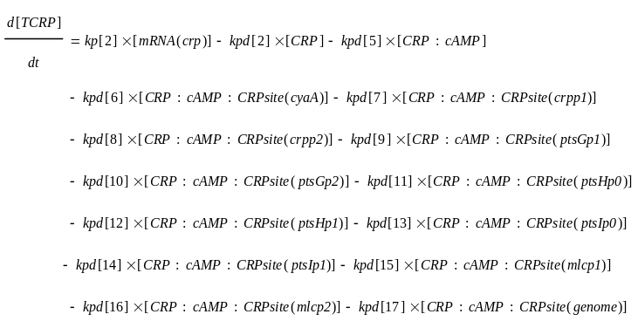
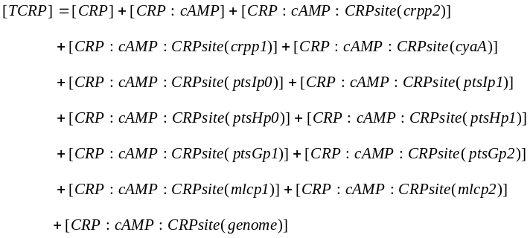
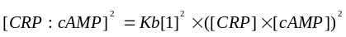 (3.10)
(3.11)
(3.12)
(3.13)
Brake Actuator 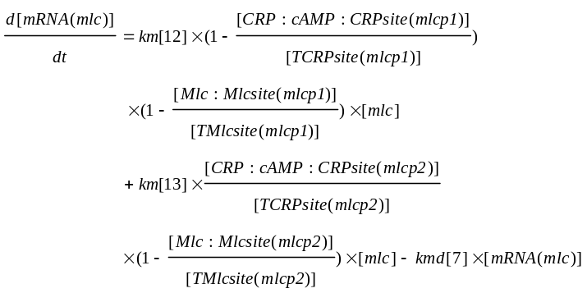
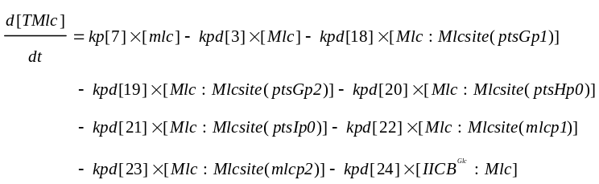
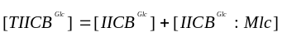
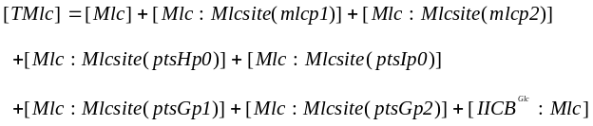
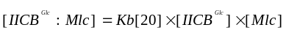
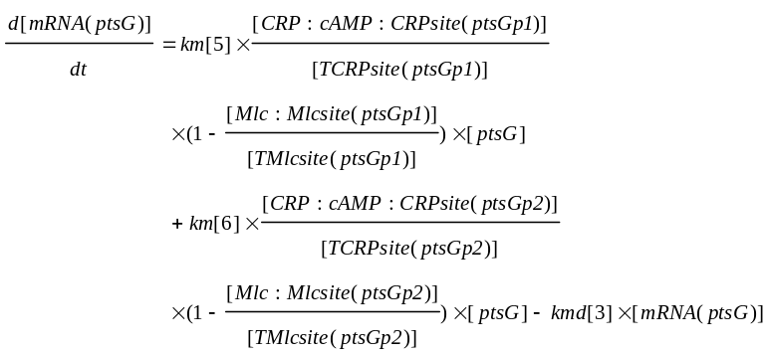
Accelerator
Actuator
