APPENDIX 1

Exact analytic expressions derived from the 3-step model:

(I-A)

(I-A-1)

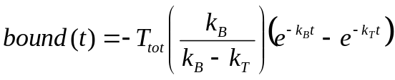 (I-A-2)

(I-A-3)

(I-A-4)

