Supplemental supporting material

Supplemental Results

Environmental signals cause DegS to autophosphorylate and transfer its phosphate to the regulator protein DegU enabling it to activate aprE gene transcription (for reviews see Msadek et al., 1993; Kunst et al., 1994; Msadek, 1999). DegS however, also acts as a phosphatase on DegU~P (Dahl et al., 1992). Remarkably, artificial induction of DegU was shown to lead to activation of aprE in a degS mutant background, indicating that other phosphate donor(s) can phosphorylate DegU as well (Ogura et al., 2001). To see whether aprE expression (and thus DegU phosphorylation) is completely DegS dependent under our experimental conditions, we introduced a degS mutation in our aprE reporter strain. The resulting strain aprE-gfp/hy/ΔS was induced with IPTG (500 μM) during the logarithmic growth phase and compared to the parental strain and a strain mutant for both degS and degU by flow cytometry. As shown in Fig. S5, the aprE response in the degS mutant upon DegUhy induction is significantly lower compared to the wildtype after 1 h of induction (P<0.001, Student T-test) and similar to a degSU mutant. This shows that under these experimental conditions, DegS is required to phosphorylate DegU and commence degU autoactivation. After prolonged induction however (3h), the difference in aprE-gfp between wild-type and degS is not significant anymore (P = 0.13, Student T-test). The degSU mutant strain however shows significantly higher aprE-gfp expression at prolonged induction with DegUhy (P<0.001, Student T-test). This is likely caused by the fact that in this strain unphosphorylated DegU cannot accumulate and repress degU transcription in contrast to the wild-type and the degS mutant strains (also see Fig. 4).

To demonstrate that in principle all non-endospore forming cells are able to exhibit fluorescence from production of a fluorescent protein under these conditions, we constructed a strain that harbors both the P_{aprE}-gfp construct and an inducible copy of the cyan fluorescent protein. As shown in Fig. S6, all vegetative cells express CFP but not all vegetative cells highly express GFP again demonstrating that heterogeneity in aprE expression is regulated.

Materials and Methods

Recombinant DNA techniques and oligonucleotides
Procedures for DNA purification, restriction, ligation, agarose gel electrophoresis and transformation of E. coli were carried out as described before (Sambrook et al., 1989). Enzymes were obtained from Roche (Mannheim, GER). Oligonucleotides were purchased from Biolegio BV (Malden, NL). B. subtilis was transformed as described before (Harwood and Cutting, 1990).

Construction of plasmids
To construct plasmids pGFP-aprE, pGFP-bpr, pGFP-acoA, pGFP-srfA, pGFP-hag, pGFP-sunA, pGFP-degS and pGFP-‘degSU, PCR’s with primer pairs aprE-F/aprE-R, bpr-F/bpr-R, acoA-F/acoA-R, srfA-F/srfA-R, hag-F/hag-R, sunA-F/sunA-R, degU-F+HindIII/degS-R+RBS+EcoRI and degU-F+HindIII_inside/degU-R-R+RBS+EcoRI (Table S3) were performed, respectively, using chromosomal DNA of B. subtilis 168 as a template. The resulting amplified fragments contained the promoter regions of the genes aprE, bpr, acoA-L, srfAA, hag, sunA, degS and degU, respectively. The amplified fragments were subsequently cleaved with HindIII and EcoRI, and ligated into the corresponding sites of pSG1151, in that way generating fusions with the gfpmut1 gene (Lewis and Marston, 1999), resulting in plasmids pGFP-aprE, pGFP-bpr, pGFP-acoA, pGFP-srfA, pGFP-hag, pGFP-sunA, pGFP-degS and pGFP-‘degSU, respectively (Table S2).
To construct plasmid pDG-PdegSU-gfp, a PCR’s with primer pairs degU-F+HindIII and gfp-R+BglII (Table S3) was performed, using chromosomal DNA of strain ‘degSU-gfp as a template. The 2.5kb product was digested with HindIII and BglII and ligated into the HindIII/BamHI sites of pDG1664 (Guerout-Fleury et al., 1996). To construct plasmids pDG1730-PdegS-gfp and pDG1730-PdegSU-gfp, PCR’s with primer pairs degU-F+HindIII and gfp-R+BglII (Table S3) were performed, using chromosomal DNA of strains degS-gfp and ‘degSU-gfp as a template, respectively. The products were digested with HindIII and BglII and ligated into the HindIII/BamHI sites of pDG1730 (Guerout-Fleury et al., 1996).
To construct plasmid pDG-hy, carrying the B. subtilis degU32(Hy) allele fused behind the IPTG inducible P_{spac} promoter, a PCR with the primers degU-F-hy (carrying at the 12th codon the nucleotide sequence ‘CTT’ coding for a lysine instead of the wildtype codon ‘CAT’ coding for a histidine) and degU-R+SalI was performed, using chromosomal DNA of B. subtilis 168 as a template. The amplified fragment was subsequently cleaved with HindIII and SalI, and ligated into the corresponding sites of pDG148 (Stragier et al., 1988).
To construct plasmid pDR-hy, carrying the B. subtilis degU32(Hy) allele fused behind the IPTG inducible P_{hyper spank} promoter, in between flanking regions coding for the non-essential amyE gene, a HindIII/SalI fragment from plasmid pDG-hy, containing the degU32(Hy) allele, was ligated into the corresponding sites of pDR111 (kind gift of David Rudner).

Construction of bacterial strains
B. subtilis strains aprE-gfp, bpr-gfp, acoA-gfp, srfA-gfp, hag-gfp, sunA-gfp, degS-gfp and ‘degSU-gfp, respectively, were obtained by Campbell-type integrations of plasmids pGFP-aprE, pGFP-bpr, pGFP-acoA, pGFP-srfA, pGFP-hag, pGFP-sunA, pGFP-degS and pGFP-‘degSU, respectively, into the chromosome of B. subtilis 168 (Kunst et al., 1997). Transformants were selected on TY agar plates containing chloramphenicol (5 µg/ml), after overnight incubation at 37°C. Note that strains acoA-gfp, srfA-gfp and hag-gfp have also recently been described elsewhere (Smits et al., 2007; Lulko et al., 2007; Veening et al., 2008). B. subtilis strain degSU-gfp was obtained by a double crossover recombination event between the thrC regions located on pDG-degSU and the chromosomal thrC gene of strain 168. Transformants were selected on TY agar plates containing erythromycin and lincomycin, after overnight incubation at 37°C. Correct integration into the thrC gene was tested and confirmed by lack of growth without threonine and spectinomycin sensitivity. Strains A:degS-gfp and A:degSU-gfp were obtained by a double crossover recombination event between the amyE regions located on the pDG1730-PdegS-gfp and pDG1730-PdegSU-gfp plasmids and the chromosomal amyE gene of strain 168, respectively. Transformants were selected on TY agar plates containing spectinomycin after overnight incubation at 37°C. Correct integration into the amyE gene was tested and confirmed by lack of amylase activity upon growth on plates containing 1% starch. Strains degS-gfp/hy, degU-gfp/hy and aprE-gfp/hy were obtained by a double crossover recombination event between the amyE regions located on pDR-hy and the chromosomal amyE gene of strains degS-gfp, degSU-gfp and aprE-gfp, respectively. Transformants were selected on TY agar plates containing spectinomycin after overnight incubation at 37°C. Correct integration into the amyE gene was tested and confirmed by lack of amylase activity upon growth on plates containing 1% starch. Correct DegUhy overproducing clones were tested and confirmed by increased halos upon growth on plates containing 1% skim milk and IPTG. Construction of the other strains used in this study is explained in Table S1.

Microscopy
Cells were prepared for fluorescence microscopy and applied to agarose slides as described before (Glaser et al., 1997), and images were acquired using an Zeiss Axiovert M200 equipped with a CoolSNAP HQ (Princeton Instruments, Trenton, New Jersey, United States). Metamorph (Universal Imaging, Doningtown, Pennsylvania, United States) was used for image capturing and figures were prepared for publication using ImageJ (http://rsb.info.nih.gov/ij/) and Corel Graphics Suite 11 (Corel Corporation). In all cases exposure times were 1 sec, but for Fig.3, exposure times were 2 sec. It should be noted that the low amount of GFP molecules that are produced from the degU promoter makes it difficult to accurately quantify the signal. Image analyses and quantification were performed using ImageJ. For time-lapse microscopy, cells were grown on a semi-solid chemically defined medium (CDM). A detailed description of this technique is described elsewhere (Veening et al., 2008). In brief, CDM-agarose contained 0.4 μg/ml of the membrane dye FM5-95 (Invitrogen, Paisley, UK) and microscope slides were mounted on a Deltavision RT automated temperature controlled (30 °C) microscope (Applied Precision, Marlborough, UK). Images were obtained up to 20 h with a CoolSNAP HQ (Princeton Instruments, Trenton, New Jersey, United States) at 60X magnification. Fluorescent images were recorded at each field every 15 min.

Flow cytometric analyses

Cells were 100x diluted in 0.2 μM filtered minimal medium and directly measured on a Coulter Epics XL-MCL flow cytometer (Beckman Coulter, Mijdrecht, NL) operating an argon laser (488 nm) essentially as described (Veening et al., 2005). For each sample, at least 20,000 cells were analyzed. Data containing the green fluorescent signals were collected by a FITC filter and the photomultiplier voltage was set between 700 and 800 V. Data was captured using System II software (Beckman Coulter) and further analyzed using WinMDI 2.8 software (http://facs.scripps.edu/software.html). In all FACS figures, fluorescence is plotted on a logarithmic scale. Figures were prepared for publication using WinMDI 2.8 and Corel Graphics Suite 11.

Western blot analysis and immunodetection
Cells were separated from the growth medium by centrifugation (14,000 RPM, 1 min, room temperature). Pelleted cells were resuspended in protoplast buffer (20 mM potassium phosfate pH 7.5, 15 mM MgCl₂, 20% sucrose and 1 mg/ml of lysozyme) and incubated at 37°C for 30 min. The resulting protoplasts were diluted with 2xSDS-sample buffer, incubated at 95ºC for 5 min and separated by SDS-polyacrylamide gel electrophoresis (SDS-PAGE) as described (Sambrook et al., 1989). Next, proteins were transferred to a polyvinylidene difluoride (PVDF) membrane (Roche) as described (Sambrook et al., 1989). DegU was detected with polyclonal DegU antibodies at a 1:450 dilution (Kind gift of Teruo Tanaka; Hata et al., 2001) and horseradish peroxidase-anti-rabbit-IgG conjugate (Amersham Biosciences, Little Chalfont, UK) according to the manufacturer’s instructions.

Model equations and parameter analysis

Governing equations
Kinetics of chemical reactions (1)-(9) was modeled by both a stochastic and a continuous (deterministic) approach. Stochastic simulations were done by direct sampling of master equations using Gillespie algorithm (Gillespie, 1977). Deterministic equations corresponding to the reactions for concentrations of proteins and their complexes are given below:

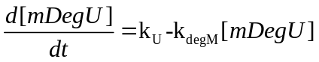
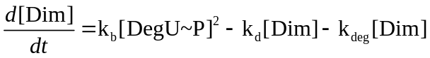
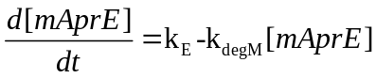
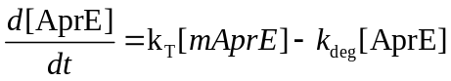
Here expression rates k_{U} and k_{E} are defined as in Eqs. (8)-(9) in the main text.

Parameters that support bistability
In steady state, right-hand sides of Eqs. - are zero. Using , and to solve for [mDegU], [DegU~P] and [Dim] respectively and using the result in we obtain:
Assuming that biochemical processes are faster than protein degradation and that [Dim] << [[DegU~P]+ [DegU] we can simplify Eq. to get a closed-form equation for [DegU]
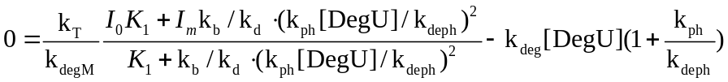
Or, equivalently,
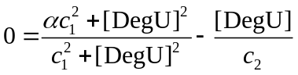
Where three new parameters are introduced

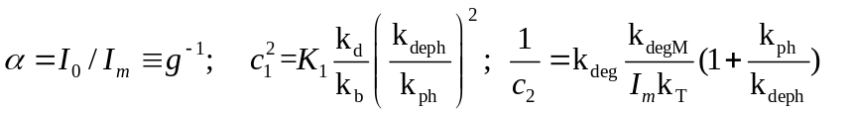
These parameters are easy to interpret: g>1 is a dimensionless parameter that represents a fold gain from basal level to a full activation of the feedback loop and 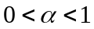 is inverse of that; concentration c₁ denote the concentration of DegU at which there is a 50% chance that the degU promoter is bound by dimer; and concentration c₂ is the DegU concentration with saturated positive feedback (for maximal expression level). To determine the parameter range that supports bistability we need to determine when Eq. (S.9) has three positive solutions, or equivalently, polynomial below has three positive roots (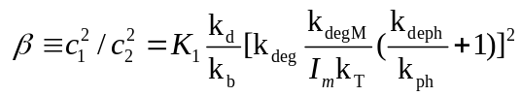 and 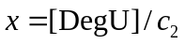):
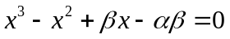
Alternating signs of coefficient indicates that real roots of this polynomial are positive (left-hand side of Eq. is always negative for x<0). To get the condition for 3 real root we use a cubic discriminant formula, . Using a quadratic formula to solve for , we obtain the following conditions on the dimensionless parameters:
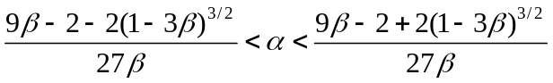
This inequality obviously only holds when the expressions are real, i.e. 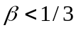. Figure S7 shows the region of bistability shaded in gray. Two conclusions are straightforward from the analysis: (i) The gain,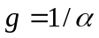, of the feedback should be at least 9-fold for the bistability to exist regardless of other parameter values. (ii) The maximal level of DegU synthesis must result in concentration saturating the feedback.

Choosing the parameters for numerical simulations
Our modeling predictions are most sensitive to the kinetic parameters that characterize the DegU/DegS system and positive feedback in degU transcription. Unfortunately, little data is available in the literature on biochemical parameters characterizing this system. However, our experimental results and measurements on other two-component system allow us to estimate some of the parameters (Table 1). The other parameters used are of the same order as in better characterized two-component systems (Wright et al., 1993; Fisher et al., 1996; Silversmith et al., 1997; Mayover et al., 1999; Jiang et al., 2000; Kato and Groisman, 2004; Kremling et al., 2004; Stewart and Van Bruggen, 2004).

- The typical lifetime of mRNA in bacteria is about 1-2 min. We therefore choose mRNA degradation rate to be 10⁻² s⁻¹ .
- Rate of translation was chosen to be relatively low given comparatively weak GFP signal from the degU-promoter fusion. We chose a translational rate that results in about 4 proteins translated per message. Note that we chose the same rate for aprE translation as well. This assumption by no means limits the generality of our conclusions because any increase in this rate will mainly affect absolute levels of AprE in the cell but not the distribution of AprE.
- We chose the rate of protein degradation to correspond to about 40 min lifetime. The same rate is assumed for all proteins and complexes. Our conclusions are not very sensitive to this assumption (data not shown).
- A relatively weak signal of our degU-GFP reporter strain leads us to assume relatively low intracellular DegU concentrations. The basal level of degU expression is chosen to be 10⁻³ #/s resulting in about 40 DegU proteins per cell prior to feedback activation. The maximal basal level of DegU expression (with feedback saturated) is chosen to be 12x the basal level, 0.048 #/s, resulting in about 500 DegU proteins per cell.
- Low concentration of DegU in cells led us to model DegU phosphorylation and dephosphorylation reactions as first order processes without saturation. These assumptions do not affect our conclusions; furthermore, saturatable Michaelis-Menten kinetics to model these reactions may even enhance bistability. The rates for these processes were measured for some in vitro conditions (Tanaka et al., 1991). These measurements indicate a ~1 min timescale of both phosphorylation and dephosphorylation reactions in approximately stoichiometric proportions. However, caution has to be taken to extrapolate such measurements to in vivo data because both the phosphorylation and dephosphorylation reaction may be strongly affected by metal ion concentrations. Moreover, in many two-component system phosphorylation or dephosphorylation rates serve as the system input and are therefore, affected by the environmental conditions to dephosphorylation rate. We therefore hypothesized that the ratio of phosphorylation to dephosphorylation rate serves as a signal to activate DegU production. We set the phosphorylation rate to be 0.004 s⁻¹ and chose the dephosphorylation rate to be 0.05 s⁻¹ so that the DegU system has only one (ON) steady state but is close to the bistability threshold to ensure long and noisy response times (see discussion below).
- For the association rate constant of phosphorylated DegU dimers, we chose a diffusion-limit value for typical sized proteins k_{a}~15 μM⁻¹s⁻¹=0.025 s⁻¹/# (cell volume of 1e-15 l is used for conversion). For the dissociation rate constant we used k_{d} ~ 0.1 s⁻¹ so that the dissociation constant corresponds to about 5# DegU~P per cell.
- Equilibrium constant of DegU dimer binding to DNA are chosen such to insure that the dimer first binds to the degU promoter activating the positive feedback and only then binds to the aprE promoter.

The selection of the parameter values for the model was mainly driven by the experimental distributions of DegU and AprE. Running our model simulations with different values of parameter values we see several general trends:
- We find that the low copy number of degU mRNA per cell is the major source of the extrinsic noise in the system.
- Existence of bistability for some intermediate rates of phosphorylation (dephosphorylation) is essential for slow and noisy response of the system. Without the bistability, the system responds much faster and homogeneous expression of DegU should be expected after overnight incubation.
- If the rates of phosphorylation and dephosphorylation used for modeling are within the bistability range and some parameter values support the transitions between two stable states (only from OFF to ON or both OFF to ON and ON to OFF) but the transitions are faster than the time the system spends in each state, bimodal distribution of DegU is observed.
- When the rates of phosphorylation and dephosphorylation used for modeling are in the region where only the ON state is stable but close to the bistability range, the transition from initial OFF to ON state is slow and noisy and often results in unimodal DegU distribution. We observe that as long as this condition is satisfied, model predictions qualitatively match the observed results regardless of the specific values for the kinetic parameters.

Supporting figures
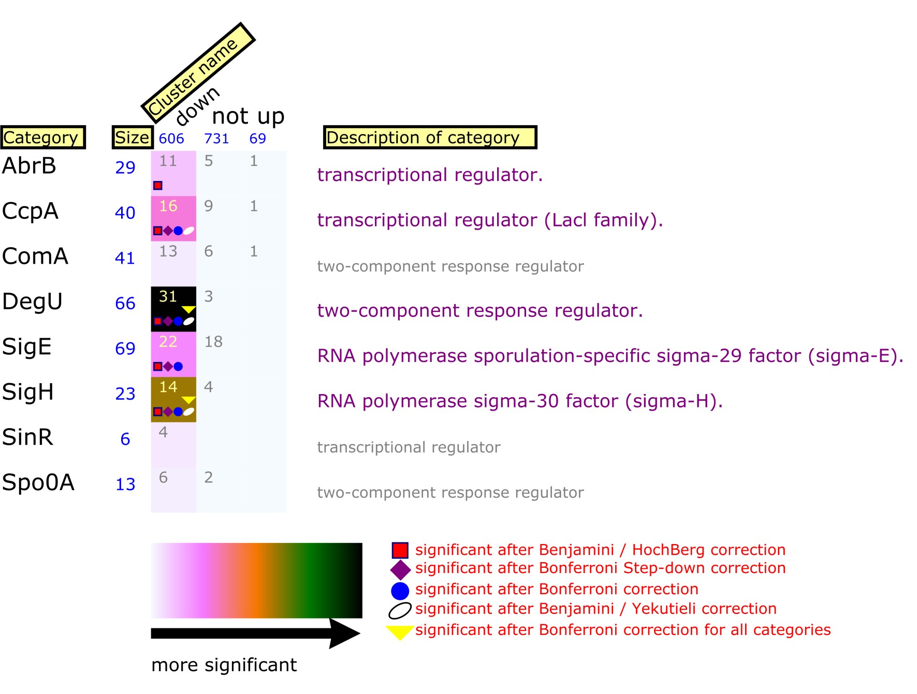
Fig. S1. Transcriptome analysis using FIVA software (Blom et al., 2007). The total number of genes that were shown to belong to a certain regulon (category) is indicated by blue numbers (size). The number of genes identified to be significantly down-regulated in the sporulating fraction from each category is indicated in the ‘down’ column, and the number of genes identified being up-regulated in the sporulating fraction is shown in the ‘up’ column. The total number of genes that were identified in both fractions, and were not significantly different, are indicated in the ‘not’ column. The darker the color of the category, the more over-represented and significant this category is. This analysis shows that non-sporulating cells express 31 members of the DegU regulon (containing a total of 66 members Ogura et al., 2001; Mader et al., 2002) more than twofold higher compared to endospore-formers.
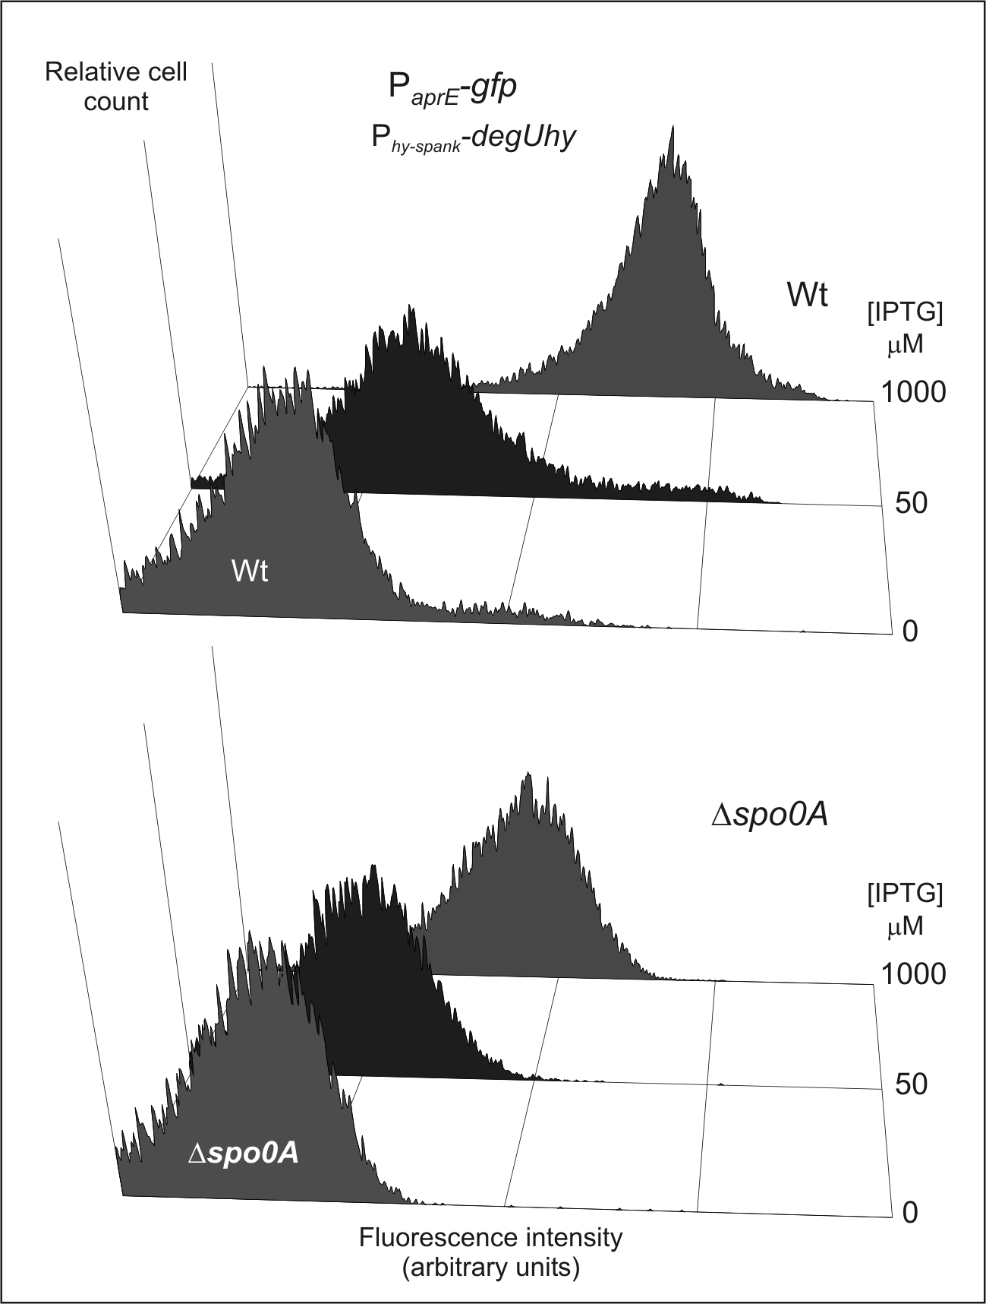

Fig. S2. Spo0A modulates aprE gene expression. Strains aprE-gfp/hy (top) and aprE-gfp/hy/Δ0A (bottom) were grown in TY medium and induced with IPTG at mid-exponential growth. Cells were collected for flow cytometric analyses after 3,5h of induction.

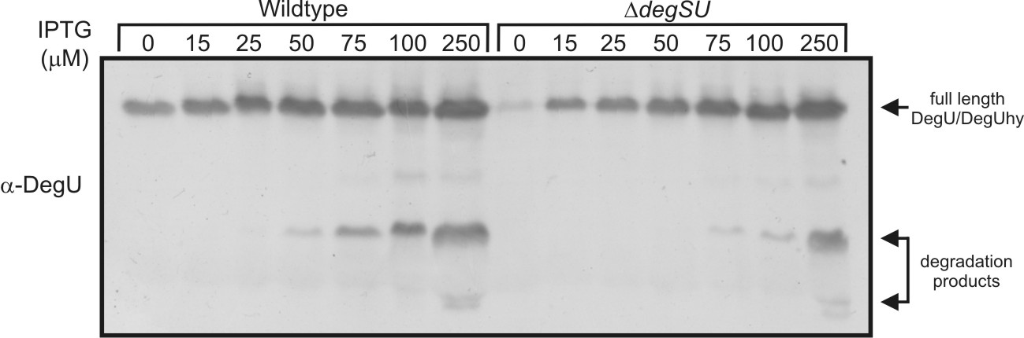

Fig. S3. Total DegU protein levels. Cells from Fig. 6A-B were subjected to Western blot analysis using a DegU specific antibody as described in the supplemental materials and methods.
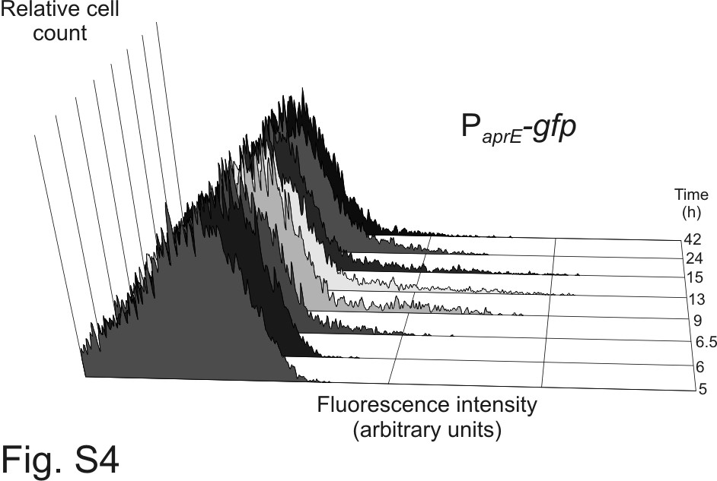

Fig. S4. Time dependent heterogeneity in aprE gene expression. Cells were grown overnight in TY medium (strain aprE-gfp) and diluted into fresh TY to an OD600 of 0.05. Samples were taken for flow cytometric analyses at the indicated times after dilution.

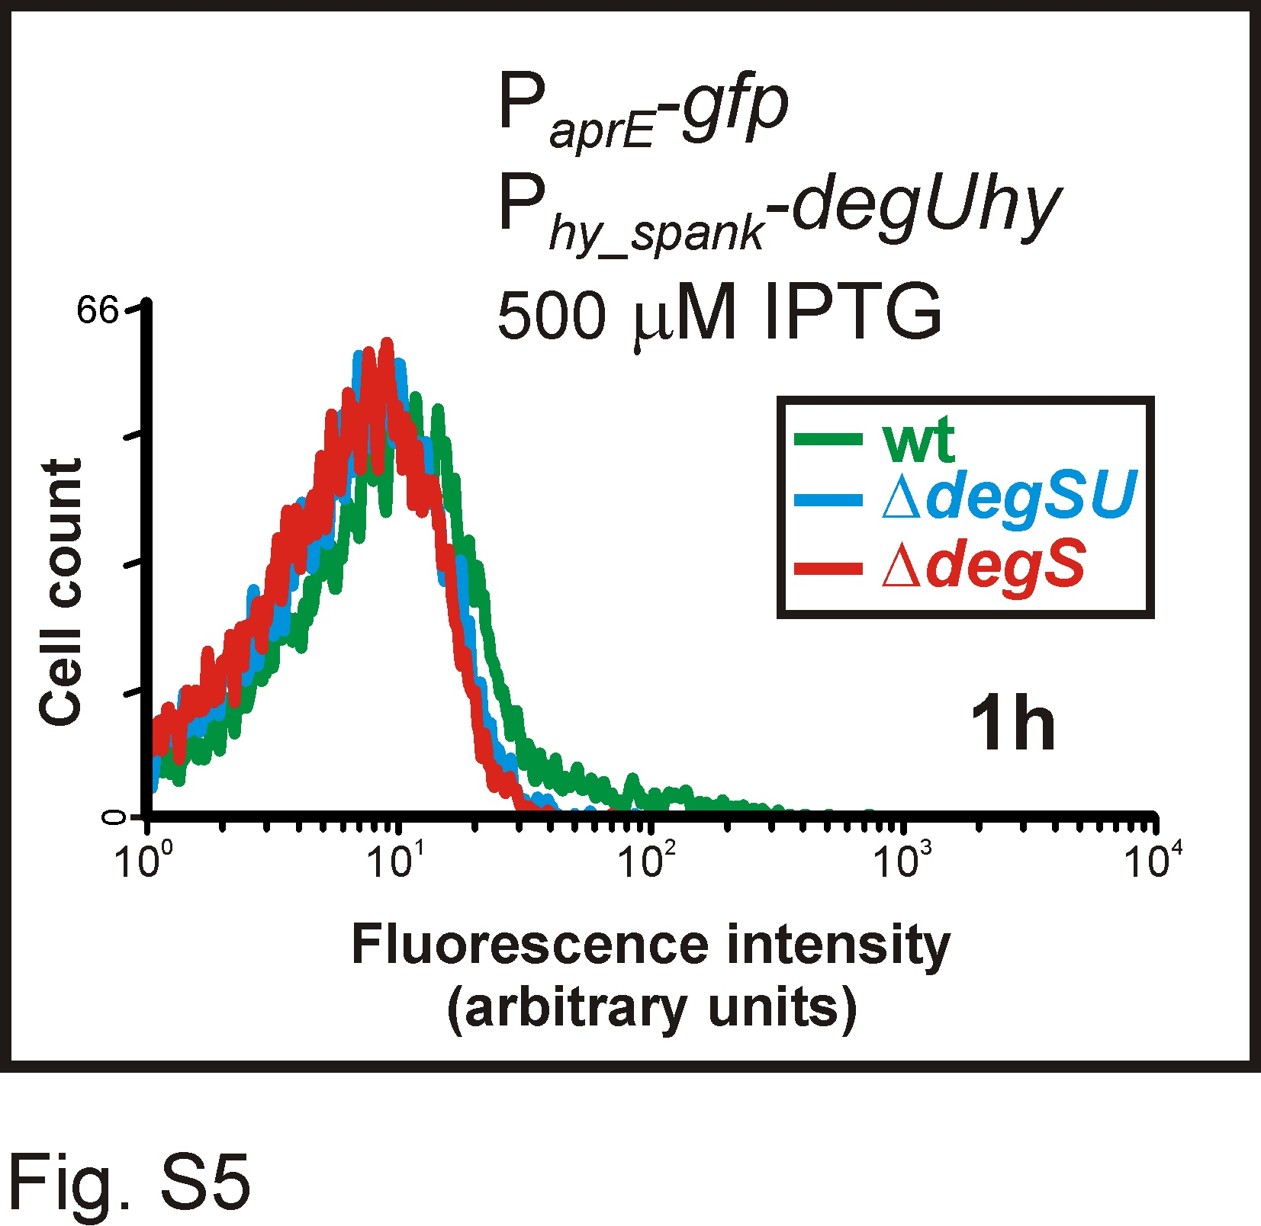

Fig. S5. DegS is required for degU autostimulation. Strains aprE-gfp/hy, aprE-gfp/hy/ΔS and aprE-gfp/hy/ΔSU were grown in TY medium and induced with 500 μM of IPTG at mid-exponential growth. After 1h of induction, cells were collected for flow cytometric analyses. Representative flow profiles are depicted.

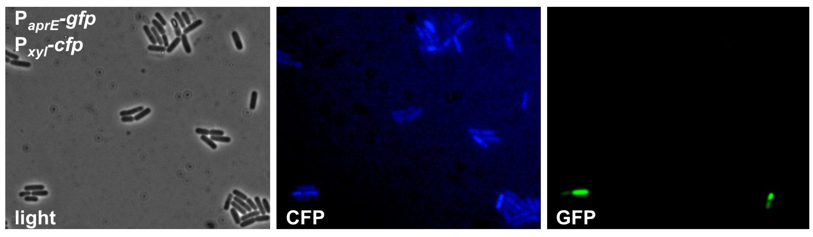

Fig. S6. Heterogeneity in aprE expression is regulated. An overnight culture of strain aprE-gfp/X-cfp (P_{aprE}-gfp, amyE::P_{xyl}-cfp_bs) was induced with 1% xylose. Cells were collected for light and fluorescence microscopy 4 hours after induction. All cells, except for endospore containing cells, express CFP from the xylose inducible promoter but only a small subpopulation expresses GFP from the aprE promoter.

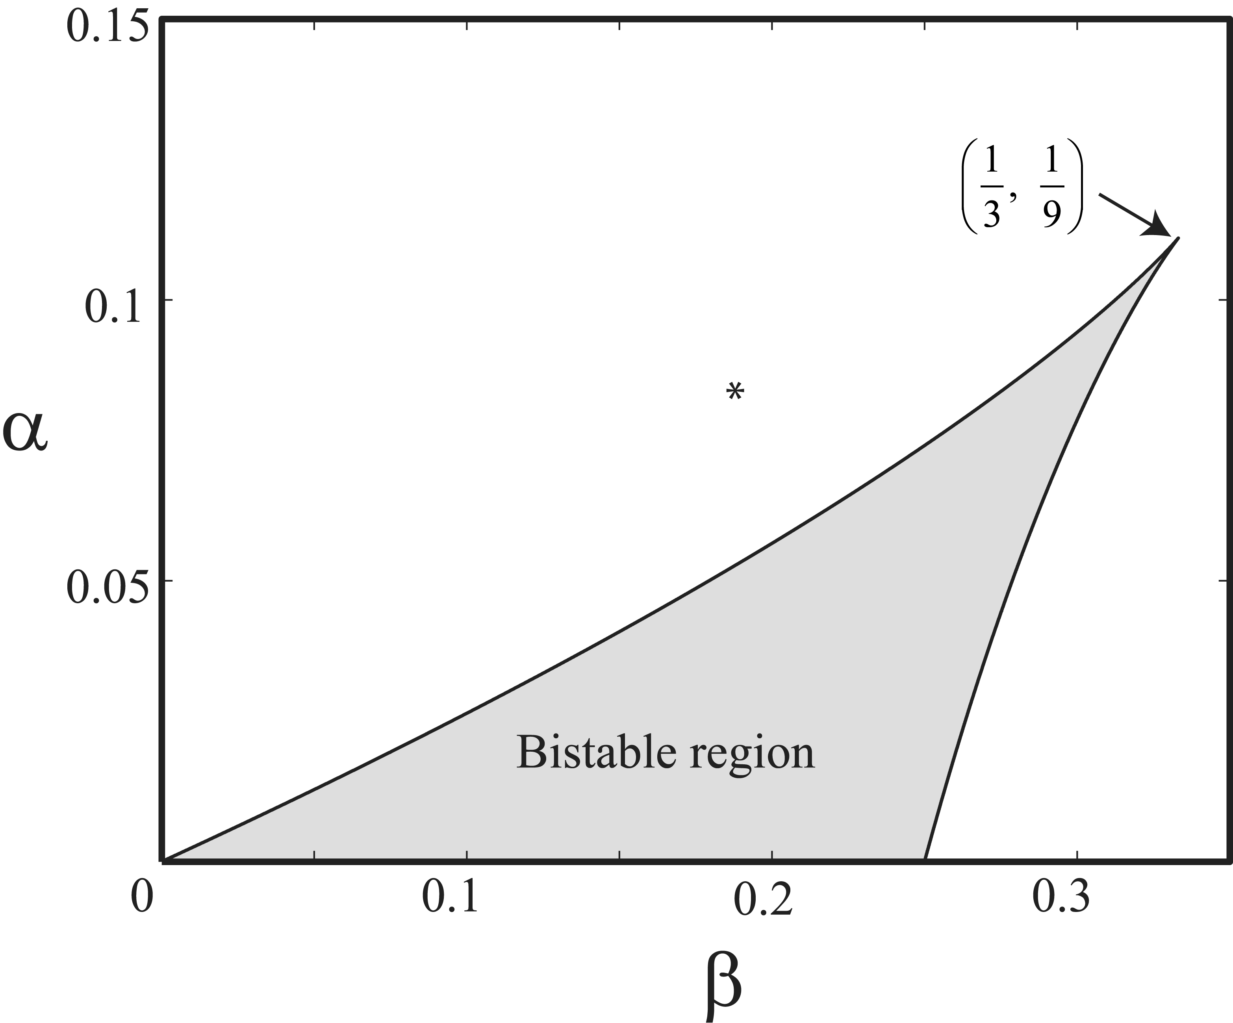

Fig. S7. The range of parameters supporting bistability for Eq. (S.12). The model parameters are aggregated into two dimensionless numbers. * denoted the value used in our simulation. For this value the system is monostable resulting in unimodal distribution of DegU but the switching kinetics are slow and noisy because of the close proximity to the bistable region.

Table S1. Bacterial strains used in this study.
Strains | Description ª | Relevant genotype | Reference

E. coli
TG90 | TG1 derivative, maintains plasmids at low copy numbers |  | (Lopilato et al., 1986)

B. subtilis
168 | Parental | trpC2 | (Kunst et al., 1997)
QB4277 | ΔdegS | degS::aphA3, Km^{r} | (Msadek et al., 1991)
QB4238 | ΔdegSU | degSU::aphA3, Km^{r} | (Msadek et al., 1990)
QB4487 | ΔdegU | degU::erm, Em^{r} | (Dartois et al., 1998)
SWV215 | Δspo0A | spo0A::kan, Km^{r} | (Xu and Strauch, 1996)
RL1265 | ΔsigF | sigF::kan, Km^{r} | (Branda et al., 2001)
abrB::Em | ΔabrB | abrB::erm, Em^{r} | (Smits et al., 2005)
aprE-gfp | pGFP-aprE→168 | P_{aprE}-gfp, Cm^{r} | This study
aprE-gfp/hy | pDR-hy→aprE-gfp | P_{aprE}-gfp, Cm^{r}, amyE::P_{hyper-spank-}degUhy, Sp^{r} | This study
aprE-gfp/hy/ΔSU | QB4238→aprE-gfp/hy | P_{aprE}-gfp, Cm^{r}, amyE::P_{hyper-spank-}degUhy, Sp^{r}, degSU::aphA3, Km^{r} | This study
aprE-gfp/hy/ΔS | QB4277→aprE-gfp/hy | P_{aprE}-gfp, Cm^{r}, amyE::P_{hyper-spank-}degUhy, Sp^{r}, degS::aphA3, Km^{r} | This study
aprE-gfp/pDG-hy | pDG-hy→aprE-gfp | P_{aprE}-gfp, Cm^{r}, P_{spac}-degUhy, Km^{r} | This study
aprE-gfp/hy/Δ0A | SWV215→aprE-gfp/hy | P_{aprE}-gfp, Cm^{r}, amyE::P_{hyper-spank-}degUhy, Sp^{r}, spo0A::Km, Km^{r} | This study
aprE-gfp/hy/ΔabrB | abrB::Em→aprE-gfp/hy | P_{aprE}-gfp, Cm^{r}, amyE::P_{hyper-spank-}degUhy, Sp^{r}, abrB::erm, Em^{r} | This study
aprE-gfp/Δ0A | SWV215→ aprE-gfp | P_{aprE}-gfp, Cm^{r}, spo0A::kan, Km^{r} | This study
aprE-gfp/ΔsigF | RL1265→aprE-gfp | P_{aprE}-gfp, Cm^{r}, sigF::kan, Km^{r} | This study
aprE-gfp/ΔdegU | QB4487→aprE-gfp | P_{aprE}-gfp, Cm^{r}, degU::erm, Em^{r}
aprE-gfp/X-cfp | P1726-cfp_bs→aprE-gfp | P_{aprE}-gfp, Cm^{r}, amyE::P_{xyl}-cfp_bs, Sp^{r} | This study
degS-gfp | pGFP-degS→168 | P_{degS}-gfp, Cm^{r} | This study
‘degSU-gfp | pGFP-‘degSU→168 | P_{’degSU}-gfp, ΔdegU, Cm^{r} | This study
degSU-gfp | pDG-PdegSU-gfp→168 | thrC::P_{degSU}-gfp, Em^{r} | This study
A:degS-gfp | pDG1730-PdegS-gfp→168 | amyE::P_{degS}-gfp, Sp^{r} | This study
A:degSU-gfp | pDG1730-PdegSU-gfp→168 | amyE::P_{degSU}-gfp, Sp^{r} | This study
degS-gfp/hy | pDR-hy→ degS-gfp | P_{degS}-gfp, Cm^{r}, amyE::P_{hyper-spank-}degUhy, Sp^{r} | This study
degU-gfp/hy | pDR-hy→ degSU-gfp | thrC::P_{degSU}-gfp, Em^{r}, amyE::P_{hyper-spank-}degUhy, Sp^{r} | This study
degU-gfp/hy/ΔdegU | pDR-hy→‘degSU-gfp | P_{’degSU}-gfp, ΔdegU, Cm^{r}, amyE::P_{hyper-spank-}degUhy, Sp^{r} | This study
bpr-gfp | pGFP-bpr→168 | P_{bpr}-gfp, Cm^{r} | This study
acoA-gfp | pGFP-acoA→168 | P_{acoA}-gfp, Cm^{r} | This study
srfA-gfp | pGFP-srfA→168 | P_{srfAA}-gfp, Cm^{r} | This study
sunA-gfp | pGFP-sunA→168 | P_{sunA}-gfp, Cm^{r} | This study
hag-gfp | pGFP-hag→168 | P_{hag}-gfp, Cm^{r} | This study
ª Arrows (→) indicate construction by transformation with either plasmid or chromosomal DNA.

Table S2. Plasmids used in this study.
Plasmids | Relevant genotype | Reference
pSG1151 | bla, Ap^{r}, cat, Cm^{r}, gfpmut1 | (Lewis et al., 1999)
pDG148 | lacI, bla, Ap^{r}, kan, Km^{r}, Pspac | (Stragier et al., 1988)
pDG148-degU | lacI, bla, Ap^{r}, kan, Km^{r}, Pspac-degU | (Ogura et al., 2001)
pDG1664 | thrC, Sp, Sp^{r}, bla, Ap^{r}, ery, Em^{r} | (Guerout-Fleury et al., 1996)
pDG1730 | amyE, Sp, Sp^{r}, bla, Ap^{r}, ery, Em^{r} | (Guerout-Fleury et al., 1996)
pDG-hy | lacI, bla, Ap^{r}, kan, Km^{r}, Pspac-degUhy | This study
pDR111 | amyE, lacI, bla, Ap^{r}, Sp, Sp^{r}, Phyper-spank | Gift of D. Rudner
pDR-hy | amyE, lacI, bla, Ap^{r}, Sp, Sp^{r}, Phyper-spank-degUhy | This study
P1726-cfp_bs | amyE, bla, Ap^{r}, Sp, Sp^{r}, Pxyl-cfp_bs | Gift of L. Wu
pGFP-aprE | bla, Ap^{r}, cat, Cm^{r}, PaprE-gfpmut1 | This study
pGFP-bpr | bla, Ap^{r}, cat, Cm^{r}, Pbpr-gfpmut1 | This study
pGFP-acoA | bla, Ap^{r}, cat, Cm^{r}, PacoA-gfpmut1 | This study
pGFP-sunA | bla, Ap^{r}, cat, Cm^{r}, PsunA-gfpmut1 | This study
pGFP-srfA | bla, Ap^{r}, cat, Cm^{r}, PsrfA-gfpmut1 | This study, (Smits et al., 2007)
pGFP-hag | bla, Ap^{r}, cat, Cm^{r}, Phag-gfpmut1 | This study, (Lulko et al., 2007)
pGFP-degS | bla, Ap^{r}, cat, Cm^{r}, PdegS-gfpmut1 | This study
pGFP-‘degSU | bla, Ap^{r}, cat, Cm^{r}, P’degSU-gfpmut1 | This study
pDG1730-PdegS-gfp | amyE, Sp, Sp^{r}, bla, Ap^{r}, ery, Em^{r}, PdegS-gfpmut1 | This study
pDG1730-PdegSU-gfp | amyE, Sp, Sp^{r}, bla, Ap^{r}, ery, Em^{r}, PdegSU-gfpmut1 | This study
pDG-PdegSU-gfp | thrC, Sp, Sp^{r}, bla, Ap^{r}, ery, Em^{r}, PdegSU-gfpmut1 | This study

Table S3. Oligonucleotides used in this study.
Oligo | Sequence (5’ to 3’)ª | Description; position
degU-F-hy | CCCAAGCTTAGGAGGAGAGGAAATGACTAAAGTAAACATTGTTATTATCGACGACCTTCAG | HindIII; 5’ end of degU, A35→C^{b}
degU-R+SalI | GCACGTAGTCGACTTACTATCTCATTTCTACCCAGCCATT | SalI; 3’ end of degU
gfp-R+BglII | CGGAAGATCTTTATTATTTGTAGAGCTCATCCATGCCATGTG | BglLII; 3’ end of gfpmut1
aprE-F | CCCAAGCTTCAGCGGCGCAATGGCGGCCGCATC | HindIII; 5’ end of PaprE
aprE-R | CGGAATTCCATTTCCTCTCCTCCTCTTTTAAAAAAATTCAGAGTAGACTTACTTAAAAGA | EcoRI; 3’ end of PaprE
bpr-F | GCCTCAGCGCCCAAGCTTAAATC | HindIII; 5’ end of Pbpr
bpr-R | CGGAATTCCATTTCCTCTCCTCCTTTTCAACATGCTTTTTAAAAAAAGTGTCGTCCC | EcoRI; 3’ end of Pbpr
acoA-F | CCCAAGCTTGCGCCTATGAGCATGACGATTCAG | HindIII; 5’ end of PacoA-L
acoA-R | CGGAATTCCATTTCCTCTCCTCCTTCTATTTAGGGTTCACCATTATAAATGC | EcoRI; 3’ end of PacoA-L
srfA-F | CCCAAGCTTGCTGAGAGAGCGTGAGCAGGATATG | HindIII; 5’ end of PsrfAA
srfA-R | CGGAATTCCATTTCCTCTCCTCCTCTAATCTTTATAAGCAGTGAACATGTGC | EcoRI; 3’ end of PsrfAA
sunA-F | CCCAAGCTTCAACGAGCTGGATTAACAGGTGGGC | HindIII; 5’ end of PsunA
sunA-R | CGGAATTCCATTTCCTCTCCTCCTCATTTGTTTGCAATCCGGATTACATTTTT | EcoRI; 3’ end of PsunA
hag-F | GGGATCAAGTGAAGCTTGGAATTGACG | HindIII; 5’ end of Phag
hag-R | CGGAATTCCATTTCCTCTCCTCCTTGAATATGTTGTTAAGGCACGTCC | EcoRI; 3’ end of Phag
degU-F+HindIII | CCCAAGCTTCGAGCATCGGCACTCCCGCTGTACCGC | HindIII; 5’ end of PdegS
degS-R+RBS+EcoRI | CGGAATTCCATTTCCTCTCCTCCTAATTTCCCTCCGTCACGGCGTTGTC | EcoRI; 3’ end of PdegS
degU-F+HindIII_inside | CCCAAGCTTGATGAGATCGGAATTAATCGAGCGG | HindIII; 5’ end of P’degSU
degU-R-R+RBS+EcoRI | CGGAATTCCATTTCCTCTCCTCCTTGTATTATTGTTCTATATACTCTAGC | EcoRI; 3’ end of P’degSU
ª Relevant restriction sites are underlined.
^{b} The A35→C base pair mutation, causing a H12→L amino acid change, is indicated in italics.

References to the supporting material

Blom EJ, Bosman DW, van Hijum SA, Breitling R, Tijsma L, Silvis R, Roerdink JB, Kuipers OP (2007) FIVA: Functional Information Viewer and Analyzer extracting biological knowledge from transcriptome data of prokaryotes. Bioinformatics, 23, 1161-1163.
Branda SS, Gonzalez-Pastor JE, Ben Yehuda S, Losick R, Kolter R (2001) Fruiting body formation by Bacillus subtilis. Proc Natl Acad Sci U S A, 98, 11621-11626.
Dahl MK, Msadek T, Kunst F, Rapoport G (1992) The phosphorylation state of the DegU response regulator acts as a molecular switch allowing either degradative enzyme synthesis or expression of genetic competence in Bacillus subtilis. J Biol Chem, 267, 14509-14514.
Dartois V, Debarbouille M, Kunst F, Rapoport G (1998) Characterization of a novel member of the DegS-DegU regulon affected by salt stress in Bacillus subtilis. J Bacteriol, 180, 1855-1861.
Fisher SL, Kim SK, Wanner BL, Walsh CT (1996) Kinetic comparison of the specificity of the vancomycin resistance kinase VanS for two response regulators, VanR and PhoB. Biochemistry, 35, 4732-40.
Gillespie DT (1977) Exact Stochastic Simulation of Coupled Chemical Reactions. Journal of Physical Chemistry, 81, 2340-2361.
Glaser P, Sharpe ME, Raether B, Perego M, Ohlsen K, Errington J (1997) Dynamic, mitotic-like behavior of a bacterial protein required for accurate chromosome partitioning. Genes Dev, 11, 1160-1168.
Guerout-Fleury AM, Frandsen N, Stragier P (1996) Plasmids for ectopic integration in Bacillus subtilis. Gene, 180, 57-61.
Harwood CR and Cutting SM (1990) Molecular Biological Methods for Bacillus. John Wiley and sons Ltd., Chichester.
Hata M, Ogura M, Tanaka T (2001) Involvement of stringent factor RelA in expression of the alkaline protease gene aprE in Bacillus subtilis. J Bacteriol, 183, 4648-4651.
Jiang P, Atkinson MR, Srisawat C, Sun Q, Ninfa AJ (2000) Functional dissection of the dimerization and enzymatic activities of Escherichia coli nitrogen regulator II and their regulation by the PII protein. Biochemistry, 39, 13433-49.
Kato A and Groisman EA (2004) Connecting two-component regulatory systems by a protein that protects a response regulator from dephosphorylation by its cognate sensor. Genes & Development, 18, 2302-13.
Kremling A, Heermann R, Centler F, Jung K, Gilles ED (2004) Analysis of two-component signal transduction by mathematical modeling using the KdpD/KdpE system of Escherichia coli. Biosystems, 78, 23-37.
Kunst F, Msadek T, Bignon J, Rapoport G (1994) The DegS/DegU and ComP/ComA two-component systems are part of a network controlling degradative enzyme synthesis and competence in Bacillus subtilis. Res Microbiol, 145, 393-402.
Kunst F, Ogasawara N, Moszer I, Albertini AM, Alloni G, Azevedo V, Bertero MG, Bessieres P, Bolotin A, et al. (1997) The complete genome sequence of the gram-positive bacterium Bacillus subtilis. Nature, 390, 249-256.
Lewis PJ and Marston AL (1999) GFP vectors for controlled expression and dual labelling of protein fusions in Bacillus subtilis. Gene, 227, 101-110.
Lopilato J, Bortner S, Beckwith J (1986) Mutations in a new chromosomal gene of Escherichia coli K-12, pcnB, reduce plasmid copy number of pBR322 and its derivatives. Mol Gen Genet, 205, 285-290.
Lulko AT, Veening JW, Buist G, Smits WK, Blom EJ, Beekman AC, Bron S, Kuipers OP (2007) Production and secretion stress caused by overexpression of heterologous alpha-amylase leads to inhibition of sporulation and a prolonged motile phase in Bacillus subtilis. Appl Environ Microbiol, 73, 5354-5362.
Mader U, Antelmann H, Buder T, Dahl MK, Hecker M, Homuth G (2002) Bacillus subtilis functional genomics: genome-wide analysis of the DegS-DegU regulon by transcriptomics and proteomics. Mol Genet Genomics, 268, 455-467.
Mayover TL, Halkides CJ, Stewart RC (1999) Kinetic characterization of CheY phosphorylation reactions: Comparison of P-CheA and small-molecule phosphodonors. Biochemistry, 38, 2259-2271.
Msadek T (1999) When the going gets tough: survival strategies and environmental signaling networks in Bacillus subtilis. Trends Microbiol, 7, 201-207.
Msadek T, Kunst F, Henner D, Klier A, Rapoport G, Dedonder R (1990) Signal transduction pathway controlling synthesis of a class of degradative enzymes in Bacillus subtilis: expression of the regulatory genes and analysis of mutations in degS and degU. J Bacteriol, 172, 824-834.
Msadek T, Kunst F, Klier A, Rapoport G (1991) DegS-DegU and ComP-ComA modulator-effector pairs control expression of the Bacillus subtilis pleiotropic regulatory gene degQ. J Bacteriol, 173, 2366-2377.
Msadek T, Kunst F, Rapoport G (1993) Two-component regulatory systems. In Sonenshein AL, Hoch JA, Losick R. (Eds.) Bacillus subtilis and other gram-positive bacteria. American Society of Microbiology, Washington DC, pp. 729-745.
Ogura M, Yamaguchi H, Yoshida K, Fujita Y, Tanaka T (2001) DNA microarray analysis of Bacillus subtilis DegU, ComA and PhoP regulons: an approach to comprehensive analysis of B. subtilis two-component regulatory systems. Nucleic Acids Res, 29, 3804-3813.
Sambrook J, Fritsch EF, Maniatis T (1989) Molecular Cloning: a Laboratory Manual. Cold Spring Harbor Laboratory Press, Cold Spring Harbor, New York.
Silversmith RE, Appleby JL, Bourret RB (1997) Catalytic mechanism of phosphorylation and dephosphorylation of CheY: Kinetic characterization of imidazole phosphates as phosphodonors and the role of acid catalysis. Biochemistry, 36, 14965-74.
Smits WK, Bongiorni C, Veening JW, Hamoen LW, Kuipers OP, Perego M (2007) Temporal separation of distinct differentiation pathways by a dual specificity Rap-Phr system in Bacillus subtilis. Mol Microbiol, 65, 103-120.
Smits WK, Eschevins CC, Susanna KA, Bron S, Kuipers OP, Hamoen LW (2005) Stripping Bacillus: ComK auto-stimulation is responsible for the bistable response in competence development. Mol Microbiol, 56, 604-614.
Stewart RC and Van Bruggen R (2004) Association and dissociation kinetics for CheY interacting with the P2 domain of CheA. J Mol Biol, 336, 287-301.
Stragier P, Bonamy C, Karmazyn-Campelli C (1988) Processing of a sporulation sigma factor in Bacillus subtilis: how morphological structure could control gene expression. Cell, 52, 697-704.
Tanaka T, Kawata M, Mukai K (1991) Altered phosphorylation of Bacillus subtilis DegU caused by single amino acid changes in DegS. J Bacteriol, 173, 5507-5515.
Veening JW, Hamoen LW, Kuipers OP (2005) Phosphatases modulate the bistable sporulation gene expression pattern in Bacillus subtilis. Mol Microbiol, 56, 1481-1494.
Veening JW, Stewart EJ, Berngruber TW, Taddei F, Kuipers OP, Hamoen LW (2008) Bet-hedging and epigenetic inheritance in bacterial cell development. Proc Natl Acad Sci U S A, in press.
Wright GD, Holman TR, Walsh CT (1993) Purification and Characterization of VanR and the Cytosolic Domain of VanS - a 2-Component Regulatory System Required for Vancomycin Resistance in Enterococcus faecium Bm4147. Biochemistry, 32, 5057-5063.
Xu K and Strauch MA (1996) Identification, sequence, and expression of the gene encoding gamma-glutamyltranspeptidase in Bacillus subtilis. J Bacteriol, 178, 4319-4322.

http://mathworld.wolfram.com/PolynomialDiscriminant.html

