Table S1. Equations of the Model
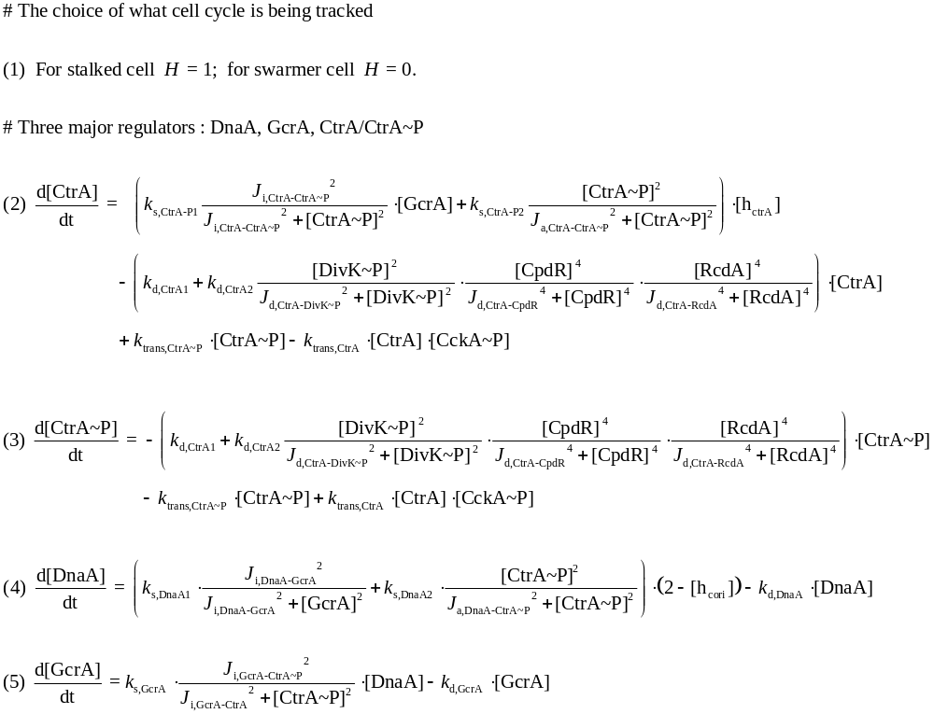
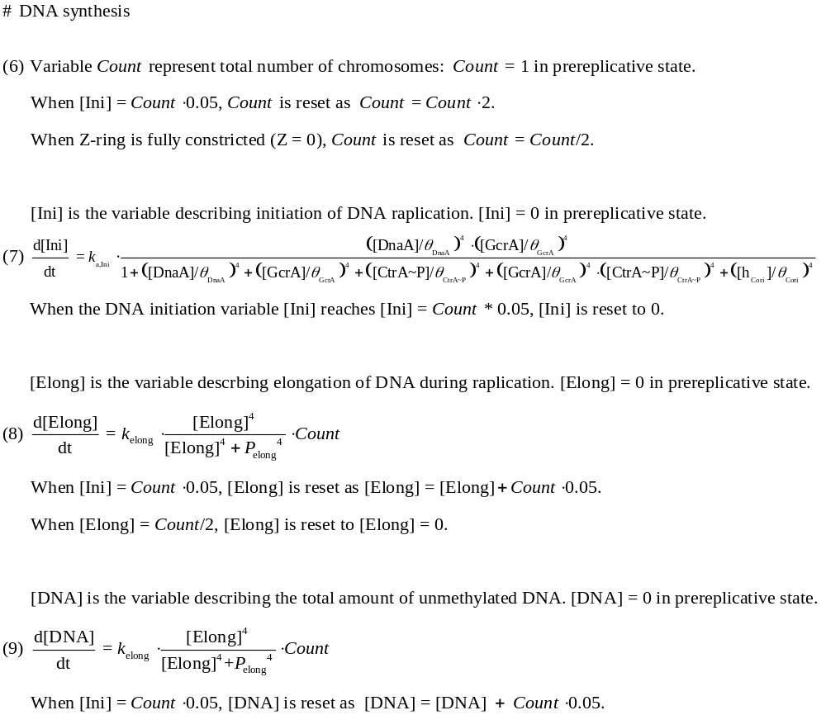
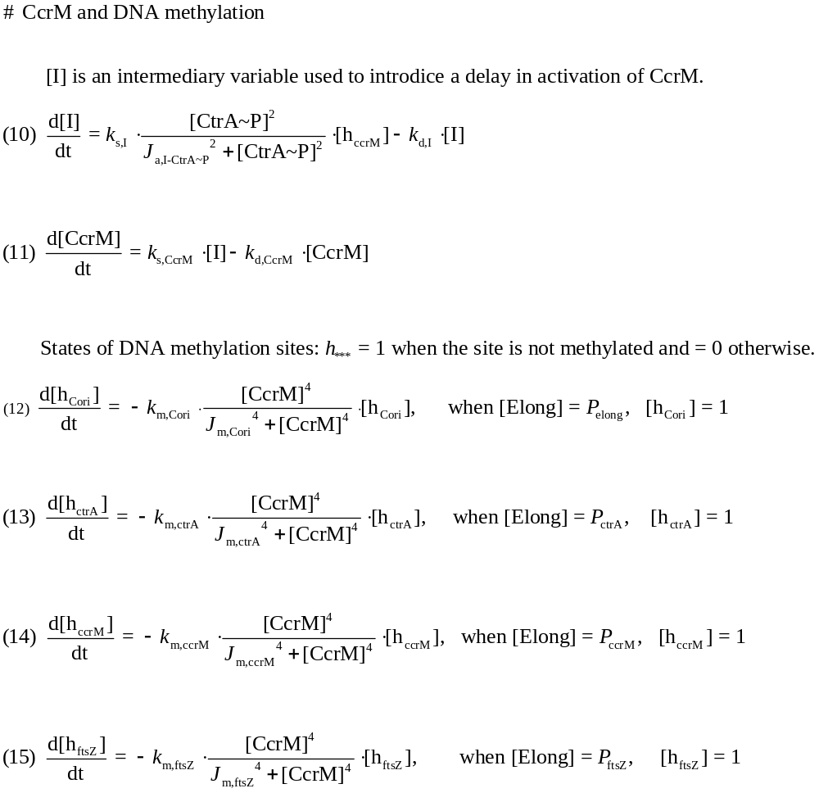
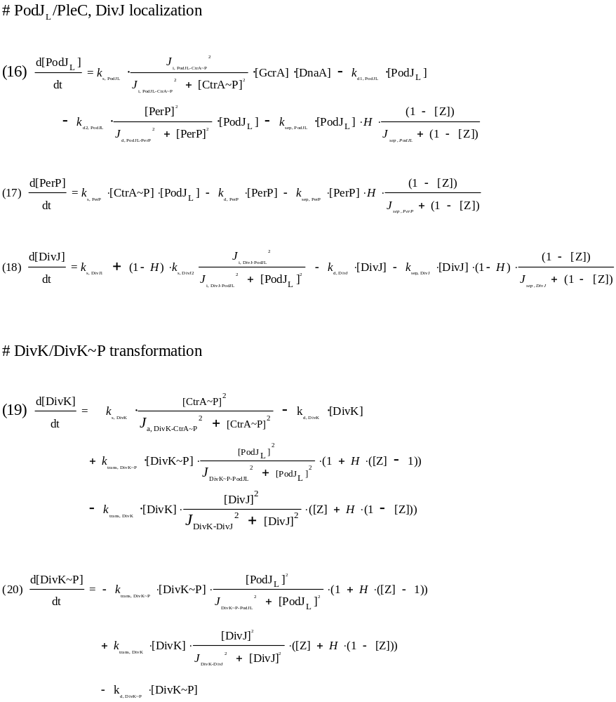

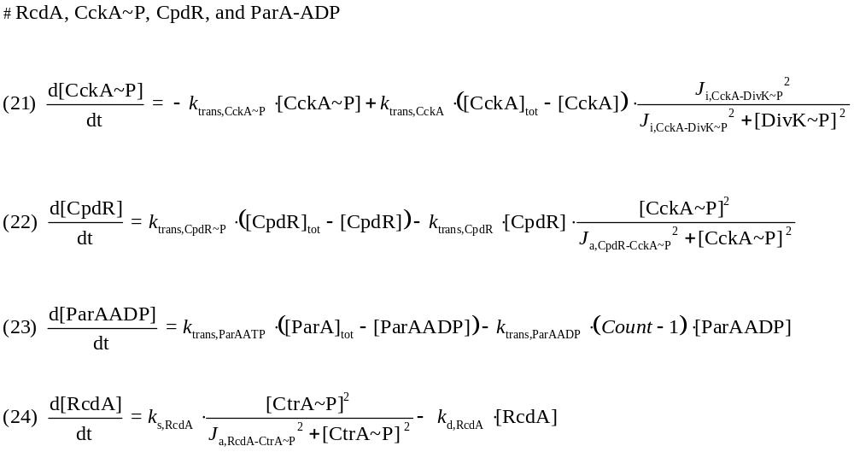

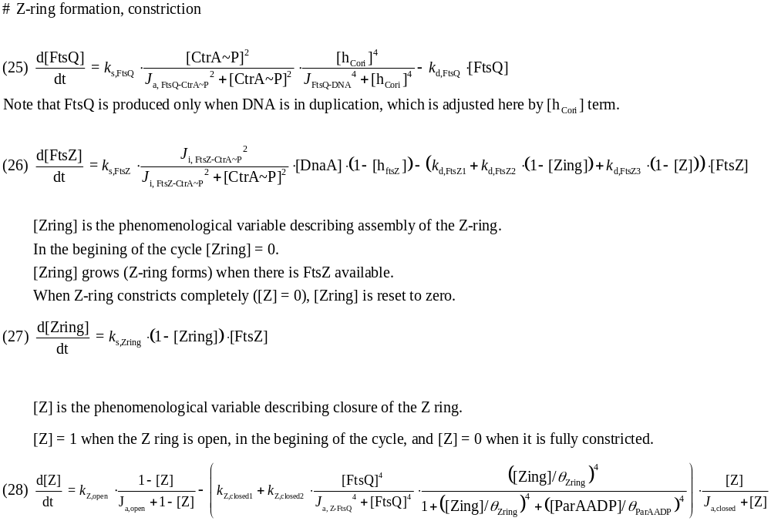
Symbols:
k = rate constants (min⁻¹), J = binding constants (dimensionless), θ = thresholds (dimensionless), P = position of genes relative to origin site (dimensionless). s = synthesis, d = degradation, a = activation, i = inactivation, trans = transformation (phosphorylation and dephosphorylation in our case), m = methylation, sep = separation due to Z-ring constriction, tot = total amount of proteins.

