Table S1. Mathematical Notation for Model Variables as Subdivided into Independent and Dependent Variables

Concentration | Component
independent variables
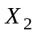 | Dsh_{a}
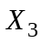 | (APC*/axin*/GSK3)
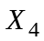 | (APC/axin/GSK3)
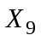 | (β-catenin*/APC*/axin*/GSK3)
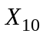 | β-catenin*
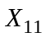 | β-catenin
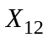 | Axin
dependent variables
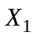 | Dsh_{i}
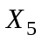 | GSK3
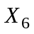 | (APC/axin)
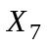 | APC
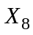 | (β-catenin/APC*/axin*/GSK3)
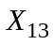 | TCF
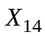 | (β-catenin/TCF)
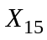 | (β-catenin/APC)

