Supplementary Figure 1. Parameter fit to experimental data.

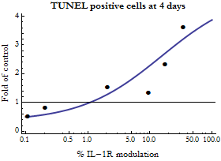

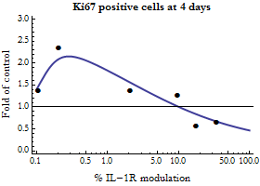

Data were obtained from human islets cultured for 4 days using different concentrations of IL-1β. IL-1β concentrations were translated to IL-1R modulation levels using Suppl. Eq. 4 and concentrations of endogenously produced IL-1Ra reported in¹. TUNEL and Ki67 positive cells reflects β-cell apoptosis and replication rates respectively.

1. Maedler K, Schumann DM, Sauter N, Ellingsgaard H, Bosco D, Baertschiger R, et al. Low concentration of interleukin-1beta induces FLICE-inhibitory protein-mediated beta-cell proliferation in human pancreatic islets. Diabetes 2006, 55(10): 2713-2722.

2. Maedler K, Sergeev P, Ris F, Oberholzer J, Joller-Jemelka HI, Spinas GA, et al. Glucose-induced beta cell production of IL-1beta contributes to glucotoxicity in human pancreatic islets. J Clin Invest 2002, 110(6): 851-860.

