Table S2. Rate expressions and kinetic parameters used in the MA model
 | Reactions | Reaction rates | Parameters | Parameter values | Parameter values normalized by [R1B_{tot}]
v₁ | 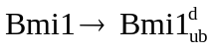 | 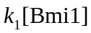 | k₁ | 0.002 (s⁻¹) | 0.002 (s⁻¹)
v₂ | 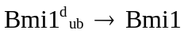 | 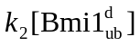 | k₂ | 0.002 (s⁻¹) | 0.002 (s⁻¹)
v₃ | 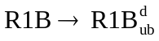 | 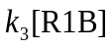 | k₃ | 0.01 (s⁻¹) | 0.01 (s⁻¹)
v₄ | 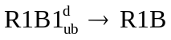 | 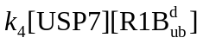 | k₄ | *
v₅ | 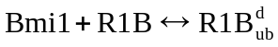 | 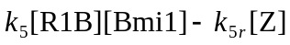 | k₅  k_{5r} | 0.02 (nM⁻¹ s⁻¹)  0.2 (s⁻¹) | 2 ( s⁻¹)  0.2 (s⁻¹)
v₆ | 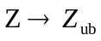 | 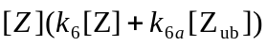 | k₆  k_{6a} | 2·10⁻⁴ (nM⁻¹ s⁻¹)  0.002 (nM⁻¹ s⁻¹) | 0.02 ( s⁻¹ )  0.2 ( s⁻¹)
v₇ | 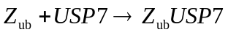 | 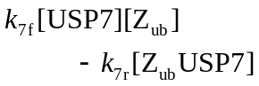 | k_{7f}  k_{7r} | *
v_{7’} | 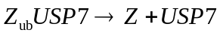 | 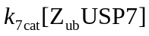 | k_{7cat} | *
v₈ | 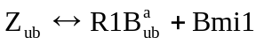 | 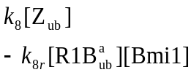 | k₈  k_{8r} | 0.012 (s⁻¹)  2·10⁻⁷ (nM⁻¹ s⁻¹) | 0.012(s⁻¹)  2·10⁻⁵ (s⁻¹)
v₉ | 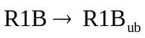 | 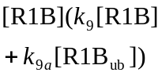 | k₉  k_{9a} | 0.002 (nM⁻¹ s⁻¹)  0.002 (nM⁻¹ s⁻¹) | 0.2 ( s⁻¹)  0.2 ( s⁻¹)
v₁₀ | 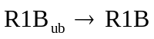 | 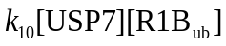 | k₁₀ | *
v₁₁ | 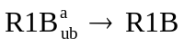 | 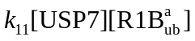 | k₁₁ | *
v₁₂ | 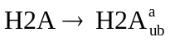 | 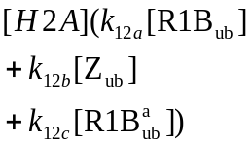 | k_{12a}  k_{12b}  k_{12c} | 2·10⁻⁵ (nM⁻¹ s⁻¹)  0.02 (nM⁻¹ s⁻¹)  0.002 (nM⁻¹ s⁻¹) | 0.002 (s⁻¹)  2 (s⁻¹)  0.2 (s⁻¹)
v₁₃ | 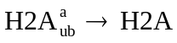 | 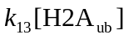 | k₁₃ | 0.01 (s⁻¹) | 0.01 (s⁻¹)
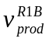 | 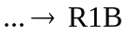 |  |  | 5·10⁻⁴ (nM s⁻¹) | 5·10⁻⁶ (s⁻¹)
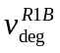 | 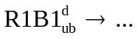 | 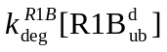 | 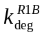 | 2·10⁻⁵ (s⁻¹) | 2·10⁻⁵ (s⁻¹)
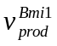 | 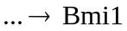 |  |  | 5·10⁻⁴ (nM s⁻¹) | 5·10⁻⁶ (s⁻¹)
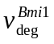 | 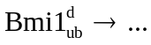 | 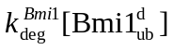 | 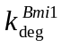 | 2·10⁻⁵ (s⁻¹) | 2·10⁻⁵ (s⁻¹)
 |  |  | [R1B_{tot}] | 100 nM | 1
 |  |  | [Bmi1_{tot}] | 325 nM | 1
 |  |  | [H2A_{tot}] | 10 nM | 0.1
 |  |  | [USP7_{tot}] | * | 1
*A wide range of values has been explored for these parameters as explained in detail in the figure legends.

