## docker存储空间不足

Failed to create pod sandbox: rpc error: code = Unknown desc = failed to create a sandbox for pod "csi-node-5n8tg": Error response from daemon: devmapper: Thin Pool has 53522 free data blocks which is less than minimum required 163840 free data blocks. Create more free space in thin pool or use dm.min_free_space option to change behavior

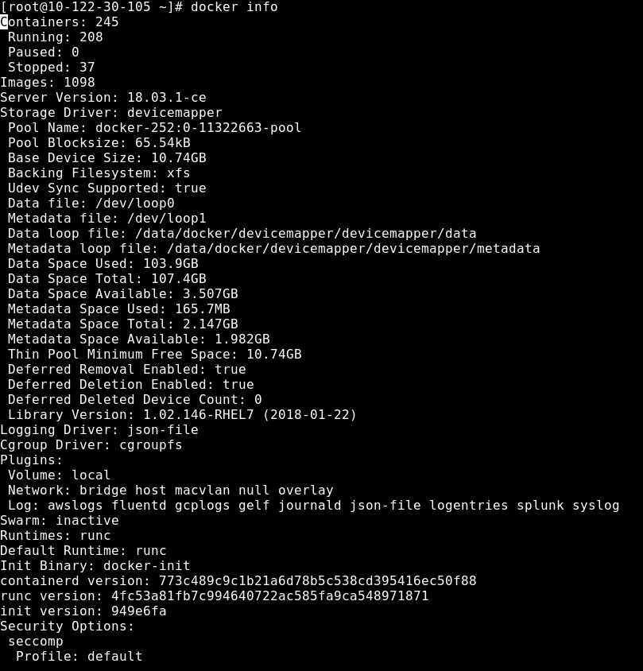

删除关闭的容器

docker ps -a | grep Exit | cut -d ' ' -f 1 | xargs docker rm

删除没有Tag的镜像

docker rmi $(docker images | grep "^<none>" | awk "{print $3}")

删除dangling Volume

docker volume rm $(docker volume ls -qf dangling=true)

或者使用以下命令清理，将删除当前不在运行的所有镜像容器网络volume

docker system prune