# 单节点Ceph升级

当前系统

Centos7

Linux ceph 3.10.0-1160.el7.x86_64 #1 SMP Mon Oct 19 16:18:59 UTC 2020 x86_64 x86_64 x86_64 GNU/Linux

当前Ceph版本

ceph version 13.2.10 (564bdc4ae87418a232fc901524470e1a0f76d641) mimic (stable)

升级后的版本

ceph version 14.2.22 (ca74598065096e6fcbd8433c8779a2be0c889351) nautilus (stable)

1. 首先升级ceph-deploy

|  |
| --- |
| pip install -U ceph-deploy |

1. 安装nautilus版本ceph,并重启ceph

|  |
| --- |
| ceph-deploy install --release nautilus ceph  systemctl restart ceph.target |

重启后如图

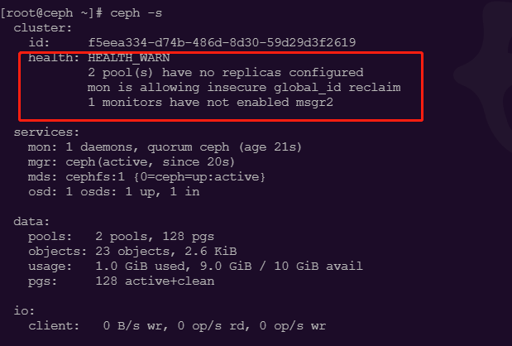

1. 解决警告

|  |
| --- |
| ceph mon enable-msgr  ceph config set mon auth_allow_insecure_global_id_reclaim false  ceph config set global mon_warn_on_pool_no_redundancy false |

1. 执行结果，若还存在警告，再次重启ceph服务

