

**GROUP ASSIGNMENT**

TECHNOLOGY PARK MALAYSIA

CT042-3-1-IDB

INTRODUCTION TO DATABASE

APU1F2006CS / APU1F2006CS(IS) / APU1F2006IT(IOT) /

APU1F2006CS(DF)

HAND OUT DATE: 11 JANUARY 2021

HAND IN DATE: 08 MARCH 2021

WEIGHTAGE: 50%

|  |  |
| --- | --- |
| Student ID | Student Name |
| TP059851 | Sim Yoke Shin |
| TP056199 | Brian Lamri See |
| TP061557 | Ng Kai Dong |

Contents

Database and Database Management System 3

Disadvantages of file-based system 3

Advantages of Database and DBMS 4

Business Rules 7

Entity Relationship Diagram 9

Database Schema 10

Relational schema of ERD 10

UNF 13

Normalize relations 15

1NF 15

2NF 22

3NF 23

Data Dictionary 24

Database Diagram 31

SQL-Data Definition Language (DDL) 31

Create Tables 31

Insert Data into Tables 34

Show Tables’ Data 37

SQL-Data Manipulation Language(DML) 41

Student 1 (Sim Yoke Shin TP059851) 41

Student 2 (Ng Kai Dong TP061557) 43

Student 3 (Brian Lamri See TP056199) 45

Reference 47

Workload Matrix 48

# Database and Database Management System

The software system that helps users to identify, build, maintain, and monitor database access is known as a Database Management System (DBMS). End users can build, read, edit, and erase data in a database using a DBMS. It's a layer that sits between the programs and data. Compare to traditional File Processing Systems, Database Management System is more useful for better data integration and stability.

## Disadvantages of file-based system

In the history of development technology, file-based system has been proposed since 19th century. Nowadays, it has still been using in computers to store and maintain the data of records and files. Although it is very easy for using by users, but it also has a lot of disadvantages for using file-based system to store the data. In this part, researchers will explain some disadvantages that found in file-based system.

The first disadvantage is separation and isolation of data (Chaitanya Singh, 2015). Since all of the data has store in different files, it will be harder for programmer to do coding with those isolated data. In this case, programmer need to do a lot of coding for calling out the different types of files from different folders. Thus, it is not recommender to use file-based system to search for appropriate data. The second disadvantage for using file-based system is duplication of data. In the file-based system, it is allowed any user to enter any data, and it has not any method to check whether the data has duplicated or not. Besides that, users will become confusion while they want to use the file-based system and it will be easy to lead redundancy the space of storage.

The third disadvantage of file-based system is data dependence (Chaitanya Singh, 2015). It means user will not recommend changing the format of files which for change the program for processing the current file. It is because when user change the format of files, it will also affect the other program s which dependent on this file. It will easily make the whole application crash since the change file’s format will not updated automatically in other dependent files.

In additionally, data inconsistency has become one of the disadvantages of file-based system (Rahul, 2019). If a data has been used in multiple files, then file-based system has not functioned that will automatically search and update the data in each and every file. Thus, it will easily get a mismatch of data in different files. The main reason of this issue is because there is not list the whole files which has the same copies of data correctly.

The last disadvantage of the file-based system is data security (Chaitanya Singh, 2015). It is the most complicated issue that users will face while using file-based system since it is not providing a proper security system for protect those files while the illegal user want to access files. Thus, it will hard apply some security constraints in the file-based system.

In a nutshell, the file-based system is a system which use as a normal using in technology equipment. It will perform well while there has only limited number of data and files. While the data and files become more and more, it will become messy and hard to use. So, for storing data, researchers have recommended users to use a database or DBMS.

## Advantages of Database and DBMS

In terms of advantages, database and DBMS can reduce data redundancy. Not like File-Based Data Management Systems which stored different files in several different places within a system, or even through several systems. As a result, there were occasionally several versions of the same file, resulting in data replication. In database, this is avoided since there is only one database and all improvements made to it are automatically replicated. So, there will be no risk of encountering identical data. (Castro, 2018)

Other than that, the database and DBMS methodology has the benefit of assisting in the development of an environment where users have greater access to more and better-managed data. This means that users can share data between themselves by using database and DBMS. There are different standards of authorization for accessing the data, so information can only be shared if the appropriate authorization procedures are followed. Besides that, many remote users can still access the database at the same time and exchange information among themselves. (Castro, 2018)

Better data integration is also an advantage when using database and DBMS. The word "data integrity" refers to the database's data being reliable and consistent. Because a DBMS contains multiple databases, data integrity is critical. Many of these databases provide data that can be accessed by many users. Consequently, it is important to ensure that the data in all databases and for all users is accurate and reliable. Besides, access to well-managed data makes for a more holistic understanding of the organization's operations and a better understanding of the larger picture. It's a lot easier to see how activities in one sector of the organization impact the rest of the sector. (Castro, 2018)

In additionally, data security is vital concept in a database. When the number of users expands, the amount at which data is exchanged or transmitted grows as well, raising the risk of data security. It is commonly used in the corporate world, where organizations spend a considerable amount of capital, resources, and commitment to ensure data protection and correct usage. So, DBMS has solved this problem which it provides a solid framework for maintaining data protection and reliability. Only authorized users should have access to the database, and their identities should be verified with a username and password. Unauthorized users will never be given access to the database because it breaks the credibility restrictions. (Castro, 2018)

Privacy is also one of the benefits that database and DBMS pay attention for. A database's privacy rule states that only authorized users are allowed access to the database, as defined by the privacy restrictions. There are different types of database access, and an user can only see the information that he is permitted to see. For example, on social networking sites, access requirements vary based on which accounts a person wants to access. (Castro, 2018)

Last but not least, database and DBMS allow data to be consistency. Since there is no data replication in a database, data consistency is assured. All data is identical in the database, and all users accessing the database see the same information. Furthermore, all database updates are automatically reflected to all customers, ensuring that there is no data inconsistency. (Castro, 2018)

# Business Rules

Business rules are specific description of policies or procedure within an organization's environment. During the process of database design, database engineers would define the entities, attributes, relationships, and constraints of the database based on the business rules. Structural business rules are business rules that decide the types of information to be stored and the relation between the information elements. On the other hand, procedural rules describe the prerequisites, processes or workflow requirements of a business.

The following statements are the business rules for the Malaysia Airlines Reservation System:

1. **Customer** consists of Customer ID, First Name, Last Name, House Phone Number, Email Address and Mailing address.
2. Customer Mailing Address consists of Street, City, State, Postal Code and Country.

* 1 Customer makes many Flight Bookings.
* 1 Customer boards many Flights.
* A customer can have zero or more house phone numbers.
* A customer can have zero or more email address.

1. **Flight Booking** consists of Booking Number, Flight Number, Customer ID, Departure Date, Departure Time, Arrival Date, Arrival Time, Booking Date, Booking State, Total Price, Amount Paid So Far, Outstanding Balance, Status Indicator, Class Indicator, Customer First Name and Customer Last Name.

* Departure Date, Departure Time, Arrival Date and Arrival Time are in local time, and time is in hours and minutes.
* Class Indicator is either Business or Economy.
* Status Indicator is either Booked, Canceled or Scratched.
* Status Indicator is Canceled when the customer canceled the booking.
* Status Indicator is Scratched when the customer had not paid in full 30 days prior to the departure.
* Total Price, Amount Paid So Far and Outstanding Balance are in local currency.

1. **Flight** consists of Flight Number, Number of Seats in Business Class, Number of Seats in Economy Class, Company ID, Pilot ID and Flight Attendant ID.

* 1 Flight belongs to 1 Airlines Company.
* 1 Flight can have many Customers.
* 1 Flight must be piloted by 1 Captain Pilot and 1 Co-captain Pilot.
* 1 Flight has maximum 3 Flight Attendants.

1. **Airlines Company** consists of Company ID and Company Name.
2. **Pilot** consists of Pilot ID, First Name, Last Name, Age, Year of Experience, Position, Flying Hours and Salary.

* 1 Pilot flies many Flights.
* A pilot needs to have 20,000 flying hours to become a senior pilot.

1. **Flight Attendant** consists of Flight Attendant ID, Full Name, Position, Salary, Phone Number and Address.
2. Flight Attendant Address consists of Street, City, Province or State, Postal Code and Country.

# Entity Relationship Diagram

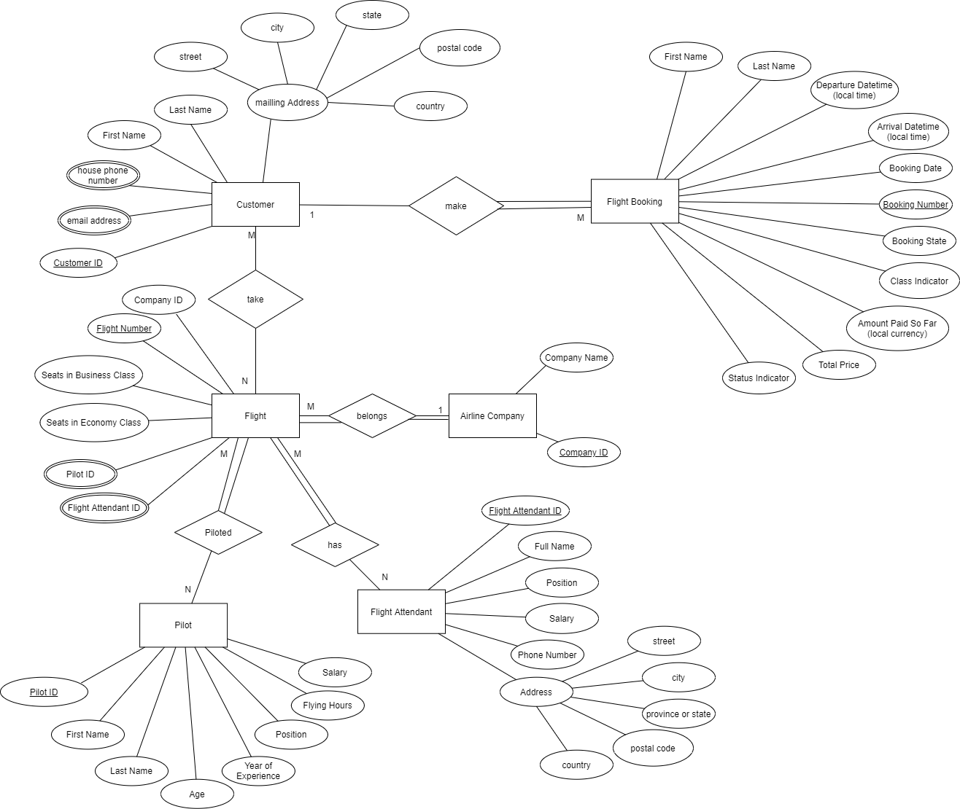

# Database Schema

## Relational schema of ERD

flight booking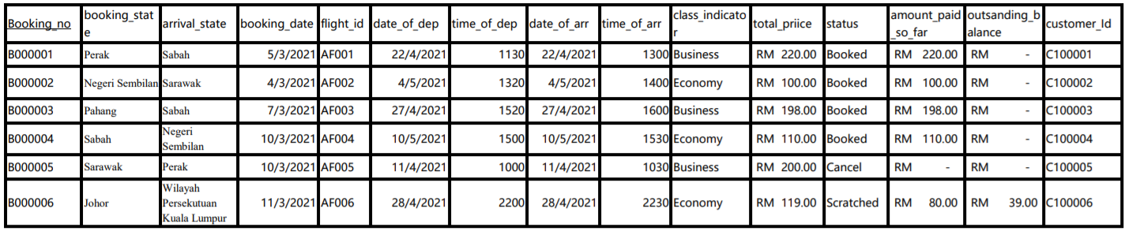

airline company

|  |  |
| --- | --- |
| Company Id | Company Name |
| EA1709 | Echo Airline |
| SA1865 | Spark Airways |
| PA2098 | Peak Airways |
| CA8760 | Core Airways |

Pilot table

|  |  |  |  |  |  |  |  |
| --- | --- | --- | --- | --- | --- | --- | --- |
| Pilot id | First name | Last name | age | Year of experience | position | Flying hours | salary |
| PL001 | Muhammad Alif | Bin Abdullah | 25 | 1 | Co-captain | 1000 | 2000.00 |
| PL002 | Dylan | Mathew | 30 | 5 | Captain | 20100 | 5800.00 |
| PL003 | Ramesh | A/L Shri Raam | 28 | 4 | Co-captain | 4500 | 4500.00 |
| PL004 | Philip Kah Ming | Lee | 40 | 14 | Captain | 30000 | 10000.00 |
| PL005 | Leong | Timoty | 26 | 2 | 1500 | 1500 | 2500.00 |
| PL006 | Mikael | Tinnason | 29 | 5 | 20500 | 20500 | 6000.00 |
| PL007 | Ng | Mi Qing | 23 | 1 | 800 | 800 | 2000.00 |
| PL008 | Keter | Sam | 30 | 7 | 30000 | 30000 | 6200.00 |
| PL009 | Zarad | Liew | 24 | 2 | 1900 | 1900 | 2100.00 |
| PL010 | Ong | brenda | 45 | 20 | 40000 | 40000 | 10000.00 |

|  |  |  |  |  |  |  |  |  |  |
| --- | --- | --- | --- | --- | --- | --- | --- | --- | --- |
| Flight attendant id | Full name | position | Phone no | salary | street | city | Province or state | Postal code | country |
| FA008 | James Lee | Purser | 172234567 | 3000.00 | 15 Jln 17/108 Salak South Site And Service | Kuala Lumpur | Wilayah Persekutuan | 56100 | Malaysia |
| FA009 | Hor Alan | Purser | 012-3332819 | 3200.00 | Kg Dock,6214,Jln Pengkalan,Bukit Tengah | Bukit Mertajam | Penang | 14000 | Malaysia |
| FA010 | Alis Helt | Chief Purser | 323-12-4322 | 3400.00 | 1,Jln Teluk Piah Kanan | Kuala Selangor | Selangor | 45000 | Malaysia |
| FA011 | Proman Shaw | Cabin Crew | 022-1238131 | 2400.00 | 1 Bandung Ujung,Lubuk Linggau | Kota Lubuklinggu | Sumatera Selatan | 31614 | Indonesia |
| FA012 | Zam Bras | Cabin Crew | 9814-1231 | 2800.00 | 1500,YECC,Tayuman St,353 | Metro | Manila | 1014 | Philippines |
| FA013 | Kul Naman | Purser | 2937123111 | 3100.00 | No 43 Bo Aung Gyaw Street | Yangon | Yangon | 11181 | Myanmar |
| FA023 | Ali Bin Mansur | Chief Purser | 0-21-845-0226 | 3500.00 | Jl Kp Sawah 44, Dki Jakarta | Dki Jakarta | Jakarta | 17422 | Indonesia |
| FA024 | Thilak A/L Ramalingam | Purser | 6052535930 | 3000.00 | 15 Jln 17/108 Salak South Site And Service | Kuala Lumpur | Wilayah Persekutuan | 32000 | Malaysia |
| FA035 | Jamie Seah | Cabin Crew | 32141-7414 | 2700.00 | Lorong Sungai Lokan 3/3, Southtech Industrial Park, Butterworth | Pulau Penang | Penang | 42000 | Malaysia |
| FA088 | Kunlavut Phrompan | Cabin Crew | 662 6121124 | 2800.00 | 69/13 Soi Athens Theater Phythai Road | Bangkok | Bangkok | 10400 | Thailand |

Flight attendant table

Flight table

|  |  |  |  |
| --- | --- | --- | --- |
| Flight id | No business seats | No economy seats | Company id |
| AF001 | 280 | 100 | EA1709 |
| AF002 | 300 | 140 | SA1865 |
| AF003 | 400 | 200 | PA2098 |
| AF004 | 350 | 170 | CA8760 |
| AF005 | 290 | 110 | SA1865 |
| AF006 | 300 | 210 | EA1709 |
| AF007 | 280 | 100 | EA1709 |
| AF008 | 300 | 140 | SA1865 |
| AF009 | 400 | 200 | PA2098 |
| AF010 | 350 | 170 | CA8760 |

Customer table

|  |  |  |  |  |
| --- | --- | --- | --- | --- |
| Customer_id | first_name | last_name | house_phone_no | email_address |
| C100001 | Kai Dong | Ng | 03-32847268 | kdng@gmail.com |
| C100002 | Yoke Shin | Sim | 03-23482736 | simyk@yahoo.com |
| C100003 | Muhammad Shah | Bin Allahin | 03-48492834 | muhammadsb@gmail.com |
| C100004 | Lamri See | Brian | 03-56713296 | brianls@gmail.com |
| C100005 | Bon | James | 03-55129463 | jamesbon@yahoo.com |
| C100006 | Jia Xin | Yap | 03-23113219 | payjx@gmail.com |
| C100007 | bin Muhamad | Adam | 03-22448890 | AdambM@gmail.com |
| C100008 | David | Leong | 03-55992444 | Leongd@yahoo.com |
| C100009 | Poh Keng | Sim | 03-56422992 | SimPk@gmail.com |
| C100010 | Berhad | Kim | 03-10047829 | Kimberhad@gmail.com |
| C100011 | Wikiam | Sim | 03-22200044 | SimW@yahoo.com |
| C100012 | Lee Hod | Tan | 03-48222005 | TanLH@gmail.com |
| C100013 | Shqo Wei | Chong | 03-99973822 | ChongSw@gmail.com |

***continue Customer table***

|  |  |  |  |  |
| --- | --- | --- | --- | --- |
| Street | city | province_or_state | postal_code | country |
| 8 Kompleks Jln Sultan | Kuala Lumpur | Wilayah Persekutuan | 50000 | Malaysia |
| No. 36 A Jln Ss2/10 Ss2 | Petaling Jaya | Selangor | 47300 | Malaysia |
| 1 17 Jln Sulaiman | Kajang | Selangor | 43000 | Malaysia |
| No. 1 Jalan Ronggeng 5 Taman Skudai Baru | Johor Bahru | Johor | 81300 | Malaysia |
| 21St Floor Ambank Group Jln Raja Chulan | Kuala Lumpur | Wilayah Persekutuan | 50200 | Malaysia |
| 17 Jln Hilltop 5 | Miri | Sarawak | 98000 | Malaysia |
| 56 Palm Residence,Jln Ensing Timur,Tmn Stapok | Kucing | Sarawak | 932500 | Malaysia |
| H01 Along Jln Diwarta, Bintulu City Centre | Bintulu | Sarawak | 97000 | Malaysia |
| 107,Jln Green | Kucing | Sarawak | 931500 | Malaysia |
| 7V4P Tmn Guan Soon | Tawau | Sabah | 91000 | Malaysia |
| 23,Jln Bakawali 42,Johor Jaya | Johor Bahru | Johor | 81100 | Malaysia |
| 4,Jln Pandan Damai 2/31,Tmn Pandan Damai | Kuantan | Pahang | 25150 | Malaysia |
| 1,Tanah Merah | Tanah Merah | Kelantan | 17500 | Malaysia |

### UNF

|  |  |  |  |  |  |  |  |  |  |
| --- | --- | --- | --- | --- | --- | --- | --- | --- | --- |
| Customer_id | first_name | last_name | house_phone_no | email_address | Street | city | province_or_state | postal_code | country |
| C100001 | Kai Dong | Ng | 03-32847268 | kdng@gmail.com | 8 Kompleks Jln Sultan | Kuala Lumpur | Wilayah Persekutuan | 50000 | Malaysia |
| C100001 | Kai Dong | Ng | 03-32847268 | kaidong01@gmail.com | 8 Kompleks Jln Sultan | Kuala Lumpur | Wilayah Persekutuan | 50000 | Malaysia |
| C100002 | Yoke Shin | Sim | 03-29876545 | simyk@yahoo.com | 1 17 Jln Sulaiman | Kajang | Selangor | 43000 | Malaysia |
| C100002 | Yoke Shin | Sim | 03-23482736 | simyk@yahoo.com | 1 17 Jln Sulaiman | Kajang | Selangor | 43000 | Malaysia |

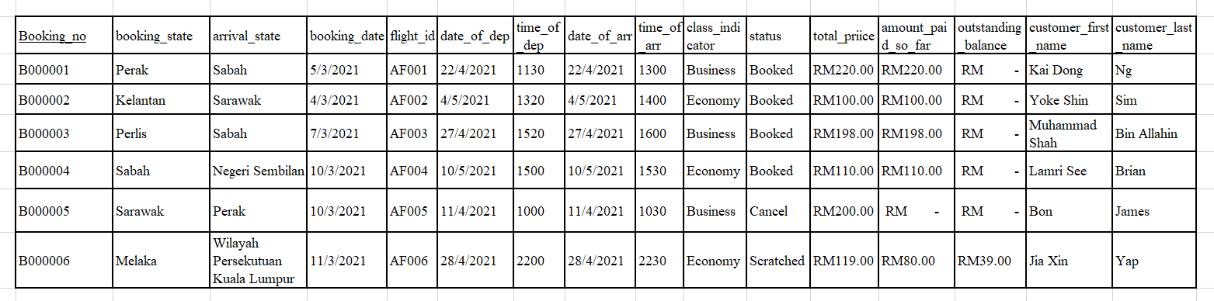

|  |  |  |  |  |  |
| --- | --- | --- | --- | --- | --- |
| Flight id | No business seats | No economy seats | Company id | Pilot id | Flight attendant id |
| AF001 | 280 | 100 | EA1709 | PL001 | FA008 |
| AF001 | 280 | 100 | EA1709 | PL001 | FA024 |
| AF001 | 280 | 100 | EA1709 | PL001 | FA023 |
| AF001 | 280 | 100 | EA1709 | PL002 | FA008 |
| AF001 | 280 | 100 | EA1709 | PL002 | FA024 |
| AF001 | 280 | 100 | EA1709 | PL002 | FA023 |
| AF002 | 300 | 140 | SA1865 | PL003 | FA023 |
| AF002 | 300 | 140 | SA1865 | PL003 | FA088 |
| AF002 | 300 | 140 | SA1865 | PL003 | FA035 |
| AF002 | 300 | 140 | SA1865 | PL004 | FA023 |
| AF002 | 300 | 140 | SA1865 | PL004 | FA088 |
| AF002 | 300 | 140 | SA1865 | PL004 | FA035 |

|  |  |  |  |  |  |  |  |
| --- | --- | --- | --- | --- | --- | --- | --- |
| Pilot id | First name | Last name | age | Year of experience | position | Flying hours | salary |
| PL001 | Muhammad Alif | Bin Abdullah | 25 | 1 | Co-captain | 1000 | 2000 |
| PL002 | Dylan | Mathew | 30 | 5 | Captain | 6000 | 5800 |
| PL003 | Ramesh | A/L Shri Raam | 28 | 4 | Co-captain | 4500 | 4500 |
| PL004 | Philip Kah Ming | Lee | 40 | 14 | Captain | 30000 | 10000 |

|  |  |  |  |  |  |  |  |  |  |
| --- | --- | --- | --- | --- | --- | --- | --- | --- | --- |
| Flight attendant id | Full name | position | Phone no | salary | street | city | Province or state | Postal code | country |
| FA008 | James Lee | Purser | 172234567 | 3000.00 | 15 Jln 17/108 Salak South Site And Service | Kuala Lumpur | Wilayah Persekutuan | 56100 | Malaysia |
| FA009 | Hor Alan | Purser | 012-3332819 | 3200.00 | Kg Dock,6214,Jln Pengkalan,Bukit Tengah | Bukit Mertajam | Penang | 14000 | Malaysia |
| FA010 | Alis Helt | Chief Purser | 323-12-4322 | 3400.00 | 1,Jln Teluk Piah Kanan | Kuala Selangor | Selangor | 45000 | Malaysia |
| FA011 | Proman Shaw | Cabin Crew | 022-1238131 | 2400.00 | 1 Bandung Ujung,Lubuk Linggau | Kota Lubuklinggu | Sumatera Selatan | 31614 | Indonesia |
| FA012 | Zam Bras | Cabin Crew | 9814-1231 | 2800.00 | 1500,YECC,Tayuman St,353 | Metro | Manila | 1014 | Philippines |
| FA013 | Kul Naman | Purser | 2937123111 | 3100.00 | No 43 Bo Aung Gyaw Street | Yangon | Yangon | 11181 | Myanmar |
| FA023 | Ali Bin Mansur | Chief Purser | 0-21-845-0226 | 3500.00 | Jl Kp Sawah 44, Dki Jakarta | Dki Jakarta | Jakarta | 17422 | Indonesia |
| FA024 | Thilak A/L Ramalingam | Purser | 6052535930 | 3000.00 | 15 Jln 17/108 Salak South Site And Service | Kuala Lumpur | Wilayah Persekutuan | 32000 | Malaysia |
| FA035 | Jamie Seah | Cabin Crew | 32141-7414 | 2700.00 | Lorong Sungai Lokan 3/3, Southtech Industrial Park, Butterworth | Pulau Penang | Penang | 42000 | Malaysia |
| FA088 | Kunlavut Phrompan | Cabin Crew | 662 6121124 | 2800.00 | 69/13 Soi Athens Theater Phythai Road | Bangkok | Bangkok | 10400 | Thailand |

## Normalize relations

### 1NF

No repeating elements or group of elements

Customer

|  |  |  |  |
| --- | --- | --- | --- |
| Customer_id | first_name | last_name | Address id |
| C100001 | Kai Dong | Ng | CA000001 |
| C100002 | Yoke Shin | Sim | CA000002 |
| C100003 | Muhammad Shah | Bin Allahin | CA000003 |
| C100004 | Lamri See | Brian | CA000004 |
| C100005 | Bon | James | CA000005 |
| C100006 | Jia Xin | Yap | CA000006 |
| C100007 | bin Muhamad | Adam | CA000007 |
| C100008 | David | Leong | CA000008 |
| C100009 | Poh Keng | Sim | CA000009 |
| C100010 | Berhad | Kim | CA000010 |
| C100011 | Wikiam | Sim | CA000011 |
| C100012 | Lee Hod | Tan | CA000012 |
| C100013 | Shqo Wei | Chong | CA000013 |

The customer table was normalized in 1NF by creating new tables to store customer’s multiple emails and house phone number in Customer_email table and Customer_hpno table. The address details of the customer were also store in a new table, Customer_Address table and is referred with the address_id as foreign key.

Customer_email

|  |  |
| --- | --- |
| Email (PK) | Customer_id |
| kdng@gmail.com | CE100001 |
| kaidong01@gmail.com | CE100001 |
| simyk@yahoo.com | CE100002 |
| simyk@yahoo.com | CE100002 |
| muhammadsb@gmail.com | CE100003 |
| brianls@gmail.com | CE100004 |
| jamesbon@yahoo.com | CE100005 |
| payjx@gmail.com | CE100006 |
| AdambM@gmail.com | CE100007 |
| Leongd@yahoo.com | CE100008 |
| SimPk@gmail.com | CE100009 |
| Kimberhad@gmail.com | CE100010 |
| SimW@yahoo.com | CE100011 |
| TanLH@gmail.com | CE100012 |
| ChongSw@gmail.com | CE100013 |

Customer_hpno

|  |  |
| --- | --- |
| house_phone_no (PK) | Customer_id |
| 03-10047829 | C100010 |
| 03-22200044 | C100011 |
| 03-22448890 | C100007 |
| 03-23113219 | C100006 |
| 03-23482736 | C100002 |
| 03-32847268 | C100002 |
| 03-48222005 | C100012 |
| 03-48492834 | C100003 |
| 03-55129463 | C100005 |
| 03-55992444 | C100008 |
| 03-56422992 | C100009 |
| 03-56713296 | C100004 |
| 03-99973822 | C100013 |

Customer address table

|  |  |  |  |  |  |
| --- | --- | --- | --- | --- | --- |
| Mailing_address_id (PK) | Street | city | province_or_state | postal_code | country |
| CA000001 | 8 Kompleks Jln Sultan | Kuala Lumpur | Wilayah Persekutuan | 50000 | Malaysia |
| CA000002 | No. 36 A Jln Ss2/10 Ss2 | Petaling Jaya | Selangor | 47300 | Malaysia |
| CA000003 | 1 17 Jln Sulaiman | Kajang | Selangor | 43000 | Malaysia |
| CA000004 | No. 1 Jalan Ronggeng 5 Taman Skudai Baru | Johor Bahru | Johor | 81300 | Malaysia |
| CA000005 | 21St Floor Ambank Group Jln Raja Chulan | Kuala Lumpur | Wilayah Persekutuan | 50200 | Malaysia |
| CA000006 | 17 Jln Hilltop 5 | Miri | Sarawak | 98000 | Malaysia |
| CA000007 | 56 Palm Residence,Jln Ensing Timur,Tmn Stapok | Kucing | Sarawak | 932500 | Malaysia |
| CA000008 | H01 Along Jln Diwarta, Bintulu City Centre | Bintulu | Sarawak | 97000 | Malaysia |
| CA000009 | 107,Jln Green | Kucing | Sarawak | 931500 | Malaysia |
| CA000010 | 7V4P Tmn Guan Soon | Tawau | Sabah | 91000 | Malaysia |
| CA000011 | 23,Jln Bakawali 42,Johor Jaya | Johor Bahru | Johor | 81100 | Malaysia |
| CA000012 | 4,Jln Pandan Damai 2/31,Tmn Pandan Damai | Kuantan | Pahang | 25150 | Malaysia |
| CA000013 | 1,Tanah Merah | Tanah Merah | Kelantan | 17500 | Malaysia |

Flight Booking

|  |  |  |  |  |  |  |  |  |  |  |  |  |  |
| --- | --- | --- | --- | --- | --- | --- | --- | --- | --- | --- | --- | --- | --- |
| Booking_no (PK) | booking_  state | arrival_state | booking_date | flight_id | date_of_dep | time_of_dep | date_of_arr | time_of_arr | Class  _indicator | total_price | status | amount_paid_so_far | customer_Id |
| B000001 | Perak | Sabah | 5/3/2021 | AF001 | 22/4/2021 | 1130 | 22/4/2021 | 1300 | Business | RM220.00 | Booked | RM 220.00 | C100001 |
| B000002 | Negeri Sembilan | Sarawak | 4/3/2021 | AF002 | 4/5/2021 | 1320 | 4/5/2021 | 1400 | Economy | RM100.00 | Booked | RM 100.00 | C100002 |
| B000003 | Pahang | Sabah | 7/3/2021 | AF003 | 27/4/2021 | 1520 | 27/4/2021 | 1600 | Business | RM198.00 | Booked | RM 198.00 | C100003 |
| B000004 | Sabah | Negeri Sembilan | 10/3/2021 | AF004 | 10/5/2021 | 1500 | 10/5/2021 | 1530 | Economy | RM110.00 | Booked | RM 110.00 | C100004 |
| B000005 | Sarawak | Perak | 10/3/2021 | AF005 | 11/4/2021 | 1000 | 11/4/2021 | 1030 | Business | RM200.00 | Cancel | RM - | C100005 |
| B000006 | Sabah | Wilayah Persekutuan Kuala Lumpur | 11/3/2021 | AF006 | 28/4/2021 | 2200 | 28/4/2021 | 2230 | Economy | RM119.00 | Scratched | RM 80.00 | C100006 |
| B000007 | Sarawak | Perak | 2021/03/11 | AF007 | 2021/04/08 | 1200 | 2021/04/08 | 1230 | Economy | RM110.00 | Booked | RM 80.00 | C100007 |
| B000008 | Sabah | Pahang | 2021/03/05 | AF008 | 2021/04/01 | 1700 | 2021/04/01 | 1730 | Business | RM 210.00 | Booked | RM 50.00 | C100008 |
| B000009 | Negeri Sembilan | Sabah | 2021/03/08 | AF009 | 2021/03/28 | 2000 | 2021/03/28 | 2045 | Economy | RM 110.00 | Booked | RM 70.00 | C100009 |
| B000010 | Wilayah Persekutuan Kuala Lumpur | Sabah | 2021/03/02 | AF010 | 2021/05/28 | 2200 | 2021/05/28 | 2230 | Business | RM 200.00 | Cancel | RM 0.00 | C100010 |

The Flight_booking table is normalized in 1NF by using customer ID as foreign key to reference first name and last name of customer from customer table. The outstanding amount column was removed because can be calculated by minus total price with amount paid so far.

Flight

|  |  |  |  |
| --- | --- | --- | --- |
| Flight id (PK) | No business seats | No economy seats | Company id |
| AF001 | 280 | 100 | EA1709 |
| AF002 | 300 | 140 | SA1865 |
| AF003 | 400 | 200 | PA2098 |
| AF004 | 350 | 170 | CA8760 |
| AF005 | 290 | 110 | SA1865 |
| AF006 | 300 | 210 | EA1709 |
| AF007 | 280 | 100 | EA1709 |
| AF008 | 300 | 140 | SA1865 |
| AF009 | 400 | 200 | PA2098 |
| AF010 | 350 | 170 | CA8760 |

The Flight table is normalized in 1NF by using company ID as foreign key to get company name. The pilot ID and flight attendants ID are also removed by creating a composite table to link them together.

Airline company

|  |  |
| --- | --- |
| Company Id (PK) | Company Name |
| EA1709 | Echo Airline |
| SA1865 | Spark Airways |
| PA2098 | Peak Airways |
| CA8760 | Core Airways |

Flight_FA composite table

|  |  |  |
| --- | --- | --- |
| Flight id (FK) | Flight Attendant id (FK) | position |
| AF001 | FA088 | Cabin Crew |
| AF001 | FA023 | Chief Purser |
| AF001 | FA012 | Purser |
| AF002 | FA012 | Cabin Crew |
| AF002 | FA013 | Purser |
| AF002 | FA023 | Chief Purser |
| AF003 | FA035 | Cabin Crew |
| AF003 | FA023 | Chief Purser |
| AF003 | FA088 | Purser |
| AF004 | FA088 | Cabin Crew |
| AF004 | FA023 | Chief Purser |
| AF004 | FA008 | Purser |
| AF005 | FA011 | Cabin Crew |
| AF005 | FA024 | Purser |
| AF006 | FA012 | Cabin Crew |
| AF006 | FA023 | Chief Purser |

Flight and flight attendant have a many to many relationship (M:N) where a flight has many flight attendants and on the other hand, a flight attendant can board many flights. M:N relationships are not implemented in relational database as they would lead to redundancies. Instead, entities with M:N relationships are stored in relational database by creating a composite entity with 1:M relationships to link with the two other entities. The Flight_FA composite table has a composite key (flight_id, flight_attendant_id) as primary key which are also foreign keys from Flight table and Flight_Attendants table.

To satisfy the requirement where a maximum of three flight attendants are in one flight, a unique key constraint (flight_id, position) was used. We assumed that a flight would have flight attendants with three different position (chief purser, purser, cabin crew) thus the unique key is applicable.

Flight_Pilots composite table

|  |  |  |
| --- | --- | --- |
| flight_id (FK) | pilot_id (FK) | position |
| AF001 | PL002 | Captain |
| AF001 | PL001 | Co-captain |
| AF002 | PL004 | Captain |
| AF002 | PL003 | Co-captain |
| AF003 | PL006 | Captain |
| AF003 | PL005 | Co-captain |
| AF004 | PL004 | Captain |
| AF004 | PL001 | Co-captain |
| AF005 | PL002 | Captain |
| AF005 | PL003 | Co-captain |
| AF006 | PL002 | Captain |
| AF006 | PL003 | Co-captain |

Flight and pilot also have a many to many relationship (M:N) where a flight has two pilots and a pilot can fly many flights. To implement the M:N relationship in relational database, a composite entity was created to link with the two other entities with 1:M relationships. Similarly to Flight_FA table, the Flight_pilot composite table has a composite key (flight_id, pilot_id) as primary key which are also foreign keys from Flight table and pilot table.

To satisfy the business rule where a flight has one captain pilot and one co-captain pilot, a unique key constraint (flight_id, position) was used. By doing so, every flight_id will only have one captain and one co-captain.

Pilot

|  |  |  |  |  |  |  |
| --- | --- | --- | --- | --- | --- | --- |
| Pilot id (PK) | First name | Last name | age | Year of experience | Flying hours | salary |
| PL001 | Muhammad Alif | Bin Abdullah | 25 | 1 | 1000 | 2000 |
| PL002 | Dylan | Mathew | 30 | 5 | 6000 | 5800 |
| PL003 | Ramesh | A/L Shri Raam | 28 | 4 | 4500 | 4500 |
| PL004 | Philip Kah Ming | Lee | 40 | 14 | 30000 | 10000 |
| PL005 | Leong | Timoty | 26 | 2 | 1500 | 2500.00 |
| PL006 | Mikael | Tinnason | 29 | 5 | 20500 | 6000.00 |
| PL007 | Ng | Mi Qing | 23 | 1 | 800 | 2000.00 |
| PL008 | Keter | Sam | 30 | 7 | 30000 | 6200.00 |
| PL009 | Zarad | Liew | 24 | 2 | 1900 | 2100.00 |
| PL010 | Ong | brenda | 45 | 20 | 40000 | 10000.00 |

|  |  |  |  |  |  |
| --- | --- | --- | --- | --- | --- |
| Flight attendant id (PK) | Full name | position | Phone no | salary | Flight Attendant Address id |
| FA008 | James Lee | Purser | 172234567 | 3000.00 | FAA008 |
| FA009 | Hor Alan | Purser | 012-3332819 | 3200.00 | FAA009 |
| FA010 | Alis Helt | Chief Purser | 323-12-4322 | 3400.00 | FAA010 |
| FA011 | Proman Shaw | Cabin Crew | 022-1238131 | 2400.00 | FAA011 |
| FA012 | Zam Bras | Cabin Crew | 9814-1231 | 2800.00 | FAA012 |
| FA013 | Kul Naman | Purser | 2937123111 | 3100.00 | FAA013 |
| FA023 | Ali Bin Mansur | Chief Purser | 0-21-845-0226 | 3500.00 | FAA023 |
| FA024 | Thilak A/L Ramalingam | Purser | 6052535930 | 3000.00 | FAA024 |
| FA035 | Jamie Seah | Cabin Crew | 32141-7414 | 2700.00 | FAA035 |
| FA088 | Kunlavut Phrompan | Cabin Crew | 662 6121124 | 2800.00 | FAA088 |

Flight attendant

The flight attendant table is normalized by creating a new Flight Attendant_Address table to store the address details.

Flight_Attendant_Address

|  |  |  |  |  |  |
| --- | --- | --- | --- | --- | --- |
| Flight Attendant Address id (PK) | street | city | Province or state | Postal code | country |
| FAA008 | 15 Jln 17/108 Salak South Site And Service | Kuala Lumpur | Wilayah Persekutuan | 56100 | Malaysia |
| FAA009 | Kg Dock,6214,Jln Pengkalan,Bukit Tengah | Bukit Mertajam | Penang | 14000 | Malaysia |
| FAA010 | 1,Jln Teluk Piah Kanan | Kuala Selangor | Selangor | 45000 | Malaysia |
| FAA011 | 1 Bandung Ujung,Lubuk Linggau | Kota Lubuklinggu | Sumatera Selatan | 31614 | Indonesia |
| FAA012 | 1500,YECC,Tayuman St,353 | Metro | Manila | 1014 | Philippines |
| FAA013 | No 43 Bo Aung Gyaw Street | Yangon | Yangon | 11181 | Myanmar |
| FAA023 | Jl Kp Sawah 44, Dki Jakarta | Dki Jakarta | Jakarta | 17422 | Indonesia |
| FAA024 | 15 Jln 17/108 Salak South Site And Service | Kuala Lumpur | Wilayah Persekutuan | 32000 | Malaysia |
| FAA035 | Lorong Sungai Lokan 3/3, Southtech Industrial Park, Butterworth | Pulau Penang | Penang | 42000 | Malaysia |
| FAA088 | 69/13 Soi Athens Theater Phythai Road | Bangkok | Bangkok | 10400 | Thailand |

### 2NF

The condition of 2NF is there is no partial dependencies on a concatenated key.

In Flight_FA table where there is concatenated key, there is no partial dependencies on the key as each column in this composite table is part of a primary key or unique key.

The similar condition was applied to the Flight_Pilots table.

All other table only has one primary key and do not have a concatenated key so 2NF is not applicable.

### 3NF

The conditions for the third normal form (3NF) are:

• It is in 2NF

• Contains no transitive dependencies

There are no transitive dependencies between the attributes in each of the tables so the 2NF table meets the 3NF conditions.

## Data Dictionary

Customer

|  |  |  |  |  |
| --- | --- | --- | --- | --- |
| Columns | Data type | Constraint | Example | Explanation |
| customer_id | varchar(30) | NOT NULL, PK | C100001 | A unique ID for every customer. The primary key for customer table. |
| first_name | nvarchar(50) | NOT NULL | Kai Dong | First name of customer. |
| last_name | nvarchar(50) | NOT NULL | Ng | Last name of customer. |
| mailing_address_id | nvarchar(20) | NOT NULL, FK | CA000001 | A unique ID for every address. A foreign key from customer_address table. |

Customer_email

|  |  |  |  |  |
| --- | --- | --- | --- | --- |
| Columns | Data type | Constraint | Example | Explanation |
| email | nvarchar(100) | NOT NULL, PK | kdng@gmail.com | E-mail address of customer. Primary key for Customer_email table. |
| customer_id | varchar(30) | NOT NULL, FK | C100001 | A unique ID for every customer. A foreign key from customer table. |

Customer_hpno

|  |  |  |  |  |
| --- | --- | --- | --- | --- |
| Columns | Data type | Constraint | Example | Explanation |
| house_phone_no | varchar(20) | NOT NULL, PK | 03-32847268 | House phone number of customer. Primary key for Customer_hpno  table. |
| customer_id | varchar(30) | NOT NULL, FK | C100001 | A unique ID for every customer. A foreign key from customer table. |

Customer_address

|  |  |  |  |  |
| --- | --- | --- | --- | --- |
| Columns | Data type | Constraint | Example | Explanation |
| mailing_address_id | nvarchar(20) | NOT NULL, PK | CA000001 | A unique ID for every address. The primary key for the customer_address table. |
| street | varchar(50) | NOT NULL | 8 Kompleks Jln Sultan | Street of the address. |
| city | varchar(50) | NOT NULL | Kuala Lumpur | City of the address. |
| province_or_state | varchar(50) | NOT NULL | Wilayah Persekutuan | Province or state of the address. |
| postal_code | varchar(20) | NOT NULL | 50000 | Postal code of the address. |
| country | varchar(50) | NOT NULL | Malaysia | Country of the address. |

Flight­_booking

|  |  |  |  |  |
| --- | --- | --- | --- | --- |
| Columns | Data type | Constraint | Example | Explanation |
| booking_no | nvarchar(20) | NOT NULL, PK | B000001 | A unique number for every flight booking. The primary key for flight_booking table. |
| booking_state | varchar(50) | NOT NULL | Perak | The state the booking was made from. |
| arrival_state | varchar(50) | NOT NULL | Pahang | The destination state. |
| booking_date | date | NOT NULL | 5/3/2021 | The date the booking was made. |
| flight_id | varchar(20) | NOT NULL, FK | AF001 | A unique ID for every flight. A foreign key from flight table. |
| date_of_dep | date | NOT NULL | 22/4/2021 | Departure date of flight in local time. |
| time_of_dep | time(7) | NOT NULL | 1130 | Departure time of flight in local time, in hours and minutes. |
| date_of_arr | date | NOT NULL | 22/4/2021 | Arrival date of flight in local time. |
| time_of_arr | time(7) | NOT NULL | 1300 | Arrival time of flight in local time, in hours and minutes. |
| class_indicator | varchar(30) | NOT NULL, CHECK “Business” or “Economy”. | Business | Class type of flight seat |
| total_price | money | NOT NULL | RM220.00 | Total price of flight. |
| status | varchar(30) | NOT NULL, CHECK “Booked”, “Canceled” or “Scratched”. | Booked | Status of the flight booking |
| amount_paid_so_far | money | NOT NULL | RM220.00 | Amount paid so far in local currency |
| customer_Id | varchar(30) | NOT NULL, FK | C100001 | A unique ID for every customer. A foreign key from customer table. |

Flight

|  |  |  |  |  |
| --- | --- | --- | --- | --- |
| Columns | Data type | Constraint | Example | Explanation |
| flight_id | varchar(20) | NOT NULL, PK | AF001 | A unique ID for every flight. The primary key for flight table. |
| no_business_seats | int | NOT NULL | 280 | Number of business class seat in the flight. |
| no_economy_seats | int | NOT NULL | 100 | Number of economy class seat in the flight. |
| company_id | varchar(20) | NOT NULL, FK | EA1709 | A unique ID for every airline company. A foreign key from airline company table. |

Airline_company

|  |  |  |  |  |
| --- | --- | --- | --- | --- |
| Columns | Data type | Constraint | Example | Explanation |
| company_id | varchar(20) | NOT NULL, PK | EA1709 | A unique ID for every airline company. The primary key for airline company table. |
| company_name | nvarchar(50) | NOT NULL | Echo Airline | Name of Airline company. |

Flight_pilot

|  |  |  |  |  |
| --- | --- | --- | --- | --- |
| Columns | Data type | Constraint | Example | Explanation |
| flight_id | varchar(20) | NOT NULL, PK, FK | AF001 | A unique ID for every flight. A foreign key from flight table. Part of the composite primary key of flight_pilot table. |
| pilot_id | varchar(20) | NOT NULL, PK, FK | PL001 | A unique ID for every pilot. A foreign key from pilot table. Part of the composite primary key of flight_pilot table. |
| position | varchar(50) | NOT NULL, check “Captain” or “Co-captain” | Co-captain | Position of pilot in the flight. |

Flight_FA

|  |  |  |  |  |
| --- | --- | --- | --- | --- |
| Columns | Data type | Constraint | Example | Explanation |
| flight_id | varchar(20) | NOT NULL, PK, FK | AF001 | A unique ID for every flight. A foreign key from flight table. Part of the composite primary key of flight_FA  table. |
| Flight_  attendant_id | varchar(20) | NOT NULL, PK, FK | FA008 | A unique ID for every flight attendant. A foreign key from flight attendant table. Part of the composite primary key of flight_FA table. |
| position | varchar(20) | NOT NULL, check “Chief Purser”, “Purser” or “Cabin Crew” | Purser | Position of flight attendant in the flight. |

Pilot

|  |  |  |  |  |
| --- | --- | --- | --- | --- |
| Columns | Data type | Constraint | Example | Explanation |
| pilot_id | varchar(20) | NOT NULL, PK | PL001 | A unique ID for every pilot. The primary key for pilot table. |
| first_name | nvarchar(50) | NOT NULL | Muhammad Alif | First name of pilot. |
| last_name | nvarchar(50) | NOT NULL | Bin Abdullah | Last name of pilot. |
| Age | int | NOT NULL | 25 | Age of pilot. |
| yo_experience | int | NOT NULL | 1 | Years of experiences of pilot. |
| flying_hours | int | NOT NULL | 1000 | Flying hours of pilot. |
| salary | money | NOT NULL | 2000 | Monthly salary of pilot. |

Flight Attendant

|  |  |  |  |  |
| --- | --- | --- | --- | --- |
| Columns | Data type | Constraint | Example | Explanation |
| Flight_attendant_id | varchar(20) | NOT NULL, PK | FA008 | A unique ID for every flight attendant. The primary key for flight attendant table. |
| full_name | nvarchar(100) | NOT NULL | James Lee | Full name of flight attendant. |
| phone_no | varchar(20) | NOT NULL | 172234567 | Phone number of flight attendant. |
| address_id | varchar(20) | NOT NULL, FK | FAA001 | A unique ID for every address. A foreign key from FA_Address table. |
| Salary | money | NOT NULL | 3000 | Salary of flight attendant. |

FA_Address

|  |  |  |  |  |
| --- | --- | --- | --- | --- |
| Columns | Data type | Constraint | Example | Explanation |
| address_id | varchar(20) | NOT NULL, PK | FAA001 | A unique ID for every address. The primary key for the FA_Address table. |
| street | varchar(200) | NOT NULL | 15 Jln 17/108 Salak South Site And Service | Street of the address. |
| city | varchar(50) | NOT NULL | Kuala Lumpur | City of the address. |
| province_or_state | varchar(50) | NOT NULL | Wilayah Persekutuan | Province or state of the address. |
| postal_code | varchar(20) | NOT NULL | 56100 | Postal code of the address. |
| country | varchar(50) | NOT NULL | Malaysia | Country of the address. |

## Database Diagram

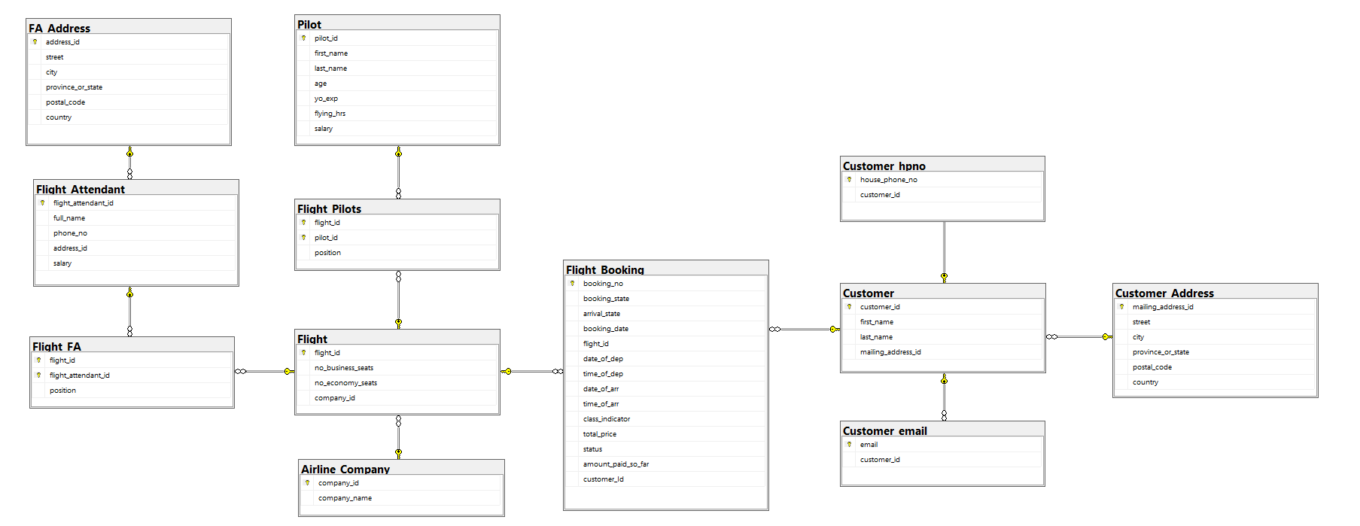

# SQL-Data Definition Language (DDL)

## Create Tables

Create airline company table

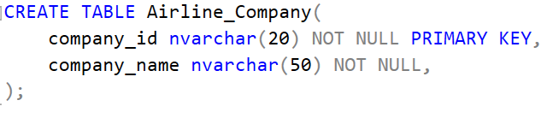

Create customer table

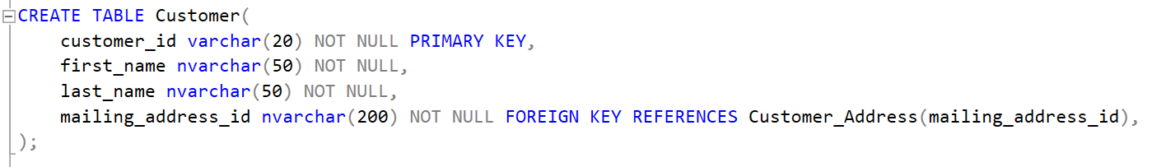

Create Customer Address table

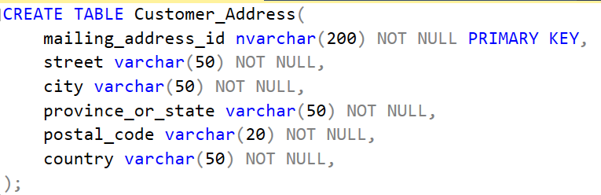

Create Customer_hpno table

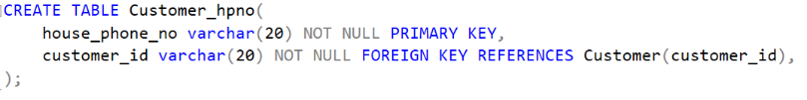

Create Customer_email table

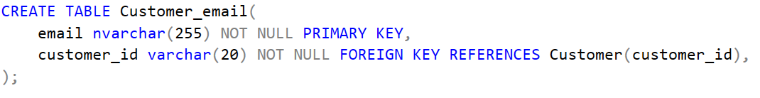

Create FA_Address Table

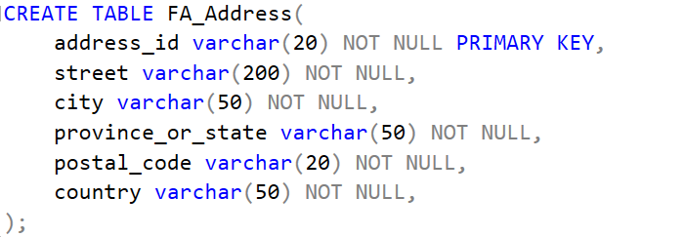

Create Flight table

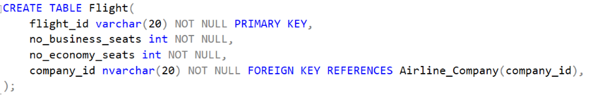

Create flight attendant table

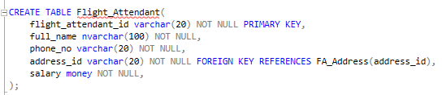

Create flight booking table

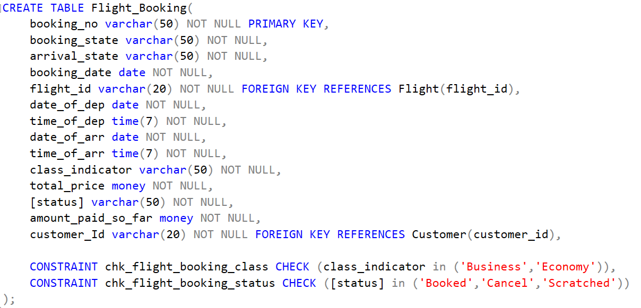

Create Flight_FA table

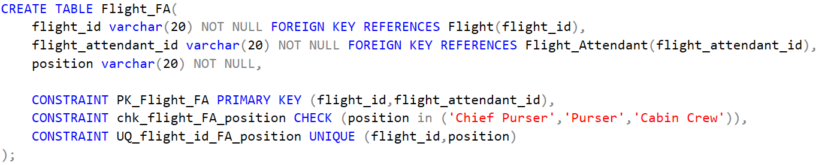

Create Flight _Pilots table

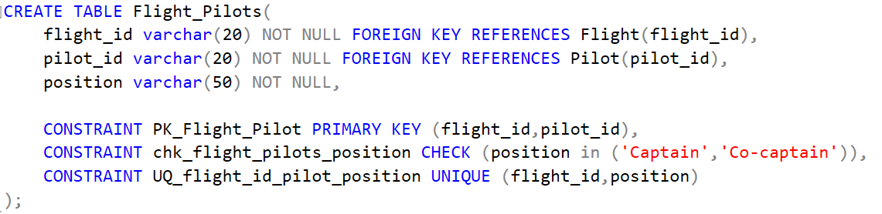

Create Pilot table

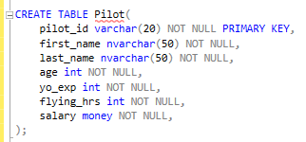

## Insert Data into Tables

Insert airline company table

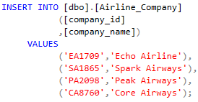

Insert customer table

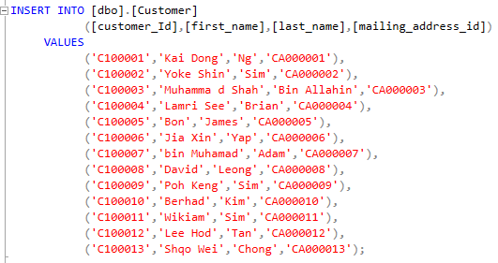

Insert Customer Address table

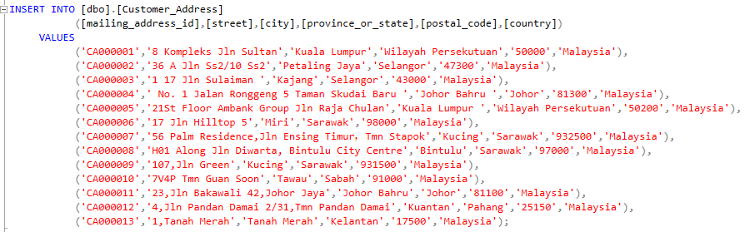

Insert Customer_hpno table

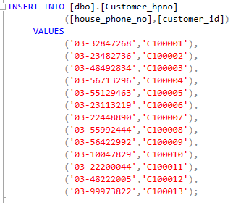

Insert Customer_email table

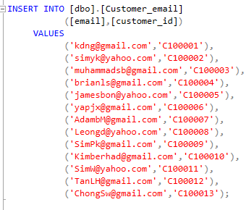

Insert FA_Address Table

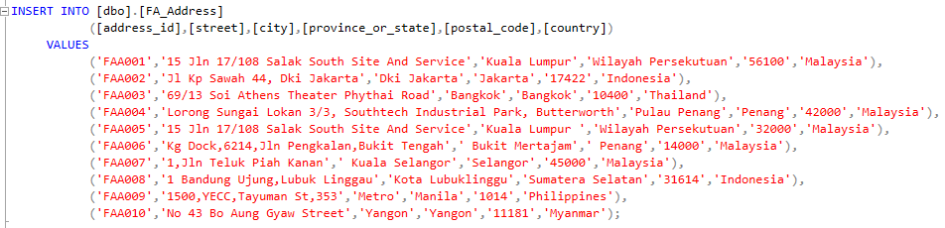

Insert Flight table

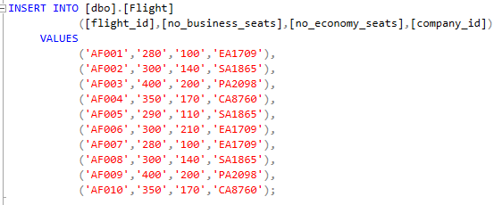

Insert flight attendant table

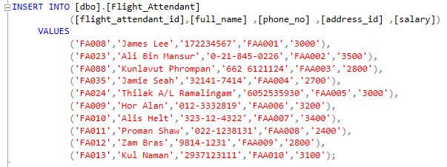

Insert flight booking table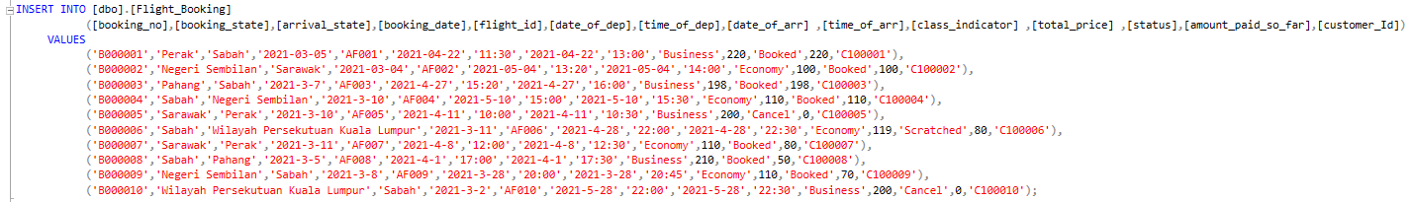

Insert Flight_FA table

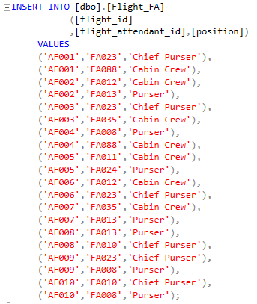

Insert Flight _Pilot table

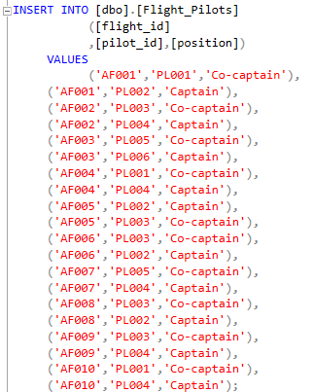

Insert Pilot table

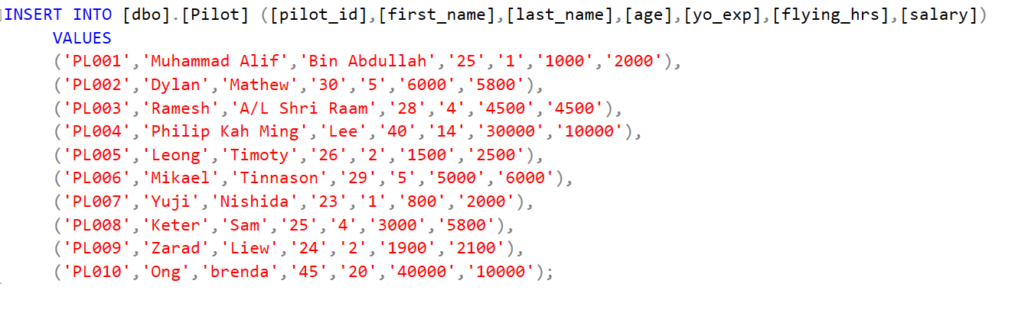

## Show Tables’ Data

Show airline company table’s data

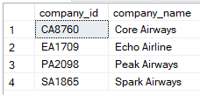

Show customer table’s data

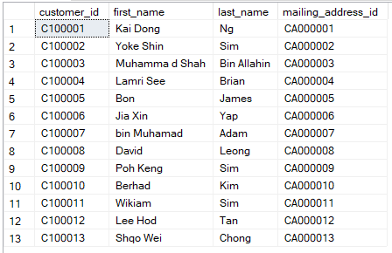

Show Customer Address table’s data

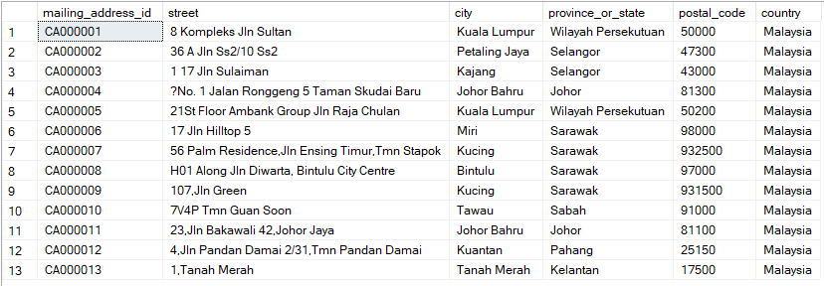

Show Customer_hpno table’s data

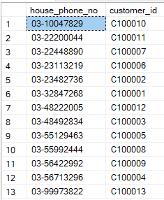

Show Customer_email table’s data

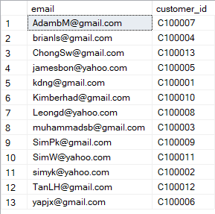

Show FA_Address Table’s data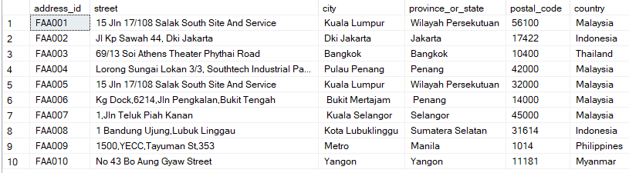

Show Flight table’s data

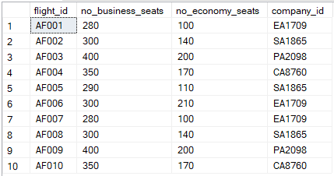

Show flight attendant table’s data

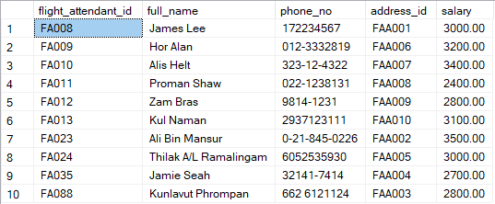

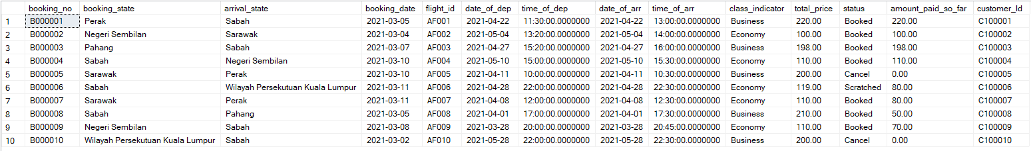Show flight booking table’s data

Show Flight_FA table’s data

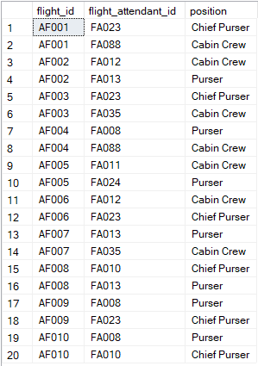

Show Flight _Pilot table’s data

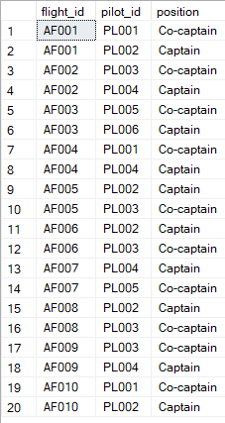

Show Pilot table’s data

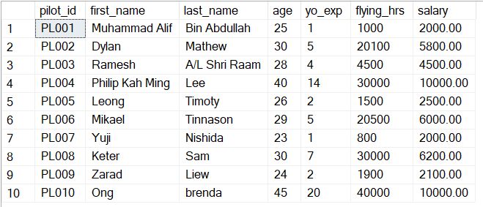

# SQL-Data Manipulation Language(DML)

## Student 1 (Sim Yoke Shin TP059851)

Question 1

List whole customer whose live in Sarawak and first name end with consonant ‘d’.

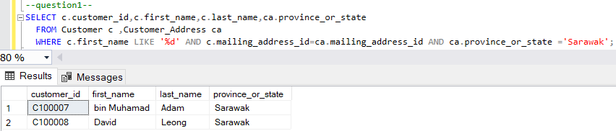

Question 2

Show the average of salary for pilots whose flying hours has more than 20,000.

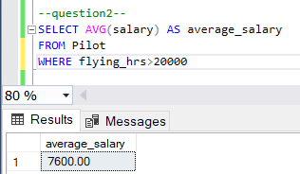

Question 3

List the pilot’s first name, last name, age, and experience who piloted for the flight for Spark Airways.

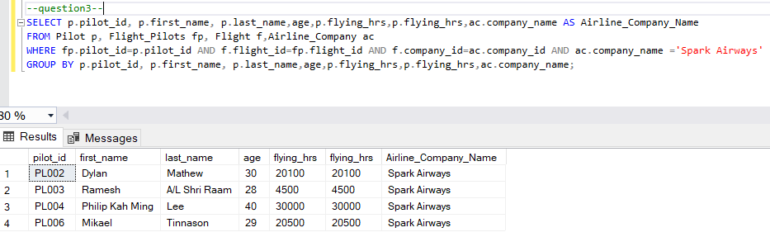

Question 4

List the booking information of booking’s date, flight number, and customer last name where the customer has not outstanding balance.

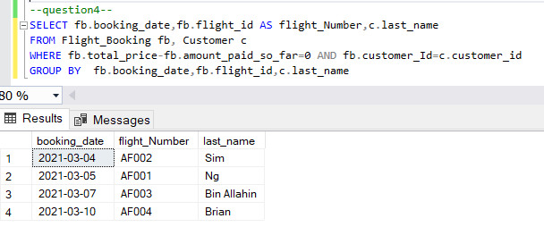

## Student 2 (Ng Kai Dong TP061557)

Question 1

List the name and the position of flight attendants whose salary is neither 2,800 nor 3,500.

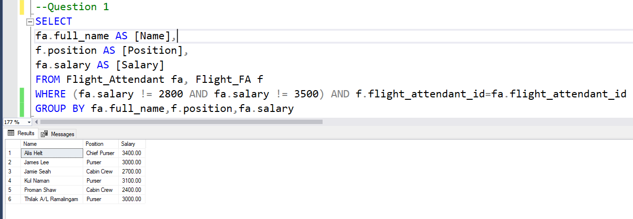

Question 2

Display customer’s first name and last name who have made bookings.

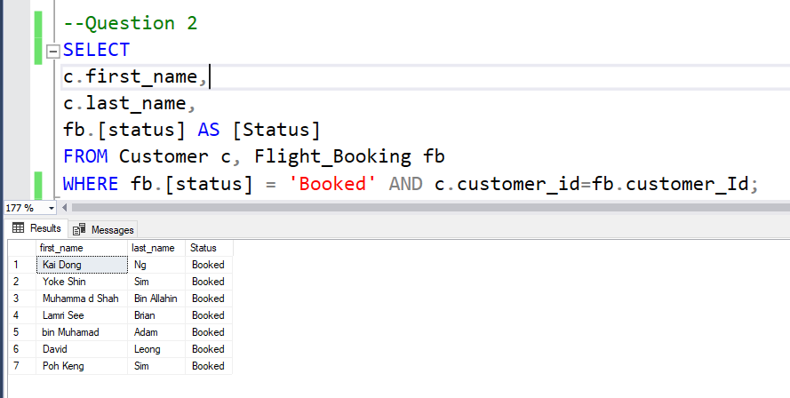

Question 3

List flight attendant’s full name and position who have worked in the same flight as a

pilot named ‘*Mikael Tinnason*’.

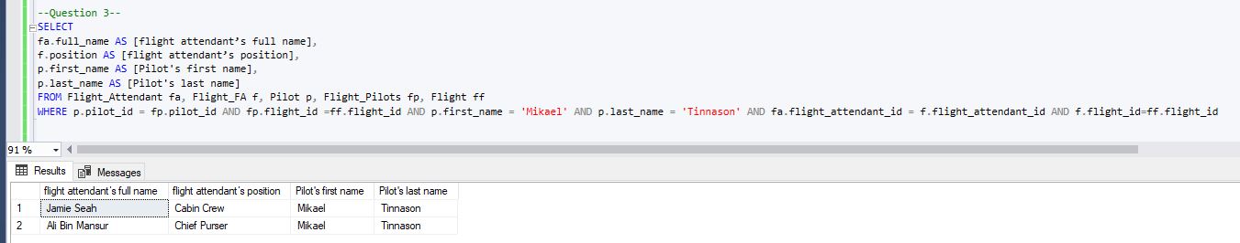

Question 4

List all customers who did not live in any of the airline offices located. Please display the customer first name, last name, and customer’s state.

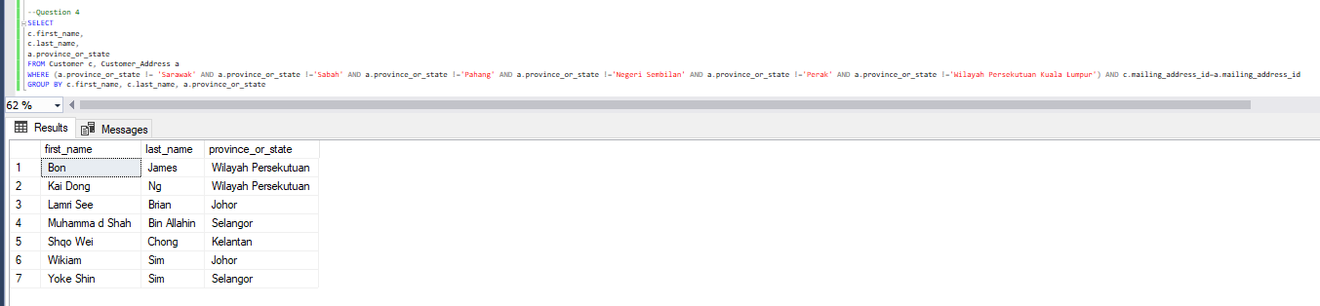

## Student 3 (Brian Lamri See TP056199)

1. Find the highest salary of flight attendants.

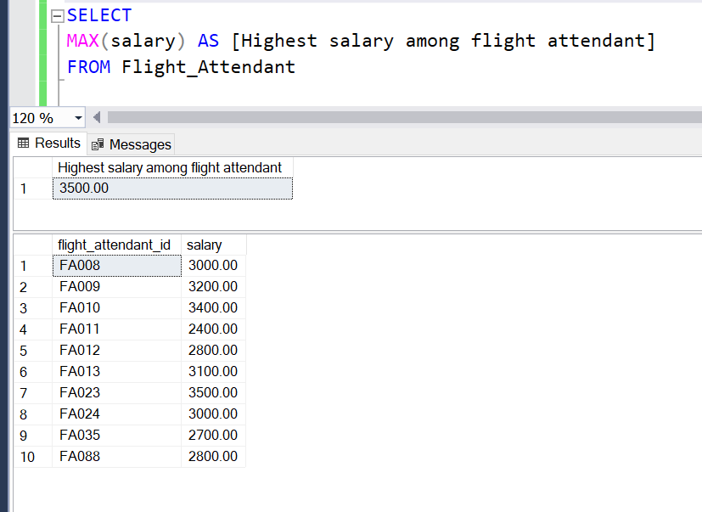

1. Display customer’s first name, flight booking number, booking date, flight airlines

name, date of departure, time of departure, and status indicator is *Canceled.*

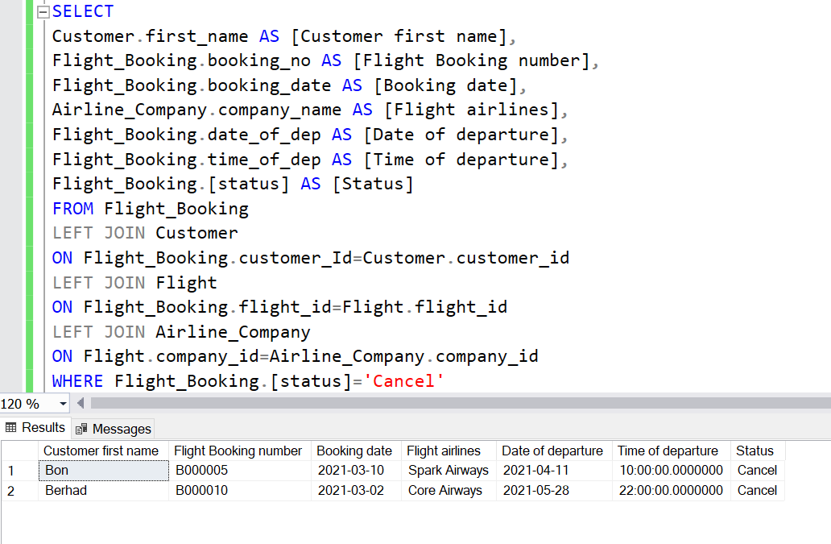

1. List all customer’s first name and last name who did not place any booking. Sort the

records by customer id in descending order.

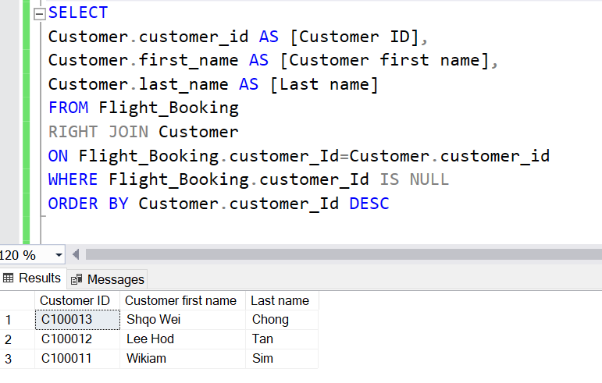

1. List all customer’s first name and last name who still have outstanding balance for their flight bookings. Sort the records based on the outstanding balance in ascending order.

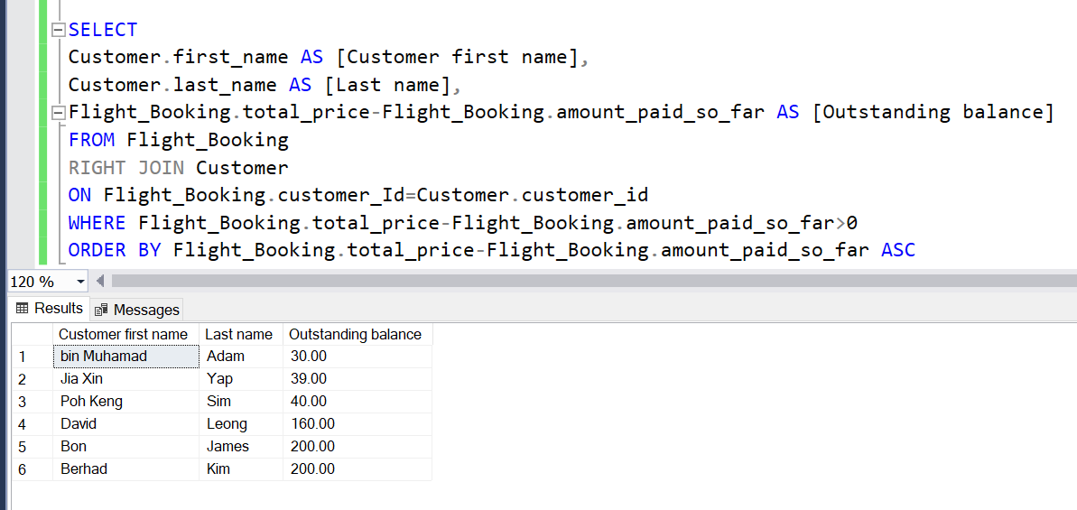

# Reference

Castro, K. (2018). *Advantages of Database Management System*. [online] Tutorialspoint.com. Available at: https://www.tutorialspoint.com/Advantages-of-Database-Management-System.

Chaitanya Singh (2015). *Advantages of DBMS over file system*. [online]. Available at: https://beginnersbook.com/2015/04/dbms-vs-file-system/ [Accessed 3 Mar. 2021].

Rahul (2019). *File Processing System - File System - Disadvantages of File Processing*. [online]. Available at: https://www.tutorialcup.com/dbms/file-processing-system.htm [Accessed 4 Mar. 2021].

# Workload Matrix

|  |  |  |  |
| --- | --- | --- | --- |
| Area | Sim Yoke Shin  TP059851 | Brian Lamri See  TP056199 | Ng Kai Dong  TP061557 |
| Database and Database Management System | 33.3% | 33.3% | 33.3% |
| Business Rules & Normalization | 33.3% | 33.3% | 33.3% |
| Entity Relationship Diagram | 33.3% | 33.3% | 33.3% |
| Database Schema | 33.3% | 33.3% | 33.3% |
| SQL-Data Definition Language (DDL) | 33.3% | 33.3% | 33.3% |
| SQL-Data Manipulation Language (DML) | 33.3% | 33.3% | 33.3% |