**# this file is the readme which can be found at**[**https://github.com/sys123-data/helm-wordpress**](https://github.com/sys123-data/helm-wordpress) **install ssh**

sudo apt update sudo apt install openssh-server

**get ip**

ip a

**generate ssh key**

ssh-keygen -t rsa -b 4096

**copy ssh key into slave**

ssh-copy-id hack@92.168.0.131

**remove from host (if error WARNING: REMOTE HOST IDENTIFICATION HAS CHANGED! then try again)**

ssh-keygen -R 192.168.0.131

**ssh into slave machine**

ssh hack@192.168.0.131

**swich to root**

sudo su -

**install jenkins**

sudo apt update

sudo apt install fontconfig openjdk-17-jre openjdk-17-jdk

java -version

sudo wget -O /usr/share/keyrings/jenkins-keyring.asc \

https://pkg.jenkins.io/debian-stable/jenkins.io-2023.key

echo "deb [signed-by=/usr/share/keyrings/jenkins-keyring.asc]" \

https://pkg.jenkins.io/debian-stable binary/ | sudo tee \

/etc/apt/sources.list.d/jenkins.list > /dev/null

sudo apt-get update

sudo apt-get install jenkins

systemctl status jenkins

# get password

8feeec003e594c32b859bd80fe6de2ef

# install def plugins

# create account admin/admin

**intall docker engine**

<https://docs.docker.com/engine/install/ubuntu/>

# Add Docker's official GPG key:

sudo apt-get update

sudo apt-get install ca-certificates curl

sudo install -m 0755 -d /etc/apt/keyrings

sudo curl -fsSL https://download.docker.com/linux/ubuntu/gpg -o /etc/apt/keyrings/docker.asc

sudo chmod a+r /etc/apt/keyrings/docker.asc

# Add the repository to Apt sources:

echo \

"deb [arch=$(dpkg --print-architecture) signed-by=/etc/apt/keyrings/docker.asc] https://download.docker.com/linux/ubuntu \

$(. /etc/os-release && echo "${UBUNTU_CODENAME:-$VERSION_CODENAME}") stable" | \

sudo tee /etc/apt/sources.list.d/docker.list > /dev/null

sudo apt-get update

sudo apt-get install docker-ce docker-ce-cli containerd.io docker-buildx-plugin docker-compose-plugin

sudo docker run hello-world

docker ps -a

# add jenkins user to docker group

sudo usermod -aG docker jenkins

sudo usermod -aG docker hack

sudo systemctl restart jenkins

sudo systemctl restart docker

**install minikube**

apt install snapd

snap install kubectl --classic

kubectl version --client

curl -LO https://storage.googleapis.com/minikube/releases/latest/minikube_latest_amd64.deb

sudo dpkg -i minikube_latest_amd64.deb

**systemctl reboot**

**minikube start from !!! non-root-user**

minikube start

**create namespace**

helm delete my-wordpress -n wordpress-ns

kubectl create namespace wordpress-ns

**!! back to root**

**install helm using apt a**

curl https://baltocdn.com/helm/signing.asc | gpg --dearmor | sudo tee /usr/share/keyrings/helm.gpg > /dev/null

sudo apt-get install apt-transport-https --yes

echo "deb [arch=$(dpkg --print-architecture) signed-by=/usr/share/keyrings/helm.gpg] https://baltocdn.com/helm/stable/debian/ all main" | sudo tee /etc/apt/sources.list.d/helm-stable-debian.list

sudo apt-get update

sudo apt-get install helm

**or**

sudo snap install helm --classic

**add bitnami repo**

helm repo add bitnami https://charts.bitnami.com/bitnami

**add jenkins user to hack group | change file perm for authorization to k8s**

sudo usermod -aG hack jenkins

sudo systemctl restart jenkins

sudo chmod g+r /home/hack/.kube/config

sudo chmod g+r /home/hack/.minikube/profiles/minikube/client.key

**create namespace**

kubectl create

# helm uninstall my-wordpress -n wordpress-ns

# kubectl delete pvc --all -n wordpress-ns

kubectl delete namespace wordpress-ns

kubectl create namespace wordpress-ns

kube

helm install my-wordpress bitnami/wordpress --version 24.1.13 --namespace wordpress-ns --set service.type=NodePort

create Jenkinspipeline

new job -> pipeline -> from SCM -> GIT ->

-> https://github.com/sys123-data/helm-wordpress.git

-> branch ->*/main

-> save

run job

observe the output

Started by user admin

Obtained Jenkinsfile from git https://github.com/sys123-data/helm-wordpress.git

[Pipeline] Start of Pipeline

[Pipeline] node

Running on Jenkins in /var/lib/jenkins/workspace/wordpress_helm_pipeline

[Pipeline] {

[Pipeline] stage

[Pipeline] { (Declarative: Checkout SCM)

[Pipeline] checkout

Selected Git installation does not exist. Using Default

The recommended git tool is: NONE

No credentials specified

> git rev-parse --resolve-git-dir /var/lib/jenkins/workspace/wordpress_helm_pipeline/.git # timeout=10

Fetching changes from the remote Git repository

> git config remote.origin.url https://github.com/sys123-data/helm-wordpress.git # timeout=10

Fetching upstream changes from https://github.com/sys123-data/helm-wordpress.git

> git --version # timeout=10

> git --version # 'git version 2.43.0'

> git fetch --tags --force --progress -- https://github.com/sys123-data/helm-wordpress.git +refs/heads/*:refs/remotes/origin/* # timeout=10

> git rev-parse refs/remotes/origin/main^{commit} # timeout=10

Checking out Revision db91e6155271dd7eac98e8f2990f96af133fe1c6 (refs/remotes/origin/main)

> git config core.sparsecheckout # timeout=10

> git checkout -f db91e6155271dd7eac98e8f2990f96af133fe1c6 # timeout=10

Commit message: "4th"

> git rev-list --no-walk db91e6155271dd7eac98e8f2990f96af133fe1c6 # timeout=10

[Pipeline] }

[Pipeline] // stage

[Pipeline] withEnv

[Pipeline] {

[Pipeline] withEnv

[Pipeline] {

[Pipeline] stage

[Pipeline] { (Deploy WordPress)

[Pipeline] script

[Pipeline] {

[Pipeline] sh

+ export KUBECONFIG=/home/hack/.kube/config

+ helm install my-wordpress bitnami/wordpress --version 24.1.13 --namespace wordpress-ns --set service.type=NodePort

NAME: my-wordpress

LAST DEPLOYED: Thu Feb 27 14:53:16 2025

NAMESPACE: wordpress-ns

STATUS: deployed

REVISION: 1

TEST SUITE: None

NOTES:

CHART NAME: wordpress

CHART VERSION: 24.1.13

APP VERSION: 6.7.2

Did you know there are enterprise versions of the Bitnami catalog? For enhanced secure software supply chain features, unlimited pulls from Docker, LTS support, or application customization, see Bitnami Premium or Tanzu Application Catalog. See https://www.arrow.com/globalecs/na/vendors/bitnami for more information.

** Please be patient while the chart is being deployed **

Your WordPress site can be accessed through the following DNS name from within your cluster:

my-wordpress.wordpress-ns.svc.cluster.local (port 80)

To access your WordPress site from outside the cluster follow the steps below:

1. Get the WordPress URL by running these commands:

export NODE_PORT=$(kubectl get --namespace wordpress-ns -o jsonpath="{.spec.ports[0].nodePort}" services my-wordpress)

export NODE_IP=$(kubectl get nodes --namespace wordpress-ns -o jsonpath="{.items[0].status.addresses[0].address}")

echo "WordPress URL: http://$NODE_IP:$NODE_PORT/"

echo "WordPress Admin URL: http://$NODE_IP:$NODE_PORT/admin"

2. Open a browser and access WordPress using the obtained URL.

3. Login with the following credentials below to see your blog:

echo Username: user

echo Password: $(kubectl get secret --namespace wordpress-ns my-wordpress -o jsonpath="{.data.wordpress-password}" | base64 -d)

WARNING: There are "resources" sections in the chart not set. Using "resourcesPreset" is not recommended for production. For production installations, please set the following values according to your workload needs:

- resources

+info https://kubernetes.io/docs/concepts/configuration/manage-resources-containers/

[Pipeline] }

[Pipeline] // script

[Pipeline] }

[Pipeline] // stage

[Pipeline] }

[Pipeline] // withEnv

[Pipeline] }

[Pipeline] // withEnv

[Pipeline] }

[Pipeline] // node

[Pipeline] End of Pipeline

Finished: SUCCESS

export NODE_PORT=$(kubectl get --namespace wordpress-ns -o jsonpath="{.spec.ports[0].nodePort}" services my-wordpress)

export NODE_IP=$(kubectl get nodes --namespace wordpress-ns -o jsonpath="{.items[0].status.addresses[0].address}")

echo "WordPress URL: http://$NODE_IP:$NODE_PORT/"

echo "WordPress Admin URL: http://$NODE_IP:$NODE_PORT/admin"

WordPress URL: http://192.168.49.2:32133/

WordPress Admin URL: http://192.168.49.2:32133/admin

[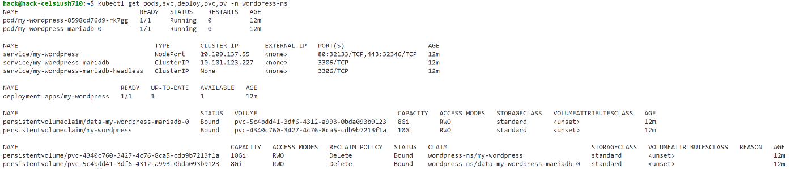](https://github.com/sys123-data/helm-wordpress/blob/main/image-1.png) [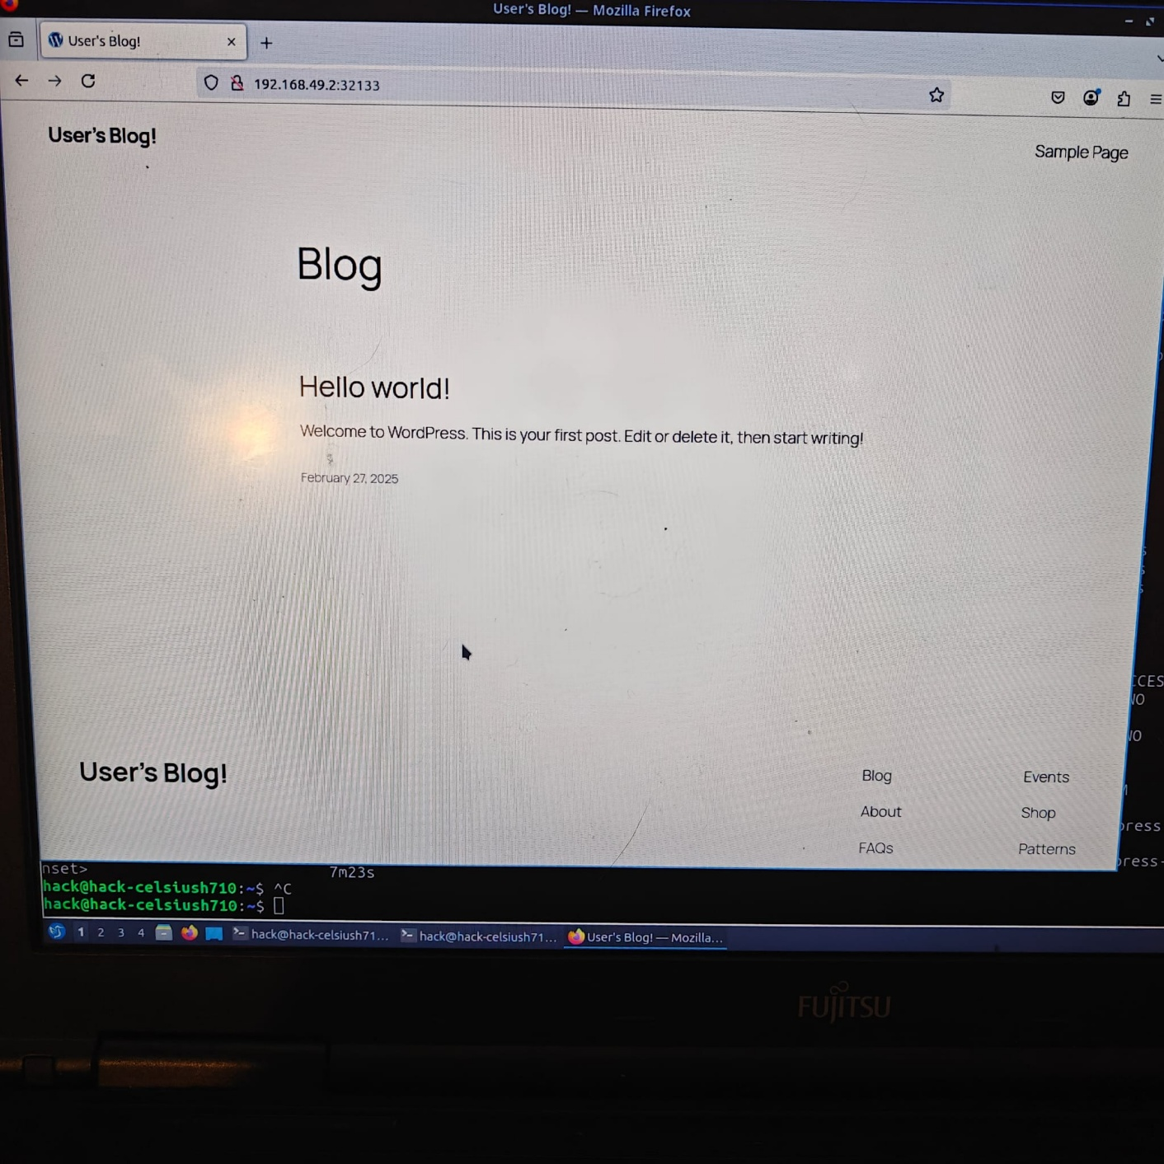](https://github.com/sys123-data/helm-wordpress/blob/main/image.png)

autoscaling can be done by updating custom yaml file

# pipeline script is in Jenkinsfile at  
<https://github.com/sys123-data/helm-wordpress>

pipeline {

agent any

environment {

HELM_REPO = "bitnami"

HELM_CHART = "wordpress"

RELEASE_NAME = "my-wordpress"

CHART_VERSION = "24.1.13"

NAMESPACE = "wordpress-ns"

SERVICE_TYPE = "NodePort"

}

stages {

stage('Deploy WordPress') {

steps {

script {

sh '''

export KUBECONFIG=/home/hack/.kube/config

helm install ${RELEASE_NAME} ${HELM_REPO}/${HELM_CHART} \

--version ${CHART_VERSION} \

--namespace ${NAMESPACE} \

--set service.type=${SERVICE_TYPE}

'''

// helm install my-wordpress bitnami/wordpress --version 24.1.13 --namespace wordpress-ns --set service.type=NodePort

}

}

}

}

}