Name: Patan Mohammed Moinuddin Bajid Khan
Reg : 2023PGDM1403
Section – C
Case Study
9) Code :
pip install scikit-learn
pip install matplotlib
import seaborn as sns
from sklearn.datasets import load_iris
from sklearn.tree import DecisionTreeClassifier
from sklearn.model_selection import train_test_split
from sklearn.metrics import classification_report
iris=load_iris()
x_train,x_test,y_train,y_test=train_test_split(iris.data,iris.target,test_size=0.2,random_state=42)
tree=DecisionTreeClassifier(max_depth=3)
tree.fit(x_train,y_train)
y_pred=tree.predict(x_test)
print=("Classification Report:\n",classification_report(y_test,y_pred))
plt.figure=figsize(10,6)
plot_tree(tree,feature_names=iris.feature_names,class_names=iris.target_names,filled=True)
plt.show()
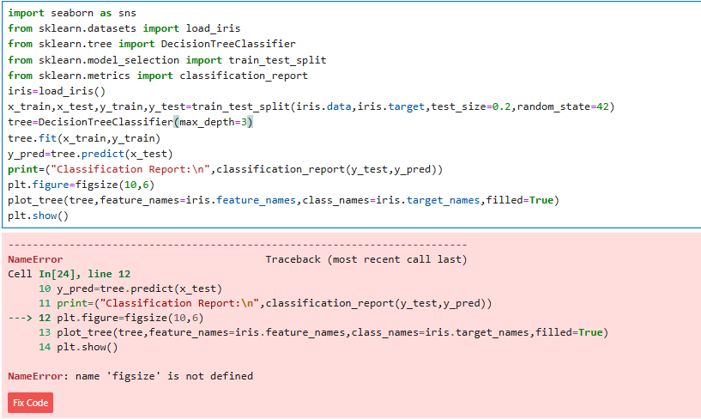
Section – B
7)
Code & Output
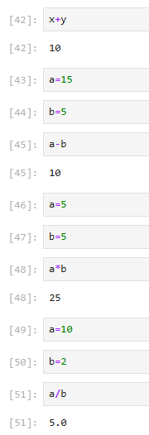
6)
import matplotlib.pyplot as plt
x=[1,2,3,4]
y=[10,15,16,14]
plt.plot(x,y)
plt.title("Line Plot")
plt.xlabel("X-Axis")
plt.ylable("Y-Axis")
plt.show()
