This document provides the internal specification and site-integration guide for the V9-HydroPulse Nutrient Circulation Hub, manufactured by Bio-Loop Dynamics.

BIO-LOOP DYNAMICS
"Feeding the Future, One Cycle at a Time"
System Manual: V9-HydroPulse (Mk. II "Veridian")
Document ID: BLD-V9-MAN-REVA
Status: Draft / Pending Legal Review

1. Introduction: The Bio-Loop Philosophy
The V9-HydroPulse is the backbone of any modern vertical farm. It doesn't just move water; it manages a delicate ecosystem of mineral-rich solutes to ensure that every leaf receives the exact micro-dosage of nitrogen it craves.
Global Support Liaison:
- Contact: Gertrude "Green-Thumb" Glass
- Email: g.glass@bio-loop.internal.org
- Internal Extension: #009 (If she doesn't pick up, she's in the greenhouse. Leave a voicemail or a physical note on the door of Pod B).

2. The Physical Architecture
The V9 consists of a central pillar with a rotating carousel of nutrient canisters and a high-pressure distribution manifold.
2.1 The Vertical Carousel (Component C-1)
To prevent sediment buildup, the nutrient canisters are mounted on a rotating ring.
- Mechanism: A heavy-duty stepper motor with a 100:1 gearbox.
- Rotational Velocity: The carousel maintains a constant angular velocity of $\omega = 0.5$ rad/s.
- Physical Radius: The center of each canister sits at a radius $R = 1.25$ meters from the central axis.
- Physics Note: This creates a gentle centripetal acceleration of $a_c = \omega^2 R = (0.5)^2 \cdot 1.25 = 0.3125 \text{ m/s}^2$, just enough to keep the micronutrients suspended without shearing the organic compounds.
2.2 The High-Pressure Manifold (Pump-P2)
The water is propelled through the tower using a multi-stage centrifugal pump.
- Power Supply: 120V AC, 60Hz (Requires a dedicated 20A circuit).
- Motor Speed: 3,450 RPM.
- Outlet Pressure: Max $P = 45$ PSI.
- Connection: 1.5-inch PVC threading. Don't use metal fittings; the nutrient salts will corrode them in weeks.
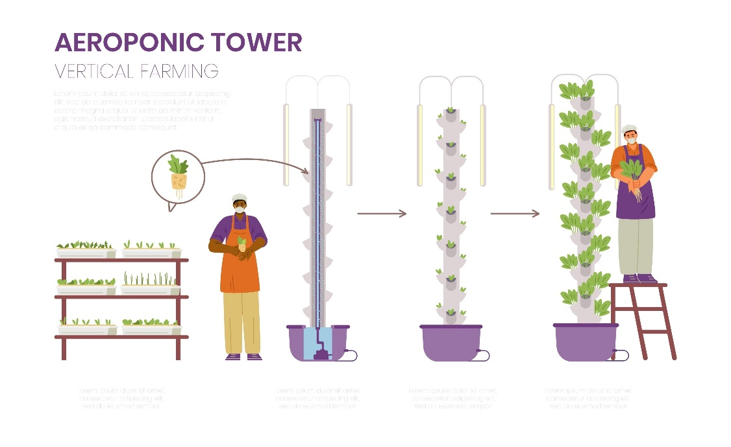
Shutterstock

3. Nutrient Mixing Ratios (Table 1.4)
The V9 allows for precise titration. Use the following table for the "Standard Kale" preset.
Chemical Component | Target PPM | Injection Rate (mL/min) | Valve ID
Nitrogen (N) | 250 | 12.5 | NV-01
Phosphorus (P) | 80 | 4.2 | PV-02
Potassium (K) | 320 | 18.0 | KV-03
Iron Chelate | 5 | 0.5 | FE-09
pH Down (Acid) | Variable | Linked to Sensor S-9 | PH-X

4. Operational State Logic
The V9-HydroPulse is controlled by the "Gaia-OS" firmware. It functions as a finite state machine to manage the 24-hour light/growth cycle.
- DAWN (Initialization):
  - Action: Carousel speed increases to 1.2 rad/s for 5 minutes to stir the tanks.
  - Transition: Move to GROWTH_ACTIVE when the light sensors detect $>200$ Lux.
- GROWTH_ACTIVE (Primary):
  - Action: Pump-P2 activates at 80% capacity. Solenoid valves NV-01 through KV-03 cycle on/off in 30-second pulses.
  - Transition: If the reservoir float switch (S-11) drops below the 10% mark, move to CRITICAL_REFILL.
- DUSK (Maintenance):
  - Action: Pump-P2 drops to 10% capacity (Trickle flow). Carousel stops.
  - Transition: Enter SLEEP after 2 hours.
- CRITICAL_REFILL:
  - Action: All nutrient valves closed. Pump-P2 deactivated. Emergency strobe active.
  - Transition: Move to DAWN once S-11 is satisfied.

5. Field Service Notes (Unstructured/Scanned)
- May 14th: "The belt on the carousel (C-1) is slipping again. I think the humidity in the room is messing with the tension. I've tightened the M8 bolt, but we might need a toothed belt for the Mk. III." — Signed, Aris.
- Warning: Do not touch the UV sterilization lamp while it is active. It emits $P = 1200\text{W}$ of high-energy radiation. You will get a sunburn in 4 seconds.
- Spilled Nutrients: If you spill the 'Iron Chelate' on the floor, use the specialized neutralizer under the sink. If you use regular soap, it turns into a purple foam that won't stop growing.
- WiFi: The V9 tries to connect to the 'BLD_GUEST' network by default. The password is LettuceGrowTogether2024.

6. Component Connectivity Table
Connection Point | Type | Signal / Voltage | Destination
J-101 | RJ45 | Modbus TCP | Central Command
P-02 | 3-Prong | 120V AC | Wall Outlet
S-09 | BNC | 0-5V Analog | pH Probe
V-GATE | 2-Pin | 24V DC Pulse | Main Water Inlet

7. Maintenance Schedule & Troubleshooting
Issue: The plants are wilting but the pump is running.
Diagnosis: Check the manifold (P2) for air bubbles. This is known as "The Cavitation Gasp."
Fix: Open the bleeder valve (the little red knob near the base) until water flows steadily. Do this while the system is in DAWN state to avoid getting sprayed.
Safety Disclaimer: Bio-Loop Dynamics is not responsible for any giant, sentient vines resulting from improper nutrient mixing or the accidental introduction of radioactive isotopes into the reservoir. Keep the lid closed at all times.

