# CASE STUDY : Using NaviCell Web Service for visualization of transcriptome dynamics after shRNA-based inhibition of EWS/FLI-1 chimeric oncogene in Ewing’s sarcoma inducible cell line

Ewing sarcoma is the second most frequent pediatric bone tumor. In most of the patients, a chromosomal translocation leads to the expression of the EWS-FLI1 chimeric transcription factor that is the major oncogene in this pathology. Relative genetic simplicity of Ewing sarcoma makes its particularly attractive for studying cancer in a systemic manner. Silencing EWS-FLI1 induces cell cycle alteration and ultimately leads to apoptosis. For studying the mechanisms of this phenomenon, a network linking EWS-FLI1 to cell cycle and apoptosis phenotypes was constructed through original format and method of network reconstruction (Stoll et al., 2013). Transcriptome time-series after EWS-FLI1 silencing were used to identify core modulated genes by an original scoring method based on fitting curves.

The network prepared in Cytoscape format (see Supplementary materials for Stoll et al, 2013) was converted into a CellDesigner file using BiNoM Cytoscape plugin (Zinovyev et al, 2008; Bonnet et al, 2013). For visualization in NaviCell (Kuperstein et al, 2013), the original image of the network was used. Dynamical transcriptomic data used in (Stoll et al, 2013) for network reconstruction were visualized using the functions of NaviCell Web Service (see Figure 1). The data depict the temporal changes in the expression of all the genes (measured by Affymetrix microarray technology) followed silencing expression of EWS/FLI-1 in cell lines by shRNA. There are in total 10 time points measured during 17 days after EWS/FLI-1 silencing.

Map staining technique allows to evaluate the global changes in the transcriptome of the tumoural cells (Figure 2). This visualization illustrates the switch of a cancer cell state from tumorigenic and proliferative (DAY0) to apoptotic and non-proliferative (e.g., DAY 9). Note increased expression of the genes regulating cell motility (bottom part of the network) as a result of EWS/FLI-1 inactivation: this is an unexpected effect which can be interesting for biological validation.

This case study illustrates using NaviCell Web Service (<https://navicell.curie.fr/pages/nav_web_service.html>) for visualization of dynamic data, using the networks which were not initially prepared in CellDesigner format. Using BiNoM functions, NaviCell Web Service can be applied to practically any networks which can be loaded into Cytoscape environment (e.g., from a BioPAX file).

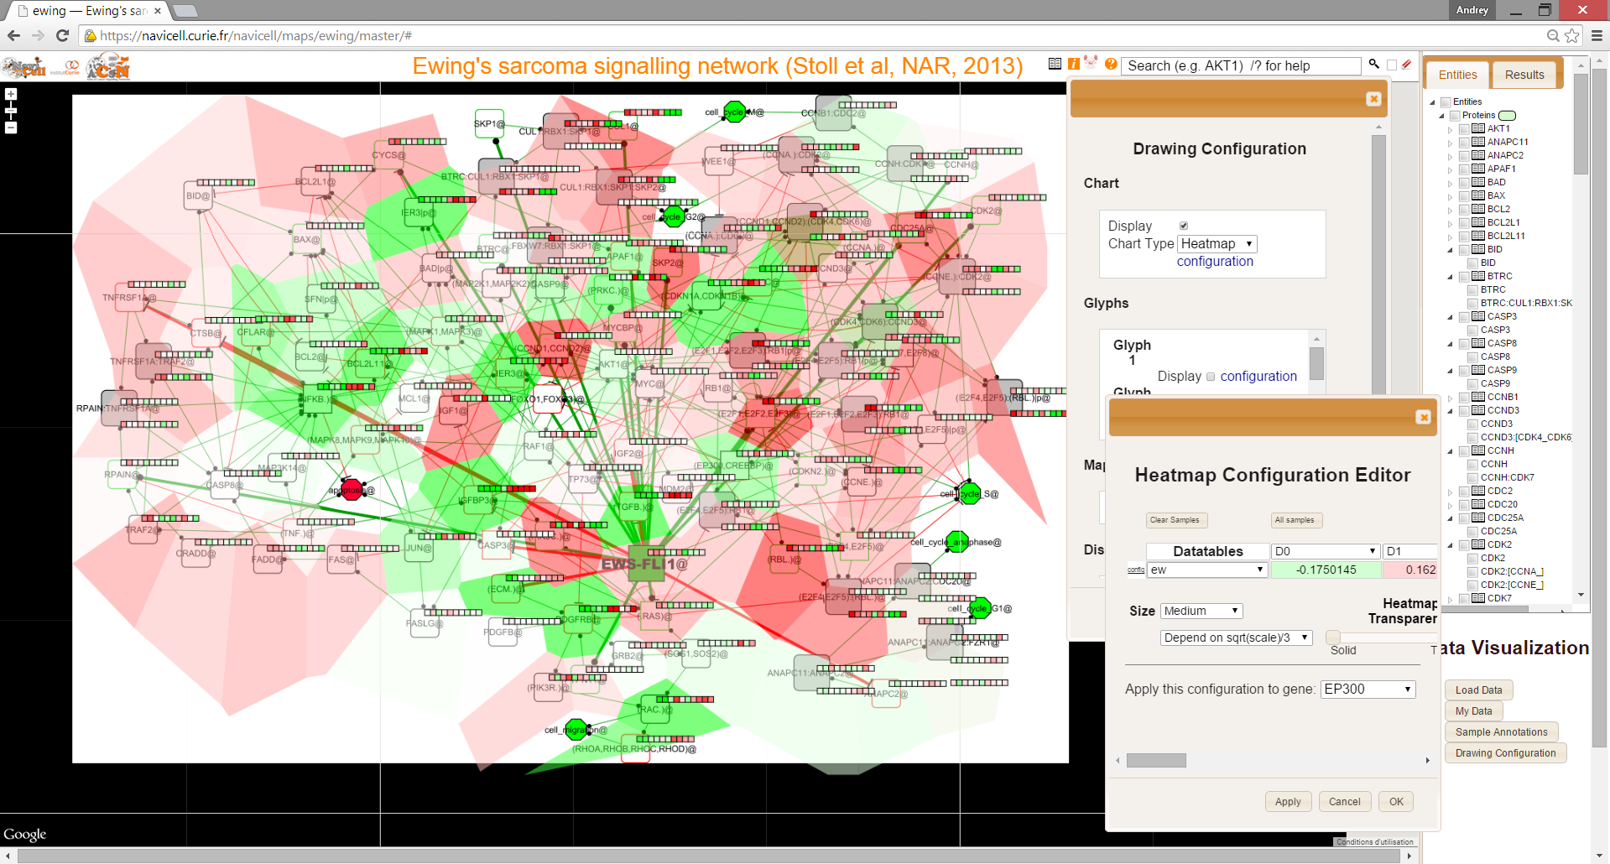

Figure 1. Screenshot of NaviCell Web Service GUI with the network of downstream effects of EWS/FLI-1 chimeric oncogene (Stoll et al, 2013). Dynamic transcriptomic data visualized on top of it. Map staining shows expression at day 0, when EWS/FLI-1 is expressed. Heatmap method is used to visualize expression of the genes for the whole time series (10 time points, 17 days after inhibition). The color gradient visualizes the continuous scale of expression values, centered around the average value for each gene. Red color signifies elevated expression, green – decreased expression, and white – close to average values.



Figure 2. Visualization of the transcriptome dynamics using map staining technique.

# Reference:

1. Stoll G, Surdez D, Tirode F, Laud K, Barillot E, Zinovyev A, Delattre O. Systems biology of Ewing sarcoma: a network model of EWS-FLI1 effect on proliferation and apoptosis. 2013. *Nucleic Acids Res.*, **41**(19):8853-71.
2. Bonnet E, Calzone L, Rovera D, Stoll G, Barillot E, Zinovyev A. BiNoM 2.0, a Cytoscape plugin for accessing and analyzing pathways using standard systems biology formats. 2013. *BMC Syst Biol.***7**(1):18.
3. Zinovyev A., Viara E., Calzone L., Barillot E. BiNoM: a Cytoscape plugin for using and analyzing biological networks. 2008. *Bioinformatics* **24**(6):876-877
4. Kuperstein I, Cohen DP, Pook S, Viara E, Calzone L, Barillot E, Zinovyev A. NaviCell: a web-based environment for navigation, curation and maintenance of large molecular interaction maps. 2013.*BMC Syst Biol* **7**(1):100.